and no one thought to question it, even if you had to do without food to keep the grocery bill down. Don’t ask me why. Remember I was just a dumb kid.
Before he left for the store he would tell me the things he wanted me to do while he was away. There were other farmers doing the same thing. They gathered at the store, while their sons were doing their work at home. It’s called “Being the Boss” or was it “Shooting the Bull?” How long they stayed depended on who all came in. When he arrived home he would tell mom all the local community news, which was of course always welcome. Then he would complain to me that I had not got enough work done while he was away. Well perhaps I could have done better but one got very tired of working so often alone. The trips to the store every morning and then afternoon trips into town while I was left to work always bugged me. Sons were not allowed to complain; it was looked upon as being ungrateful.
The good thing was dad lived to be 93 years old and those last few years we grew very close. I would see his face light up when I arrived at their door. There were times I knew he wanted to right things between us as he mellowed with age. He told me that I had been a good son a number of times, and that he was proud of me. Then one day he told me,
“Jack I wish I had a chance to do it all over again and things would be a lot different between you and me.” That was the nicest thing he ever said to me. I remember answering,
“Well dad lets just be thankful we have had these last few years to get to know and appreciate each other,” but I am getting ahead of my self here.
Len My City Cousin
One summer in about 1937 or 1938 my mother’s brother who lived in Stratford sent his oldest son out to the farm for the summer. His name was Len and he would be 16 or 17 at the time. Of course I was quite happy to have him there, as I had always wanted a brother. But I didn’t enjoy that summer very much because Len knew all kinds of crazy things to do that got us into trouble. Of course Len got off as he was a city kid out on the farm and didn’t know any better but I was a farm kid and should know better. So almost everyday I got a whipping from my dad, and I do mean I got a proper pounding. I remember dad saying that I must enjoy it or I would not get into so much trouble so I could not accuse my dad of not having a sense of humour.
One morning just as dad was leaving to go to the village store for tobacco, he told Len and me that we had to dig a hole in the orchard and bury a dead calf. I don’t remember how the calf had died but I do remember it was dead and stiff as a doornail. Dad showed us the spot were he wanted it buried under an apple tree, straight out from my grandparents kitchen window. I could see my grandpa looking out at us.
It had been quite dry that summer and the old orchard sod made hard digging. The sun grew hot and the ground seem to get harder the deeper we dug. Finally Len says it is deep enough, but I said I didn’t think so. I was only about ten so not exactly an expert on digging graves. Len suggest we drag the calf over and see how it fit. Mmmm this sounded like a good idea. We did that and there was no way it would fit, as the hole was not long enough or wide enough and definitely not deep enough. So we went back to more serious digging. We decided to water the hole and see if it made the soil any easier to dig. Well, maybe it helped some, but it got us pretty wet and muddy.
Finally very tired and all sweaty wet and muddy, we decided enough was enough, and as long as it was buried who cared how deep. We dragged the calf to the hole again and sort of rolled it in. It didn’t look very comfortable with its feet-sticking straight up in the air. So we pushed them down as best we could close to its body. Dad still was not home and we wanted to have it all covered over before he did or we knew we would have to dig the hole deeper. All was going along very well though and finally we had it buried. We decided to pack the earth down a bit with out feet. So we stomped on it.
Suddenly the calf’s two front legs popped up out of the grave under us. Mmm this was not good. We tried to push them back down again but without any luck. Finally Len had a great idea. He asked me to run to the woodpile and bring back the axe. We took turns chopping the calf’s legs off. Then dug another hole and buried them. We didn’t think anyone would ever know about this. It seems my grandfather was watching all this from his kitchen window and he was rolling in laughter. Even dad saw humour in it and I didn’t get my usual pounding. For years my dad told all our friends about the day Len and Jack buried a calf.
The War Years
I remember the day the Second World War started. Germany had already taken over Czechoslovakia and on Sept. 1st, 1939 attacked Poland and two days later were at war with France and England. Canada officially declared war Sept. 10th. We had just started back to school in September of 1939 when someone came to the school door to tell the teacher, and the teacher relayed the message to us. We were now at war with Germany! As children we could not possibly grasp the meaning of this or how it was going to affect history or our very own lives. Let us say that in 1939 the world we lived in was rather small, and close to home. Germany seemed a long ways away and we were safe here in Canada. I remember hearing several of my Uncles who were veterans of the First World War talk endlessly about war every time we visited them. As a child I got rather upset with the fact that the conversation always got around to the war, which to me was fought many years ago, long before I was born. Now I know it was something they had experienced and had to talk about in order to deal with it.
Soon we heard news of our neighbour sons enlisting, first a trickle and then a flow. I began for the first time in my life to see uniformed men and boys at the village store or on the street in town. Patriotism was born to the look of crisp new uniforms and to the sound of marching feet. But none of these young men were aware of the kind of war that lay ahead of them. Canada actually had no military at all in 1939. We had to start from scratch. Germany was years ahead of us with military equipment we never dreamed of.
In 1939 Canada was largely a rural nation of eleven and a half million people. Now in the year 2004 it has a population of about thirty three and a half million. The city of London had a population of seventy six thousand in 1939 but now in the year 2003 it has a population of about three hundred and fifty thousand.
This war was a tragedy to all sides with a terrible loss of property and life, but it changed Canada forever. Within five year’s time we were a different nation and it was unbelievable. From a sleepy nation plagued with seemingly hopeless unemployment and poverty we made a complete about turn to prosperity. Everywhere people were working spending money and creating more jobs. We had one of the largest air forces in the world, and a navy to be proud of. The nation had finally awakened from its slumber. There is a verse in the Old Testament, which has universal truth. It says, “ Where there is no vision the people perish.” It is sad it took a war to awaken us, to make us pull together and find our vision.
In the nineteen forties things got a lot better out on the farm. The second world war effort, caused farm production to increase along with good prices for their products, to feed England and the armed forces built up from all the “at that time” British Empire.
For the first time ever farmers felt they could step out and enlarge their farm enterprise. Canada had secured a contract trade agreement with England for all the, bacon and eggs we could produce. My mom was in seventh heaven and she increased her flock of hens from about a hundred and fifty, to three hundred, and then to five hundred. Our evenings were now largely taken up with a wet cloth in hand cleaning hen eggs, a job none of us seemed to enjoy.
Up until now I don’t think any farmer who farmed ever gave thought of doing it to make money. It was more often not a chosen way, but rather an inherited way of life, which might allow you to earn a decent living but nothing more. Farming was not thought of as a real job. It was said some people left the farm and got a job. Others never had a job, as they farmed all their life. This was probably the reason why my mother never had any Canada pension when they retired. She was a far wife and while she kept a house and raised 4 kids and helped with all the farm work from driving the tractor to the milking the cows she didn’t have a job, or so the government said and so could not pay into Canada pension. “Go figure.”

Saturday Nights
We lived for Saturday night when we would all pile into the family car and head off to town, but first we each had to have our weekly bath in the old round galvanized steel tub. In the summer we bathed out in the wood shed. And in the winter mom used the clotheshorse with a sheet on it to hide us in the tub in a corner of the kitchen. Water was heated in a large copper boiler on the wood-burning stove in the kitchen. There would also be a copper water reservoir built into the rear of the stove. Shoes were shined and hair was combed and we donned our next to Sunday best to do up the town in style. As kids we were very happy and very excited as we lived for these Saturday night outings. Once a week we were able to break free from our long work-a-day week on the farm.
On getting out of the car I was given 25 cents and my sisters 10 cents. Every one knows girls don’t need as much money as boys. We would search the town for the best buys. There were B B Bats for one cent each and gum balls two for a penny, liquorice cigars and pipes for a penny each. A hot dog cost a whole five cents and an ice cream cone the same.
Mother’s brother and wife, my Uncle Loril and Aunt Pearl always went to town early on Saturday nights and took my Grandmother Butson to town with them. They would find a parking place along main street so my grandma could sit in the car and watch for her friends to go walking by. Your neighbours would be there and all your relatives and friends from near and afar, and to add some mystery many, many, strangers you had never met. The streets were packed as many of these people came to town only on Saturday nights. You could not walk straight down the street you had to dodge back and forward through the crowd much like you would today in a really crowded mall before Christmas. Oh the kids all loved it and they walked down one side of the street crossed over and back on the other side, around and around. You see at that time Mitchell was very much just a one block long town. Often the Salvation Army would be playing in the band shell in central of town and there would be a good crowd surrounding it singing hymns.
While I enjoyed the music I was much more a Roy Rogers and Gene Autry fan at the Plaza Theatre, so off to the show I would go every Saturday night. Children were not allowed to enter the theatre at night without an adult accompanying them. Thus we would have to stand out in front of the show looking for a friend or friendly face and ask if they would take our money and buy our tickets for us. Most of the time they would if you promised not to sit with them. Ha ha.
There is one thing I should tell you about the movies at that time and that is all the bank robbers and crooks were much more polite in those days. You see they would never think of interrupting Gene Autry or Roy Roger in the middle of a song. It was always as the last few notes of the song drifted off into the sunset that the shots would ring out... and some one would exclaim,
“ It’s the bank, it’s being robbed.” So Gene on Champion or Roy on Trigger would gallop off, with their guitar slung on their backs, and their big white hats on their heads. They always drew their guns and shot the sky full of holes as they went after the bad men. Like the Mounties they always got their man. Then too, it was always easy to tell a bad man from a good man, as the bad men always wore black hats and the good men white. The good man never lost his cowboy hat while galloping after the robbers, and a good fistfight never even ruffled the good guy’s hair, nor dirtied his clothes.
I would meet my dad and mom and sisters after the show was over, usually about eleven o clock. On the way home we would stop at Mrs. Elliott’s store on the edge of town and buy a Brick (Quart) of ice cream. As we didn’t have a refrigerator we had to eat it as soon as we walked in the door. Mom would hold onto the ice cream out the car window. She thought she was keeping it cold, because her hand got so cold. But as we know now it was the worst thing she could possibly do to keep it frozen. But that is the way it was, and that was the way we were. Mom would divide the ice cream into six pieces and we all sat around the table and ate it very slowly as it was a real treat and not something we got very often. Needless to say ice cream tasted much better in those days.
On the street corners there were often crowds of people talking in a foreign language, and many people complained about it. Now I know that it was because many of the older folks found it hard to learn English without any kind of help and while the young learned English at school, they spoke German or whatever, when they were with their older family members or neighbours of their community. It took many years for this country to come to terms with our different nationalities, as it was inbred in all nations everywhere for generations not to trust other kinds of people. I believe it was the high schools that led us out of this dead lock. Ron was Scottish and he met Nancy at high school who was German and they fell in love. Today they have children and grandchildren. They are great Canadians and we are all very proud of them.
As things got better farmers started to put in, inside plumbing, built in cupboards and running water. Those that didn’t have hydro put in hydro and bought refrigerator and electric stoves. I worked hard on the farm all week and on Saturday night I got 25 cents. I was able go to more Gene Autry or Roy Rogers movies. Children paid eighteen cents and adults forty-three. The three cents on each was the government amusement tax. Most often I went to the show with my neighbour Stanley Morrison who was a great fan of Gene and Roy. Sometimes when my dad and mom would want to go home early Stanley’s brother Bill would meet us coming out of the show. He always wanted to go across the street to Bill Hoflick’s for a hot dog and a coke before heading home The problem was that after the movie I only had 7 cents left from my quarter, and a hot dog was 5 cents and a coke was another 5 cents. So I would just order a hot dog. When Bill found out why I never had a coke, he would just say give me your money and let me buy for us all and he would pay that three cents. I know today that does not sound like much but it was at that time, and I have not forgotten Bill for doing it. On top of that he had to drive me a half mile farther down the road to take me home. Without a doubt I knew I had a good friend and neighbour in the Morrisons.
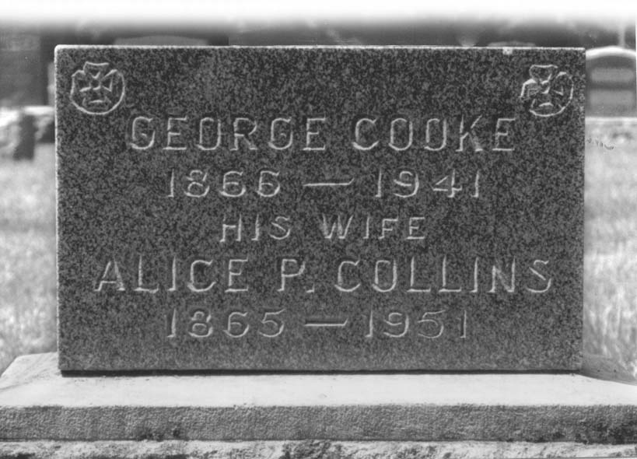

“ My Grandfather Cooke ”
In 1941 while the Germans were dropping what they called blockbusters on London and other English cities, my grandfather lay in bed dying of cancer. His greatest concern seemed to be, what will happen to his dear old England as by now we realized this war was a long ways from being won. When the war started he was sure it would be over in a short time as he thought no one had the might to stand up to old England This turned out to be a different kind of war; one the world was not prepared for. I was 12 years old and I loved my grandfather dearly. He was perhaps the only person in the world in whom I had no doubts, I just knew he loved me. I remember sitting beside his bed and how he said Jack (A) (he always called me Jack- A)
“Jack A I’m not afraid to die. I am ready to go. But I would give anything to know what is going to happen to dear old England.” He also asked me not to forget him and I promised him that I would not. I still remember being at our old public school when the teacher answered to a knock on the school room door. The teacher came back in and told my three sisters and me our dad was waiting for us. In my heart I knew even then what had happened but to a child death is a distant thing. You have to see it close up to truly believe it. I remember walking into my grandpa’s bedroom and seeing and knowing that life had flown from this lifeless body. It struck me then, my grandpa was dead. I fell on my knees and cried.
I find myself driving up to the old cemetery in St Marys every year with a pail of suds and water and a brush keeping my grandparent’s stone clean. After my grandfather passed away my grandmother spent the winters in Detroit with her daughter my aunt Maude and the summers with us on the farm. I dearly loved my grandma so summers were a special time.

My Grandpa and Grandma Butson of Munro

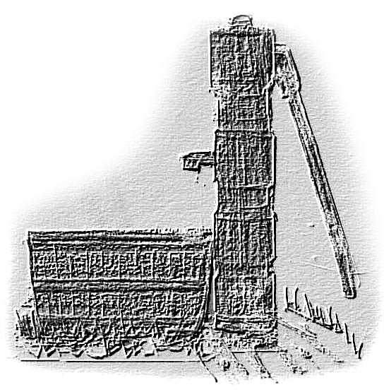
Grandpa Butson’s Wooden Well Pump by Jack
I don’t remember very much about my Grandpa Butson, as he died while I was still very young. When I visited them it seemed he was always out at the barn doing chores or in the field. I feel he never gave me a chance to get to know him. On the other hand my Grandma Butson doted on me. I was well aware that cousin Reggie my Uncle Bob’s oldest son and I competed for first place among all the grandchildren and believe me there were many. I do believe I should have given the spot up willingly to Reggie as he lived closer to them and I know he helped his grandma a lot more then I ever did. In fact I think about all I ever did for her was eat her chocolate cake and smell her flowers, but wait,.. I was a cute little varmint.
Would you believe it, my Grandma Butson always had a chocolate cake sitting on the kitchen table along with the sugar bowl, the salt and pepper shakers and a special kind of container with a thumb flip up lid, filled with maple syrup. The maple syrup was always on the table just in case there was an apple pie around. Grandma’s Chocolate cake was heavenly and always a thing of great beauty and if you didn’t have at least one piece my grandmother would think you were sick. The cake was constantly replaced as a house hold necessity just before the last piece disappeared. Two things I always think of when I think of my Grandma Butson. The first being of course her chocolate cake and the second would be her flower beds. It was Grandma Butson that got me interested in flowers. She had beds all around the old white clapboard house, big wide beds four to six feet out into the lawn. Then there was a huge mound of earth across the front of the house perhaps 15 feet wide and 30 ft long. The centre of it was easily 3 ft. higher than the lawn that surrounded it. I think it had to be the soil that came from the basement of the house when it was dug. Rather than haul it all away with horse and wagon they covered it with top soil……gave it to grandma, and …..called it a flower bed.
A vast lawn in front of the house ran all the way to the road (which was the 23 highway). Down each side were flower beds, and a huge chestnut tree spread across the lawn at the road. All this grass had to be cut with a hand pushed lawn mower. The older grand kids who lived close by often had the job, then after they grew up cousin Reggie took over the chore. I have seen his blisters.
Cars on the 23 highway often drove by slowly just so they could look, but many people came in to visit her just to see her flowers. Every time we visited in the summer she would take us out to see the flowers and do a walk around. I always loved that. However, grandma and mom would stand in one spot talking for ten or fifteen minutes about a certain flower, plant or bush. All the while I would be ten plants ahead begging and waiting, waiting, waiting. I would beg them to catch up. Saying, “Hurry up mom, hurry, come and see this one it’s a butte.”
I was fascinated by what my grandma could do with flower and flower beds, but grandma would not be hurried. She took her time telling my mom all about this or that plant, - where it came from, how long she had it and how well it flowered last year. I am sure my mom had heard it all many times before but that didn’t really matter. This was one thing they both had in common – a great love for, flowers.
While they both loved their flowers I’m sure they each secretly knew this walk around was a very special time for them together. Mother and daughter. Perhaps what they didn’t realize at the time was that I would remember all this as well. It was special to me too.. Ah! pleasant memories of my Grandma Butson.

“ Fur and Feather Farm Pests ”
It seemed that every farmer in those days had problems with farm pest. Squirrels would invade the barns in search of easy food. They chewed holes in the barn siding, tore open sacks of feed, tantalized the cats and dog and in general made a mess. Young boys would find sport on week ends with a rifle shooting squirrels. Next to squirrels, groundhogs in your grain field or meadows were a constant nuisance. It was dangerous to gallop a horse across a pasture with high grass as the horse could step in a groundhog hole and break a leg. The most agitating problem I believe though was when you were cutting a field of grain. If you didn’t know or see where the hole was your binder cutting bar would run aground on the mounded earth around the area breaking the guards, teeth and blade, shutting you down while you made repairs.
It was not uncommon to see a farm truck with a couple of farm boys driving slowly down a country road in the evening or a Sunday afternoon in search of groundhogs to shoot. While I am squeamish on the kill today, at that time it was considered a sport.
Foxes had all but disappeared in the thirties but made a comeback in the forties, and were killing chickens in the spring and summer months. They were wily, crafty creatures and hard to shoot. Often there would be a den of young ones and the best way, or perhaps at that time the only way to be rid of them was to dig them out. The end was not a pretty sight, but that was how it was and everyone accepted it.
Few farmers had much love for crows or black birds as they would walk down a row of corn taking out the corn seed one after the other until they had their fill. You could not get close enough to shoot them and a scare crow soon became a bird perch. In the end poison corn seed became the only choice. Starlings in the mail box were an endless messy problem as were sparrows in the sheds and barn.
A barn is usually home to a few pigeons and I don’t think any farmers minded a few, but for some reason some barns seem to appeal to pigeons more then others. Our neighbour’s barn was one of those. I remember well my cousin Arlo Cooke and a neighbour Vernon Roger coming by early one Saturday morning asking me to come along with them to our neighbour’s barn to catch pigeons. They both had a sling shot but I was not allowed to have one. I would be about twelve or so. As I was always a climber they wanted me to climb the ladder on the end of the barn to the hole in the gable end and catch any pigeons which tried to escape. I wrapped my legs onto the ladder and I caught handfuls and handfuls of pigeons but I didn’t enjoy what I was asked to do. That was to ring their necks and throw them down. I still remember that day with shame as I have always loved pigeons.
“ I Lose My Hearing ”
In the early forties most farm women were raising large families. Four, six and even eight children were not uncommon. I had three sisters who have always been very close to me and we are even closer today. They have given me all I have in the line of family. Every winter it seemed the school got hit with some kind of diseases. We had whooping cough, measles, flu and chicken pox. When you have 4 or 6 kids in the house down with the flu it was much like running a hospital. Scarlet fever came to us in Dec. 1942.
My three sisters and I had Scarlet Fever in the early winter of 1942. Where it came from we will never know. We were the only family in the community to get it. The school Christmas concert was called off and the school closed for several weeks. We were immediately put under Quarantine, with a big official looking sign placed on the farmhouse door. My one sister Pearl and I lost our hearing because of this. No one thing ever changed the lives of my sister Pearl and me as much as our hearing loss. While it did affect our hearing right away, making school work very difficult, the nerve endings in our ears were damaged so severely that they just kept dying off steadily over the next several years, until we both were almost 100 percent deaf. For Pearl and me this was an all-new world we had to learn how to deal with. Pearl used to play the piano and she had to give that up.
Music also meant a great deal to me. I used to sing first at school and church concerts and then at music festivals and I never got anything but a first prize for my singing. On the farm I sang from dawn till dust. I sang to the cows. I sang to the horses and to the pigs. Perhaps it was because I spent so much time working alone, I don’t know. Life for me seemed much happier with a song. I do know all this singing all day long expanded my vocal cords allowing me to sing like the birds.
Mom swore the cows would not give down their milk if I were not there to sing to them. I was asked to sing at weddings and funerals and at talent shows, but as time went by it got so I could not hear the piano when I went on stage. I remember one of the last times I ever sang in public. It was in the Crystal Palace ballroom in Mitchell and half way through the song I forgot a line in “ My Bonnie Lassie “ and then I could not seem to get back with the piano as I didn’t hear the music. It was very embarrassing. But the worst was that most of the people in the audience didn’t know that I was deaf so they really didn’t understand what had happened.
I also played the piano by ear and for a while I would play the song in an octave lower so I could hear while I practiced. But as time went on I had to put my ear right down on the piano itself to hear anything. Well, I finally had to give up my music. It was much like losing my left arm. I am a lefty you see. There was a time I knew every song that was sung in public, both old and new. Today I have no idea what the songs sound like, but I find the words of most songs offending and the English terrible. If they honestly can sing why do they have to sing profanity to get attention and dress weird and shake their butts while making asses out of themselves and then insult us by calling it entertainment?
As I had been doing quite a bit of singing I had bought every new popular song that came out. Today I have no idea what happened to all my music, it disappeared. I especially miss a little black book in which I had neatly written down every song I ever knew, I carried it with me all the time.

Making Maple Syrup
In the springtime on the way home from school we would visit Roger’s sugar shanty, in the bush next to the road. They always made us feel welcome and would give us a big dipper full of hot maple syrup to sample. We would pass the dipper one to the other until it was empty, then they would offer us more. We always got all the syrup we could drink.
We also found out to that if you drink too much hot maple syrup you would end up making a hasty run for the outer house. Of course the Roger brothers knew all about that and I guess thought it a joke. Sometimes we ventured into the shanty during a cold spell when no one was there, just to see if there was some syrup left in the pans we could drink. We often found the sappy syrup in the evaporator frozen over, and mice tracks frozen in the ice along with a few of those little brown droppings. Still it did nothing to stop us from breaking through the ice so we could enjoy a cold treat. We lived dangerously in those days and I have fond memories of my visits to the Roger’s sugar shanty.
We had a lot of maple trees in our lane way and down the road on the front of the farm. So I talked dad into letting me tap these trees and boiling the sap in the orchard. My Uncles lent me a syrup pan to boil it in. I managed to scratch up enough money to buy spiles. As for pails I used anything I could lay my hands on, mostly five and ten pound honey pails or beehive corn syrup pails right down to bacon powder tins. It was an odd assortment. I would rush home after school to find everything running over. I got no help from dad but my sisters occasionally helped me out to gather sap. We gathered the sap in the milk pails and stored it in dad’s cream cans out in the orchard where some nights I boiled till near midnight until it was well down towards syrup. Dad would come out and get me and tell me to shut down and get off to bed. My agreement with dad was that I didn’t take any of his firewood in the wood yard beside the house. There were always lots of branches that came down from the trees during the winter. So in a way dad got an early spring clean up but I have to admit I burned every thing wood that was not nailed down.
Mom not so willingly finished the syrup off on the kitchen stove in the back summer kitchen. The problem was the steam makes the wallpaper come off, and she thought that was bad. The syrup however was extremely good, and I made a number of gallons.
The Day We Played Hooky From School
I always fell in love with spring- the freshness of the morning air- the forest all about us green once again, and the morning sun warming us as much on the inside as it did on the out. It was such a morning on my last year of public school that I talked my two sisters into playing hooky from school for the day. I had never played hooky before and I might add never since.
We were walking past Roger’s bush when it donned on me that on a day like this no kid should have to sit in school. Laurine was in her first year of high school, so I just had to talk Pearl and Jean into it. They readily agreed with me that it was a great idea for a day like this. For the first few hours we enjoyed our new found freedom and the freshness of the forest all about us. We played about looking for wild flowers, frogs or anything that crawled. But as the day got warmer the mosquitoes came out looking for their morning breakfast and it was so good they stuck around for lunch. They looked at my sisters and me as a newfound smorgasbord. We swatted and swatted but more and more hordes of wild and hungry mosquitoes descended onto us. My sisters were crying, buckets of tears and I knew I was to blame, but what could I do. If we went to school now we would have to explain to the teacher and going home now to face dad and mom was out of question. So we had to stay in the bush until the kids got out of school. After they passed the bush on their way home we left and hurried home. While we didn’t enjoy the day one bit we thought at least we had got away with it. I knew my sisters would not tell on me. Late that night a girl in my class at school phoned my mom to find out why we were not in school that day. Caught! There was hell to pay and my sisters and I never played hooky again.
High School And The Aftermath
I started Mitchell high School with great hope that somehow I could get my education. I realized with my hearing loss it was not going to be easy. During my last year in public school Miss McMillan had worked very closely with me. I remember her telling me that she was not going to let me fail my grade eight. I could not expect that kind of help in high school. What made high school so difficult for me was that most things were taught verbally and I just could not take reliable notes and keep up. I remember asking a number of my friends for their books after school so I could take them home and copy, but after all too many times they had to say no to me, as they had to have their books at home at night to study. So I was getting farther and farther behind as the weeks went by.
About Easter on my first year in high school while sitting in class, there was a loud pop in my ears and then, a great silence. I remember looking around me. It felt as if everyone had left the room and I was just sitting there alone. There was no scuffing of feet, nor rustle of paper, just silence. It was scary. So I went up to the teacher, Peter Pidgeon and tried to explain to him that my hearing, which he already knew was bad, had finally left me all together. He sent me to see Doctor Pridham. The doctor told me to take my books home, that I had to stay away from school and loud sound for a while. One eardrum was totally shattered full of holes and the other one in bad condition. At that time not too much was known about such things. The public in general all had the theory that when you were deaf you bought a hearing aid and if you had poor eyesight you bought glasses. I had hoped a hearing aid would help me, but I found out that when you lose the nerve endings in your ears a hearing aid was of no use to you.
Loud noises hurt my ear drums. Long hours of noise on a tractor or around machinery left me with what I would call a dead head for a long time after. My head just felt separated or aloft from my body. It was as if I was floating or walking on air. Tractors in those days did not have mufflers; they barked out real raw power, which heightened our senses. The louder they sounded the more power the farmer felt he had. The roar and vibration of the grain threshing machine going full blast and ready to receive a load of grain sheaves was high on the list of assault on my ears. The one that bothered me the most though was the grain grinder. It had two steel plates within which were gradually tightened together as the grain funnelled down onto them. They screamed out a loud torment and a terrifying noise. How I dreaded the day that dad would tell me that we were going to chop, which meant to grind grain into chop to feed our pigs and chickens. The noise of the two grinding plates coming together sent a deadly message screaming into my already dying eardrums. Yet the job had to be done and there was no thought at all given to what more damage such loud noise might do to my already damaged eardrums.
I think I have always been allergic to dust in any form and the fine dust from the chopped grain sent me wild with itch. I itched from head to toe. It didn’t seem to bother my dad one bit, and of course when it didn’t bother him he could not understand why I made such a fuss about it. The more I itched the longer he chopped grain. My dad would carry the grain from the granary to the hopper on the grinder in a bushel basket while I kept the chop (ground grain) away from the grinder by shovelling it back into a pile. When the hopper was full I held the bags as dad shoved them full of chop with a scoop shovel. You had to lift the bag a number of times, as it was being filled and let it slam back down onto the floor to pack the chop down in the bag. This of course sent large volumes of flour into your face and added to the misery. As soon as we finished I would head off to the house for a much needed shower.
I kept hope that by the next year, my hearing would be better so I could go back to school, but this was just the first part of the slow deterioration of my hearing caused by Scarlet Fever. Things were only going to get worse, never better. If I had the right contacts at that time I would have found out that I could have had my high school education paid for by the government, at The School For The Deaf in Brampton. It seems neither the school system nor the government reach out to those in need, but it was there for those who were more informed and the privileged in society, but I was just a farmer’s son.

Shirlyan My Kid Sister
On August 13th 1942 Aunt Maude gave birth to a daughter Shirlyan. My Aunt Maude’s first husband Jack Noble came from London Ontario. He had died of pneumonia and my Aunt Maude then married Guy Starks. Each had a son about the same age from their first marriage. Aunt Maude had Jack Jr. and Uncle Guy had Bill. At this time Jack was in the US Navy and Bill was in the US Marines. This little girl was an adored sister to both Jack and Bill and it seemed she was God’s blessing to seal this marriage and make it a ……united family.
Uncle Guy worked for General Motors and Aunt Maude had just opened up her very own Hairdressing Shop, “Alice’s Beauty Shop.” Together they had just bought a new house at 20243 Alcoy St. and a new baby had not been planned for. At the age of 41 my aunt had not expected she would have another child. They considered Shirlyan a miracle and somehow they would make it work.
In order to make the mortgage payments on the house my aunt had to keep her shop open. So in the end what happened was this little girl Shirlyan came up to the farm in Canada and spent a lot of time growing up along with my sisters and me. We loved her as a kid sister, and to this day we feel she is one of the family.
She would follow me everywhere, often in old rubber boots, which came up to her hips. She asked question upon questions, about things most city girls never ever though of, questions like,.
“But Jack, why do all the little pigs have curls in their tails?” “But Jack, who puts the curls in?” “But Jack, how do the little pigs know which titty is their own?”
She had a pet hen called Pecky that was blind in one eye. She loved that old hen and carried it about. Old Peck came to the house door several times a day just to be with her. Then there was Suzy the pet cow who stood still to be petted. At this time we had a huge rough looking half Collie half German shepherd dog. Most people were afraid of him, but to Shirlyan the dog was just a part of the family
When my dad went to the field with the tractor to work the land she would go along for the ride and fall asleep at his feet lulled by the warmth of the sun pouring down from above and the tractor roaring from within. All the while dust fell upon her making her look anything but that little city girl her mom thought she was.
On Saturday nights she got her weekly bath just like the rest of us and went to Mitchell to see the city lights and to do up the town. Even though she was very young I don’t remember her ever getting homesick. It seemed she was surrounded by people who loved her. Her dad and mom came every other week end to see her.
Shirlyan, married Dan Hurt her twelfth grade sweetheart, and moved to California. They had two children Scott and Michelle, both married with children.

A Long Trip Home
One summer day my dad told me he had bought a model L Case tractor from a farmer away down south of London near a place called Delaware and he wanted me to drive the tractor home. Well as I was just fifteen this would be quite an adventure. I had been driving dad’s 10 / 20 McCormick Dearing on the farm so I was sure I was up to it. But I was not very worldly about the roads very far afield. I had been to London a number of times with my dad but I didn’t know much about the roads to anywhere other than to St Marys, Mitchell and Stratford. To this day I don’t know how he came to trust me to do this.
On the way down my dad explained the route I would have to take to drive home. He would see me onto what was the old highway going from London south to Windsor, then leave me to make my way home driving north. I remember feeling very grown up, that my dad would trust me. I would come back to London on what is now Wharncliffe Road and follow it all the way to Western Road behind Western University, coming out to Richmond Street, just north of the old bridge over the Thames River. Then I was to proceed north, on # 4 through Arva and Birr to Elginfield and turn right there onto #7 going towards Stratford. A quarter of a mile down that highway is the # 23 highway going north which I would take home going through Whalen Corners to Woodham, Kirkton, and on until I reached the old red brick Mt Pleasant United Church on the 11th line where I would turn right and follow through until I reached the Mitchell Road. Once there I would be almost home as we were the second farm north of the corner.
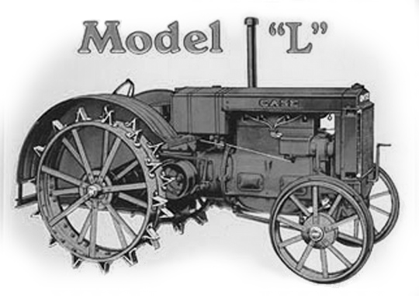. Dad’s Second Tractor
But once we arrived at the farm there were unforeseen problems. The model L Case was a huge brute of a tractor on steel with a large stick hand clutch. Even as a boy I was always very strong, but I had trouble handling that hand clutch. The only way I could move it was to stand up high and try to jerk the stick using two hands. On a busy highway this was not good. So they solved the problem by putting a 3 ft. gas pipe atop the clutch stick. To stop I would have to stand as high as possible and grab the top of the gas pipe and jerk it with all my might.
Now picture this: The tractor was on steel wheels with huge steel lugs. Is it any wonder my dad would not drive it home nor could not find anyone else to drive this tractor well over 50 miles from Delaware home to Motherwell? It was a bone-shattering trip and I stood up for most of the way. They didn’t have mufflers on tractors then either and the noise was deafening.
I was to stay on the shoulder as much as possible but driving through London I had to drive over people’s driveways and across side streets. Not everyone was happy to see this kid and his monster tractor cross their driveway tearing up their oil and gravel driveways. However all went as well as could be expected until I got to Elginfield.
By now it was late in the afternoon and there was a nice fresh stretch of fresh black top laid from Elginfield east to the 23 highway. It had been rolled to perfection and looked simply beautiful in the late afternoon sun. The problem was Jack had to cross over it to turn down the 23 highway to go home, amid dozens of angry waving arms and shouting voices trying to get me to stop or to go away. I proceeded to cross at high speed, the lugs tearing great wads of black tops out of the freshly laid highway and throwing it hither and yonder. I looked behind as I roared off down the 23 as I was expecting the whole herd of trucks to follow me. It must have been their worst nightmare to have this happen at anytime but especially at the end of their day. To this day I am both very sorry and more than a bit amused by what happened. I am sure they all had something to talk about that night at their supper table.
The war was still on in Europe in 1944 and great grain crops were growing once more in Western Canada. But there was a great shortage of men to harvest it. The government offered a plan to send all able bodied men out for free by train. They called it “ The Harvest Excursion Train.” Whole trainloads of men left Toronto on these harvest specials bound for Winnipeg dumping a human cargo in to the Winnipeg Union Train Station to be placed where needed. It was on one of those trains I found myself the end of August 1944 when I was fifteen coming sixteen in October. I know my dad and mom were worried and in despair and I was deaf, strong willed and thought I was grown up but so alone in my Silent World.
Chapter 2
THOSE EARLY YEARS - THE BOOMING 40’S
The great drought had ended and good crops were once again growing all across Canada in the forties. The price for almost everything from a bushel of wheat to a dozen eggs or a pound of pork was the best we ever had. Things were very good again down on the farm. When all is said and done and things are going well I don’t think there is a greater feeling of reward than that which comes to the farmer each fall when he has his harvest off.
In the spring he prepares his seed bed and sows his crop with care. All year he watches it grow; he prays for rain when it is dry; he gives thanks to the Lord when it rains. When it is ripe he works long hours cutting and stooking, then hauling it to the barn with his horses and wagon to be threshed. A great stack of straw would be built in the barnyard with great pride. The granary would be full and over flowing. Then came a feeling of thankfulness to God and pride in yourself, along with this a great feeling of contentment as finally you had time to relax from the usual long days of labour.
By 1944 the population of Canada had grown to 12 million. Almost fifty percent of Canadians lived in the country. Only a mere 20% of the rural homes had electric lights and appliances. Almost all homes were heated by wood or coal. Due to hand pumped presser systems over fifty percent had inside running water.
The harvest was off on our farm and I had answered a large advertisement in the Stratford paper where the federal government was asking for harvesters to travel to western Canada, to help harvest the huge 1944-grain crop. As I was not sixteen for almost two months yet I had not expected that I would be accepted. But word arrived that I could go. So I packed my two huge and battered old black cardboard suitcases with all my worldly belongings, as actually I had no intentions of coming home. This was I thought, my escape from my everyday life of drudgery on the farm into adventure. Every young man seems to have a great need for adventure in his life. For the next number of years many young men and some not too young found adventure going west on the harvest excursion train, working and seeing the country and making new friends.
The train left Stratford in the afternoon with a number of younger chaps and a few older men, none of which were of military age as they were all off to war fighting Hitler’s army all over Europe. The train picked up more harvesters as it stopped at each and every station along the track to Toronto. This was going on all across the province. When we arrived at the huge train station in Toronto we were herded like cattle into a wing where everyone settled down for a long wait for the train to Winnipeg. All the time more men were arriving from all over Ontario, and some even from Quebec and on down east. I remember thinking they were a very rowdy looking crowd and as I had led a rather sheltered life in a rural community I was not exactly comfortable among them.
Soon after the train left Toronto it got dark, I remembered that mom had packed a few sandwiches for me to eat on the train, and I was glad she had the foresight to do this. All around me it seemed other mothers had done the same. A man would come through the train hawking sandwiches and pop and bars, from a small tray, which hung from a strap around his neck. But of course every thing he sold was at two or three times the price it normally sold for in stores. The train stopped at every little station along the way, picking up eggs and cream and dear knows what, and dropped off newspapers and mail, groceries and machine parts and repairs.
Not every car on the train had a bathroom. The cars with bathrooms were placed every so far apart so that you had to walk through maybe six or eight cars one-way or the other to find a bathroom. There was constant traffic up and down the aisle all night. Every time the door on either end of the car was opened a rush of cool night air shot down through from one end of the car to the other. This alone was bad enough, but the train’s coal fired engines spewed black soot from its smoke stack. So every time the door was open soot came in and clung to your hands face and clothing. By morning we looked a bit like a trainload of chimney sweeps. The seats were not at all comfortable, even to just sit in for a long trip. Sleep of course evaded us as the train had violent start-ups and stops all night loading and unloading cars. There were loud shouts and voices of anger, laughter and rushes of cold air with showers of soot. We were certainly not travelling first class, that’s for sure, but then at that time no one expected much of anything for free from the government.
Morning found us in the far north, deep in wilderness amid trees and lakes, such as I had never seen before. I was enchanted with the great expansion of space and the sheer emptiness, and the mystery of the unknown. We travelled all day, stopping at all the small villages and towns taking on and delivering. Those start-ups and stops were apparently meant to leave no one standing on their feet. Our bodies ached from being abused. All day we slowly wound our way through Northern Ontario and then night descended upon us. By now I had bought some food from the vendor as he travelled down through the cars calling out the name of his wares,
“Sandwiches! Bar’s! Pop!” A chap told me when the train stopped at some of the larger stations they sold sandwiches and things inside at a much better price. But I was a bit nervous about leaving the train as I might not hear the:
“ All Aboard! All Aboard! ” call. However I was able to watch the other boys and men and made sure I headed back to the train on time.
Late that second night as we neared the lake head a great fog rolled in, and engulfed our train. We could see nothing from our windows until we pulled into strange stations, - its lights dimly showing its structure. I would see the forms of Indians standing on the station platform amid a swirl of fog. In some way it seemed unreal as I stared out my window at them wondering. Where do you come from? What are you doing here? Why are you standing there on the train platform staring at us? Then something seemed to click inside me and I felt I was in their shoes and was looking into the train seeing all those boys and men, wondering, who are you, what are you doing here, where are you going? And then the train would start with an ‘All Aboard’ and lurch ahead and they were left behind. Somehow I felt, there were just so many feet and a windowpane between us It’s sad we had to remain strangers, and maybe we could have been friends. I always remembered those Indians on the platform in the fog and their silent questioning stance.
The train rolled into Winnipeg on a Sunday, the afternoon of the third day. A human cargo of travel- weary passengers was dumped into the city’s Union Station. We were tired and dirty with clothes we had slept in. Again we were herded into a wing. As it was Sunday we were told we would not be going out until Monday morning. It was then and there I decided to leave the crowd and find the rest room and clean up.
Before I had left home my mom told me that her father, (my grandfather Butson) had a brother Fred in Winnipeg. They knew he had once worked as a barber in the Union Station in Winnipeg. But it seems she had lost track of him over the years.
I washed myself up as best I could in the restroom and then went to see if I could find the barbershop. I found it but it was closed, as it was Sunday. There was a black man cleaning the shop and he came to the door to chat with me. I asked if by chance he happened to know a Fred Butson. He was sure he recognized the name but it was from many years ago. He said if I could wait for a few minutes he would check on the name and get back to me. Before long he came back and told me Fred Butson had worked there for several years many years ago. And he understood he now had a shop in the basement of the Confederation Life Building in the heart of down town. This was great news for me!
I have no idea now, how much money I had on me at that time, but I know it would not be much. Also as a farm boy I knew absolutely nothing about travelling in the big city on streetcars, buses or taxis. I did know though it would cost me money, -money that I didn’t want to spare just now so I had better walk. A stranger pointed me in the right direction towards the heart of the city near Portage and Main where I would find the Confederation Life Building. As it was Sunday almost every single place was closed. I am not sure just what I hoped to do when I got there. But with two large heavy suitcases I started to walk. Every once in a while I had to put them down and rest, for as I said I had all my worldly possessions with me and they weighed a ton. I never did learn how to travel light. I remember chatting with a policeman who was curious about my heavy suitcases. Maybe he thought I had robbed a bank as was carrying the loot. I told him I was searching for my uncle and his barbershop, which was in the basement of the Confederation Life Building.
Sometimes now I wonder why he didn’t load me in his police car and deliver me to the building just to be nice. But no such luck. I finally arrived and every door was locked up tight. I sat on my suitcases trying to think of what I should do now. I remembered my mom had told me that he had been married but his wife died of pneumonia a long time ago. So I reasoned, - well if he had no wife then he likely ate lunch at some restaurant or lunch counter in this area so maybe I should look around.
I started visiting all the eating-places and for a while it seemed as if it was not a very good idea. Then I noticed a small lunch counter place in the Leland Hotel. I went in and sat at the counter and waited for the waitress to come. I told her I was from Ontario and I was searching for my great uncle, a barber who worked in the barbershop in the basement of the Confederation Life Building. She asked me to describe him. Well the truth was I had never met him so I described my Grandfather Butson, saying he would not be too tall perhaps even a bit on the short side with white hair and a neat white moustache.
“Yes, I am sure he comes in here for lunch.” We searched for his name in the phone book, but his residence was not listed, he was only listed at the Barbershop address. In those days not everyone had phones in their apartments, but there would be one down the hall for everyone to use to call out. She told me there was a taxi driver who works out of the hotel and I should wait until he comes in as, “your Uncle always ask for him when ever he needed a ride home from work.”
I waited patiently for quite some time and finally he did arrive, and yes it was a Fred Butson and a barber whom he often drove home. He said,
“ I will take you to the location where I let him off, but I don’t really have his address.” He drove me to a corner of a beautiful tree lined street with a long row of apartments on either side with great wrought iron balconies, and let me out. As I paid him he pointed in a northerly direction and said,
“ He always walks that way.” I looked up and a short way down the street on the second floor balcony was a man looking down at me. Something within me tingled as I looked up at him and I said to myself, “That’s my uncle.”
I Meet My Uncle Fred Butson In Winnipeg
I walked into the entranceway, of a walk up apartments, and looked at the names listed as residents. Sure enough there was a Fred Butson. I could not believe my luck. But was it “ just luck? ” I have asked myself that question many times over the years. Was it possible for a fifteen-year-old farm boy to find his uncle in a city of several hundred thousand? Or do you believe in a Guardian Angel?
Moments later I knocked on the door and there was my Uncle exactly as I had described him. He looked at me and said,
“ You are the young man that just got out of the taxi ”
“ Yes, I said and, do you know Leonard Butson? ”
“ Yes he is my brother ”, he replied.
I asked him if he remembered Reta Butson and he said he did, so I told him I was Reta’s son Jack Cooke from near Mitchell Ontario. He said in all the years he had been in the west no one from home had ever come west to see him. He was so happy to have someone from his family come to visit him.
I stayed for about three or four days, during which he took me to a different place to eat every day and proudly told every one I was his grand nephew visiting him from down east. We walked the wide streets of downtown Winnipeg together and I found out it is a great city full of grandeur and beauty and proud of its place in Canadian history, “the gateway to the west.” I loved the huge hand carved stone and the great round pillars in the historic old buildings, many of which still stand today. Winnipeg is truly the Chicago of Canada with its wide streets, historic buildings and oh yes.... the wind.
He took me down to where the Assiniboine River enters the Red River, then we walked up the riverbank path to the parliament buildings high up on the bank. There I saw all the magnificent statues, which surrounds the parliament building and grounds. He pointed out the golden boy a-top the parliament buildings dome facing north, to where Manitoba was told their future would lay. Not in the south nor the east or west, but to the north.
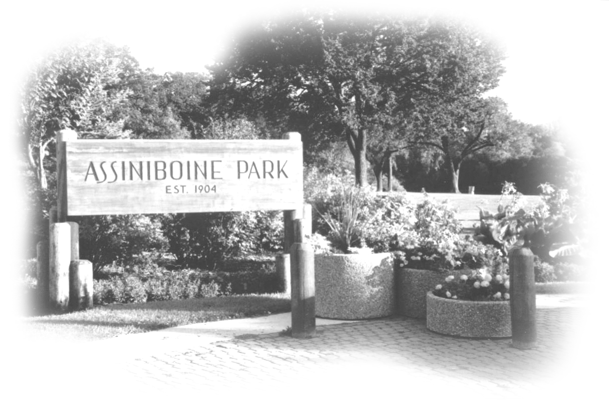
Assiniboine Park Winnipeg
The next day we took the bus out to the Assiniboine Park, where we crossed the Assiniboine River on the footbridge into the park. Never in all my young years had I seen so many flowerbeds or such a variety of flowers and colours, as I saw that day in the “ English Gardens.” My thought went back to Ontario to my mom and my Grandmother Butson both of whom loved their flowers. If only they could have been with Uncle Fred and me right then! Uncle Fred had packed a lunch and we sat on a park bench, and chatted while we ate our lunch. He was easy to chat with and much like my Uncle Roy, my mom’s brother. I would remember this day that I spent with my Uncle Fred in the Assiniboine Park forever.
I spent a day with him in the huge barbershop, and he proudly introduced me to all his customers. It was his own business and there were about six or so barbers working for him. I watching him cut hair and chat with his customers. I could see that he enjoyed his trade and he had the respect of his customers. He made a great impression on me. I will always remember him as a kind, wonderful person, and I am sure he had a lot to do with me becoming a barber.
I guess you might say Uncle Fred too, had his own story to tell, and it was a bit like my own or many others. He was born on a farm near Staffa here in Ontario to a large family. He didn’t feel there was any future for him on the farm but felt very uncomfortable about leaving. He said he always had the feeling he was the black sheep in the family as he packed his bag one night and left without saying good-bye. He just didn’t know how else to leave it all behind.
Sometime later he ended up in Manitoba working for the railway laying tracks. On weekends he started cutting hair for the men with whom he worked. It was not long until he earned the name of, “The Barber,” and some time later he left the railway and opened a Barber Shop in Indian Head Saskatchewan. But after a time he realized he would earn more money cutting hair in a big city like Winnipeg than in a town like Indian Head. So he headed back to the big city, the great city he learned to love.
Barbers in those days didn’t have to take a course and be licensed as they do today. Usually the trade was handed down from father to son and they called it the grandfather plan. When the time came for all barbers to be licensed, those who were already cutting hair were granted a license by all provinces under what they called the grandfather plan.
Having worked for the railway cutting hair he found a job quite easily in the Union Station Barber Shop in Winnipeg. But after gaining experience he wanted his own shop. Records show me he took over at the Confederation Life Building Barber Shop in 1920 and was there until after 1950.
Uncle Fred saw me back to the Union Station and managed to get me back on the train with a group of harvesters heading farther west. I said a sad farewell to my Uncle Fred and promised I would come and see him again someday. For a short time he took me in as family. This meant very much to me.
Once more I found myself back on a train, but this time I had no idea where I was heading. My ticket said Angusville but whoever heard of Angusville? However in late afternoon the train pulled into a small town called Angusville towards the Saskatchewan border and south of the Riding Mountain National Park. The park rising in the north is a part of the Manitoba escarpment, a spectacular rise of forest parkland teeming with nature. It is also surprising to find out that it is the exact geographical centre or crossroads of the North American continent
A group of farmers were waiting at the station for us. They looked just a bit different from people I was use to seeing, as they were small in stature tanned or brown with very smooth skin. I soon found out they were Ukrainians. A farmer by the name of Puska hired me. When I arrived at his place I was surprised to find that a couple of guys working for him had been on the train from Ontario. They were from Barrie. These people were apparently doing very well as they had a new house, a good barn and other good buildings. They also had good cattle and horses and the land was black and fertile with a big crop to be threshed.
The next day I found myself working with a beautiful team of matched sorrel Percheron horses and a fine wagon. I was loading my own sheaves. Now this was a first for me. In the east one man pitches sheaves up onto the wagon and the other man stands on the wagon and builds the load. True they build beautiful wagonloads of grain in Ontario. But in the west every man has to learn to build his own load. It is fast and efficient and you soon learn to make good looking loads all by yourself. After all, the trick is to get the sheaves to the threshing machine; it’s not a beauty contest.
The country was a beautiful mixture of cleared land and clusters of poplar and the ever presence of the Riding Mountains in the north. I promised myself I would go there some day, but as yet I never have.
We were working with a good crop and good equipment and the food was exceptional. There was just one problem; these people did not have much respect for the men. Two older sons stayed with the machine and pitched all the loads off. They kept the machine full to the tilt all the time. You just drove your team up beside the machine and left it. The one brother would climb up on it and start to feed the machine. They fed the machine from both sides. You took the empty wagon back to the field. They demanded everyone work hard and faster and faster. They were constantly shouted at us to get the hell in to the machine and load our wagons faster. We were tired of body and sore of muscle by the end of the day, and no one was very happy. We were very glad for a few hours of respite before going off to bed.
I remember taking a walk outside one night, with one of the chaps from Barrie just before retiring. We were amazed that no matter which direction you looked there was not a single light to be seen. There was not a neighbour for miles in any direction. We really did feel far off the beaten path and of course at that time we were.
The old house had been made ready for the harvesters and served as a bunkhouse. I found it of great interest. It rested amid a grove of tall poplar, which provided a great setting for it. It was made of fine straight logs, and perfect in its structure, and was still in excellent shape. It was of course the first home of the homesteaders. The mortar between the logs was still very white and tight and in the best of condition. Imagine my surprise when they told me their parents had made this mortar by hand from cow manure mixed with lime. Everything about these people seemed to spell hard work and efficiency.
After a few days my nose started to bleed. I had always had a problem with nosebleeds when I worked too hard and got over- heated. I was losing a lot of blood, as it would not stop bleeding as long as I had to work like this. So I felt I was in an impossible situation.
I was just fifteen coming sixteen in about two months. I was use to hard work, but not being driven like this. I felt very weak and faint from loss of blood so much so I just could not work any longer. I took stock of my options, and I thought the best thing to do was to go on to a place called Lumsden in Saskatchewan. My mom had a cousin there. His name was Earl Butson and he was a nephew of my Uncle Fred, and of all things, he owned a Barber Shop. I had met Earl and Beulah his wife once when they visited my dad and mom on the farm back in Ontario. I thought perhaps if I had a week’s rest I could maybe find a place to work where the “master” was not so demanding.
They didn’t like the idea that I was leaving and I was a bit shocked when the lady in the house struck out at me, saying,
“It is because we are Ukrainian, isn’t it?” “You don’t want to work for us.”
This of course had nothing to do with it. So I told them the truth- that the men were all farm boys in Ontario and were used to hard work but they were being driven too hard and were not being respected. I told them they would likely lose more men before the harvest got off if they didn’t treat them better. This sobered them. I did however leave there as friends. Looking back now I feel they treated others as they had been treated themselves all their lives.
I took the bus from Angusville to Lumsden, which took me first to Regina and then north. I was the only person on the Greyhound bus when I first saw the Qu’Appelle Valley. I remember how the bus driver pulled over onto the shoulder of the road and let me get out so I could take some pictures with my camera. I understand it was once a great river, perhaps an ice river, travelling from Alaska south toward the American border. You will find many kinds of rock in this valley not found anywhere else on the prairies. These rocks came down the ancient waterway from Alaska.
After travelling on flat prairie the valley is a sight to behold. Lumsden itself was a very pretty little town nestled comfortably in the historic Qu’Appelle Valley.
There is a story they told me about the name Qu’Appelle. They say long ago some people Indian and perhaps French were camped for the night in the valley. During the night they heard a voice calling out, which sounded like a child crying. A searching party went up and down the valley searching and shouting,
“Qu’Appelle, ” “ Qu’Appelle, ” which means, to call, or who calls.
My cousins made me welcome and I remember spending days walking about the town and the valley. Fall was in the air and the leaves were turning colour and the hills that surrounded the town turned to a soft grey as only natural prairie grass does. I always remember high on the hillside to the north east of town there were large stones, which had been placed, and then white washed. It could be seen for miles. It spelled out McGravins Bread, a local brand. I also remember that there was a small restaurant right across the street from my cousin’s house and barbershop. Although I didn’t have money to spare I could not resist going over there for the odd banana split, which cost me 35 cents, a luxury I could not afford.
About a week later I travelled north on the train to Davidson Saskatchewan to a brother of my grandmother Butson, my Uncle Bob Norris. No! He was not a barber. He owned a Machinery Dealership on Main Street. I only stayed a few days as my Uncle had a bad bout of flu and I didn’t want to catch it.
I had heard there was still some harvesting in Alberta to be done, so I rushed off on the train.
Uncle Fred Butson had a sister Rosena, living at Excel Alberta. So I decided to take the train out there and call on them and hopefully find work. By now I was in need of some cash. Maybe I had too many banana splits? The train from Davidson had to go first up to Saskatoon and then back down to Excel. It is actually on a route from Saskatoon to Calgary. I sent a telegram to my Aunt Rosena from Saskatoon telling her I was on the train from Saskatoon and would arrive in Excel late that night. It was starting to get cool at night and the night air coming into the train car from each end every time some one went in or out of the car was giving me a chill. By the time I arrived in Excel I was not feeling well.
It was after midnight, when I arrived in Excel. It was one of those small train station villages you found so often at that time on the prairie. Once it had been a growing hamlet, but the dry thirties had put almost everyone out of business. Just a store and grain elevator and the train station remained. The stationmasters name was Mr. Jim Barker. He met me and asked if I was Mr. Cooke, and I said I was. He told me my Uncle Frank Mc Nee, Aunt Rosena’s husband could not drive in to pick me up that night as it had rained all day. They had asked the stationmaster to put me up over night at the station and hopefully the road would be dry enough in the morning for them to pick me up. So I was handed a blanket and a pillow and he pointed towards a long bench along the station wall. This was another first for me.
I remember he walked out leaving me alone in the dark station with the door wide open to the night. I don’t know why he didn’t close it, and I left it as it was. I was chilled to the bone, and I knew it was my Uncles Bob’s flu. During the night I heard my first Coyotes howl out in the darkness and I was sure it was wolves. I was very much alone and scared to death, yet too sick to get up and close the door.
Early the next morning Mr. Barker asked me to come in for breakfast. This was in their living quarters built right into the station. I was thankful for the warmth in there, as I was not at all well. A big bowl of grits was placed before me. I was soon to find out this was a western ritual, eating your grits for breakfast. I believe it was called Red River Cereal. I grew up on oatmeal for breakfast in Ontario. Oatmeal was OK but this stuff had all kinds of ugly looking stuff in it. It reminded me of what came off the back of our old farm-fanning mill back home when we cleaned seed grain in the spring. Everyone told me it would put hair on my chest. Maybe so, but somehow something went badly wrong; I lost what hair I had on my head.
The morning train came in from Saskatoon and Mr. Barker went out to meet the incoming train. Farmers brought their cream and eggs to the station to be shipped to Calgary, so he would have to load that, and there might be machinery parts or store products arriving on the train.
I continued to mull over my Red River cereal and was finished when the train left and Mr. Barker came back in.
As you already know, my hearing was getting very bad, but I caught parts of a conversation between Mr. and Mrs. Barker in regards to some money that was missing. The conversation was getting pretty heated and no doubt my face was getting red, as there I was, a perfect stranger sitting at their breakfast table and some money was missing, which had been left on the table. Finally in despair Mrs. Barker (May) said,
“ Exactly where did you leave the money? ” With his pointer finger he thumped the kitchen table and said,
“ Right there on the newspaper.”
With that Mrs. Barker rushed to the kitchen stove and we all followed. I can see her now, holding the stove lid plate in one hand and the poker in the other. Looking down into the stove at the burning newspaper she poked at it and the burning money unfolded and we clearly saw the dollar bills in flame. I could read the numbers as they curled and turned to ashes She had burnt the money. It was a very sad day for them but inside me I was relieved. If they had not found this money they would have told everyone I was a thief.
I Meet My Uncle Frank and Aunt Rosena McNee
My Uncle Frank arrived in a model T with mica glass windows on all sides. The car was in very good shape, as he didn’t drive it very much. I was soon to feel that it must also have a very charmed life, as my uncle was a terrible driver. He was retired now and getting up in years. But he was still a miniature Paul Bunyon, with a shock of dark hair and a booming voice. I liked him immediately. He was not a bit shy in any way and had a quick and easy smile that was as convincing as his voice. He talked with ease as he loaded my two large suitcases into his car. I was now about to learn why, when it had rained all day, they could not drive their cars.
We started down the road to go to my uncle’s farm with my Uncle Frank shouting to me with his booming voice. He was trying to hold the car to the centre of the dirt road but it kept skidding to the slope of the shoulder. I could hear the tires picking up the mud and slinging it against the underside of the fenders. I later learned it is called gumbo, a type of mud that will wrap around your tires and fill the space under your fenders and bring you to a halt. In the distance a small truck loomed, coming towards us. It too was skidding to the right and to the left and back again and caused me great concern as it approached.
We gathered speed as we approached the truck and I found myself hanging onto the seat to keep afloat while my stomach churned. As we came abreast of the truck my uncle swung to the right. We hit the grass on the shoulder bounced over and slipped on down into the ditch. All the time my uncle’s booming voice never missed a beat, and I hung on for dear life. My uncle floored the gas pedal and we shot up on the road. But all too fast as we slipped right across the slippery gumbo top and down into the ditch on the far side. It didn’t seem to matter to my uncle where he drove as long as he kept up his speed.
If I had not been so sick it would have been hilarious. But I was so very sick and ready to throw up. Regardless of all this my uncle was still talking up a storm. It was as if nothing unusual was happening. We actually drove under a telephone pole guy wire and back up on the road. We did this more or less all the way back out to the farm. There are definitely a lot of advantages to driving in an almost treeless wide-open country when the roads are in this condition. In the end it only served to endear those memories, which I have of my uncle. Needless to say I have never forgotten that first time I met my Uncle Frank and the ride in that grand old model T out to his farm. It was clearly one of my adventures.
We arrived at a very small, unpainted frame house, sitting on a patch of prairie grass. There were no lawns or flowerbeds as I was used to back east, just drabness and packed dirt around the door. Somehow it all blended into the vastness of the land all about me. My Aunt Rosena came out the door to meet us. She was perhaps five foot four and she looked such a little woman, in a very big country. She was a real great aunt to me and I soon learned to love her.
I was embarrassed to arrive in this condition, very sick with flu but my aunt put me to bed and waited on my every need and in a couple days I was feeling my old self again.
Now what does a fifteen year old boy do to find entertainment while visiting an elderly uncle and aunt? - Certainly not watch television, as it had not been invented yet. Truly I don’t remember that there was any problem as in the evening we sat in their little kitchen, and they told me all about their lives, while I sat and drank it all in. This is their story, told me as I remember it.
My Aunt Rosena (my grandfather Butson’s sister) was born on a farm near Staffa Ontario in the year 1879. She said she always felt like an ugly duckling at home and in the community, as she had a large goitre growing on her neck. It was not at all unusual to see people with goitres on their necks many years ago. These women usually wore beautiful neck chokes to cover the neck area. For some reason I don’t ever remember seeing a man with a goitre. We know now it is caused by the lack of iodine in the diet and that is why we use iodine salt today. Aunt Rosena left home to find work as a waitress and somehow she ended up working in a restaurant in Chicago in 1919.

My Uncle Frank was born in Thamesford Ontario in the year 1873, and in 1910 he took a homestead near Excel Alberta. In 1919 he was passing through Chicago on a return trip from Ontario to Alberta and by chance stopped at the restaurant where my Aunt Rosena worked. She waited on his table. When he found out she was from near Mitchell Ontario they found lots to talk about. I guess you might say, one thing led to another and he stayed in Chicago much longer then he had intended to. In the end he talked her into going west with him. He was so big and brawny and she so small and petite.
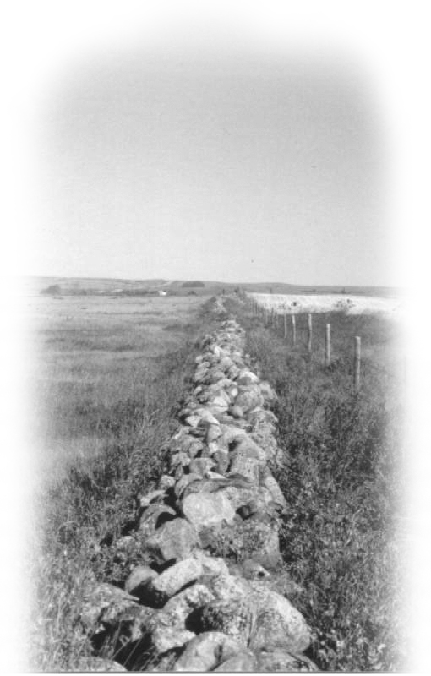
A few days after I arrived I took a long walk on the half section across the road from the house. From the house, I could see a large body of water far back on the property. It was a slough, which glistened in the sun. A slough is a small or large body of water created by the spring run off from melted snow and spring rains. Cattle drank water from these sloughs in spite of its strong taste. The summer heat would evaporate much of the water and many dry up and leave a white alkaline salt bed behind. I could see the wild ducks flying to and fro from it morning and evening. The land I was walking on was very alkaline and non productive. Later I walked over to the home place with the house and barn on it. It was very rolling with many piles of rock; truly my uncle and aunt had not found a very good piece of land.
Uncle Franks Stone Fence
All across the front of the home farm there was a pile of rocks, perhaps six feet across at the bottom and five feet high. My uncle and my aunt had drawn all these rocks off the land on the stone boat and wagon. The stone fence was used to hedge in the pasture field and keep the cows from wandering. This fence can still be seen today as a monument to my uncle and aunt’s hard labour. I look at it with sadness. I was told later that my Uncle Frank’s farm had half the rock of all Alberta on it. I often asked myself why would anyone try to farm on land like this. It is a good question and I don’t have an answer to it.
Many of these rocks found in the fields found a new home in a buffalo wallow. Unless you have lived in the west you will most likely have no idea what a buffalo wallow is. Years ago when there were herds of tens of thousands of buffalo on a bald prairie without any trees, the buffalo were in dire straits to rid themselves of their heavy
itchy coat of winter hair in the springtime. Fortunately nature helped to solve the problem. It seems the great ice age left a few giant size rocks scattered across the prairies. The buffalo found them to be a good itching post. They would walk around and around the huge rock scratching off the winter hair and perhaps ticks from their hide.
This in turn would kill the grass around the stone and churn the soil into a powder dust. The ever-blowing prairie wind would blow the dust out from around the rock and over hundreds of years gradually lower the rock into the prairie. Great herds of buffalo stood waiting for a turn to scratch the hair off their hide.

When the government opened Alberta for homesteaders they set up a land title office at the town of Brooks, about seventy-five miles west of Calgary. The homesteader would first travel to the land title office in Brooks and pick a section of land. Often it was a piece of land they had never seen. A number would be on a surveyor’s section stake in the northeast corner of every section. They would travel overland walking or riding a horse looking for the right section stake, and then claim their homestead. It was very much potluck as some got a much better section of land than others. Alas, Uncle Frank and Aunt Rosena had picked land covered with rock, alkaline soil and sloughs. Little of it was productive.
In 1944 my Uncle Frank was 71 and Aunt Rosena 65. They had retired from working the land and rented the home farm to the next-door neighbour Harry Bull. They did however keep two or three Hereford cows and milked them night and morning from spring to late fall. The milk would be put through the hand turned cream separator, which separates the cream from the milk. Aunt Rosena would churn the cream twice a week and make butter, which she sold, to the neighbour. It was natural for all cows in the west to have their calves in the springtime, thus for a while there was more milk then was needed. During the winter months the cows would be dry and milk from the closest store was miles away. So Aunt Rosena canned whole milk. That is, she boiled it and sealed it in jars for when it was needed. I had a chance to taste some canned milk and I really could not get to like it. It taste exactly like cold boiled milk and not at all to my liking.
Mr. Bull’s crop was already combined, and most of his grain was in his bins. Farmers had grain piled everywhere, even in their machinery sheds. The local elevators were full to capacity. Whenever an empty boxcar came in everyone made a fast trip to the elevator with a load of grain.
Mr. Bull needed help with many other fall jobs to ready his farm for winter. He asked my uncle if this eastern lad knew how to stack bundles. Note I said stack bundles. People in the west call sheaves bundles. My uncle explained to me that stacking bundles would be much like what we would do when we built a load of grain on our wagon at home, only this time we would be building a stack on the ground.
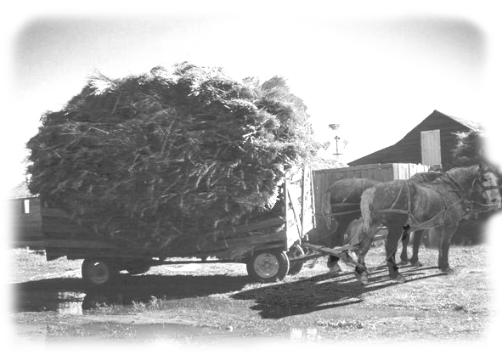
This was exactly what I had hoped would happen, as I needed a job. This was also the beginning of a great life long friendship with the Bull family and many others in that community. We stacked oat bundles beside the barn for winter- green feed for the cattle. Farmers and ranchers in the west have long supplemented there winter hay with oat green feed this way. The cattle and horses love it, and as winter-feed it has a rich aroma, which I love when you pull it from the stack to feed the cattle.
Making a good stack with grain bundles is a work of art. You first lay a row of sheaves all around the outer edge keeping the butt of the sheaf out. Then you lay the centre by overlapping the sheaves from end to end. Always covering the butt of the last sheaf you just laid. Remember to keep the centre well up for if you don’t, the rain or melting snow will be able to Stacking Bundles for Winter Feed get into the stack. When moisture gets into the stack it can spoil the green feed as the grain will sprout and create musk and mould. The outer sheaf’s butts are always placed out, so the grain kernel wont start to grow. A good stack is like a thatched roof. The rain runs off. When you reach the height you want, you start bringing the outside row of sheaves in each time you start a new round of sheaves. This way you end up with a rainproof stack.
The Bulls had a wonderful garden, and it was Mrs. Bull who was the gardener. At home my grandfather liked working in the garden, and my mom was also a good gardener. It seemed though, that all the eastern gardens I knew were limited to carrots, beans, peas, turnips and potatoes. Mrs. Bull however grew many things in her garden we never grew at home. There were parsnips, cauliflower, and several kinds of squash and among other things a big wonderful red potato she was very proud of, called “Plymouth” There was also a strawberry bed, a row of rhubarb and a raspberry patch. Besides the vegetables and the fruit she grew a lot of flowers in her garden too. No one I knew in the east grew flowers along with their vegetables. Flowers were always grown around the house. In Mrs. Bull’s garden there were zinnias, cosmos, marigolds and petunias galore, and an evening primrose that gave off a heavenly scent after the sun went down. There were also rows of gladiolas for cut flowers and a rose bed by the front of the house. Other than that the house was surrounded by well-packed earth. It was there I missed the flowerbeds the most.
Under the ever-watchful eye of Mrs. Bull I learned how to top vegetables well enough to please her so they would keep when stored for winter. While she was a great gardener she was also a fantastic cook and every meal was something to look forward to. As there was no TV yet, they told me I could play the piano. I was still able to hear just enough to play. Once I lost my shyness I would even sing along to the music and they never once complained; in fact I think they enjoyed it. At that time I could play almost anything as long as I knew the tune. However I knew my time at playing the piano was running out and it didn’t seem possible, fair or right, that the day would come when I would have to give up my piano.
Mr. and Mrs. Bull always remained to me just that, “Mr. and Mrs. Bull” even though I came to love them both almost as parents. Mr. Bull was English and for some reason he had held onto that thing the English seem to have about correctness. He stood out in a crowd. He was well educated, well spoken, and always well dressed. There was a sense of well being about him and it seemed everyone around him thought he had money, perhaps even at times when he didn’t. I respected him and admired him greatly for his knowledge and his sense of humour. That was something my dad never shared with me, a sense of humour.
On Sundays I would go back to my aunt and uncles for dinner or supper. I remember the first time I returned after being away for a whole week. My aunt’s table was set fit for a king. She had put on her best tablecloth, her best dishes and best silverware. They had been in Alberta all those years and not one person had visited them from the east. Alberta at that time was far far away. I was the first relative to visit them and she wanted to celebrate. They had been married for twenty-five years and she had managed to save some of her wedding cake, which had been stored away in a special wrap. We had it for supper that night and I couldn’t believe I was eating a twenty five year old wedding cake, as it was still moist and good. Years later I inherited the silverware and crystal we used that day.
We got word a cousin of mine from Staffa Ontario was going to arrive at my uncle and aunt’s soon and stay for a few days. This was my aunt’s nephew and my cousins, Ed and Rita Butson. Little did I know but that my dad and mom had asked them to try to talk me into going home with them. When they asked me to go back home with them I declined, but I also knew that there was not much more work left to do at Mr. Bulls. They told me they thought I might get a job on a farm of a friend of theirs at Pasqua near Moose Jaw Saskatchewan. So in a few days I said good-bye to the Bulls and my aunt and uncle, and I was bound for Pasqua, a small village east of Moose Jaw.
There I met Crosley Chappel and wife. I do believe my cousins thought that if they got me that far on the road home I would give in and go home with them. But it didn’t work out that way. It seems my mother had gone to public school in Staffa with Crosley and his sister Eva, both of whom lived now on farms near Pasqua. Eva was now Mrs. Jim Howes. Ed and Rita left for home without me. I did however send home one suitcase full of clothing, mostly summer clothing I would not need. I had found out two very large suitcases were hard to travel with. I stayed on for a short while working for Crosley.
The flat land here stretched out forever to the skyline and one has to see it to believe it. It is called the Regina Plains and you can see over fifty miles in any direction. This rich black land grows some of the best crops in all Canada, and perhaps all North America. The fall work here was pretty well done and there was not much left for me to do, so again I had to consider my options.
Every now and then in your life there comes a moment of truth, a time when you might feel a high or low that you will recall from time to time for the rest of your life. It was a time like that for me. I can see myself now sitting on the back steps at Jim Howe’s house with their small dog on my lap. I was feeling very down and I wondered just what I was going to do. I didn’t feel quite ready to go home, even though I knew I was homesick. Things were not turning out well for this soon to be sixteen year old boy. But I didn’t want to go home with empty pockets. So I thought I better go back to Alberta to find work.
I had once met a rancher named Wib Duncan of High River Alberta when he was visiting some of his cousins here in Ontario. These Duncans in Ontario “Santa and Zoe” had married into my mom’s family. One winter when Wib was down visiting, they brought him over to meet us. Meeting Wib was a bit like meeting John Wayne. He wore a broad rimmed well-creased Stetson looking a bit the worse for wear, cowboy boots with pointed toes, jeans that were a might bit tight and a cowboy shirt with snap down buttons. While his dress stood out in Ontario it was standard wear in the High River ranch country. Wib had told me if I ever went west again to visit him at his place. So I decided to take the bus to Calgary and then down to High River. The bus left Moose Jaw late in the evening, which meant I would be on the bus all night. This didn’t worry me in the least as I considered it an adventure, remember I was just coming sixteen and I know now there was a lot of empty space between the ears.
Crosley was driving me to meet the bus down the only stretch of asphalt highway in the west in 1944 from Winnipeg to Calgary. It was a fifty-mile stretch of black top from Regina to Moose Jaw. A few miles east of Moose Jaw we came upon a bad accident, and we were among the first to arrive. It seemed that a huge milk truck overturned while trying to avoid a smaller truck that was returning from B.C. with a load of bright red crab apples. The driver of the small truck had been thrown through his windshield and went up the highway on his stomach, taking off most of his clothes and skin. Then his truck caught up with him and came in on top of him. When we arrived he was lying on his back under the truck with his chest under the front axle. He was bleeding badly. Close by there was a milk truck on its side and the milk gurgling out of its tank onto the highway, flowing down onto the man lying under the truck axle. Blood and red crab apples floated and bobbed away in the milk. He was conscious and screamed for us to get the truck off him. More cars stopped and more people gathered, and together we tried to lift the weight of the truck off him. He only screamed more as we struggled with the weight. It seems everyone at that time had bumper jacks and his bumper had been torn off, so it seemed we were helpless to help him.
Finally Crosley said we would have to go or I would miss my bus. By now there were enough people there to do whatever could be done for him. I hated to leave him like that and I often think back and wonder what happened to him. Did he live or die? Whenever I think of this I see his blood mixed with the white milk and the red crab apples floating away, one of those memories I’d rather forget.
When you’re sixteen and all alone travelling at night on the bus, everything around you is new and exciting. The main highway west of Moose Jaw was gravel top and not always so smooth. It seemed most of the towns were a short way off the main highway and at that time the bus would leave the highway and drive into town to let passengers off or pick then up and drive back out again. This made travelling very slow. The bus would even stop away out in the middle of nowhere to let a passenger off in dark lonely places or at side roads or waiting car. Talk about service, they had it in 1944. Every now and then we pulled into a strange place with a coffee shop open and waiting on us, and the driver would get out and shout,
“Twenty minutes” and everyone awake and others not so awake, would scramble off the bus for a cup of java, and a chance to use a bathroom. Strangers already seated in the coffee shop would eye us with suspicion and were no doubt curious as to where we were going and why. I am sure each of us had our own story to tell. We travelled all night and sometime the next morning someone on the bus exclaimed,
“Look there’s the mountains” and that was my first view of the Canadian Rockies. As we continued to drive west they rose higher and higher on the skyline, looming ever more larger and more beautiful. Sometime in the morning we arrived in Calgary. Even at that time it was a striking city built in a valley along the Bow River and against its magnificent backdrop of the foothills and The Rockies.
When I arrived at the Grey Hound Bus Station, I found that the bus going to High River had already left, but there was an afternoon bus that went part way as far as Okotoks, and then went on to Lethbridge. From Okotoks I would be about twenty or twenty five miles short of my destination. As I was not new to hitch hiking I was sure there would be no problem. I had a few hours to kill before my bus left, so I walked out of the station, and around and about the down town. All about me were men and women, old and young and boys and girls in cowboy hats and cowboy boots and it seemed as if everyone, even the poorest cowboy or Indian had on a new pair or Levis or GWG (Great Western Garment) jeans.
So I decided to arrive in High River in Style. I bought my first and only, cowboy boots in a soft medium tan and a light tan Stetson cowboy hat, with a reverse horseshoe steamed into the top, then a pair of GWG boot top pants and GWG shirt with snap buttons. Looking in the mirror I knew that I was a dude to be reckoned with.
I remember that ride on the bus going south from Calgary on the old highway, which went through all the little towns and villages. It was mostly the mountains that held my fascination as I sat staring out the bus window as the miles went by. I remember we arrived at a corner somewhere just north of Okotoks where the bus pulled over to let me out. After giving me my suitcase the bus drove off east, leaving me standing with my thumb up. I don’t remember waiting very long as hitch hiking at that time was a very “in” thing to do, and most people would stop for a young person very quickly and especially for a dude like me.
Along came a real old farm type truck with a stake rack and several barrels of gas on the back held back in place by a chain. It reeked of gasoline. Behind the wheel was an honest to goodness hard working cowboy if I ever saw one. He was well up in years, his skin dark and weathered by the sun and the wind. He was also very cheerful and talkative. I found him to be one of those people that you will never really forget. He of course asked me where I was going and I told him to High River. He told me that was where he was headed. So then he asked me who I was going to see at High River, and when I told him Wib Duncan he was overjoyed, as Wib was a friend of his. I found out later Wib Duncan was a friend of just about everyone he ever met.
This old chap had his very own story to tell, and as we poked along on the highway this is what he told me. He was born in New York City at a time of great poverty for his family. He and his three sisters were put in an orphanage and they found life there unbearable. With not enough food and constant beatings he decided he would run away. Things went well with his escape; whether or not they tried to find him he would never know. He headed south to what he hoped would find him a job and a place in life. Still very young he ended up in Texas working on a ranch. Here he found that there was a wild plan for a cattle drive from Texas to Western Canada. He applied and managed to get a job, with these people. Starting off as a handy man, he later learned to ride a horse and help to drive the cattle. It took months to make the trail ride from Texas to Southern Alberta and during that time he learned all about being a cowboy and he decided that this was the life for him. He made several of those trips before deciding to settle down on a ranch near High River. As he grew old he often thought about his sisters back in New York and wondered just what had happened to them.
So in the early forties he took a trip back to New York City hoping that somehow he could find them. He found that the orphanage where they had been was long gone and no records were available to help him. He didn’t want to give up, so perhaps in desperation he decided to try the impossible.
He rented a room in a hotel and had a telephone put in and started calling all the people with the same last name of his sisters had, hoping that perhaps even one out of the three had not got married. I guess there were hundreds and hundreds of names to call and at times he wanted to just give up and go back to High River. Then one day a lady said,
“Yes, that is my name, and yes, I have two sisters by those names and a lost brother by that name.” He had found his sisters.
They visited for a few weeks, and he enjoyed the time they spent together, but he did not like the big city. He felt a great need to return to High River. He knew now more than ever before, that in his heart he was a cowboy and High River Alberta was his home. That was his story.
I like to think he lived a full and wonderful life and that perhaps he made another trip back to New York City to visit with his sisters, and then back to Alberta again. Over the years I have thought back many times to that journey in the old truck. It is then I smell the gas fumes and feel the shudder of the stake rack as we travelled south on the old highway. While I was absorbed in the story he had to tell, I could not help but steal a look now and then to the west at those wondrous Rockies.
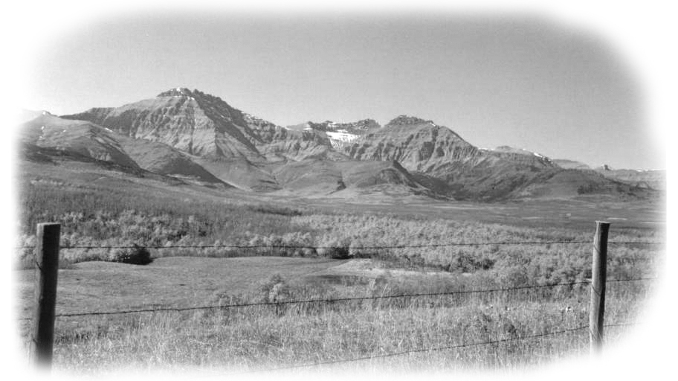
Foothills of the Rockies

Wib and the Duncans of High River

When we arrived in High River he took me to Wib’s sister Mable, Mrs. Neil Ross, where he introduced me as if he had known me all his life. She was a warm motherly woman whom I liked right away. Shortly after a phone call was make and soon Wib arrived to take me out to his Ranch. I was one tired boy, as it seemed a whole lifetime since I had left the Chappels in Saskatchewan. The ride to Wib’s Ranch was made after dark so I didn’t see much while on the road from the town out to the ranch. I remember getting out of the truck to open a barbed wire gate off the road, to a long winding lane on a downward path to the ranch house and buildings. After a warm welcome from Wib’s sister Nell and the hired man Charles over several cups of coffee, they sent me off to bed. I remember I slept like a log, as I felt I was safe and among friends.
The smell of coffee and bacon wafted into my bedroom the next morning and suddenly I knew I was very hungry. They were anxious to hear any news I had of the Duncans in Ontario and of my journey and of my dad and mom. It was a Sunday morning and everyone seemed quite relaxed and in need of rest and conversation. In those days no one would think of working on Sunday. It was the Lord’s Day and very much respected by all. I’m sure all farm horses thanked God too.
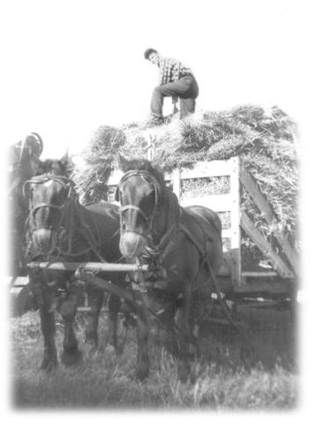
It seemed the grain crop had gone in late that spring in the High River area, and was then very late to ripen. It was however a very bountiful crop and now ready to be harvested. If I wanted work I had certainly come to the right place. As they needed more help they were glad to see me. Grown up men were hard to come by because of the war, so they were happy to have boys or very young men, anyone who was willing and able. I had been working for five dollars a day for Mr. Bull and had earned eight dollars a day threshing in Manitoba. It came as a surprise to find that Wib was actually offering eight dollars a day, if you worked from sun-up to sun-down about a twelve-hour day. I could just feel a large bundle of money in my pocket. I was very happy about this and glad I had made the trip to High River. Jack and Wib’s Team of Horses
I was awestruck by the view when I walked out of the ranch house in the morning.
The large bungalow type ranch house was built beside the Highwood River. The river’s broad cold water flows forever down out of the mountains. Across the river from where I was standing was a wall of rock that was perhaps a hundred feet high. Indians had once used this spot as a Buffalo Jump. They did this by stampeding a herd of buffalo, and then guided the herd toward the cliff where they would fall to their death. A quarter mile west up river, the river swung to the south and the great cliffs on the far side hid the mountains from my view. Behind me was a high natural prairie hill and
I could see a roadway cut into its side and I realized it as the one we had come in on last night. The whole setting, the ranch house, the barn the corrals and buildings along with the river and the wall of rock seemed secluded from all else except the Duncans. On the Monday morning, I was all set to work. I was given the choice of staying at the house or staying in the bunkhouse in the field with the men. I made a wise decision when I chose to stay with the men in the field. I found out later that at times when men from the east came out to work for them, and stayed at the ranch house, the men in the field didn’t feel free to associate with them. There were two bunkhouses in the field, both built on low steel wheeled wagons that could be pulled from one location to another. The bunks were built two bunks high on either sides and again across the end. It could actually bunk ten men if needed. A round pot bellied stove sat in the centre aisle at the front near the door. The front bunk was full of wood and coal for the stove, and we found it got very cold late at night so we took turns keeping the fire going all night.
One bunkhouse was about full when I had arrived so I was put in the other one with two lads about my age who were out there together from Quebec. They both spoke English well and we got along together splendidly.
It was now mid October and while the nights were cold the days warmed up so we could work in shirtsleeves comfortably. Each night after the day’s work was done you would take the harness off your horses and place it on your wagon tongue with extreme care. In the morning before the sun was up you would have to place that harness on your horse’s back and do it up properly in the dark. So be very careful how you lay it down. I was lucky, as I had always enjoyed harnessing horses; anything to do with horses came quite naturally to me. The horses were taken to a water tank close by and let drink, and then tied to the side of your wagon rack where they were fed sheaves of whatever you were threshing at the time. The horses spent the night right there in the field tied to your wagon. I enjoyed that as I would often go out late and see that they were ok and add a few comforting words, as I knew they too had a hard day. When you understand horses you find that some will work better, “with you, then for you.” Understanding horses is to love them.
In the morning as we went about watering, feeding and harnessing our horses our eyes would constantly turn to the lights in the cook car. The cook car was like the bunkhouse, a house on wheels. From that direction we detected the aroma of rich coffee and fresh cooked bacon and eggs. Mrs. Ross stayed right there in the field day and night getting the food ready for all these hungry men. There was a cook stove with a stovepipe going out through the roof. Then there were few cupboards and a long table with a bench on either side down through the middle. All of which made the place look a bit crowded even when empty. At the far end was a bunk for Mrs. Ross to rest or sleep. She was a joy to know.
Each morning she greeted us all cheerfully with laughter and chatter. She would soon get to know all the men’s names and speak to them personally. Nothing went on in the bunkhouse or in the field that she was unaware of. She saw the joke or humour in the many happenings in and far beyond her cook car. It was not only food she offered but also good old fashion hospitality and perhaps a motherly figure for boys far from home. A good cook is always a vital part of a work crew.
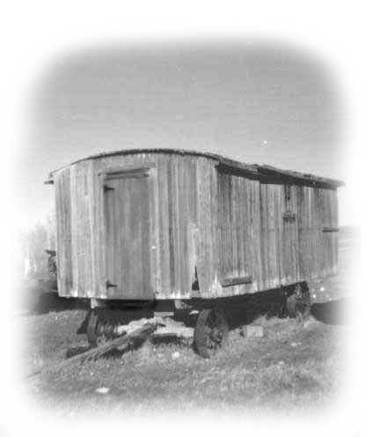
The last load of the night before, would be sitting beside the threshing machine ready to be fed into the feeder well before the sun came up. The men would be in the field loading their wagons before the chill of the cold night had left. On clear mornings they were greeted with the most spectacular sight anywhere on earth. They saw the sun rise on the Rockies. The first rays touching the peaks turning them to various shades of red and pink, orange or yellow depending on the 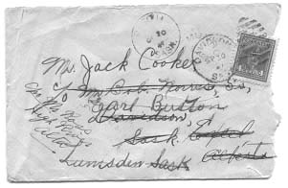
A letter from my sister Pearl all for 4 cents
atmosphere. The Duncan’s treated the men well and everyone worked hard together. It showed me that when you offer men good wages, treat them with respect and feed them well, you got
the most for your money.
About this time I was very happy when Wib Wib’s Old Bunk House

brought a letter out to the field from my sister

Pearl. I still have that letter today. It has a four-cent stamp on it. Pearl had addressed it to me in care of my Uncle Bob Norris in Davidson Sask. It had been forwarded from there to my Aunt Rosena’s
in Excel Alberta. Then forwarded again back to Crosley Chapel near Moose Jaw and the finally out to High River. There is no way the post office would give us this kind of service to us today. At that time the post office had the theory that mail at all times had to get to its destination, and all for four cents.
It was Hallowe’en weekend, and some of Wib’s work crew wanted a special dinner. It seems several of these boys had worked for Wib other years and on Hallowe’en night they always went to the Hutterite Colony and stole a turkey. Mrs. Ross would not give them her blessings. She warned them she would not prepare it for dinner. In spite of all this, the boys wanted to do it. To make a long story short we had goose for dinner the day after Hallowe’en. It seems the boys could not tell a turkeys from a goose inside a dark building. One boy grabbed something with feathers and they all left on the run. They had come very close to getting cornered and caught by the Hutterites and later found out the Mounties were out looking for the thieves. The boys were very afraid they might get caught, so they burnt the feathers in the bunk house stove and buried the ashes along with the bones well out in the field. We were all afraid, as everyone at that time knew that the “Mounties” always get their man.
By now the mountains and foothills were white with snow as it had snowed up there a number of times. We knew time was getting short to finish the harvest, but we were hopeful as we were nearing the last of the crop.
A few days later a heavy snow came down and the men were more or less confined to the bunkhouse for several days and some were getting restless to go home. The sky was all grey and heavy and threatening more snow. It was cold and wet and we just had a day or two threshing left to do so there was talk of leaving for home. I remember Wib’s brother Grant took us all into High River for the day thinking the outing would cheer us up so we would stay. They had not paid us anything yet because they knew if they did some of the men would leave for home. When it came time for dinner that day the two French boys I bunked with didn’t have enough money on them to buy their dinner, so I bought it for them. I sometimes wonder if they ever think back to that time now and think kindly of that English lad that paid for their dinner that day…………. I like to think so.
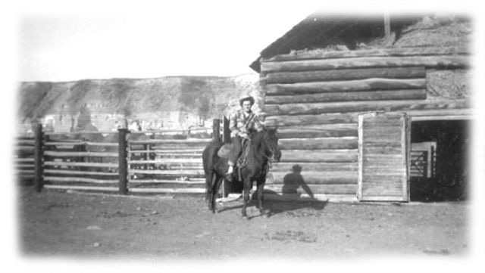
After another heavy snowfall, Wib came out to the bunkhouse to tell the men he had decided to let them all go. So he paid us all, but he wanted me to come back to the house for a few days to visit. I don’t remember how long I stayed. But soon it was that time again to ponder what I should do next
Jack Enjoying a Day At Wib Duncans
I had an Aunt Becky in Vancouver, a sister to my Grandmother Butson. It was getting cold in Alberta so I thought it might be a good idea to head for the west coast where everyone assured me it was nice and warm.
The Duncans had treated me well and I kept in touch with them for many years until they all passed away. Incidentally Charles the hired man married Nell, and Wib married late in life to a lady who owned a restaurant in High River. While all of them are gone now, I remember them fondly as true westerners and true friends.
I took a bus from High River to Vancouver; by way of the “Crows Nest Pass” It was a trip through a snow-clad mountain wonderland. I was always anxiously waiting to see what was around the next bend in the highway. I don’t recall how many hours I was on the bus but I rode it straight through all the way, sleeping when I could on the long bench across the rear of the bus. Vancouver of course was already a great city in 1944 and I was a bit concerned about getting lost. I had my Aunt Becky’s address with me so to play it safe I took a taxi to her address. That was my very first taxi ride and I don’t mind telling you I felt I had become a real city slicker. Imagine me a farm boy so far from home riding in a taxi in this strange and beautiful city of Vancouver.

My Aunt Becky (Norris) Kiel
My Aunt Becky was married to a Louis Kiel and they lived at 1775 Davie St. which was right down near the beach at Beach Ave. (At that time it was a part of Pacific Ave.) and close to the aquarium and the south entrance to Stanley Park. They had the last house on the north side of the street and were next-door to the Cunningham Drug Store. The house was a huge cream coloured wood clapboard two and a half stories high. It had a great balcony across the front outside its bay windows on the second floor. But it seemed the sea gulls had it spoken for so no one would dare venture out there.
This was actually my Great Aunt, and I had never met her before. But she was a very dear person with great insight and wisdom, which in one way or the other sooner or later found its way to you. She knew I was troubled with what I thought were problems at home and with my hearing slowly diminishing. So she talked to me kindly, saying that although parents didn’t always do what was right, they usually did the best they could. She had heard from my mother and assured me that they loved me and missed me.
Uncle Louis and Aunt Becky had retired to Vancouver from Kindersley Saskatchewan, where they had owned a successful hardware business. They seemed extremely comfortable in their retirement. Their house was furnished with old, huge and magnificent furniture. They gave me a room to myself in the basement and with it came the best lot of books I had ever seen outside a real library. Apparently Uncle Louis loved good books. I have always and I still do like books. I was in heaven. My Uncle Louis looked every bit the businessman he had been all his life. He was well dressed with an air of success about him. He was very courteous to me in a stand offish way. On the other hand my Aunt Becky took me under her wing and mothered me as one of her own.
What a wonderful location for their retirement. The air coming in off the water was always clean. English Bay Beach was only a short distance away, and one could walk for miles there, or go for a walk in Stanley Park and in a few minutes leave the busy city behind and be in another world. For a few weeks I made the most of it, even though I knew it would soon come to an end.
We were now well into late fall. I have always loved the freshness of the fall air. I can breath it deep into my lungs and it works magic for me then, even as it does for me today. I spent many hours walking along the beach; winter was in the air and wicked waves crashed the shoreline bringing in drifting logs bleached white as bone and pieces of driftwood and timber of all description. I would look at a waterlogged log or at a hand hued piece of timber and wonder where it came from. If only it could speak it would have a story to tell. While walking in Stanley Park I remember seeing a small pond near the southern entrance where there was a small boat set up on stilts and a sign, which read, “The Lost Lagoon.” At the time I thought it referred to the boat, but I guess it was the name of the small inland pond. The story goes that the boat was found on the ocean shore a long, long time ago, and they believe it came from Asia. So they found it a permanent home on stilts beside this little inland pond.
While it didn’t get very cold it did rain, and it also has the sloppiest snow in all Canada. It falls like snow but hits you like a glass of ice-cold water. If you get caught out in it you are all wet in minutes. By now I knew my life of leisure must soon end. I had to find yet another job, and jobs in the winter in Vancouver were scarce. Many people from far off places leave their farms and the bush and go to Vancouver to enjoy the climate and a few months of city life in the wintertime. For many, some work would help them to afford staying in the big city. I had been looking in the paper for a job but there were only a few jobs listed. One that caught my aunt’s eye was for help wanted on a dairy farm on Lulu Island, which is just off shore in the Fraser River. As I could not hear well on the phone my Aunt made the call and I got the job. They would come to the house to pick me up the next day.
The idea of going back to milking cows was not exactly to my liking, but one can’t always be choosey and especially so in the wintertime when you’re far from home. There is a bridge, which connects the island to the main land. I don’t remember much about the trip out to the island except my driver was very quiet.
When I arrived at the dairy farm house, I was introduced to an older married couple from Manitoba. They had answered an ad in the paper, asking for someone to keep house and cook meals for the men on a dairy farm in B.C. They didn’t need to stay on their cash crop farm during the winter months in Manitoba and didn’t keep any kind of farm stock. Before long I had the feeling that this was not at all what they had hoped it might be, a warm and cozy winter at the west coast. The weather was always damp and they were not used to the dampness. Thus they always complained about feeling the cold. There were two other boys working there and we all lived together in the house. We got along well together, but our staggering work scheduled bothered the couple from Manitoba with their sleep hours. Three guys in the house getting up at 3:00 am every morning is bound to interrupt anyone’s sleep One of the great bonuses of our job was that we all liked our milk, and now we had all the milk we wanted to drink, free.
It was a beautiful dairy as dairies go, two long white wood barns end to end with firewall doors in between. Steel stanchions for the cows and overhead litter carriers to take the manure out. There were also two big wooden silos, in which they kept real smelly pea silage for the cows, and oh how the cows loved it. The cows themselves were Guernsey very kind and gentle critters, with huge udders and were great milkers. We did the milking with the help of several milking machines.
I never did get to see much of the island as I worked seven days a week and none of us had a car to drive. The island had a dyke built all around the outer side of it, to make it possible to farm it. You see everyday when the tide comes in from the Pacific; it backs the water up in the mouth of the Fraser River flooding the island. There is a ditch all around the island on the inside of the dyke wall to catch the water, which seeps through. After the tide goes out, the water in the ditch seeps back out into the river. The island is naturally quite wet and only grass and a few things will grow, and one of these few things is a pea, which they grow and used as silage for the cows to eat.
I was never able to learn to live with that job. It was possibly the worst job I had in my lifetime and only because of the hours. All of the equipment we used was the best and the people we worked for were fine and one could hardly complain about the gentle nature of the cows. It was the hours that got us down. The day started at 3 A.M. when we went out to say good morning to the cows, and they all replied:
“ Moooo mooove it Buster were hungry, ” and so on this friendly note our day began. We fed them first and then did the milking. The milking had to be done and in the milk house by 6 A.M. Ready to be taken into Vancouver for the city’s morning milk. At seven or thereabout we were expected to be at the breakfast table. We seldom made it on time so our cook was unhappy. If you were born on the farm you know things don’t always go as planned, and often go very wrong. So a farmer’s timing has to be flexible.
We had an hour off for breakfast and at 8 A.M. we were to be back in the barns to clean the stables and bed the cows down with straw. We were supposed to be finished by 11 A.M. and have from 11 A.M. until 3 P.M. off to eat dinner and to rest or sleep if we could. But we seldom were done with our work by 11 A.M. and even when we ate dinner at 12 noon how could you get much rest before going back to work at 3 P.M? Now as you all should know the cows don’t rest on Sundays so you work seven days a week, and I had one day off a month. Yes, one day off a month. There was no union involved on dairy farms in those days.
When my monthly day off came up, I would want to make the most of it. So I would leave for my Aunt Becky’s the night before. This way I would have a whole day to spend with them. I had to walk a half-mile in the dark to a train stop; it was just a little platform along the track. I remember every time I went it was dark and a bit scary. The track right there was on a curve and as the train rounded the bend, its headlights were nowhere near you. This stop was seldom used so the train would come roaring around the bend and only at the last minute would he see you standing there dangerously close to the tracks, so as to be seen. I always thought it was going to go on by, but somehow it always managed to screech to a halt at the last minute. On one such trip I confided with my Aunt that I was very unhappy about the hours I had with my job and the pay I received. It was then that my aunt gave me a few words of her wisdom, which has stayed in my mind all these years. I remember the sincerity of her voice and the way she said it, with the emphasis on “Do” She said,
“Jack, I am very sorry about the hours you have to work as I can see it is hard on you. But as far as the money goes I want you to remember this.”
“It’s not how much money you make, but what you “do” with the money you make.” Those words of wisdom have remained with me the rest of my life, and when I chose to be a barber I knew I had to manage the money I made or I would not end up with anything. She encouraged me to go home. I knew if I did I would still have to “Get Up And Milk The Cows” but at least I would have better hours. After saying a sad farewell to my Uncle and my Aunt, I bought a bus ticket for St.Marys and a long journey home.
The bus I took travelled across the U S border into Washington State and on down to Seattle. This was I understood because of heavy snow in the Canadian Rockies. I remember the endless hills as we neared Seattle. We arrived at the Greyhound Bus Station late in the day. I had to sit most of the night in the bus station before my bus left for Chicago early the next morning . When your young it seems a train or bus trip to places you have never been before is very much an adventure. At that time I was very trusting and I could sleep almost anywhere. There was little thought given to the idea that harm might come your way.

I rode that bus day and night across the northern United States. Our first stop was Spokane Washington and then across Idaho to Billings Montana. Then across South Dakota to Illinois and on into Chicago. From there to Detroit and on to London and home to St Mary where I phoned my dad to come and pick me up. It was as if I had been away over night or for the weekend and dad had not missed me. There was no big smile to greet me much less a hug. We travelled home in silence, for as usual my dad had nothing much to say to me. Some things never changed.
I do remember though that something had changed for me, and changed for the better. It was as if while I was away I had grown up, or else my eyes had been open to the beauty of the country all about me. Where before I saw only dirty old brick houses and unpainted barns. I was now able to see the beauty in what had been before me all this time but until now I had not noticed it in this light.
For the first time I saw the beauty in those monstrous old brick houses and the great unpainted board barns. All this was something solid and lasting, built with caring hands. Its beauty to me was so obvious now, yet until this moment I had not seen it. This beauty was everywhere about me. It was in the design of the wood work under the eaves and on the gable ends of the houses. It was there in the elaborated brickwork on which the late afternoon sun shone and added warmth to the colour of the aging brick. It was in the lofty maples which lined the roadsides and shaded the farm buildings. The great unpainted silver grey of the hemlock barns that had always seemed so ugly to me were now wrapped in warmth with colour and charm. Something had awakened within me and I knew it was good.

Chapter 3
Growing Up and Times To Remember
Like all boys, I looked forward to being sixteen and getting my driver’s license. At my age now I realize this must be every parent’s worst nightmare, having your kid turn 16 and wanting to drive a car. I realize I was rather lucky about this as my dad loved cars and understood my feelings and need to drive. I never thought he would let me drive his 1938 Ford though, as he just had it into Jack Edmond’s garage and had its grill fixed and the car repainted.
One day in Mitchell as we were getting into the car he handed me the car keys saying I could drive home. Mom got in the back seat along with my three sisters and dad took the passenger side. I had watched dad shift gears all my young years so I had that down pat in my mind. I did very well and I think my dad was impressed. Soon we were well out of town and on the road home. I was cautiously travelling maybe 30 or 35 miles an hour and my mom kept shouting, slow down, slow down. I think she was just a might bit nervous. Now that is hard to understand as my dad took all corners on two wheels. He always scared me to death as once behind the wheel he was always in a hurry to get to his destination.
The 38 Ford had cable brakes compliments of Henry Ford. When they worked they would lift you right out of your seat when you made a hurried stop, but the problem was they never worked very well, very long. One day I went to cross a very narrow bridge just as a car entered the bridge on the other end. I soon realized the bridge was too narrow for us to pass, so I applied the brakes, but the car kept going merrily on its way. Our cars met grill grinding into grill and my dad’s car with its freshly fixed grill was just a bit the worst for wear. I expected much worse from dad when I got home, but for some reason he took it remarkably well.
A few days later he pointed out two of his nicest fat pigs and said,
“I am going to give you these two pigs to keep for sows, you can raise little pigs from them to sell.”
Of course this made me very happy, and then a few days later when we went into Mitchell, he drove to Sawyer’s Garage and pointed out a 39 Plymouth Coupe car and wanted to know if I liked it. Like it, well gosh darn it, it had wheels on it didn’t it?
At that time when you first started to drive you got a beginners permit. Then you could go ahead and drive as long as you had someone with a driver’s permit along with you. Later when you had gained some experience at driving you applied for your real drivers permit. Dad made a $100.00 down payment on the 39 Plymouth club coupe, which we bought for $700.00. I was supposed to pay it off from the money I would earn raising little pigs. Talk about counting your chickens before they are hatched, but I guess desperate times create desperate plans. It was many years before I drove one of my dad’s cars again.
When I went to get my first real drivers permit I had to take a driver’s test.
I had an appointment for the test at Fawms Garage in Mitchell. Dad dropped my sister Pearl and me off at the garage and he left and went on up town. The test was to be done in one of Mr. Fawm's cars. Pearl got in the back seat and Mr. Fawm seated himself in the front passenger side seat. I really didn’t know him as my dad always took his car to Jack Edmonds the Ford Garage. I just remember it was all business as Mr. Fawm was not being overly talkative, or very friendly. I suppose because of his job he felt he had to distance himself from the person he was giving the test to. He put me through his usual little jog around town telling me where and when to go and when and where to stop. Of course I had to show him I could park between two cars, and even how to make a u-turn. I was careful to always signal with my hand when I made my turns. We didn’t have turning signals on our cars at that time. We signalled by putting our arm out the car window. All the time he held a pencil and pad quietly keeping score. When we arrived back at the garage I was convinced I had done an excellent job. Mr. Fawm admitted I had done well but I forgot to signal with my hand on a certain corner. I was sure I did, but it was his word against mine and right now mine didn’t count much. Right then a little voice in the back seat chirped up,
“He did signal, I saw him” my kid sister Pearl rising to the rescue.
Wheels make a great difference in any young guy’s life, but wheels also leave your parents with many sleepless nights worrying about your safety and wondering where is my wandering boy tonight?
This was the first of many wonderful cars I have owned, I considered each one of them an experience. I would like to list all of the cars here I have ever owned.
(1) 1939 Plymouth Coupe (2) 1947 Chev Sedan
(3) 1953 Henry J Kaiser (4) 1954 Ford
(5) 1960 Ford Starliner hardtop (6) 1964 Ford Galaxie Convertible
(7) 1968 Plymouth Fury 111 Convertible (8) 1973 Ford Mustang Convertible
(9) 1978 Dodge Magnum (10) 1983 Chev Camaro
(11) 1989 Grand AM Pontiac (12) 1999 Special Edition Ford Mustang
Except for the first two all were brand new cars, I never owned one I didn’t love. As you can see I treated my cars like my politics. I never married myself off to any one party. I am hoping there will be at least one more car in my life.
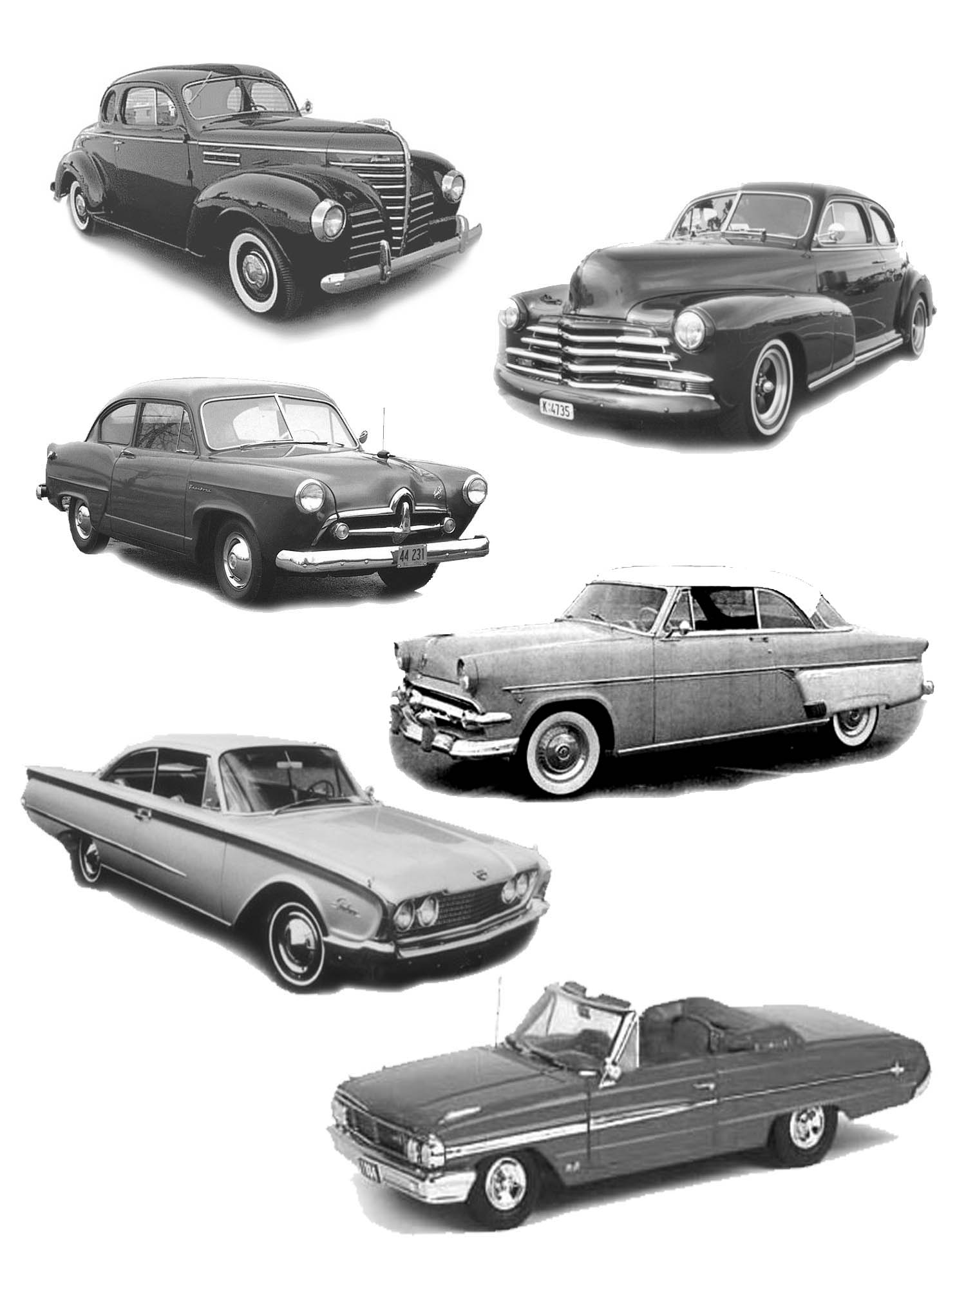
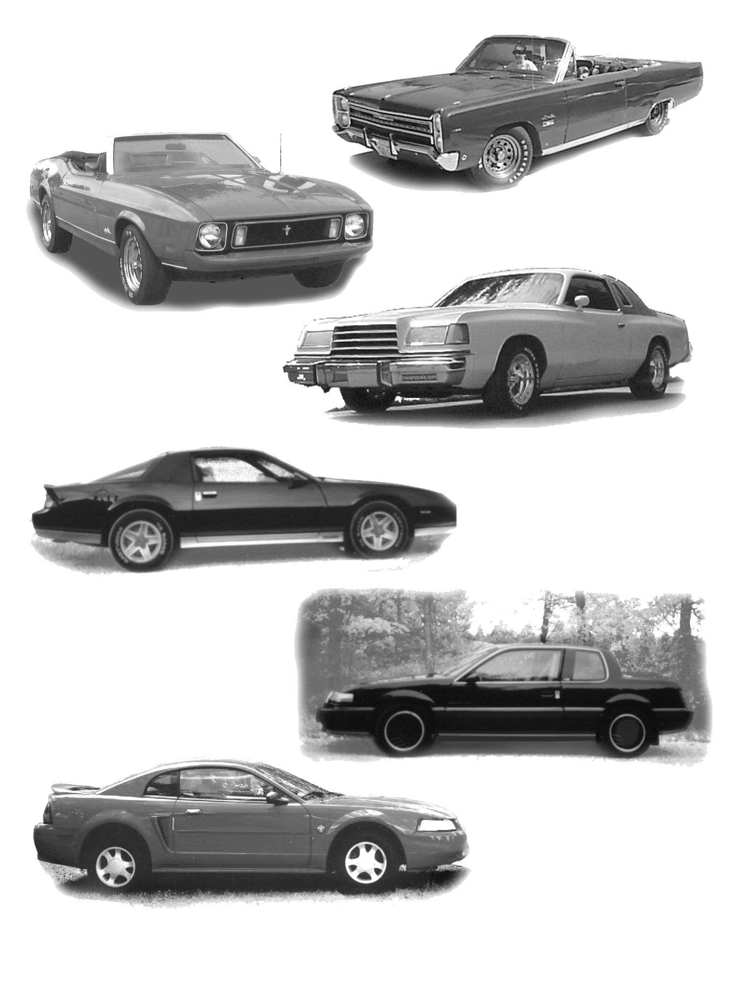
My First Car Accident
My first car accident happened while I had this 1939 Plymouth. It was New Year’s Eve and I was to pick up the two Stacey boys near Rannock and go to a movie in St Marys. When I arrived at the Stacey farm a neighbour boy Don Nairn was there and wanted to go along. This was ok with me except my car was a club coupe and this model had no back seat and four in the front was a no no. However we couldn’t refuse him on New Year’s Eve. So once we were in town he was to keep his head down. After the movie we all wanted to drive out to a popular eating-place called the Knotty Pine Inn about a mile out of St Marys on the Stratford side. We were driving behind a Grey Hound bus and as we neared the outskirts of town a car coming towards us was weaving back and forth across the highway. Again and again it pulled over onto our side of the street only to swing back again. They pulled in on the bus in front of us and pulled off, then they pulled over on me and I thought for sure they would pull off as he had been doing.
There was a hard hit and then a crunching sound as this car came down the side of my car. Although I knew my car was damaged my first concerns were for my passengers. Luckily we were all ok. I knew I had to get rid of one of my passengers, as I didn’t want to be found with four people in the front seat. However the neighbour boy Don Nairn didn’t want to go alone, so I let the second boy go along with him. The second boy would have made the best witness, but he just happened to be on the outside so he left. I couldn’t get out my door as the side was crushed in. When we were out of the car we viewed the damage. My car had been raked from the front fender all the way to the rear fender, yet there was no damage done to the front bumper or to the grill. On the highway was a wheel, which had been torn off the car that hit me. Yet there was very little damage done to this car other than to the wheel and fender.
We could see a number of boys getting out of the car that hit us. By now several cars had stopped and we didn’t know who was who. Some boys were pitching beer bottles from the car onto the lot, which was along side the street. Someone had called the police and soon a police car arrived. The cop asked us to get into the police car. My friend the Stacy boy and I got in the back seat and the other driver got in the front. We soon found out the policeman was from St Marys and he knew the boy and his family that hit me. The boy was crying and in great distress as he told the cop it was entirely his fault, as he had too much to drink, and was on the wrong side of the road.
Now I had been brought up to have full faith and totally believe in the law. I believed that you just didn’t get to be a policeman unless you were honest and honourable. So I trusted this policeman to do what was right. I was now 17. I had done nothing wrong as far as this accident was concerned, so I put all my trust in this town policeman.
The policeman told him to, “Shut up or you will get yourself into a lot of trouble”
At that time I didn’t realize what I should have done; I just left it to the policeman to handle it right. He told me I could go home. The guy that hit me was still in the front seat of the car with him when I left. After I left I believe he explained to the boy that since I had not asked him to lay any charges against him, then he was free to lay charges against me. All he had to do was say that it was I that was on the wrong side of the road instead of him. He would see that there was not anything in his report about admitting he was on the wrong side of the road, or that he was drunk. I took my car to a neighbourhood friend Jim Evans who liked to do bodywork. He did a very good job of the bodywork and then he added a fresh coat of light green paint.
I came home one day and my mom handed me a letter, it was a court summons I was charged with careless driving and was to appear in court in St Marys. Word got around to a few good neighbours what had really happened and when the court date came up, they were there for me. I really appreciated their support; there was Norman Morrison and Jim Watson and Eddie Smith and my dad. I had no money for a lawyer so I was going to be my own defence. I still had faith in the system and I was sure that if I just told the truth, all would be ok. I was of course scared speechless as I listen to the lies told by this guy, all of which was backed by the policeman. Once when the policeman said something, which was totally an outright lie, I stood up to protest. I found out this was very wrong in a court of law. Every one including the judge pounced on me and told me to sit down and be quiet. I felt totally defeated
When his lawyer had me on the stand asking questions, he would not let me answer in whole. He placed his questions just so trying to forced me to only answer yes or no so as not to disclose anything. If I tried to say more he cut me off rudely saying,
“Answer the question yes or no.” When he was finished I was completely shaken by what we call a justice system and had no fight left in me. The worst was I had lost something very valuable that day, which was my respect and faith in law and justice.
When the time came that I could have said something in my defence I was too terrorized to open my mouth. The judge found me guilty of careless driving and I had to pay a fine.
He did however say that he had the feeling that there was something missing, something that should have been told. I was thankful he made that clear. If only I had the courage to speak up when I should have I might have had that sick cop’s badge. This unhappy event has bothered me all my life and I have had to struggle to keep faith in the system. Don’t kid yourself; Yes Junior, there is, such a thing as a bad cop, but thankfully most of them are good guys.

