The Newsletter of the Grand Priory Canada January 2019
Greetings Templars of Canada . . .
Launched into the New Year, with some resolutions yet untested, may I suggest that the following be considered for 2019 . . .

- Get to know Templars elsewhere. Attend a Templar meeting in another city or another country. Best of all, plan to join a trip to the Holy Land: Templars from St James are planning one in February this year.
- Recruit others to join the work of the Templars.
- Commit yourself to volunteering and serving on a Committee or an event or researching, writing or speaking on a Templar topic at a meeting or writing for this Newsletter.

INTERNATIONAL
The Grand Priory of the UK has a weekly mailing of inspiration and prayer. A recent issue included an item on Chaplain Rev Canon Philip Norwood’s recent visit to Israel, that I would like to share.
“Last month in Jerusalem I was able to visit the area where the Jewish Temple, first built by King Solomon and later massively rebuilt by Herod, had stood until its destruction in the year 70AD. The two buildings there now are the oldest buildings of the Islamic world.
The octagonal Dome of the Rock was completed in 691 and remains today essentially intact – it became known in the days of the Latin Kingdom as ‘The Temple of the Lord’ and, without any alteration apart from a cross on its dome, was used as a church. The other building is the El-Aksa Mosque, dating originally from 715 but subsequently rebuilt. From 1099, this was the royal residence of the Crusaders, and later became the headquarters of the Knights Templar.
I was reminded that on a previous pilgrimage, we had in the party a member of the Order, and I suggested to him that he and I might stand by the El-Aksa to make a brief renewal of Templar vows. We did this, he placing a hand on the wall, and I placing on him a hand of blessing – though we were soon asked to move on!
But it was a precious moment, a moment of continuity with our origins and our first ideals.
That could be said of so much in the Holy Land, of course. It is possible to touch the rock on which the cross of our Lord stood on Good Friday. We can touch the building which we believe houses the tomb in which he was laid. We can connect with the olive trees in the Garden of Gethsemane, or the water of the River Jordan, or the well in Nazareth, or the stones of Capernaum or the shore of the Sea of Galilee and much more, of course.
Though the original artefacts may be totally changed or long gone, the continuity remains in our faith and in our ideals and our commitment. The past is real and can still inspire us and encourage us today.”
On a personal level, I have been to the Holy Land three times: Israel each time and Jordan once when the Church that the Templars supported was opened with much fanfare and Templars travelling from afar to participate. Such travel is an experience unlike any another in the world.
And I encourage every Templar to include it on their bucket list.

THE ASCENSION OF CHRIST PRIORY

The First Saturday of November always heralds a grand day when the Investiture and banquet welcome new Templars into the Order. This year was no different with three new Templars serving in Windsor and a candidate from St James joining the ceremony.
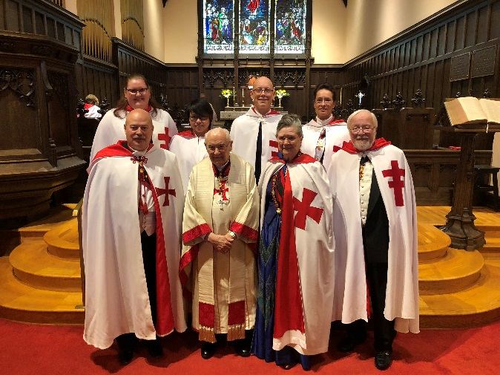
The new Templars, David Finch, Catherine Rivera (from St James), Erin Dowdell and Catherine Wollocombe, GPII Sir Peter Kelly, GPI, Canon Sir Ronald Matthewman; GP III The Rev’d Dame Nola Crewe and the Prior of Ascension, Sir Walt Pastorius

The evening continued at the Ciociaro Club withhold and new friends, drinks and conversation. And with appetizers that destroyed one’s ability to resist as a great intro to the tremendous dinner that lay ahead.
Touring the Distillery |  | . . .and dining afterwards
Then came the Christmas Social with a smart new touch: it was held at Wolfhead Distillery in Amherstburgh. They started the evening with a tour of the impressive distillery, a discussion of the operation and a sample tasting of some of their products. A buffet dinner followed and the whole evening was

Next up for Windsor . . . the Paint Nite Fundraiswer . . .
ST JAMES PRIORY
The Fall has been a busy season with Investiture and Gala and the major fund raiser: Saturday the 17th of November at the Woodbridge Gamer Furland Event Centre when the evening raised $5,000 for Toronto’s principle cause, The Wounded Warrior.
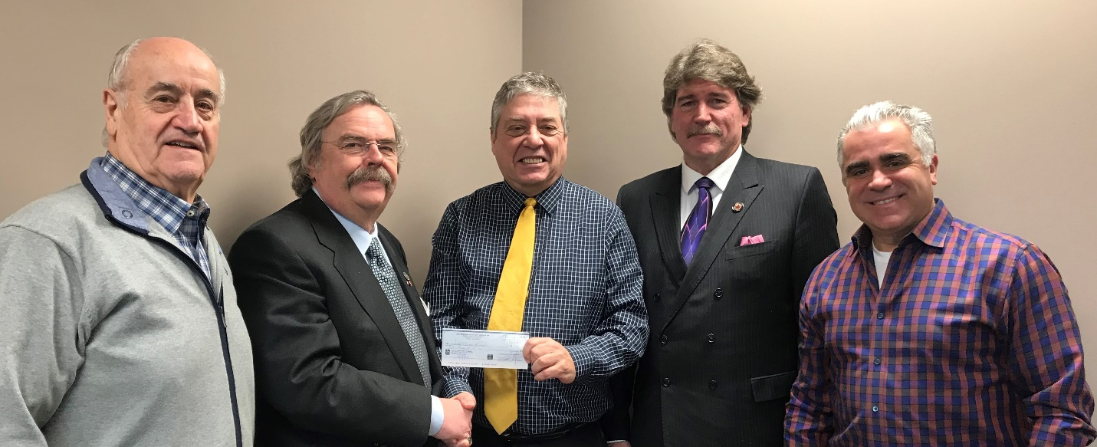

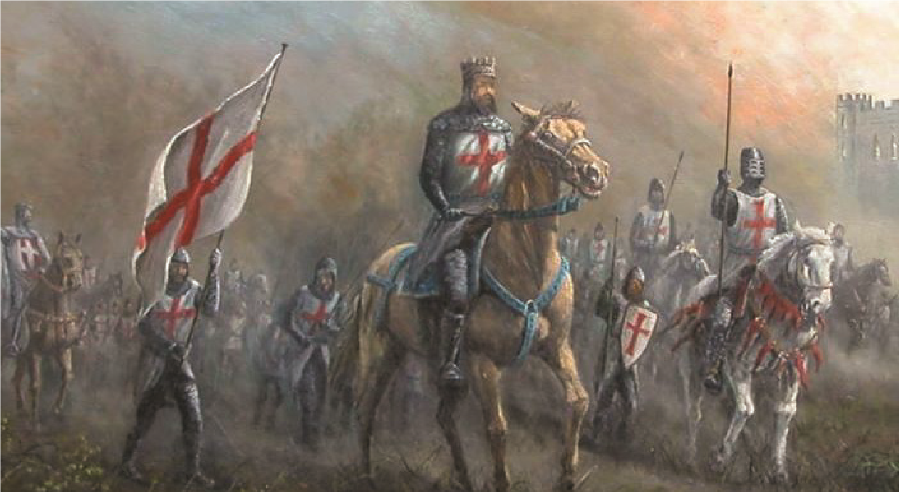
But the exciting news out of St James is their planned trip to the Holy Land from the 17th to 25th of February 2019. Here is the information about this trip and if you have questions do get in touch. It is a great opportunity to get to know our Order where it all began, to walk in the footsteps of both our Saviour and our predecessors.

THE PRIORY of SIMON-PETER . . .

. . . has an Investiture planned for the 11th of May 2019 and if you can manage to be in our Nation’s Capital do get in touch with Dame Nicole . . . Templars are always welcome at any Investiture. is your Priory’s Investiture it is the ONE compulsory event of the year. Only with the permission of one’s Prior can your absence be acceptable.

UPCOMING EVENTS
February 1st 2019 | Ascension’s Paint Nite Fundraiser
February 5th 2019 | Ascension’s Dinner Meeting
February 17th to 25th, 2019 | St James’ - KT Tour of the Holy Land
April 3rd, 2019 | Ascension’s Dinner meeting
May 11th, 2019 | Simon-Peter’s Investiture
May 22nd – 28th , 2019 | US & International GMC in Milwaukee, Wisconsin
June 11th, 2019 | Ascension’s Dinner & Annual Meeting
October 6th – 13th, 2019 | OSMTH GMC in Tomar, Portugal (with a pre-tour available)

A REMINDER . . .

Your Priory’s Investiture it is the ONE compulsory event for EVERY Templar each year. You made that commitment when you were a Postulant and it is only with the permission of one’s Prior one can be excused from attendance.

May God bless our Order and each of us with a wondrous 2019.
nnDnn

Nola

