The Gift Of Hearing
-
The Reality Of Deafness

I have never tried to use my hearing loss as a crutch in my daily life, yet all too often I feel I must explain myself, and that is no easy task. I find many people don’t seem to understand what it is like not to be able to hear. It is not just that you cannot hear, it also means that at times you have to struggle to talk, to find the right word and then how to pronounce and to express the word. Often I know there is a word for what I want to say but I am at loss to find it. I am like a computer without a good memory or a dictionary with a page missing. I cannot find the word and it is frustrating. It may not be one of my everyday words, or it might be an all-new word. I know there is such a word although I may never have actually heard it and therein lies the problem. My memory has not filed it away as it should and I feel I am left hanging in mid air. Sometimes a friend will have me repeat a word over and over until I get it right, but most likely it won’t stick, or register in my poor old brain simply because when you don’t hear it spoken it seems you have no real memory of it.
My condo is my home and I feel I have a refuge here as my life takes on its own form of normalcy. If someone comes to visit me, they push the intercom button downstairs and a white light in each room comes on. When the telephone rings a red light flashes on and off for my TTY machine, and a message is printed on a small window and also on paper. I turn the TV on and the caption machine prints the words on the TV screen. When I need to get up at a certain time in the morning there is a round pad placed between my two bed mattresses that vibrates and wakens me at the set time. All this has become normal for me between these walls, but when I walk out the door I fear I am challenged by another world. Something is missing, and there is a certain feeling of insecurity. I don’t feel totally in control. Still I know I am blessed because here I am at 80+ with a good memory and good health and no aches or pains and I still have no problem driving my car in London.
The TTY Telephone Communication Machine
For those of you not familiar with a TTY phone machine for the deaf I will try to explain.
In 1963 Dr. Robert Weitbrecht, an American physicist who was deaf developed an Acoustic Coupler that could send and receive “teletypewriter” signal over telephone lines, enabling people who are deaf to use the telephone for the first time.

This service is referred to as BRS short for (Bell Relay Service) In Southern Ontario the operators work out of Windsor, Kitchener – Waterloo, and Ottawa. It’s a free 800 number and is explained in the front of every phone book in Canada under Special Needs.

Thankfully I was born with normal hearing and as a child I grew up hearing all those wonderful sounds around me that all country children hear while growing up on the farm. Being deaf now for many years I think back to the sounds that were dear to me and I remember the most. First might be the sounds of our little feathered friends the birds. I remember their perky, pert, chirpy sounds in the early morning announcing the dawn of yet another day and their quiet cooing, murmuring-like whisper in the evening, satisfied and content at the end of another day.
In the country where I grew up the sounds around me were familiar and had a great deal to do with the hour of the day. These sounds were the very fabric of our country life. In the early morning the doves in my uncle’s bush across the road cooed their lonesome notes over and over again to their mate. All morning the barn pigeons gathered to preen and sun themselves on the barn roof, and at sudden intervals I would hear the sound of fluttering wings as they took flight only to come back and sit on the roof again. At noon the local saw mill let off steam and blew a shrill whistle at exactly 12.00 o’clock noon, six days a week. As our farm was surrounded by bush land each evening during the spring and on into summer the bush around us resounded with the joyful sound of croaking, trilling happy frogs. It was a choral masterpiece that we would listen to from our open veranda, a concert every evening and all for free.
How it works,
You talk to the operator, he or she types the message to my machine and I talk back to you.
- - - -
The machine has a standard typewriter built into it. The Bell Relay System, (BRS) number in the London area is 711. So you turn the machine on and type in that number. The operator will come on and repeating his or her message in both English and French. It goes like this.--- BRS Hello / Bonjour oper 4714 GA - the GA is short for go ahead
I would then type in, this is Jack in London please call Ralph 519 --- --and VCO
VCO stands for voice carry over, it means I will talk to Ralph.
(If I had no voice I could type the message and the operator would repeat it to you.)
However when Ralph answers he will talk to the operator and she will type his message to my machine. I can read it as it goes across my window and I also have a paper printout flowing out of the top of the TTY machine. It is important not to talk too fast but talk clearly. Remember the operator has to keep up with you typing as you talk. When you’re finished talking always let her know by saying Go Ahead or (GA)

Then for some reason I like to think of the sudden sound of the wind as it swept across the open fields coming from nowhere and going somewhere else very fast. There were those quiet sounds in the evening of cattle lowing from the pasture or pigs grunting in content while bedding down for the night. Out of the growing darkness there might be the cat’s meow to acquaintances knowingly, as it ventured out into the night. Eventually the night descends and all is still and quiet. In this stillness, there was a certain silence that in itself had presences, a presence that could be felt. It had meaning; a gift brought to us knowingly, as country folks -- a time to rest.

These are now but, faded or failing memories that linger, memories I try to keep alive as best I can. They were at one time the sounds of everyday life around me. There was comfort in their timing for when I heard them I knew that all was well. Now my world is empty of sound and I wonder if people hear everyday sounds that bring to them joy and comfort or … are they, as they appear too preoccupied to listen. Being in the city now I realize my everyday sounds are very much different from what I was once used to. Still, I am sure there are many sounds throughout the city for people to hear if people really wanted to listen. People today though tend to artfully, conveniently shut them out. Any sound of nature they feel clutters up their lives for the more important things they find in this, a too busy wired world.
There’s much more
Modern technology has made it possible to build advanced microcomputer devices that work together and perform several services from one box. Mine is located on the nightstand next to the bed. This devise has a digital alarm clock on one end and four windows on the other called an indicator panel. This panel has four pictures, the 1st being a phone, second a clock, third a door and fourth a sound microphone. There also is a plug in for a bed shaker. A light in every room from the kitchen to the bathroom is connected to this box device. If someone is at the door the light goes on and the door window on the device lights up. If the phone rings the lights in all the rooms flash on and the window with the phone lights up. It works as a fire alarm or carbon monoxide alarm causing the forth window to light up as room sound. A second remote wireless device box with all of the same features sits by my lazy boy chair.
There are times I find refuge in my own world and I almost forget it is I who has the problem, even though I am deaf, living in silence, in a hearing world. I see these unhappy people around me who look like expressionless drones plugged in to music or with hand held phones, silently going on their way with little or no awareness of the humanity that is all about them. When you visit them they answer the door with a phone to their ear. They will say, “I’m sorry I am on the phone right now.” At best they might let you in and have you sit for 10 or 15 minutes all but ignoring you. How times have changed.

They might be sitting in a car next to you at a stoplight drumming on the steering wheel with their fingers, staring straight ahead or walking aimlessly about in the mall seemingly lost in space. There is apparently nothing of interest locally thus they seem bored with life, the world and its people. It seems somewhere else, or someone else has their ominous attention. Someday a long time hence some one is going ask them, “Do you remember those wonderful days of your early life?” Of course they won’t, as they were tuned out, turned off and plugged in.
Perhaps because I am deaf I cannot understand their magnetism and attraction to devices and their absolute absence of appreciation for the people and the world in their presence.

I am sure most deaf people are like me. They put up a bold front and try very hard to rise above their problem and stay focussed. Yet, there is no doubt they feel they are missing something, a whole measurement of life. It is hard enough to hang onto the old let alone accept all that is new around us. I have had to give up many things dear to me, and as I get older and memory fails I know it will get worse. I say that because at times my memory plays tricks on me. When I see something like
water flowing in a creek or perhaps I feel the rev in my car motor when I drive away without a thought, for the moment I imagine I hear with vibrant feeling that mustang under my hood thunder into action. It has been written that although deaf people don’t hear with their ears, they hear with their eyes their hearts and with their minds and even by touch when lost in thought, I am aware that this just might be true.
When the lights go on you look at the box and see which window lights up. Of course all this means I am wired.
While it is actually a life saving machine it is difficult to get most people to accept it as they can’t get used to an operator as a go between. Naturally the system is only as good as the operator you happen to get. Most are very good but others are very very bad they are worse spellers then I am and they have even shorter tempers.

It is sad that so many people have this wondrous gift of hearing and don’t know how to appreciate it. The positive reception of the fullness of sound is a wonderful gift to those who have it within their grasp. The appreciation of sight or sound, I believe is totally in the eyes or ears of the beholder. As a little kid I remember visiting my cousins Santa (Alex) and Zoë Duncan. Zoë’s mother was my Great Aunt Tat Stillery and she was visiting them. Aunt Tat was getting on in years but after some encouragement they got her to play her violin. This was the first violin I ever heard and I was captivated. It was a new sound for me so pure and vibrating it entered every fibre of my body. It grew in volume and died and swelled as you absorbed it. It surrounded me, possessed me and filled me, a whole new dimension of sound that brought an appreciation of music into my life.

Sound has many faces. It brings to us curiosity, danger, fear or joy. I find it so incredible that when a person speaks into a phone the person on the other end instantly recognizes the voice even though in some cases you may not have seen each other for many years. Just to think of the thousands of people that you might know you, yet you can pick out your friend’s voice in and instance. I marvel at Gods creation. Its then I think of the many people close to me, friends and neighbours, nieces and nephews whose voices I have never heard. I don’t think I would even recognize my own sisters’ voices now if suddenly I could hear again.

I find my neighbours here in the condo complex are extremely kind and understanding and in general the staff at my bank and the local Shoppers Drug Store treat me royally. They take time to explain things to me so that I know my banking and I am familiar with my medication. The most uncomfortable thing I have to do is eat out. I would eat out more often if I could stand the hassle. I find it hard to keep my cool when I am being waited on as there is no way you can order right from the menu without going through a certain procedure. It takes backbone to enter an eating-place and sometimes I lose my courage and I turn around and go back out. Even at Tim Hortons or McDonalds just count the number of questions they have to ask you before they will place your order. Nothing is missing. “ Do you want a small, medium, or large, cold or hot, do you want it in or out, are you ordering for one person or two?” Because I don’t hear everything I might not give them the right answer so I may have to go through this 3 or 4 times. Dear knows why I can’t just ask for a Big Mac, French fries and coffee, or order an apple fritter and coffee. Those people behind the counter are like trained monkeys and they automatically repeat what they are told to say by the management from beginning to end over and over again. If you don’t get it the first time just hang in there as they will say it all over again word for word until the line up behind you stretches out the door, and everyone looks at you as a terrorist.

Away from home entertainment is all but non-existent,
I haven’t been to a movie in perhaps over 50 years and as I loved music and the theatre I know I would enjoy seeing and hearing many kinds of entertainment. Here in London there are some of the best entertainments in Canada right on my doorstep. I know you will be wondering about hearing aids, but you see I am not hearing impaired. I am deaf. As they say deaf as a doornail thus I cannot be helped by hearing aids. The nerve endings to the inner ear have died off. Of course that does not stop some people from shouting in my ear. I challenge my deafness in many ways everyday in order to function when I go about in society by myself. I do believe I manage so well that few of my hearing friends give much thought to how I manage and certainly I do not want to appear helpless. The good thing is they are there for me when I ask. I think they realize that it is best I stay independent and do things for myself as much as possible.

Getting my business done.
Doing banking and handling your savings or RRIF portfolios is a challenge to most seniors. However it has always been of interest to me. This interest saved me from taking a great loss in this 2009 meltdown. When I go to the bank or trust companies I take along my pad and pen and I have them write everything I need to know down on paper. I don’t want to guess at this kind of information. Often they use a laptop to communicate with me.

For better or worse I believe my personal response to my hearing loss has moulded my character. People who have known me for a long time have both good things and not so good things to say about me and I will admit to most of them. Without them I would not have been able to do as well as I have. When you stop to think about it, our forefathers were not exactly timid men when they crossed the ocean a hundred and fifty years and more ago. They could not have homesteaded in the wilderness without having within them the right stuff to survive.

When someone keeps a friendship alive with a deaf person you know you have a special friend. A friendship is an honourable thing, not something you turn on and off. If you want a true friendship then you don’t want just a yes person. So even though you might think you’re right, expect to occasionally disagree. Good friendships are built on honesty. I have never liked to end a friendship. If I seriously offered you a friendship then I feel you are worth holding on to so I will not give you up easily. Nevertheless, as they say it takes two to tango.

My mother always told everyone I was made up of equal parts of appetite and curiosity. It is that curiosity that keeps me abreast of what goes on in this our troubled world today. Everyday I read the newspaper from front to back and I have a better collection of magazines then most of our city doctors. I always follow the 6 o’clock and the 11.00 o’clock news. That is the local the national and the international news. I keep my car shiny and my condo clean. My favourite thing might be my cat Mandy, my flower boxes and flower garden and of course my computer. All this tends to entertain me and expands the mind. Being deaf does not mean you have to sit in your cage and watch the world go by.

It is said, “Man has no cage like his own mind”.
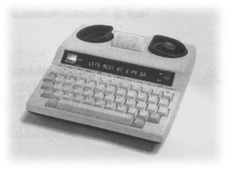

< This is a TTY machine with a mini printer.
Incoming messages go across the front window and a paper print out comes out the top. It is used along with the telephone. Two deaf people, such as my sister Pearl and I can type messages machine to machine without an operator.

This is called the Alertmaster a whole system utilizing, flashing lights, a powerful bed shaker and panel of indicator of lights to alerts you.

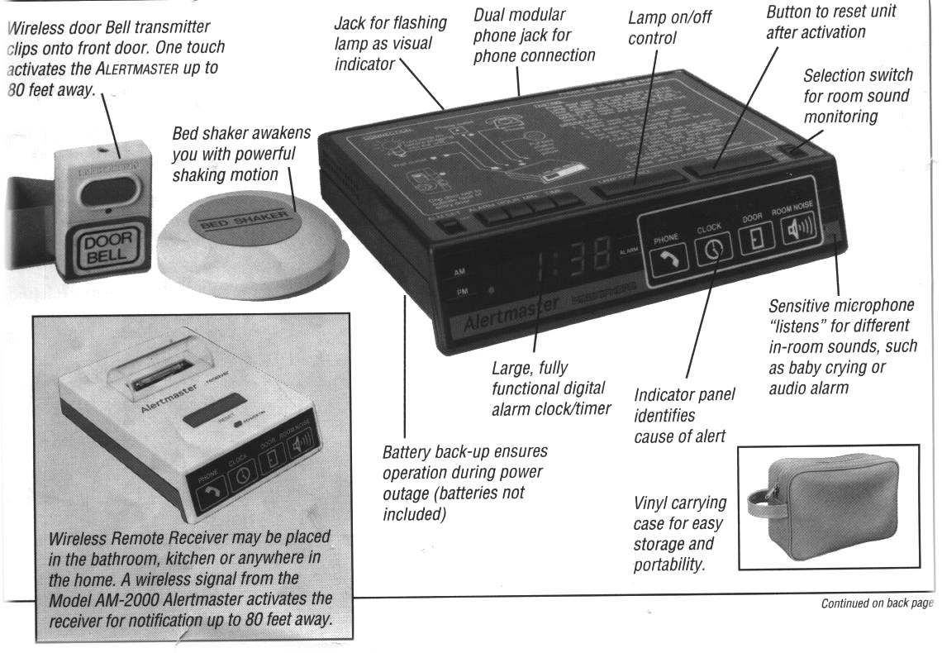

When the phone rings

Someone at your door

Alarm clock goes off

Smoke detector

Carbon dioxide warning

