spite of our differences we respected each other and were the best of friends. He had made me very much aware of his love for, “His way of life,” which included first horses, then white face cattle and of course ranch lands of all Alberta. At that time I knew all this was dwarfed by his love for Cathy. Cathy was his everything.

Yet I was troubled by his open defiance and his seemingly lack of any religious acknowledgement, and I feared what might happen to this great pair of young people who were at that time very close to me. I myself was certainly no angel but still I knew God and I always felt that God was with me even though I may not have always measured up. The question I asked then was what does life hold for this young couple that I thought so much of…….Deke and Cathy?
I will continue with that story now.

Late in the summer of 1961 well before the harvest was ready at Bulls I drove down south of the Red Deer River to visit Deke and Cathy. They were renting a small ranch near Bindloss. While it had a very nice barn and coral and fencing, the house itself left much to be desired. It was a small square unpainted frame clapboard house seemingly lost in a huge spacious yard on the flat empty prairie. The packed dirt earth expanded all the way from the corals to the front door. Only a true westerner could learn to live like that. An easterner would have planted a tree, dug a flowerbed and grown a lawn, but I knew the best Cathy could ever hope for was a vegetable garden.

Deke was working off the ranch to supplement his ranch income. He worked for other ranchers and tried to get his own work done on the side. There had never been a lazy bone in his body. He was obviously a very happy and satisfied man. Cathy was by now heavy with child. She was only about five foot seven and small in frame, but now mid summer and it did not look as if she could wait much longer, but the baby was not due for perhaps a month yet. Cathy glowed and wore her maternity with pride.
The house consisted of one large room with an enclosed staircase going to a sole upper bedroom. Against the staircase wall was a large wood cook stove, which heated the whole downstairs and the stovepipe warming the bedroom above. To the rear of the stove and under the stairs was Cathy’s pantry. While it wasn’t much it was theirs and they happily shared it with me. I truly felt welcome, and the warmth of their hearts.
I stayed overnight sleeping on a couch. The only thing that bothered me was the stack of empty beer boxes in the kitchen. It made me very aware that while dollars might be short, beer was still very much in demand and a solid part of Deke’s life. Cathy was as good in the kitchen as she was on a horse and always every inch a gracious ranch lady.

That was the very last visit I had with them. Deke’s mom Olive wrote me many long wonderful letters over the years keeping me informed on the weather, the crops, and community activity and on Don and herself and the Sutherland family. In the end I came to realize her proud Scottish family pride would not allow her to acknowledge a bad situation if she saw one. In her mind she was sure if she willed herself not to see or believe some things, then all would turn out alright in the end.
Two beautiful healthy twin boys were born to Cathy late that summer. The Campbell and the Sutherland families rejoiced with pride. Of course Olive wrote to tell me the news.

When Christmas came, Deke wanted to party to celebrate his first year of marriage and his good fortune. He asked his many young drinking friends to come and party. The night of the party the temperature outside the little house dropped very low to perhaps 36 or 38 F below. The cook stove was fed wood and the house would grow very hot and then someone opened the door and it was suddenly cold again. The little house rocked with music and loud voices and free beer flowed.
As always when people drink heavily they have to relieve themselves and this little house had no inside plumbing. Every few minutes someone opened the door to go out and as it was so cold out there they were soon back in again. The two babies were in a crib in the same room and I don’t suppose the loud music shouting and laugher and cold and hot air was at all good for them.

At that time almost one hundred percent of Alberta ranchers smoked, so these two babies were also struggling to breath in a house full of smoke. I remember how at the tender age of fifteen, Deke could roll a cigarette with one hand. It was a skill he had perfected. I know he had practiced long and now did it with ease and pride. It was a part of his ranch life, his personal cowboy make up. He had long practiced doing all the things he felt a rancher or cowboy should know or do..

A day after the party, Olive got word the two small children were both sick. She was very concerned so she made a hurried trip down to see them. In a short time they were taken to the hospital, as both were very ill. A day or two later one died and the other came home.
There was much talk in the community as to why they chose to party in such cold weather when they had two very small children in the house. The Sutherland and Campbells were sad and in distress, but they hesitated to openly lay blame.

By now I was running my own barbershop here in London and as we sometimes say, “Life moves on” and for a number of years I did not hear much about Deke and Cathy.
I often thought of them and through Olive’s letters I did know that several more children were born, I believe another boy and two or three girls.
Then one winter I heard shocking news of a second death in the family, a boy in his young teens. The story saddened me and I understand there was an inquest into his death as he died from a broken neck.
At this time Deke was butchering his own cattle and selling the beef to customers he had made in the town of Brooks. The children now were now old enough to be left alone. Cathy sometimes went into town with him to help deliver the meat and perhaps to shop, as Brooks even at that time was a large town.

The Sutherland family had always liked to work with their very own leather. Thus they all had a tack shop somewhere on the property. It was a nice place to spend a quiet winter afternoon, a place where they could make or mend their own saddles or fix a bridle or halter, or do repairs to horse harness from their very own leather. Because of the butcher business Deke had lots of cattle rawhide which is what they call new leather. They sometimes cut long strips of leather which was hung in the basement to dry. In this case a strip of leather had been strung along the front of the boy’s bunk in the basement to dry.

Cathy who was helping Deke to deliver meat in Brooks made a phone call home to tell her daughter Maryann they were on the way home. She was to start supper and to tell her brother to start the evening barn choirs. Maryann went to the basement door and told her brother mom had called and they were on the way home. He was to start the evening chores.

Perhaps they will never know exactly what happened but what they are inclined to believe is that the boy quickly slid off the top bunk under the strip of leather rawhide, and as he did the strip of raw hide came up under his chin snapping his head back quickly breaking his neck. After a time when he didn’t come up his sister went to the basement and found him dead hanging from the rawhide under the chin with the back of his head against the bunk bed. We suppose that after his neck snapped he was unable to move. Again tragedy had struck this little family and many people were again in shock. Some thought while it was a tragedy it should not have happened and could have been prevented. We can all, always benefit from hindsight; however such was the way of life in those days of yesteryears. Bad things happened and few questions were asked. It would be many years before I heard much about Deke and Cathy again, not until a further tragedy.

It is hard to remember exactly when but I would say sometime in the mid- eighties I received a message from a friend that Deke was in extensive care in the Foothill Hospital in Calgary and that something very bad had happened to him. They said they would keep me informed but asked me not to contact the family just yet until things were a bit more clear. I received more word from others but there was nothing very clear to help me to understand what had happened.
Sometime in the mid eighties I decided to fly out to Calgary and see all my friends again. I was advised not to ask Don or Olive any questions, as it was too painful. I think I have explained to you somewhere in my book that old families out there hesitate to speak too openly about neighbours as it seems somewhere down the line everyone is related.
However before I left for home I did find out what happened and it was hard to believe. It seems that Deke’s drinking had consumed him and he often came home drunk and beat up Cathy and his kids. It was after one such beating Cathy left him. By now the last of the children had left home and Cathy had a very good job working at a huge sale and auction barns south of Calgary. She was on her own.

When Deke finally realized what he had done to his life and to his family he was in a sorry state of mind. He realized Cathy was serious and was not going to once again forgive him and come home. In spite of all he had done, in his heart he still loved Cathy and did not want to live without her. He took an old revolver out and put it to the centre of his forehead and pulled the trigger. No one will ever understand why it did not kill him outright. At that range the bullet should have gone right through his head but for some reason it lodged in his brain. I don’t know who it was that found him or how he got to the hospital. They managed to get the bullet out but at some expense to his brain. He lingered near death for weeks and I suppose he had every reason to want to die. After all as far as he was concerned it would then be over, no heaven to think about, no God to answer to. It would be over and he would be free.

When he left the Calgary hospital he was taken to a ‘Home For The Seniors’ in Brooks. It was a home for elderly and people with problems like him. My friend Lenora Oddie in Pincher Creek was by her first marriage an Aunt to Deke. She was also a life-long friend. Naturally she was concerned about him and his welfare and she wanted to help. She called him on the phone at times and sometimes visited him when she drove from Pincher north to her hometown of Oyen.
Several times when I was west to visit I asked Lenora to ask him if I could have a visit with him, but he declined. Then on a trip west in the year 1997 I was driving a rented car from Pincher Creek to Oyen and I had to pass through the town of Brooks. I decided to visit Deke at the home as I longed to see him once more. I knew it was risky, as he did not allow many people to visit.

There was an intercom just inside the doorway. I hate all intercoms as in my Silent World I never know if anyone is there or not. I didn’t feel I could handle it with Deke, not knowing how well he was or if he would remember me.
I beckoned to a lady within and she came to the door. I explained the situation to her as best I could. She said it would be no problem, to just take the elevator to the third floor then go to his door and walk in.
I found his door and knocked but he didn’t answer. After knocking a few times the neighbour across the hall looked out and told me to just open the door and walk in. So that was what I did. I saw a perfect stranger seated at the far end of a long table. He was watching a TV on the other end of the same table. I noticed that the channel was blank. In front of him was an assortment of coffee mugs, dirty dishes and jars of jam and a loaf of bread. He looked at me without any sign of recognition.
I said, “Are you Deke Sutherland?”
He said. “Yes.”
I said. “Do you know me?”
“ No, I have never met you before.”
“ You mean to tell me you don’t remember Jack Cooke from Ontario?”
A look of recognition came to his troubled face and he said,
“Oh yes I remember you now Jack, but it has been a long, long time.”

It was hard to look at his face, as it seemed the bullet must have exploded inside the head bursting the entire scull outward. His head was so very large with a hole clearly visible in the very centre of the forehead. Never would he be able to look in the bathroom mirror and forget what he had done to himself. All the problems in his life surrounded that hole the size of a pencil and as deep as you could see in.

Now that I was here I was not at all sure it was a good idea. It seemed with his lack of memory and my lack of hearing it was hard to keep a conversation rolling. I soon found out though that his thoughts were a constant hit and miss. He thought he still had a truck and a ranch to go to. On his refrigerator I could see a few family pictures. Several of his son Cameron riding a bull with a story telling about his Alberta Bull Riding Championship. I left sooner then I had planned as time started to get heavy on our hands. I think I did right to go to see him, - perhaps more for him then for me, as now he might know I didn’t just walk away and desert him. Deep within myself I grieve for Deke and Cathy for I know what could have been. Forever now when I think of Deke, in my mind’s eye I will never be totally free of that hole in the centre of his forehead.

Cathy was working for a man by the name of John Scott who supplied horses and wagons for the movie industry. She also worked part time at the sales barns.
A few years later good fortune smiled on Cathy and her son Cameron when an American movie maker came to Southern Alberta to shoot the movie “Lonesome Dove.” They needed all kinds of help to find the right horse to match to the right riders and someone who knew how to hitch wagons and buggies up properly.
Have you ever given thought to the fact that while some of those handsome dudes look great seated on a horse or wagon in the movie, most could not harness or even saddle their own horse? They would not know a whipple tree from a double tree nor neck yoke from the hames All this was right down Cathy and her son’s lane as they grew up on a ranch with all this in her everyday life. I am not sure but I think Cameron the son still works in this field today on movie sets in Alberta and BC. Don died in the home a few years ago, thus ending his life.

I sometimes wonder why one way or another I could not have made a difference in the lives of the Sutherland boys as at one time I shared much with them. I cared about them and I had foreseen the trouble brewing, but as Don had said, I could tell them what I believed, but I was not to tell them what they should believe.

At one time while working at Bulls I started to write a story on my troubled thought based on Don and Olive and what they thought they had given their children to protect them from the knocks of life. This basically was “You are what you are because of your ancestors and it is up to you to live up to your family name and not let them down.”
It troubled me that I was forbidden to talk to the Sutherland boys about God or Faith, and they openly tried to bait me. Perhaps in my feeling of defeat I wrote down my thoughts for a book. Then after a time I realized I didn’t want to or could not finish it so I put it away in my suitcase in my room. I think Mrs. Bull went looking for clothes to wash and she ran across the story. As it was based on her niece and family it troubled her, so she told Mr. Bull about it.
Some time later he came to me and asked me about it. It was the title that bothered them the most. I had chosen for the title, “The Bitter Fruits Of Empty People.”
I told Mr. Bull someday I might finish the story; ---- this is the story that you have just read. I have finally finished it, as I had expected it has a sad ending.

Back to my visit with Deke, - I left Deke behind knowing in my heart I would never see him again. As I drove on to Oyen I had mixed feelings as to whether this visit had served any purpose or not. I think up until then I had found the whole thing bizarre and hard to believe. Perhaps I was looking for something I’m not sure just what, an excuse or perhaps for me, closure. I had once known Deke as a healthy vibrant and active young man, and now he was not only old but also a different person. How could all this be true? How could something so terrible happen to someone you grew up with, someone you had admired and cared for?

A Return Visit to Oyen
The Oyen country was still under a severe drought condition and I could see that no one had harvested a grain crop. Those that had cattle were already feeding their stock to keep them alive. Dust entered my car and did not agree with me.
I found my friend Alma and son Brian Bull home waiting supper for me. I had actually planned to stay for a few days there, as this at one time had been my home away from home. Then I would drive on to my nephew Wayne in Red Deer. By now I had a pounding headache caused by the endless prairie dust. There was no way you could escape it, as it is so fine. It was on every breath of air you breathe. After the second day I knew I had to get away from this dry and dusty country or I was going to be very sick.
I felt rather sad to leave Alma and Brian so soon. I felt my visit was interrupted.
I drove on towards Red Deer to visit with Wayne my nephew and his family. As I left the dry and dusty country behind my headache started to clear and by the time I arrived in at Wayne’s in Red Deer I was feeling fine again.
Wayne knew I was coming so he had taken a few days off so we could be together. Before I knew it we were out in the garden digging up Yukon Gold potatoes again. No one grows monster potatoes like Wayne, but I am beginning to think what I hear is true. They say he relies totally on eastern help to harvest his potato crop.
When I left Wayne, I drove on to Edmonton. Upon approaching Edmonton I found the traffic backed up for miles. It seems the Rolling Stones were in town and all of Alberta was on the road. Eventually I was able to get away from the traffic and found the place where Mike and Jigs were staying. Because of the Rolling Stones being in town all the inns and hotels were already full when I arrived. Dave and Kathy said not to worry, as they would set up a cot in the laundry room for me. This worked out excellent, as I could stay with Mike and Jigs all the time. I rewarded the Laing’s by going out and buying the hugest steaks I ever bought for everyone for supper the next night and Mike did the barbequing.
I also got to know the Laings. Since then they have come to London to visit me.

I had arrived about 5 PM and Dave and Cathy had to work late every evening as that was when people wanted to get into their lockers. So the first night I treated Mike and Jigs to supper at a restaurant plaza across the street. I paid for the supper with my master card. We chatted as old friends do, and while walking back across the lot towards the street a man came up behind me and said,
“I think you dropped this.” In his hand was my master card. I am getting older and I am sure God has given me a Guardian Angel to watch over me as several things happened to me on this trip that could have been very bad.
Shelly, Mike and Jig’s daughter had come down to Edmonton with her boyfriend from Grand Prairie to the Rolling Stone Concert and then had come by to see her mom. Shelly begged me to drive to Grand Prairie to see the city and have a visit with her.
As I had long wanted to see more of Alberta and BC interior I said yes.
I made plans to leave early in the morning and drive first to Peace River and then back down to Grand Prairie, a distance of over 700 km. or roughly 450 to 500 miles. This is a nice day’s drive as long as you don’t sit still too long in one place.

Mike assured me that with my heavy foot I was quite capable of doing it. I asked Shelly if she could arrange a place for me to stay in Grand Prairie the next night so I would not have to worry about lodging when I arrived. They said they would look after it as soon as they arrived back in Grand Prairie and then phone me. I got their phone call before midnight and the address of an inn not too far from where Shelly lived.
My little 4-cylinder Ford rental car took the trip with ease, and mile after mile flew by. All my life I had heard of these far away places. Now here I found myself looking down at the Peace River and all about me was this flat wonderful rich prairie farmland. I know I should have taken more time, as who knows if ever again will I stand there and view that historic place, a proud part of Canadian heritage. I arrived in Grand Prairie late that evening and found my inn. It was a bit more plush than I needed but Shelly seemed to think I had money to spend and she wanted me to spend it.
The next morning when I went down to the office Shelly was there waiting for me. We went to a Pancake House for breakfast and then she showed me a bit of the town. We also went to a Price Costco Store that was not far from my inn.

By early afternoon I was anxious to get on my way to Dawson Creek and hopefully on to Prince George by night. Shelly on the other hand was trying to get me to stay one more day. She was very sad when I left, as I was to her a touch of home. I had known her since she was a baby and she always called me Uncle Jack.
I was impressed with the newness of the country between Dawson Creek and Chetwynd, and then somewhere far beyond I was back into real mountain country again. Suddenly a blinding snowstorm came up and for miles I drove close behind a huge logging truck. I knew as long as I kept his taillights in sight I was fairly safe. This however slowed my driving down to a crawl. Then suddenly I rounded a bend at Pine Pass and as if by magic the storm had passed and it was calm and over. I remember pulling off the road to clean off my windshield and being amazed at the pure whiteness of the country all around me after this flash snowstorm. It was a ghostly sight as the mountains and trees, shrubs and weeds near and far were all pure white. It was all so quiet, so still, it was almost reverent.
The storm had put me hours behind in my planned arrival in Prince George and I was thinking I should pull into the first place I could find. But finding lodging in this country is not easy when you leave it too late. There is a stretch north of Prince George where there is no lodging, gas station or a store for over a hundred miles. Then if you come to a small place late in the evening there is “No Vacancy.” So I knew I was going to have to drive on to Prince George. I had my CAA book along with me and I had picked out a place where I hoped to stay. The driving was now good and I was making good time again. I was aware one should slow down driving in the mountains at night and especially so when you’re in strange territory.
I was driving down a steep hill with a rocky ditch on my left, and forest on the right. My headlight showed only downward until I came to the bottom of the hill, then the lights suddenly shone up and ahead. Caught in my headlights was a huge bull moose. I kid you - not, - the daddy of all moose. He was standing broadsided to me snorting vapour into the cool night air. He was taking up oh … so much highway and I was driving oh… so fast. I doubted very much that I could stop in time. I had to make an instant decision. What was the best thing for me to do?
I realized my headlights had blinded him. I could not pass behind him as the shoulder dropped all too fast onto big rocks, but if I tried to swerve around in front of him would he stand still and let me pass, or as soon as the lights were off him would he continue to cross the highway? I was sure my only way out of this was to swerve and pass in front of him, but I had wasted precious seconds thinking about it so…. Is there still time? I swerved sharply to the left and as if by magic the great moose seemed to turn, smoothly as if on a lazy Susan towards me so he faced me and I glided by him, his huge body within a hair length of my far side window.
I found I was shaking from head to toe, as I realized I just escaped from having a terrible accident, and then I thanked my God for sending me that guardian angel. I slowed down; oh yes I did, as I continued on the way and neared Prince George. Truly I was not expecting much of Prince George, perhaps a lumber town with all too many huge trucks and rough truck stops, ill kept restaurants and tumbled down bars in old hotels.
Imagine my surprise to enter the city on a wide expressway that would put my London to shame. The traffic was heavy and as I was still shaken from my near accident. I got in the outside lane so I could drive slower and watch the highway signs and also for a motel. I already noted many NO VACANCY signs along the way. Suddenly I noted that the right lane had to exit, and the inside lane was full and would not let me over. I had to exit to the right. The ramp took me up and then to the left and soon I was driving over top of the highway below the one I had just come in on. Naturally I was worried about getting lost at this time of night, about 10 pm.
Oh well I thought, I will look for an inn or hotel and worry about the highway in the morning. To my left far down were bright lights, which turned out to be a huge gas bar along with a variety store. I filled up with gas and then went in to pay for it.
The store was busy and I had to get in line for the till. I wanted to ask about an inn or motel, a place to stay that night and about directions. When I asked the lady behind the counter she looked at me in despair, and shouted,
“ Stephen come here.” She explained to him that I was deaf, lost, and needed help.
I told him about my narrow escape with the moose out on the highway, and he told me it was rutting season and very dangerous to drive in the country at night.
Stephen said there was a nice motel close by and he knew the owner. He asked me to follow him and off he drove around the corner and down a side street. Soon a nice big motel came in view all lit up, looking warm and inviting in the cool night. I was in shock as it was the place I had hoped to find, - the one in my CAA book I had been looking for. Now what were my chances of getting totally lost and yet ending up here? However a big “No Vacancy” sign was showing and my heart sunk to a new low.
Stephen came over to my car and said to me,
“You wait here while I go in and talk to them.”
I could see them from my car windshield talking in earnest. I had little hopes, but soon Stephen came to the motel door and beckoned me to come in.
The lady behind the counter looked me in the eye and said,
“Do you smoke?”
“No. I don’t smoke.” I said.
“Well I have one single left which I always keep back for emergencies and it is yours for tonight.”
Stephen helped me carry my luggage to my room and then he drew me a map to show me how to get from the motel back onto the highway towards Kamloops. Then he gave me his card and phone number and said.
“If you have any trouble at all in the morning have someone call this number and I will come and put you on the right road.” How could I thank him enough?
Now I ask you again, “Do you believe in Guardian Angels?”

The next day I wandered south down through Williams Lake country where Lenora’s father owned a ranch for many years before he passed away. He and a son moved there and homesteaded about 50 years ago when there was only a trail in. It is great ranch country; the kind people like you and I have forever dreamed about. It is also the home of a large Jehovah Witness community. I drove on to Kamloops where I stopped for supper and then on again to Vernon on the northern end of the Okanagan Lake and valley where I stayed for the night.
In the morning I drove east through rather empty spacious country to Needles on the main branch of the Columbia River. Here you board a ferry and cross the river to Fauquier. I might add here that the ferries are government owned so free to travel on. Once across the river and back on the road again I found it hard to believe I had to travel over sixty miles due north around a mountainous part of the country before I could drive east again. So I drove north to Nakusp and then mainly southeast, then east to Nelson. That evening I was back in familiar territory again at Creston, but as Mike and Jigs were in Edmonton I had no reason to stay there.
I stopped at one of the larger fruit and vegetable stands and bought two half bushels of apples for Ron and Lenora, one of Spartan and one of McIntosh and also a large basket of plums. Driving on the smell of apples wafted in the car.
It was late when I decided to stop in Cranbrook for supper and perhaps the night. The waitress serving me was talkative and offered to call Ron and Lenora and let them know where I was and that all was OK.
Lenora was upset, as there was a bad snowstorm on the way. It would hit the Crows Nest Pass that night and Pincher Creek before morning.
She said, “ Jack get out of the mountains tonight with that small car. You are about a two-hour drive from Pincher Creek. Have your supper and then drive on. You can be here shortly after eleven and I will have your bed ready and the coffee on.”
I felt refreshed after my supper and actually eager to drive on to Pincher Creek to be with my old friends Ron and Lenora again. By the time I reached the Crows Nest Pass I could see it had snowed for some time, and was still snowing. As if by magic my world was suddenly white and much like a Christmas card. The driving though was good and shortly after eleven I was in Pincher Creek. Very soon I was driving east out of Pincher to the Oddie ranch. I could see the lights in the living room window and I knew the coffee was on and a warm welcome awaited me.
I arrived amid a few lonely snowflakes, which had followed me all the way out of the mountains. Certainly it felt great to find myself back inside under a friendly roof. I was sure that by morning I would wake up to a different world. Somehow I didn’t mind the change of weather, as there is a certain comfort to be found within the home of friends on a wintry night.
Wood Carving and Photography
For many years Lenora had taken two hobbies very seriously, photography and woodcarving. Every wall in their house reflects her interest. I marvel at how she manages to shuffle everything and still find room for yet one more picture or carving. Her photography even found a place on the cover of the American Appaloosa magazine a number of years ago. Many livestock breeders call on her to go to their ranch or farm to take professional pictures of their stock for advertisement or sales purpose. Wherever she goes her camera is always close at hand and ready for a by-chance picture. So often a bi chance picture is the very best
In August of 2004 she exhibited her carving at the Cultural Centre Gallery in Medicine Hat along with other Canadian artist and sculptures.

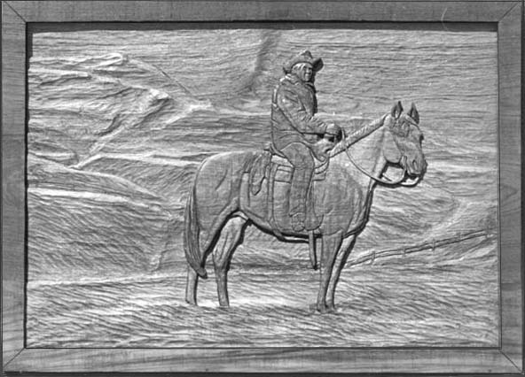
“Walk On”
Bull of the year 1999
Lenora’s Carving

“Lenora’s Carving “Zips Top Crop”

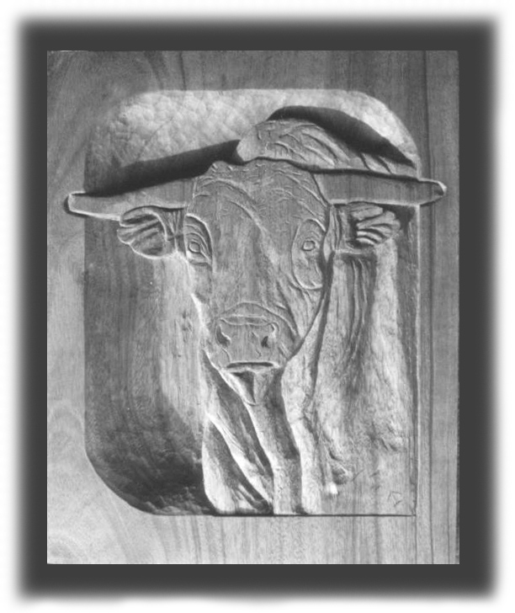

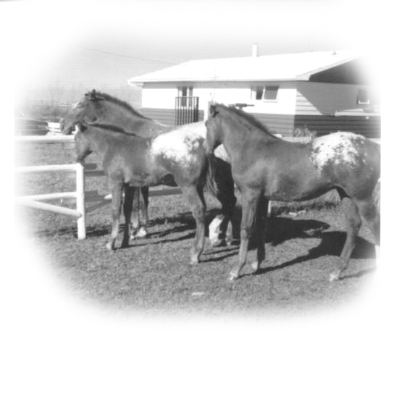
Lenora’s Appaloosa Horses
The next morning the snow had reached Pincher Creek and everything was under a blanket of heavy snow from the kitchen window to the far-off mountains.
I spent a couple of great days with Ron and Lenora and then flew back home to London. Wednesday and Thursday found me back in the shop behind the barber chair, cutting hair along with Yvonne. Hair was falling on the floor but my mind was still out there somewhere, lost in the mountains.
My Friend - Don Sutherland Sr.
Passes away Dec. 27th, 1997
December 27, 1997 I received word that my friend Don Sutherland Sr. in Alberta passed away at the age of 87. I feel an empty place in my heart for Don and Olive as they were there for me at a time in my life when I needed them. Don was born at Govan Saskatchewan, the third of six children. He came to Lanfine of the Oyen district in the spring of 1913 with his father and mother. In 1936 he married Olive Partridge and bought the farm south of Lanfine. Neil the youngest son now runs the farm.

We received a notice of yet another yearly rent increase on our apartments and I thought it was time to get serious about buying a condo. I had Bill and Jean come down to London and go with me to see the condos at 735 Deveron Cres. They too liked what they saw, and Bill mentioned that nearly all of the cars parked on the lot were late models so this would tell you a bit about the average tenant living here. These condos came in one, two, or three bedroom units. I decided on a two-bedroom, and I would turn the one into a den with a sofa bed for company.
So I started the paper work to proceed to buy a condo in early August 1998.
I had my choice of several condos, and I ended up picking this one. I also could pick out the paint and carpet. Everything was to be ready for me by Oct. 1st, 1998.

Bill and Jean and Jack Fly West Aug. 1998

About this same time in August of 1998 my sister Jean and Bill decided to fly west to visit their son Wayne and family in Red Deer Alberta. They asked me if I would like to fly out with them and show them some of the interior part of BC. They thought I would make a good guide as they were not at all sure how to pick a scenic route. I thought that it might be fun to share the trip with them so I went along. The good thing about three or four people travelling together is they can all share the cost and make things more affordable. Lets say the Inn in Grand Prairie cost me about $100.00 for one night which I really couldn’t afford, but with three it would cost us only $33.33 each, so is very affordable.
Wayne and Alana met Bill and Jean at the Calgary Airport and took them back to Red Deer to visit for a few days. Ron and Lenora met me and took me back to Pincher Creek to visit with them. About three or four days later Lenora drove me north to the Banff highway where Wayne met us and took me back to Red Deer so I could have a visit with them.
I won’t go into this trip in detail as it pretty well follows the same route I took the year before except in reverse. That is, we drove to Drumheller to see the Royal Tyrell Dinosaur Museum and then down to Pincher Creek to the Oddies before heading off into BC and then north in the interior. This was Bill and Jean’s first visit to Pincher Creek and the Oddies. Ron and Lenore took us down to Waterton Park, to Head Smashed In Buffalo Jump and to see the Oldman River Dam. We also went out to see the windmills at Crowley.
Our trip continued from Pincher Creek driving past the historic Frank Slide, then through the Crows Nest Pass and on down to Creston, then into the interior of BC to Kamloops and Prince George and north to Grand Prairie, then all the way to Peace River and back through Jasper Park to Red Deer. Truly it was a wonderful trip. One of the things that surprised me was that I always visualized my brother-in-law Bill as a slow driver, but I found out he had a much heavier foot then I do. His grand kids would never believe how speedy grandpa is in the mountains.

Buying A Condo

When I arrived home there was much work to do, meeting with the lawyer and the bank and the condo corporation, signing ever so many forms and papers.
One of the perks the condo people were offering right then to get you to sign was a one thousand dollar coupon on furniture at Martins Furniture on Dundas E.
I had all new furniture by now except for a bedroom suite. I had been looking at them with my cousin Wayne Butson at Patons Place so I knew exactly what I wanted which was an oak Palliser suite made in Winnipeg. I also knew the best price on every piece of furniture that I wanted. So I drove a hard bargain at Martins and got everything at the right price, and then I used the coupon from the condo corporation and got a thousand dollars off that best price. Jack was a happy boy.
I had to order venetians and valances for the windows and borders for each room. I decided on a better bathroom vanity of oak with basin and matching oak cabinet above with three glass door mirrors. Then too I had to pack things at the apartment and find a mover. More “Garage Sales,” oh yes-several, all in a row on weekends on the front lawn. Then there was still my two-days of cutting hair. I tell you there was never a dull moment, but truly I loved it. After all these years of renting and living in an apartment I was finally going to have my very own home to retire to. This meant a lot to me.
When it came time to move, my two nieces Nancy and Lori and husbands Martin and Grant came with their vans to move the packaged stuff. There was also a wonderful little ole lady with a new hatchback that made more than one trip for me from the apartment building to my condo. Her name was Vera Hewitt. I had done some paper hanging for her and she thought she owed me some help. When all the packaged stuff was unloaded and in my condo Nancy and I went down to the local Pizza shop and bought two large pizzas and some chicken wings and cold pop for supper before everyone left for home.
I went back to the old apartment to sleep that night for the last time. In the morning a mover truck and two men would come to move the larger things. Every thing was to go except for the fridge and stove. I had made a deal with the landlord for him to keep the two appliances in exchange for my last month’s rent, which was about $500.00. I had bought both the fridge and stove from Don Brown Appliance next door to my old shop on Wellington road in 1969 for $500.00. They had been good to me all these years. Now in 1998 twenty nine years later I was getting my money back out of them in the way of rent.
The movers arrived early in the morning and soon everything was loaded and on the way to my condo. They charged by the hour, which I thought was a good, enough idea. However they both smoked, and took time off to smoke while they were being paid to work. To add to this they stopped at Tim Horton’s on the way to my condo for thirty minutes. I was not impressed as I was paying them $60.00 an hour, which is a dollar a minute. When they billed me I reminded them about their 30-minute stop en route at Tim Horton’s. They said it was legal for them to charge for time off to eat en route. Their donut and coffee or whatever cost me thirty dollars.
That afternoon Yvonne arrived to help me, and I was glad to see her as I was sitting there amid all those boxes and furniture, with nothing yet in its right place. I felt overwhelmed by it all. After a few minutes Yvonne got me to my feet saying,
“Lets get started?” Truly I didn’t know where to begin.
Yvonne said, “We should start in the kitchen first,” so that was what we did and by evening things were actually taking shape. I will always be thankful for her help.
That afternoon Martin’s Furniture truck arrived with my bedroom furniture; we quickly pushed many boxes aside to make a pathway in. The bedroom furniture came in huge cardboard boxes, which they put in the centre of the room and then they were going to leave. Yvonne though was right onto them and had them un-crate the furniture before they left shaming them for not respecting a senior my age. Hmm? That night I slept in the condo for the first time and I felt good about it. I remembered thinking back to the first night I had spent in the old apartment building and the bad feeling of despair and panic. This time it was different and I felt something good would come of this move.
Yvonne returned to help me put up a border in every room; I have always loved this wide border I used on my living room, hall and den walls. It is of thundering Mustang horses all galloping off in the same direction.
My sisters warned me about putting too much stuff on my walls, and about clutter, but it seems I have many treasures. When I go into other people’s homes the first thing I always notice are their empty walls and tables. I always feel your home should speak volumes of you personally and of the things in life that are important or dear to you.
Over the years I have collected many beautiful things among them thirty some Beswick horses. There are also Llandro figurines, small and large Staffordshire floral arrangements and a large G. Armani horse and colt figurine, a real treasure.
I have a collection of about one hundred plates, half of which are in oak frames made close to home in St Marys. The plates are by such great artists as Kevin Daniels, Fred Stone, James L Keirstead, and Lena Liu, puppy plates by Lynn Kaatz and five beautiful Royal Doulton plates by artist Nigel Hemming of Labrador Dogs. I have four of Ken Danby’s famous Reflection of Youth Plates, framed two together in a frame. Perhaps some of the more favourite plates in my collections might be the seven plates I have of Peter Snyder’s who depicts the Amish and Mennonites countryside scenes of rural southern Ontario. In spite of all this, one of my more treasured things might be a hand-made oak clock made by my brother-in-law Bill Butler. The clock is made of special cuts made in oak grain then fitted together so they accent each other in the face of the clock. The hours are told by Canadian, provincial coins, truly, - a great conversational piece.
Piece by piece, one by one my beloved stuff found a home on wall and shelf. I guess it is what one might call organized clutter. My sisters still joke about my clutter, and I still dislike looking at empty walls.

One of the first things I had to do after I arrived at my condo was to contact the Canadian Hearing Society to see what could be done about connecting something to the intercom to let me know when someone was at the door. The condo corporation would not let me use the old apparatus I had been using at my apartment and truly it was very outdated. Up until then I really didn’t know what was available. I found out that there are some great new things available now. I will try to explain to you how it works.
They have what they call an Alert Master AM 6000, an all-in-one wireless system. It sounds impressive eh? Well it really is. First there is a master box, which sits on the nightstand beside my bed. On the front of it is a digital alarm clock with auto snooze. There is a round pad bed shaker which is placed between the two mattresses, which when set to the clock will awaken you with a powerful shaking motion. An in-line amplifier inside a small box is placed next to the intercom. When someone pushes the intercom button down stairs the buzz goes to the intercom as usual. Then this small boxlike amplifier picks it up and sends it to the Alert Master in the bedroom, which in turn, turns on the condo lights.

I wired every room in my condo to matching brass coach lights, which the Alert Master turns on when called upon for any reason. It can be the door, the telephone or a fire or carbon monoxide alarm. It also lights up for a strange noise such as a vacuum cleaner or a power drill. I also have a button on my condo door so people inside the building do not have to walk down stairs to the intercom to contact me. This is also hooked up to my TTY phone machine. However nothing is fool proof. There is nothing like being wakened up in the middle of the night with your bed shaking and every light in the condo flashing on and off, because some joker has pushed the wrong intercom button downstairs and set off the system. I have it so red lights come on for the phone and white lights for the door.
Summer of 1999 was very hot and I still had my old 8000 BTU AC, which I had used in my old apartment on Dufferin Ave. I put it in the box for an AC high in the bedroom wall. This of course is not a good idea as a window AC vents from the side, so you’re venting into the box and then in-taking the hot air, making your AC very hot and drying it out. In the end I took the one bedroom window out and put the AC in there using Plexiglas above. This however was not good enough to cool the whole condo, so I bought a second 8000 BTU from Sears and put in the den window.
Then I bought some great looking ceiling fans; two were Honeywell with wall control buttons. So there I was with two AC and four fans, one in the living room one in the den one in the bedroom and one in the kitchen. My hydro bill took off.

People were friendly throughout the building but as yet I didn’t have any close neighbours. There was no one living above me, and no one across the hall from me, and there was no one on either side of me. I longed for some real neighbours. One day when I was returning from a long walk two people were walking on the sidewalk towards me. I recognized them as tenants in my building, so I stopped to chat. When I left the lady told her husband that she was sure she knew me from somewhere. A couple of nights later the lady pushed the button on my door and when I answered she held up a large wedding picture in her hands and said,
“Do you know these people?”
I looked and said, “That’s Jack and Phyllis Murdock.”
She looked at me and said, “My dad and mom.”
I looked at her in question, and said, “Bonnie?”
“Yes, I am Bonnie.”
It seems she was chatting with a lady called Carrie. Carrie had a little dog that she used to bring over to a pet grooming shop in the plaza where my barbershop was. I had talked to her a few times when she was there with her dog. When Bonnie was out walking her dog she mentioned to Carrie that she had met me and somehow felt she should know me.
Carrie said, “Oh, that’s Jack the barber.”
Then of course Bonnie remembered me, and told Carrie I use to visit her dad and mom years ago when she was about sixteen. She remembered how I loved her mother’s home-made cooking, and she claimed I ate them out of house and home. (Now really does that sound like me?) Bonnie used to drop by the Executive House to visit with Bob Scott who shared my first apartment with me here in London. Bob’s father and Bonnie’s father were in the army together thus the family kept in touch. It was good to feel I had an old acquaintance in this building to be an even closer friend and my neighbour too.
Finally in March of 1999 new neighbours moved in on the south side of me. I was really happy to see them. I remember going down the hall to their door to welcome them. I introduced myself and I told them I really needed a neighbour. They said they were the kind that needed a neighbour too. They were Fred and Muriel Halle.

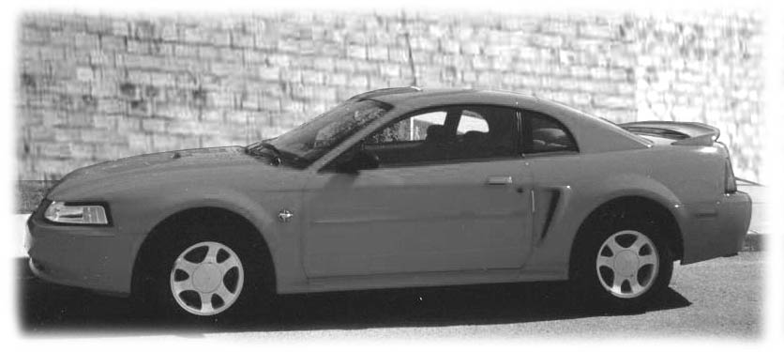
My 1999 Rio Red Special Edition Ford Mustang

In the spring of 1999 my 89 Grand AM Pontiac was now ten years old, and still looked in good condition. Its beautiful shiny paint showed no outward sign of visible rust but I knew though once a car gets to a certain place the body starts to fall apart and with or without care, and it is going to start costing you money.
The Grand AM had been a good car and so I was tempted to buy another. But since they had stuck so close to the same body design for all to many years I felt I wanted something altogether new and different. So I went shopping for a car. I have never liked a four-door family type car; it simply does nothing for me. I want something I can drive with pride, something that makes a statement, as to me a car is more then just transportation - it’s a lifestyle.
Bill and Jean came down to help me make up my mind about which car I should buy and the colour. I told them there were two or three cars I liked but the new 99 Ford Mustang was my pick, but unfortunately it was more money then I should pay for a car. It seems that Bill and Jean feel differently about my money and so encouraged me to go for the Mustang. For many years I have driven black cars, but Jean put down her foot. “ No more black cars.” All these years she had wanted to tell me she did not like black cars, so this time I had to pick something else. It was between the Rio Red and a Dove Grey; in the end I picked the Rio Red.
I have always managed to sell my car privately. It seems if you look after your car, have pride in it, and keep them clean, people do notice. This in turn helps to sell your car when the time comes. I put a 4-sale sign on it and the two days that I cut hair with Yvonne it was parked on the plaza lot. Soon people were asking me about it. In the end I sold the car to a lady across the street from the plaza for $3,650.00 I was fortunate enough to have the rest of the money in cash. So on April 15 1999 I was the proud owner of a Rio Red Special Edition Ford Mustang.
About three weeks after I bought the car I had a bad accident on Horton Street, here in London. It was one of those head tail head tail kind. A van up front darted across the street causing everyone up front to brake fast. The farther back you are it seems, the less time you have to brake. I hit the rear end of the car in front of me causing damage to the rear end and damaged the front of mine. I was really sick.
The damage to the front of my Mustang was just in the bumper, grill and hood, and not back as far as the radiator nor did it damage either of my front fenders. However as it was almost brand new, and the whole front, bumper grill and hood was replaced and cost over $7,000.00.
I had a 5 star rating on my car insurance. Which is the very best. However in the following October when I renewed my car insurance I found that it had jumped on a first accident from about $1,400.00 to well over $2,000.00 for the year. A mustang is recognized as a sport car; thus the insurance is high to start with, but this was a bit much. So I lost my 5 star rating and will have to wait and be five years accident free to get it back. Touch wood, it will be five years this spring that I have been accident free.
After I had been accident free for three years my broker allowed me to change companies which saves me about$600.00 a year.
In September George and Betty Vezeau, cousins of Fred and Muriel moved in two condos south of me and Elaine moved into the condo on the north, - all good neighbours. There are 51 condos in this building. By late 1999 all of the condos had been sold. It seems at least one is always “For Sale” as people move, leave town or move up to a house. The good thing is that the sales price has increased each year.
A Big Step Forward – “ I Bought a Computer ”
Older people, (That’s not me), I mean OLDER people; think a long time about buying a computer before they take the leap. My sister Pearl had bought one some time ago and was doing well. She put us all to shame and we envied her. For her, being deaf did not seem to be a great disadvantage. She of course had members of her family who had computers and could help her. They were also used to her deafness and managed to help her to understand. By that I don’t mean it was easy.
My neighbour Fred had a computer and urged me to go for it. I told him I was afraid to get involved because I felt I was not only deaf but also kind of dumb. He scoffed at this and said,
“ I will be there for you and help you to get started.”
To which I said, “ You have no idea what you would be in for Fred, as not only do I feel dumb but it seems when I struggle so hard to understand what you’re trying to tell me, I reach the point where I just have to shut down. When I reach that place I’m exhausted and I will snap out at you if you try to continue.”
Fred said, “So what is the problem? We would stop and just shut down.”
A young lad from White Oaks, whose hair I had cut for a number of years was now going to Western University. A few nights of the week he worked for Staples Business Depot. I chatted with him about a computer and he told me that since he was not on commission it didn’t matter to him what I bought. But he would like to put a package together for me of what he thought would work best for me. He wanted me to stick with Hewlett Packard all the way. We settled on a 17 in. monitor, and the 6535-pavilion modem and the Desk Jet 612C printer plus a special connection cable, all of which along with the tax set me back $2,051.56
I was now the very proud owner of my very first and my very own computer, but unlike the new car I bought, I could not make it run.
The first thing I had to do now was buy a desk for the computer, I found this at Staples to, a “Jagger” work station by Bush furniture and it cost me with tax $345.00 It came in a large box. Fred and I put it together; it turned out to be a good desk.
Fred’s son in-law, Bob Borisenko unpacked the computer and printer and put it all together and then connected me to a server.
From there Fred took over.
He arrived all bright and cheerful in the morning and started me out on the correct program where you get use to handling the mouse and opening and closing programs and how to send E Mail, open and shut down etc. This went on for days and I was not exactly happy at the progress. I don’t know how he managed to survive and sometimes when he went out the door I was sure he would never come back. The next day he would be back, ever so cheerful again wanting yet more punishment. In the end it seems that you reach a point where you start to understand and are able to help yourself. The first thing you have to learn is that things have to be done the way the computer thinks, and you have to do all things in the correct order. Until you accept this you will continue to get into trouble. I will never be able to thank Fred enough for his time and patience and for proving to me that, …….. I was not as dumb as I thought I was. Every day or two I still learn something new about my computer, but I am happy that I can do the things I set out to do, and better then I ever hope to do it.
Yvonne Moves To London
Early in 2000 Yvonne sold her beautiful big house in Dorchester and moved to a smaller one in White Oaks not far from where she worked. Mike and I helped her move her boxes; and a mover handled the furniture, it was a very dirty day when she moved.
Everything seemed to be going well for everyone. I continued to cut hair and enjoyed it as a two-day paid outing which I spent with old friends, (my customers). Mike had renewed a friendship with an old friend Charlotte, who had lost her husband to cancer a year before Jigs passed away. She was also one of Jig’s very best friends. I liked her right away and I was happy for Mike, as I knew he was not happy living alone. There was a problem though she was Mennonite and he a Catholic. Charlotte eventually became a Catholic and in time they got married.
In July 2000 Yvonne was not feeling well, and put in a very bad summer, not always being able to work. In November she had surgery and I had to work a few weeks in the shop alone. Her lease was up at the end of the year so rather then renew it she decided to take her business home to her house. She had a rear room with sliding glass doors out onto a covered deck. It all worked out perfectly. I painted the room a great antique shade of green. Mike and I helped her to move and hook up her plumbing and cupboards and place her chairs. It turned out to be a very nice looking shop and since then I am happy to say things have gone well for her. Yvonne had an extra chair, which she was going to sell along with some other equipment, but offered it to me if I wanted to cut a few head of hair at home. She felt her shop was not going to be big enough for two. So I took the chair home to my condo. Every Thursday I cut a few head of hair. I enjoy it as it keeps me in touch with a few of my older clientele some of whom I have cut for over forty years.
One of the reasons I had chosen this condo was because of the nice flowerbeds below my window. Two older brothers by the name of Smith had moved in here. The one was not well and appeared quite sick. He usually sat around in a wheel chair. The other one looked healthy enough and was trying to do the best he could for his brother. It was he who looked after the flowerbeds. I don’t know how long they had lived here, but it seemed they had never been able to get totally unpacked. They had two small trucks both with a covered rear box. The one just sat there backed up to the sidewalk and was never moved. It was full of just about everything one can imagine. Every now and then Mr Smith would open the back and rummage through until he found what he was looking for. I remember visiting his condo once to ask about something and I saw boxes upon boxes, which had never got unpacked. Getting about in a wheel chair in that condo was not an easy chore.
The spring of 2000 arrived and people were out preparing their flowerbeds, and there I was on the second floor just itching to get involved. Mr. Smith had not yet touched his beds so one day I asked him if he needed any help with them. He told me he was not going to put them in that year as they were moving to a house in June, so if I wanted to take over the beds from him it was ok. So that was how I inherited my first flowerbed here. After it was dug up and the flowers in I could not help but notice how wild it looked on either side of our rear door. There were weeds and wild shrubs of all kinds growing in the hard clay soil amid rock and debris. Then to complicate the problem even more there was a down drain flooding the area. I decided to adopt this area too, as I park my car below my balcony and use this entranceway every day. It could stand to be beautified.
I took out all the weeds, wild shrubs and roots and added several bags of black garden soil. Bernie and Bonnie Holton gave me half a bag of peat moss they had left over. I went to Home Depot and bought some cement m-like flowerbed edging and put it on either side of the doorway and also under my balcony. I attached a long flexible drainpipe to the down drain, to shoot the water out and over the flowerbed.
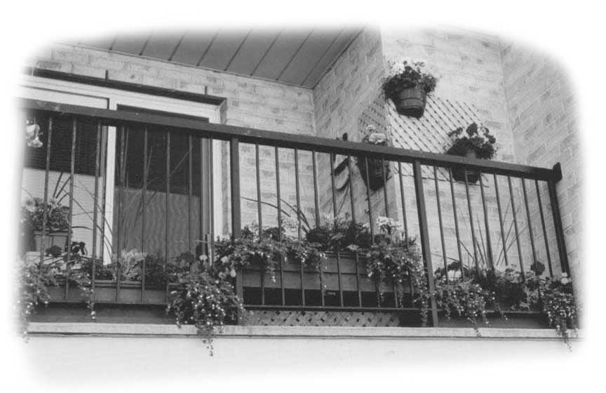
Flowerboxes on Jack’s Balcony
Soon the space below my balcony and around the rear doors was looking very much better; in fact it turned into one of the more beautiful areas of this building. It is not without cost and hard work. I kept wondering how so many people could just wander in and out of the building apparently blind to the effort of those who make life a bit more beautiful and enjoyable for them. However I have to remind myself that many people buy a condo just for that reason, to escape flowerbeds and yard work.
I have suffered an allergy for a number of years, dust, spore, mould, whatever and in the heat of summer it is worse so I find myself staying close to home on hot days.
One spring day while talking to Fred and Muriel next door I found that they were going to install a new kind of AC in their condo. I had never heard of it before. It was called a “Goodman Ductless Split AC ” and is similar to central air as the compressor is located out doors, in our case on the balcony. Copper insulated tubes run from the compressor to the unit located in your condo. A wireless remote control lets you control it to your comfort. George and Betty went for it too and when I found out just how well it worked I just had to put one in too. It is amazing and keeps the whole condo cool so easily and it also frees up your windows for letting in light. Perhaps best of all, it is very cost efficient to operate, much cheaper then window AC.
While it is quite expensive to put in, - about $2,400.00, with tax. I have no regrets. I was lucky in selling both my window AC for a fair price along with the Plexiglas to tenants in this complex. The year 2000 was an expensive year so no holidays.

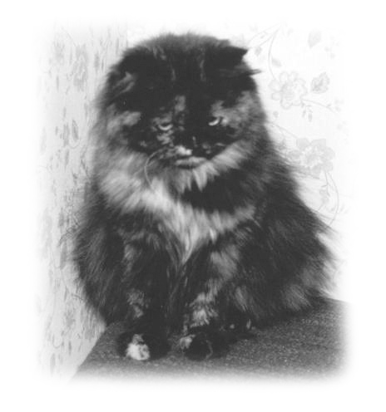
When spring came in 2001 after a mild winter, I had the urge to take my Mustang out on the road for a long trip while it was still relatively new. It would have to be either in the early spring or the fall as my allergies did not let me function well in hot weather. There is not a lot of air conditioning in homes or motels in the west, so in all truths I could not find a place more comfortable than home. Besides my flowerbeds needed me.
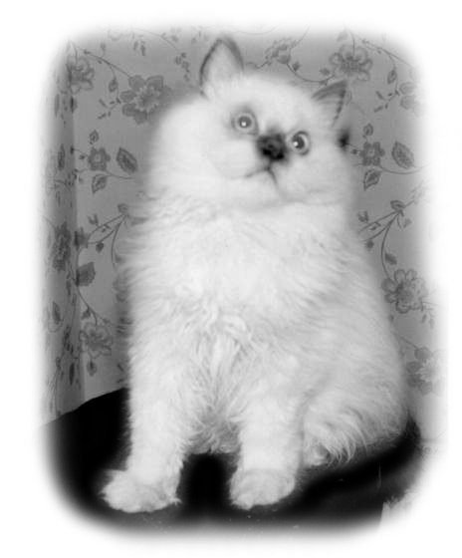

My Sister Pearl raised Beautiful Cats

My Manx Cat Mandy Dies
Some time in August my cat Mandy stopped eating. There were no bowel movements for a number of days. For a few days I was not alarmed but when it stretched out to three, four and five days I knew I had to get her to a vet. My sister Pearl had been raising beautiful kittens while living in Russeldale and had great faith in the vets in the village of Kirkton. I put Mandy in her cage and drove to Kirkton. Mandy does not travel well, and when I took her out of the cage she was not about to have anyone but me handle her. With my help, the vet examined her closely. He said her hair was a thing of beauty and her skin or hide was nice and loose. Outwardly he could not detect a thing wrong with her So he suggested that if I really wanted to know if there was a problem he could do blood work. He added, “But that would be costly, at about $75.00.”

I knew I would not forgive myself if she died and I might have done something to save her, so I told the vet we would proceed and do blood work. Mandy though would not hold still for him to draw blood, so he gave her a needle to make her settle down and get sleepy. After giving her a needle he left the room and I stayed with her. I remember yet seeing her gulp a few times but as I trusted the vet I thought it was ok. Actually she was struggling to breath. She suddenly was very still with her open eyes staring into space. I went to get the vet saying I was sure she was out, and maybe he should look at her.

When he saw her staring off into spare he quickly gathered her into his arms and rushed her to a back room, and called to another vet for assistance. After a few minutes he carried Mandy’s lifeless body back into the room telling me he was sorry but she was dead. He said he had given her only the recommended amount in the injection and this had never happened to him before. This of course was of little comfort to me as I was in shock, and I didn’t trust myself to talk just then so I just said,
Daddy
“I will be back, I have to go for a walk.”
I walked around the block, and I am not ashamed to say I shed a few tears for Mandy my cat, but I realized the vet was in a difficult position and very unhappy about what had happened. When I went back to the office they had put Mandy back into the cage for me. I asked about the billing and of course they said there was no bill.

While I was walking I had decided to drive on to Mitchell to Bill and Jeans, so often it seems it is Jean I turn to when life gets me down. I had arrived just in time for lunch; while we ate I pondered what to do about Mandy.
Jean’s daughter Lori and Grant had just put there dog Spike to sleep. He was a brown Dachshund and very much a loving family dog. He loved nothing better than being under the table during family dinners and going from one to the other, secretly begging for handouts, which he usually got. Stiff, and sore from old age and arthritic they finally took pity on him and put him to sleep. He was buried in the lawn to the north of their garage.

Lori was at work in Stratford so I drove out to where Grant worked at a machinery dealership just east of Mitchell. Grant was very understanding of my sorrow as he still missed his dog Spike. I asked if he thought it would be ok if I buried Mandy somewhere out on the farm.
Grant said. “Burry her along side Spike. I know Lori would be happy about that as she keeps saying, poor Spike out there all alone, now he will have company.”
So that was what I did. Bill made a nice wood box for Mandy and together we went out to the farm and dug a deep grave and buried Mandy next to Spike.
Lori and Grant’s youngest daughter was only a little girl at the time and every day that fall she would go out and sit beside the graves and chat to Spike and Many. I wonder what she said?
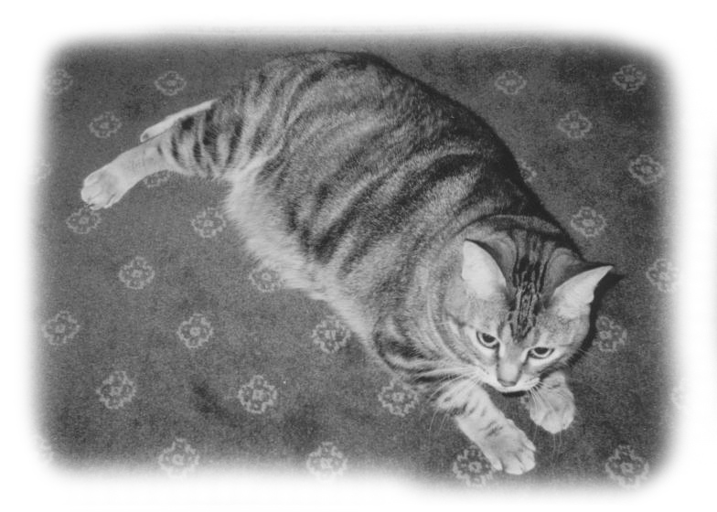
With Mandy gone I had no reason not to be able to get out on the road in my Mustang for that nice long trip that had been smouldering away in the back of my mind.

My Very First “Mandy” a Manx cat

Chapter 9
A Great CANADIAN HOLIDAY TRIP
Friday September 14, 2001
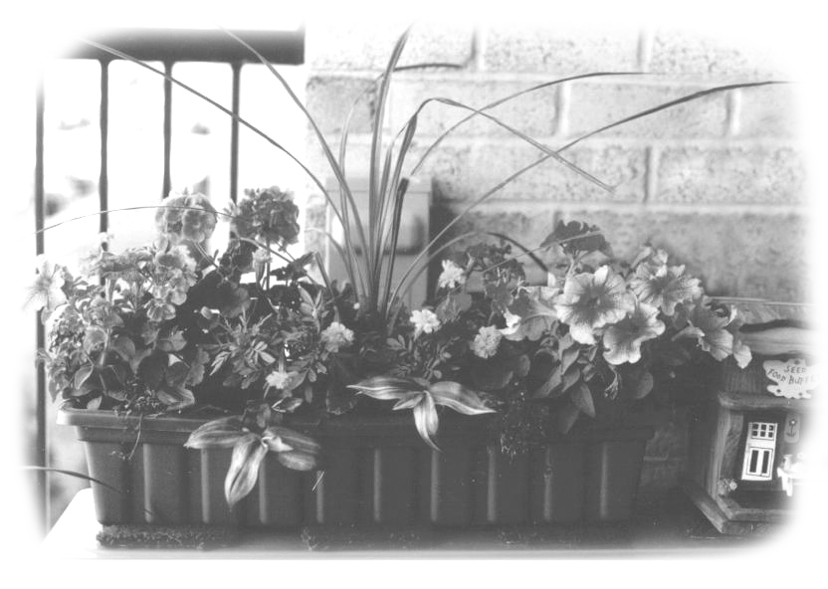
Flower Boxes on Jack’s Balcony
I was up early to be sure everything had been looked after. My Mustang was vacuumed, washed and waxed. My condo was clean and tidy and my flower boxes on the balcony were watered with care. The neighbours were given the keys to the condo and the mailbox, but I still had a last minute hair cut to do at eight o’clock. One of my long time customers called me the night before and said he could not wait until I got back, so he was coming over for his hair cut at eight AM. This proved to be a good thing though as he not only gave me $15.00 for his hair cut, but he and his wife helped me carry my things down from the condo and loaded it into my car, and then they saw me off.
My first stop was to be at my sister and brother in law’s cottage at Maple Island north east of Parry Sound. For some reason I never seem to be able to drive up there by the same route. I feel that Ontario’s road sign leave much to be desired. I don’t actually get lost, but it is hard to follow the road numbers as the highways zig zag every which way hither and yonder. However I always get there. I arrived in time for supper and spent two quiet days with Arnold and Pearl; we caught up on the family, our health and social activities.

Their cottage sits high on the bank of the Magnetawan River in a park like setting, facing a great expansion of water like a huge bay, which starts off right there under the deck. The river here is more like a lake with a grand collection of poplar, cedar, spruce and pine all along the sides, then there’s a sprinkle of oak and maple on the higher ridges. We took a boat ride on Saturday, down to the falls as they are called where the river drops several feet through a rocky gorge to flow on its way to Georgian Bay. On Sunday evening I took Pearl and Arnold out to McKellar for supper, and after that we took a long quiet drive through solid bush. As the sun went down and evening came on there is a great feeling of quietness and tranquillity out there, far from the warring world.
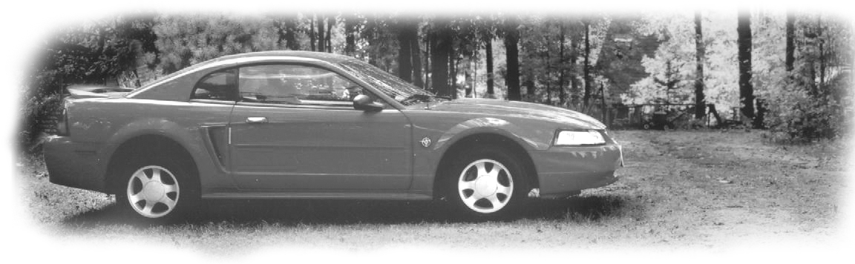

My Rio-Red 1999 Special Edition Ford Mustang
On Monday morning about 8:00 AM I said good-bye to Pearl and Arnold and started out on my long journey to Winnipeg. I think it was then that I wondered about the wisdom of starting out on this trip alone, at my age and with my deafness, all alone in a Silent World. It was overcast and cloudy all day, with a few drops of rain; there was just a hint of fall colour in the forest mostly with the poplar and birch. It was not a good day to use the camera. I guess I didn’t really mind, as I wanted to make good time that very first day.
The speed limit is 90 km. so I had the cruise control on at 95. I seldom caught up with anyone but people were often passing me by. On this trip a traffic ticket I did not need.
By late afternoon I was driving through miles and miles of burned out bush on both sides on the highway. The fire was out but the smell of wood smoke hung in the air. Everything beneath the trees was gone and the whole forest stood bare, a blackened tragic and death for everything caught in its path. It was not a pretty sight.
As it started to get dark I noticed many NO VACANCY signs going up, so I thought it was time to find a place for the night. I was shocked to find out that because of the forest fire all the inns and motels were spoken for, for miles in every direction. They told me I would have to drive on to Nipigon about a two-hour drive to find a place. It was 11 pm when I got to bed, but one good thing about all this was that it was now just a nice day’s drive to Winnipeg.
The next morning I was up early. As it had rained during the night the day started off cloudy and wet. I was now driving along the northern shore of Lake Superior but I could not see far out on the lake because of the clouds. I noted that the maple trees here were showing their first hint of red. So I hoped that I would be on time to see them in all their glory when I returned. Hopefully at that time the weather would be clear. I sometimes wonder if it is always raining around Thunder Bay or just when I pass by.
Twelve km. west of Thunder Bay is one of the more necessary stops I would have to make. It is the Terry Fox Memorial Park, with a bronze statue visible from the highway high on a cliff on the north side. The statue itself is one of the few really worthy works of art that has been erected in Canada for many years. It is also an inspiring site, and an all too young Canadian Hero truly worthy of it.
I saw tears in the eyes of many people who came there to pay their respects.
The sky was clearing by afternoon and so I got a glimpse of the Rainy Lake, then on to Fort Frances and past Lake of the Woods and on to Kenora. As I drew near the Manitoba border the hi-way seems to finally run straight. The border appeared rather suddenly and I was greeted with a great freeway. The land started to flatten out and for a while intermittent areas of bush of poplar and Manitoba maple dotted the countryside in fall colours of yellow and bronze. As you drive farther west bush gives way to true prairie and the land reaches out to the skyline.
I had not visited Winnipeg for many years so I was looking forward to it. With so much hype about Calgary and Edmonton, we are inclined to overlook the city of Winnipeg. It is a great city with a population of over seven hundred thousand. The downtown area has a large number of older more wonderful buildings still in excellent condition. These buildings were built when huge pillars and large building blocks were a norm. Perhaps it is because it has escaped much of the dust and smog from industrial pollution, that these old buildings look so remarkable today. It is the Chicago of the north. Unlike Calgary and Edmonton, which grew by leaps and bounds, Winnipeg gives off an air of a place where growth comes slowly but steadily. It seems more secure in its multi-type industries. It has two great rivers flowing into it, the Assiniboine River flowing in from the west, and the Red River flowing in from the south. In the heart of the downtown area, within a few blocks of Portage and Main the two rivers merge gracefully as the Assiniboine flows into the Red on a flowing angle; thus they merge without much flare. It’s like a good marriage in which both benefit.
My long time friend Jerry Baltesson is a retired schoolteacher and lives in a penthouse in the heart of the downtown with a magnificent view from its 16th floor. Jerry’s wife died of cancer a number of years ago. Our friendship goes back to the early nineteen forties when I first ventured west on what was called The Harvest Excursion, but that is a story I have already told you. Jerry and I had been in contact by e-mail and he was expecting me.

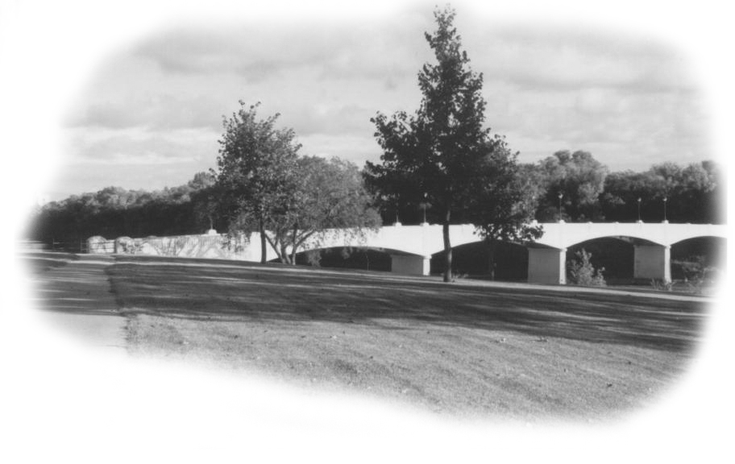
Assiniboine Park Bridge and Confederation Life Bldg
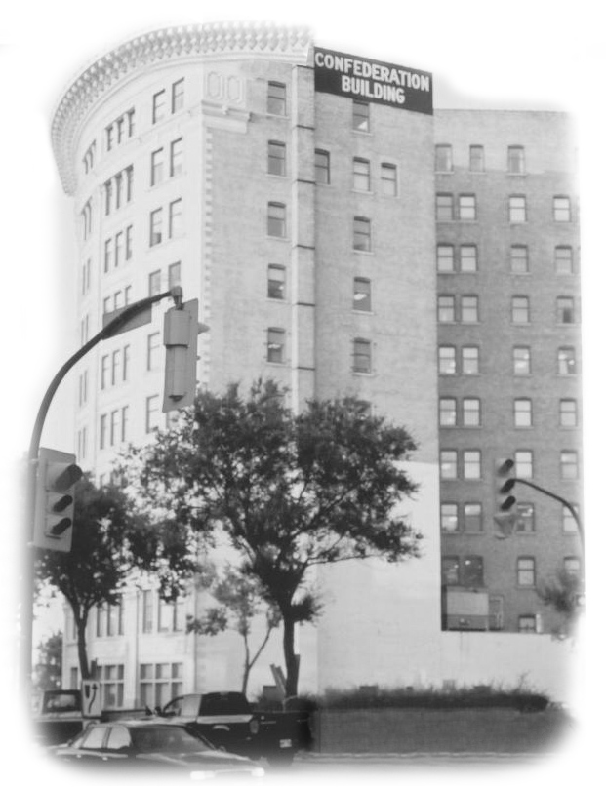
I told Jerry this story, just as I had told it to you a few chapters back. I told him of my train trip west and how I found my Uncle Fred the barber. It had much to do with what happened the next few days. The Confederation Life Building is visible from Jerry’s balcony. It is within walking distance to the northeast. The next day we went for a walk to the historic corner of Portage and Main. Beautiful historic buildings, small green parks, flowerboxes and wide streets surrounded us. We then walked north to see the old Confederation Life Building. Somehow it seemed much smaller now than when I first came here in 1944. It appeared to be empty but still in good condition. The building that was next to it had been torn down exposing its sidewall of unfinished rough brick. I felt happy that I came to visit the site once more, as just maybe it will not be there too many more years. Jerry showed me the vacant lot where the old Leland Hotel once stood. It was good to walk the streets of Winnipeg once more, and remember.

Jerry wanted me to once again get the feeling of knowing Winnipeg. To know Winnipeg you must know its rivers. Sunday morning arrived sunny but brisk and the city was now very quiet. I found myself walking east with Jerry along the gravel path on the north shore of the Assiniboine. Looking back over my shoulder as far as one could see were huge rounded pillars carrying overpasses over the river, one after the other like dominos. That day we were heading east to the “Fork” so I could witness the exact spot where the two rivers merged. For some reason I expected to see a lot of action where the rivers meet, but the Assiniboine flows on an angle into the Red, which absorbs it with grateful need.

We walked a little farther around the bend and across the Red River stands the old French city of St. Boniface, which is now just a part of Winnipeg. The old but beautiful historic St. Boniface Cathedral still stands proudly on the east bank of the Red. Many years ago when Jerry lived in St. Boniface he took me to see this very old and beautiful Cathedral. Perhaps 20 years or so ago a great fire destroyed a large part of it. It was like many of those huge churches or cathedrals in Europe. It never could be heated in winter so they built a new cathedral along side, then preserved the old one for historic reasons. With Winnipeg’s long and very cold winters it probably made sense, sad as it really is.

In the evening we drove out to The Assiniboine Park, I realized by now that Jerry wanted me to relive my first visit to Winnipeg knowing how close it was to my heart. As I walked through the flower gardens of multi colour in the Assiniboine Park I could almost feel my uncle Fred’s presence and I wondered if he enjoyed that day in the park so long ago as much as I had. The sunset and darkness came on as we drove in quietness back to Jerry’s Penthouse. Once there we sat down to chat in the glassed enclosed balcony with a pot of tea while watching the lights of the great city below, like a bed of jewels in the black of night flashing its colours. I was packed and ready to leave in the AM.
In the morning I left for Pincher Creek Alberta some 850 miles west as the crow flies. The speed limit on the Trans Canadian Highway in Manitoba is 100 km. and in Sask. and Alberta and BC it is 110km. So you can cover a lot of miles in a day on these straight highways. I seldom had to pass anyone but many including little old ladies passed me by. Again I didn’t want to spoil my trip by getting a ticket. Winnipeg sprawls far to the west actually some sixteen miles. Once out in the open I watched the miles fly by.
The harvest appeared all but finished, but here and there I would find a combine working in the field, and by looking at the stubble I could tell much about the crop. While some parts of Manitoba had a fair crop most of it was poor, and as you drove farther west it got worse. By the time I got to Swift Current the ground was bare of stubble. All my life I had heard of the saying “The Bald Prairie.” Now for the first time in my life I saw it. I remember seeing thin cows walking, walking, looking for grass that did not exist, and seeing them standing knee deep in mud praying for water. This was not the west, as I knew it, and it was very sad.
The miles flew by and soon I realized I was going to be able to reach Pincher Creek that evening. I had passed through a time zone and that gave me an extra hour to drive by. I arrived in Pincher Creek about 8 PM. I had not stopped for supper so I went to a restaurant to eat. The waitress called Ron and Lenora to tell them I had arrived safely. When I arrived at my long time friends, Ron and Lenora Oddie the welcome was warm and the coffee hot. We sat and chatted till late as we had a lot to catching up to do. I always carry a pen and pad to help me understand what is said when I get stuck. It amazes me that neither Ron nor Lenora seem to ever tire of writing page after page of notes to be sure I understand what it is they want to tell me. Ron seems to get all his writing done while I am there, or so I have it figured, as I never hear from him on paper again until my next visit. However I do get many great letters from Lenora over the year keeping me informed on the weather, the crops, our mutual friends, and the bad eastern governments So what is left for Ron to tell me?
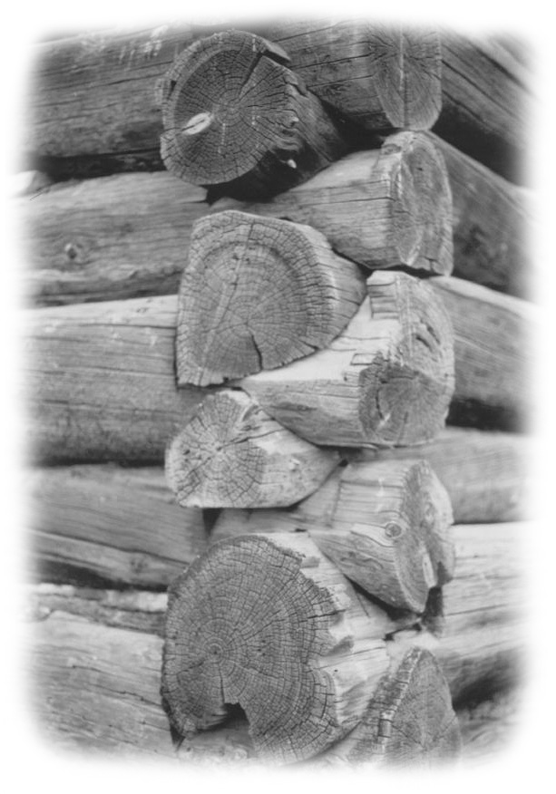
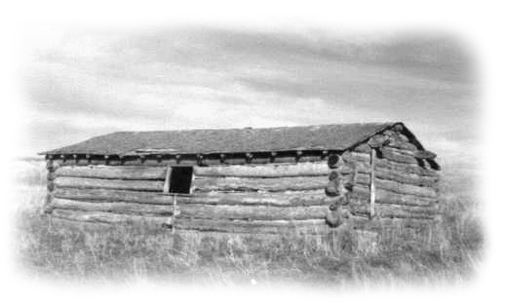
Log Cabin up the Livingston Range North of Pincher Creek
Basically we like many of the same things, starting out with horses, and Hereford cattle but ending with Ontario and the federal government. Fortunately we both have a sense of humour and a great love for Canada. Westerners are a really weird lot of individuals. They have never met an easterner “personally” that they didn’t liked, but collectively they feel we are the source of all their problems. Oh yes, there is a long list of things we are to blame for so I won’t get started.
The next day was Sunday and I rested. At my age now I am in need of more Sundays per week. The days got a bit too hot and I missed my AC. The nights cooled the house down nicely and by morning it felt just right, but unfortunately Lenore suffers from fibromyalga and needs the heat so the furnace comes on first thing in the morning and soon the house is uncomfortably hot again. Ron and Lenora live just a few miles southeast of Pincher Creek, with a view of the Livingston Mountain Range in the northwest. We decided to drive up to the Chain Lakes and have a picnic lunch. I volunteered to buy a bucket of Kentucky Fried Chicken, and Lenora built a great picnic lunch around that.

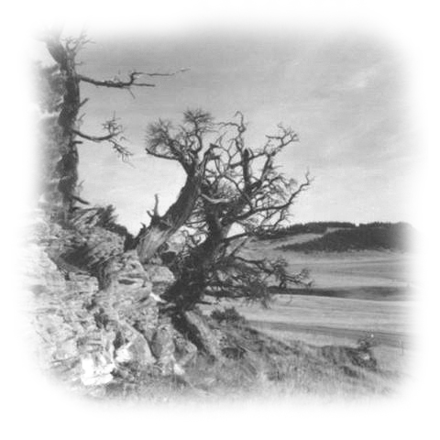
Pine Trees Grow in Rugged Outcrop North of Pincher Creek
It is a colourful drive north through real ranch country. Out there it’s easy to visualize the west as it use to be. Here and there are old log houses and ranch buildings slowly decaying…weathered by westerly winds, bleached by the summer sun, and heaved by winter frost. They stubbornly refuse to accept their fate. Along the east side of a winding road is an outer crop of rock within the hillside. From these rocks stunted, weathered pine trees with flaying knotted branches struggle to survive against the hot dry summer sun and the ever-blowing year round winds from the Crows Nest Pass.
We came home via Cowley where there are many windmills working to create electrical power, stretching out miles in every direction. After many years of being ignored it seems they have finally won some recognition by the Alberta OIL Revenue rich government. There are no royalties to be collected from the wind.
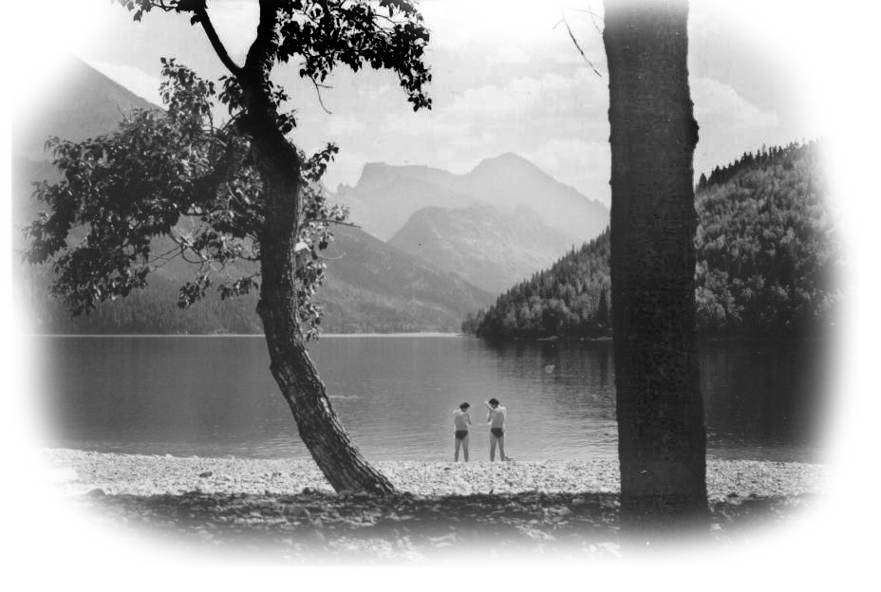
Waterton Lake in Waterton Park
We took a drive down to Waterton Park, perhaps one of the less spoiled parks in Alberta. I have been there many times to dine and to take pictures. I am always amazed how the time of day reflects on the pictures one takes of Waterton Lake, with its many moods, sometimes looking angry and cold…other times mellowed by the setting sun and reflecting the beauty of lofty mountains along either side and always under the watchful eye of the great glacier from which it is fed. Ron treated us to a splendid lunch after which I spent the day with my camera. There are great pictures waiting to be taken and deer and goats willing to oblige even the worst of photographers. One of the sad sights here is the destruction being done by the Lodgepole Pine Beetle. It separates the bark off the trees and the tree dies. Luckily it only attacks the Lodgepole Pine, but there are thousands of acres of dead trees, a disastrous sight, and fodder for a great future forest fire to come. We drove home, knowing that this was my last evening visiting with my friends the Oddies. In the morning I would put my suitcases back in the Mustang and head off into the mountains.
Off Into Wonderland - The BC Interior
I took highway 3 west, going past the town of Frank and the Frank slide, where the old town lies buried under a rockslide. From there on through the Crows Nest Pass and down to Creston at the foot of the Kootenay Lakes. I love this town and its valley; here you will find something really different. It is the first valley where you will see large orchards of apple, pear, plum and peach trees. You will find everything from strawberry farms to dairy farms in the valley. I bought some fruit to take on my trip, and then I was back on the road to Castlegar where I spent the night. The next morning I drove on to Trail and to Okanagan Lake and valley to Penticton and on to Kelowna. I believe these two cities are the most beautiful cities in all Canada. Everything here is new and you will find everything from Canadian Tire to Staples, McDonalds, Burger King, or the Dairy Queen. There are tree planted boulevards rich in colour and lawns like London Life. They have it all, and Kelowna even has an International Airport. Also, many new apartments high-rises give it a neat skyline. From Kelowna, I drove up the east side of the Okanagan to Vernon and then west to the city of Kamloops.
Now I had always wondered what the country would be like in that huge area going northeast from Kamloops to Jasper. On the map it looks empty. The Highway is called, ‘The Yellow Head Highway.’ What I found was far beyond my expectations. Endless forests were highlighted in brilliant fall colours and reflected in its great rivers and lakes. It is an open country, which is very sparsely populated with people, where small villages and towns bear strange names I had never heard of before. The villages break the lonely highway and add comfort in the feeling that you are not alone. Everyone seems to own lots of horses and several large dogs.
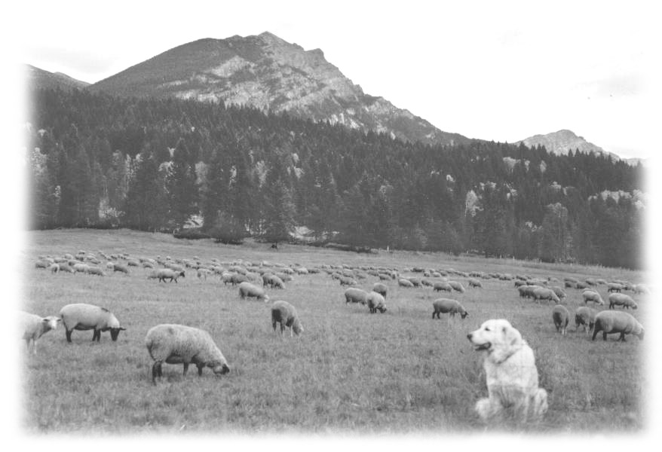
A Russian Wolf Hound On Yellowhead Hwy.
Here and there are rustic ranches with herds of cattle and sheep, and green fields of alfalfa, already cut and baled into huge round bales for winter hay. The winter snow is so deep in this area that cattle cannot forage for food in winter or spring as they do in much of Alberta. So they have to be hand-fed. Fortunately they grow great alfalfa here for hay crops and pasture, but the season is too short to grow good grain crops. I drove for miles along the Thompson River, which rushes south from its high source, the tall mountain country of Jasper.
As you near Jasper Park the mountains get higher and higher with snow covered tops. Suddenly very high mountains seem to block your northern travels and the highway splits at a huge clover leaf, and goes in two directions east and west…It was very tempting to turn east to Jasper as I looked longingly at all those tall commanding snow capped mountains to the east, but I had planned on seeing the country between Jasper and Prince George. So I drove west. The highway seems to straighten out and the country is more open. Along here new land is being cleared from meadows and adjoining bush land. New ranch buildings and modest ranch houses make it look very appealing, and I wished I were fifty years younger. It was really a beautiful drive all the way to Prince George. I stayed there for the night because in the fall one does not drive at night in this country, as you just might meet a romantic moose on the highway and that is a love affair best avoided.
I was back in familiar country again as I drove north from Prince George to Dawson. It is wise to keep the gas tank full and eat when you can, as this is really an empty country. In the afternoon I arrived in Dawson and on to Grand Prairie by evening. One is struck by the suddenness that you are in open country and true prairie again. Up here they were still harvesting grain and it looked like a very good crop. I went to the same Inn in Grand Prairie that I had stayed at before. From there I had the clerk call Shelly my friend Mike’s daughter in Dorchester to see if we could have dinner together. Shelly was born in Dorchester Ontario just outside of London and she has always called me Uncle Jack. She was home and said she would meet me at Kelsey’s for dinner in twenty minutes. However it was an hour before she finally turned up and I was beginning to be afraid it was the wrong Kelsey’s.
She said, “I am very sorry I am late but it is my dad’s fault.”
I said, “You can’t blame your dad for anything now, as he is in Ontario and you are here.” She said, “ Would you believe it, right after I got your call my phone rang again, and it was dad wanting to know if I had seen or heard from you. I told him I was just going out the door to have dinner with you.”
Supper was very enjoyable as Kelsey’s do justice to beef steak. We lingered chatting long after we had finished eating. I know to Shelly I am someone from home - a close friend of her dad and mom, It seemed just a short time ago she was that little girl that played a joke on me. She had put a nice size rock in a basket of potatoes her mom gave to me.
I kept the rock and I call it a Shelly stone. She didn’t want me to go before I had told her all about her dad back in Ontario. Her dad moved back to Dorchester from Creston after Shelly’s mom died of cancer just a few years ago. I made a rather sad departure back to my room at the Inn. I have not mentioned here that I do not like motels or inns for when you travel alone and deaf, it is just a long lonely evening that you have to put in. Not one place where I stayed knew how to turn on the Caption on their room TV and as far as reading, I had read the paper in the many eating places and coffee shops during the day and after driving all day my eyes were not up to reading anyway. Then I don’t sleep well anymore, and if I go to bed too early I will want to hit the road long before daylight.
Rising early the next morning I found out there was a healthy frost to clear from my windshield before starting out. At the outer edge of the city a work crew was working on a huge cloverleaf and in places the soil was cut away perhaps more than ten or twelve feet. It was a reminder of the stories I had heard about the number of feet of black soil all across the northern part of the Peace River country, foot upon foot of rich black soil.
It was another glorious sunny day, as I turned my Mustang towards Peace River. It just seemed as if fall was just continuously opening up to me everywhere I went. The open prairie looked good again after so many miles of mountains. Many farmers were in their fields combining the last few acres of what looked like a great crop of wheat. The stubble showed to my knowing eye that the harvest had gone well as it was rich in colour and thick enough to hold the straw aloft. I had lunch in Fairview, a beautiful small town made rather famous over the disappearance of a local doctor a few years ago. A second doctor was thought to be involved with his disappearance, as they had an ongoing feud. To this day the doctor has never been found.
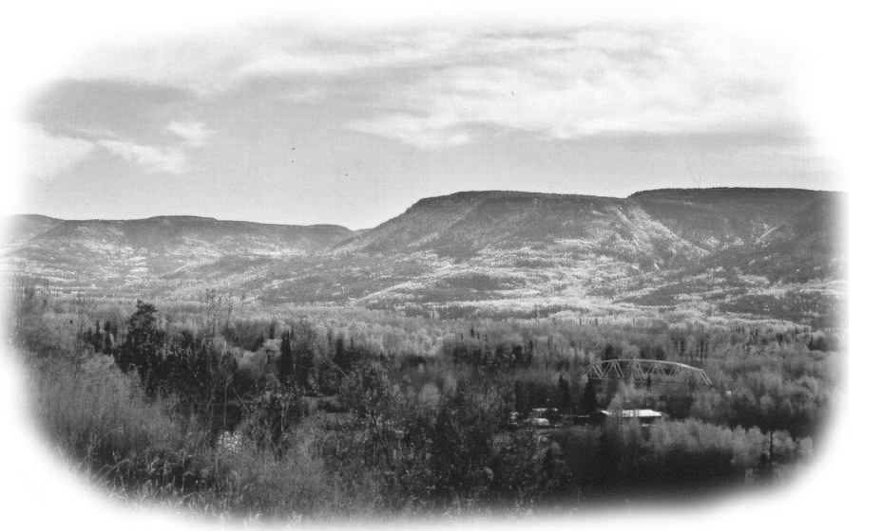
Flat Top Hills at Peace River
As you near the Peace River great flat-topped hills appear in the northeast and you enter some really beautiful rugged country. The colour up close was amazing and the hills in the distance were in a soft haze against the pale sky. As yet you have not seen the river or town as it is in a deep valley. You arrive rather quickly; and you have a clear view of a large suspension Bridge at the foot of a long winding highway awaiting you.

The Peace River and its valley are impressive to the eye and seeping with history of yesteryears. Witnessing this great river and crossing it, gave me a feeling of being a part of something historic of Canadian value. The highway winds up the steep banks on the north side of the river and to your right you are looking down onto the flood plains below. Between the steep banks of the river you see the many vegetable gardens in the fertile soil of the river flats, all under irrigation from the river. As quickly as you come onto the river and the town you leave it all behind as it is situated in the deep valley. You rise from the valley to prairie once again and soon you are travelling through fields of wheat stubble and then areas of fenced grassland.
I stayed the night at a motel just east of Peace River.

The next morning I was off to High Prairie and while I have travelled to Peace River before, I had not been into the vast country west of there. To my surprise it is more like parts of Manitoba, lots of prairie but also areas of good bush lands. It is a good mixture of cattle and cropland. In many places new land is being broken and I feel there is room for several million new Canadians in parts of BC and this northern Alberta country. Along the highway I began to see signs, ‘honey for sale’, then a sign ‘Garage Sale and Honey’. Well I have always been told the best honey in the world comes from the Peace River Country, so I thought I should stop and buy some. Here I found a nice house and all new buildings.

I was surprised by the size of the crowd they were drawing, as this place was far out on a very distant highway and houses here are far, far apart. When I parked the car a nice lady approached me and asked,
“Where in Ontario are you from?”
I said, “London,”
She said, “Before you go be sure to go over there and speak to my husband as he came from Ontario.” So I bought four 1kg pails of honey, and then I walked over and introduced myself to the husband. It turns out he used to live in Mount Forest a nice little town about 100 miles north of London. He had come out there about 20 years ago to keep bees and is very happy with the country and the way his business turned out. He has two great looking sons about 19 and 20 and a pretty little daughter he adores, very much younger. It always makes me feel good when I find that Canadians are much the same wherever you find them, friendly, happy healthy and prosperous, and very much interested in Canada as a whole.

He took me into his buildings, which were huge, insulated, and heated in winter. In there he had all kinds of professional equipment to process his honey, and everything was spotless. I asked him about his bees and the cold winters. He said when he first went there he expected to have to buy new bees every spring but he has not had to buy bees for a number of years, as they don’t get the cold winters like they used to.
He added, “If you want to experience cold winters today you go to Winnipeg.” This kind of story is repeated all over this North Country. For some reason the weather has changed and nowhere is it more obvious then in northern Alberta.

So I travelled on to High Prairie, which turned out to be a really modern and beautiful town more like a small city. It has all the things one would expect to find in a town a thousand miles south, beautiful new homes, landscaped and with nice green lawns. There are new shopping plazas and oh yes, there’s McDonalds and Tim Hortons. These northern towns show the new growth and the prosperity of Alberta while many towns all over Ontario are dying. Soon I was driving along the southern shore of a long low lake. Its water was a dark cold blue. This is the Lesser Slave Lake. The east end of the Lake is the town of Slave Lake and again a very modern town that would put most of Ontario towns to shame. Then again Ontario works hard for its tax dollars, which is not oil, related? Ouch, my western friends are going to make me pay for that, but lets face it! Its true.

Travelling on I came to the town of Athabasca, a magical name that seems to have been stuck somewhere in the back of my mind ever since I first heard of it when I was a child in Public School, and now as if it was meant to be I am here… Here too of course is the Athabasca River, which actually starts out fed by glaciers hundreds of miles to the south in Jasper Park It winds its majestic way north through Whitecourt to Athabasca and on to Ft. McMurray then north to Lake Athabasca, where it feeds many lakes and rivers.
As my map shows vast empty spaces ahead I thought I had better top up the gas tank. Then as I drove out of town I saw a donut shop so just in case I thought I had better top up Jack too, with coffee and a donut. Remember I’m on vacation here, so nothing counts. As I parked my car a man stopped to look at it so I asked him,
“How is the highway ahead to Ft. McMurray?”
He said, “Oh great, in fact it just keeps getting better” I went in ahead of him as he continued to chat. Soon I had to tell him I was deaf. I got my coffee and donut and found a table and a newspaper. The man sat two tables away and again started to chat from that distance, but soon he beckoned me to join him. I told him he would find it difficult to chat with me, as I am stone deaf. He said,
“We will make out, no problem.” So I found out he was from Newfoundland, and that there was a lot of people here and in Ft. McMurray from Newfoundland. In the end it was a very enjoyable stop, and when I drove off the lot he shook my hand and wished me a safe trip. Again I had found a Canadian who just wanted to show his friendship, the kind of friendship that ties this country together.
I Drive North to Fort Mc Murray
Actually it was a bit late to start on the highway north to Ft. McMurray, yet too early to quit driving so I decided to drive on. The day had been perfect, a fresh very new and beautiful country to explore along with good weather and friendly natives, and so what could go wrong? As I drove north the land intermingled as it changed several times from great round bales of hay in fields of dark lush green alfalfa, which was already a foot high, to good bush in fall colour. I was surprised to see a lot of yellow tamarack and tall Lodgepole pine, mixed with poplar and aspen. The soft October sun hovered long and mellow low in the west making this drive one I would always remember.
The highway to Fort McMurray is good, built high for winter driving, but there are no villages and very few houses along the way, certainly not a place you would choose to run out of gas or have car trouble at any kind. Darkness came on and my gas tank was low, and frankly I was beginning to get a bit concerned, and the words of wisdom from my little sister pops into my head, She is the one that is always advising me to stop driving in the middle of the afternoon. But suddenly the lights of a great new city of about 50,000 lights up the night sky. All along the highway into the city are no vacancy signs, and I am hearing the voice of my little sister as she says,
“I told you so.” I decided to pull into an inn and ask for advice. They were very friendly and helpful and offered to phone around and find a place for me. I had a wee bit of trouble following directions but finally found it. It was $123.00 for the night…and they asked me how long I would like to stay. I wish I had said…(about half a night).
It was late, perhaps after nine PM and I still had no supper, so as there was a restaurant connected to the inn, I thought I might as well eat right here. They already had my leg I might as well give them an arm too. In the morning I was up early, full of anticipation of seeing the sand tar works, as I have always been very much interested in it, - but first off to McDonalds.

While you will find most things very expensive in Ft McMurray breakfast at McDonalds, (or coffee and donuts at Tim Horton) will cost you exactly the same as you pay in London. So needless to say these places are thriving. But there is a problem in finding a good staff and keeping them as they have to pay their staff better here than in other places, as why work for less when you can make $70,000 working for Syncrude.
The sand tars works of Suncor and Syncrude are 50km north of the city; my inn had been in the south end thus I found myself driving through a long and beautiful city, far longer than it is wide. I could have been driving through any new city in North America except that there are no old or older, buildings visible. Its wealth is very obvious in its new cars and wide four-lane highway going north out of the city. It is said it takes 240 busses to take the sand tar workers from the city to the work site every morning. One could well imagine you were driving on one of Toronto’s busy expressways.
In early times this was a trading post where the Indians brought their furs to trade with the French and thus saved them a long trip east to trade with the Hudson Bay Company.
In 1778 Peter Pond, a Scotch American explorer built a house and trading post here, then with the Indian as guides he first marked the location of the tarry substance. The Indians referred to it as the Stinking Lakes. But nothing really happened here for hundreds of years until a half-hearted attempt to mine the tars started in 1964. But until world oil prices climbed and better methods for extraction was found things seem to sit still. The last 30 years has been good for Ft. McMurray, however no one here seems to have any ties to this city as everyone you talk to here comes from some place else. Sometime…somewhere…down the road, when they exhaust the sand tars, it will bust. Will this city with all its seemingly physical energy survive when its oil energy from the sand tars runs out??

One thing that I found very disheartening was that the Alberta Government, knowing where the big money is allowed them to build a huge Gambling Casino in the city. These guys work very hard for their money in a harsh climate and yes get paid well, but for many with no outside entertainment, they become addicted to gambling. I read that every available gal in the city is pregnant, so what else is a guy to do? They are not ready for BINGO yet!
The figures here are impressive, as this is perhaps one of the worlds greatest single oil resources, an estimated 2.5 trillion barrels, not all of which is recoverable with today’s technology, but what is recoverable is more than the known reserves of Saudi Arabia.

It isn’t a pretty sight, seeing these huge man made machines tearing up thousands of acres of riverbed and low lands, to launder it and then return it to the site where it came from. There are promises to reclaim and reforest the area as the project proceeds. Already the area that was first to be reclaimed and reforested has trees growing well above my head. It is a good start. Let me say, I am glad “I went there, and saw that” but I was happy to leave it all behind. Perhaps if I were fifty years younger I would want to be a part of it, to be involved, but as of now I am ready for a quieter more reformed life style in my condo back home in London. While I would say it is not for everyone, rest assured what is taking place in Ft McMurray now is very important to all of Canada and will some day be remembered as “Historical.”
I returned to the city and stopped at Tim Horton’s for an early lunch, soup and a biscuit, coffee and a donut. I had taken a few notes and I busied myself sorting them out for future reference and I am using them here. My penmanship at times leaves much to be desired, so it is best I don’t wait too long to read my own notes so as to be sure things will be clear later.

Now it appeared for the first time that I was actually heading in a homeward direction, but first I was to visit Dave and Cathy Laing, in Edmonton. I was supposed to call them and let them know when I would arrive but I was having trouble getting them on the phone. What I didn’t know was that Edmonton had changed their area code number from 403 to a 700 number the same as Grand Prairie and Dawson Creek. As I didn’t take my TTY machine with me I had relied on some stranger to make the call. When they first got no answer, they would all kindly say, “Don’t worry I will call again until I get them.”
So I didn’t know if they would be expecting me or not. It was another great day for driving and the miles were soon behind me and I arrived in Edmonton about six in the evening. To get to Laing’s I had to drive from the north end of Edmonton to the south and I soon found myself on the Wayne Gretzky Freeway and traffic, traffic, traffic, but I was careful and kept to my lane and had no trouble, but it sure was not for the faint of heart. No one was at home at the Laing’s. I found out after I got home that they never did get any message from me so were sorry that they had missed me.

Wayne Butler, my sister Jean and Bill’s son lives in Red Deer and about an hour and a half drive south, so I decided to drive on to Wayne and Alana’s. An hour later I stopped at a place for supper and I had some one call Wayne and let them know I was on the way. I arrived about eight o clock or so, and Wayne had just come home ahead of me. He did not look well and he could hardly talk. He said they were all just recovering from the flu. Well the last thing that I wanted was to catch the flu while en route on a holiday trip.
So I said, “Oh Wayne, I better not come in, I will go to a motel or inn.”
But Wayne said, “No Uncle Jack, we would keep the kids away from you and you can sleep in the basement away from all of us.”
This was not at all what I had hoped for, as I wanted to spend a few days with Wayne and family, and perhaps even dig up a few of his potatoes. You see I had visited Wayne a number of times over the years, and somehow it always coincides with digging Wayne’s huge size Yukon potatoes. I am sure it was just by accident mind you, but it was a job I escaped from that year. I had the house and the computer all to myself the next morning as everyone was off to school or work. I was able to write a letter and E Mail it to everyone from Winnipeg, Mitchell, Stratford, London, and my cousin in Louisiana, U.S.A.
East To Oyen
It turned quite cold and windy overnight, the first really cold weather I had on this trip. I was now heading for Oyen, that little town away out east of here, near the Saskatchewan border where I had spent so much time so many years ago. I travelled south on the Calgary to Edmonton Freeway to Innisfail then straight east through what is called The Big Valley Country. This area was so very dry; there was just no pasture or water anywhere. It is here we cross the Red Deer River, which is always scenic to see. I stopped at Dry Island Buffalo Jump, along the Red Deer River where the Indians use to kill the buffalo for their winter meat; the view is terrific in a wild and forlorn way.

I feel I should perhaps refresh your memory as to why I am driving out to Oyen.

In 1919 my Grandfather’s sister Rosena Butson was working in a restaurant in Chicago when a charming man en route home to his homestead in Alberta walked in for a meal. They chatted and found out they both came from the same part of Southern Ontario. He came from the Tavistock area and she came from the Mitchell area. He delayed his trip west to woo her and in the end she married him.
They travelled west together first going to the land title office in the town of Brooks east of Calgary where my aunt could register a quarter section homestead in her own name so as to enlarge their holdings. She picked the quarter section across the road from my Uncle Frank. Uncle Frank’s ¼ was SW1/4 of 10-27-5-4. By chance, they had both chosen the most rock infested quarter sections in all Alberta. They spent the rest of their lives picking rock. Over the years they built a solid wall of rock five feet high across the front of their land to be used as a pasture fence. It still stands to this day as a testimony of their hard work.
It is worthy to note it took the Canadian Government over 50 years to complete the land survey to turn the Prairie Provinces into townships and the townships into homesteads. They started in Manitoba in 1869 and finished parts of Alberta well into the first quarter of 1900. Oyen itself was surveyed some time before 1905. The basic survey unit is a township. A township contains 36 sections, each being one-square mile or 640 acres. Row after row of townships were laid out starting at the American border and worked its way north.
The trouble was that although the townships were supposed to be constant in size, the earth is not flat. That is, the longitude lines converge as they head north. To compensate, and offset this a correction line was introduced between every few townships. Such a correction line was found a couple miles south of my uncle’s.
Of Interest - One hundred years ago this year 2005 Saskatchewan and Alberta, were officially open for settlement. At that time the Canadian government offered one quarter section of land or 160 acres, free to anyone who wanted to homestead.
To continue - In the fall of 1944 World War 2 was still on and I was 15 coming 16, going deaf and driving my parents crazy. My dad and mother decided to let me go west. My mom had kept in touch with her Aunt Rosena. Aunt Rosena believed in Christian Science and Faith Cure and she wanted mom to let me go west to visit them, thinking the drier air and prayer might cure my hearing loss. She proved to be a dear old soul and I loved her dearly. Uncle Frank was a hard working big man with a booming voice. He had many big Clydesdale horses and if they didn’t work hard or toe the line he called them many names with his booming voice. (Let’s not go there) They were retired when I first visited them and rented the farm to a neighbour, an Englishman Harry Bull whom I met at that time. A few years later he had my Aunt write and see if I could come west and help him and his son Wm. harvest their crop in the fall. That is how I came to know the Bulls. I worked for them many years going west after the harvest was off on my dad’s farm in Ontario.
All the years that I worked for the Bulls I never felt like a hired man. I guess I was my Aunt Rosena’s nephew and soon everyone in the community knew me, as that. I sort of inherited other people’s uncles and aunts and I respect them to this day. When you are young it is so easy to win the hearts of good people. All you have to do is open up and be honest and love them back.
So now you will know why I am on my way to Oyen.
It was cold windy, dry and dusty, when I arrived at Oyen and as it was 6 pm I went directly to a restaurant for supper. Then as the Mustang was very dirty by now I took it to a car wash to make sure it would look good when I arrived. This proved a real waste of time as I found the gravel road going out of town was freshly graded and my car was engulfed with dust, the kind of dust you only seem to find in the west. When I arrived out on the farm, one could hardly tell just what colour my car was. It was the colour of road dust. It gets into your car trunk, and in around the car doors. They just have to live with it. I well remember years ago when I worked there and often ate wonderful meals in the field, and I never had to use salt or pepper, as nature provided it. This is the stuff that makes those westerners so politically gritty. Amen!
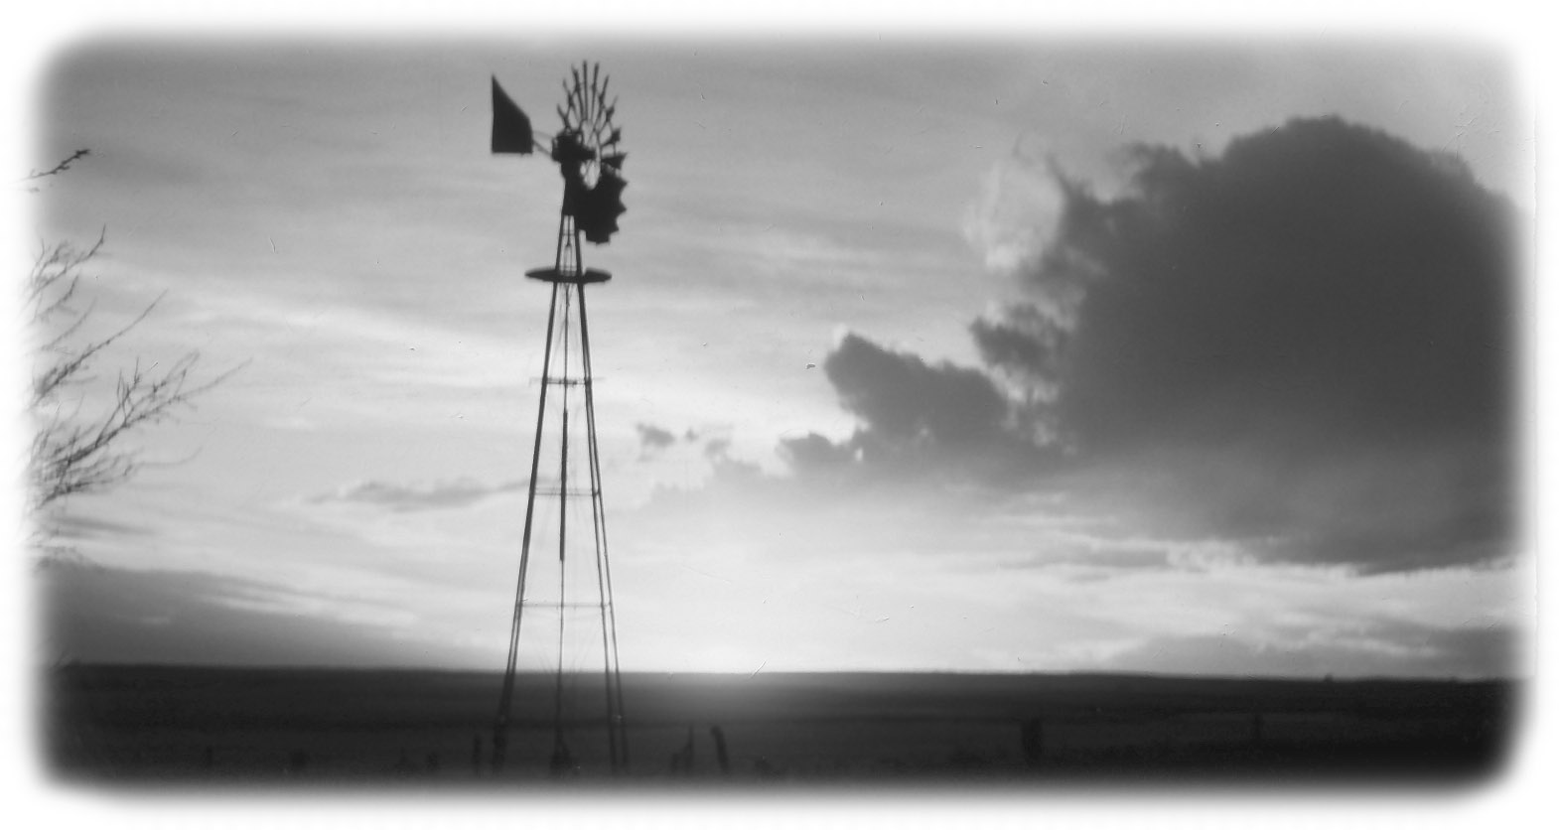
Roy Jacques Windmill in the Sunset Oyen Alberta

No one was home when I arrived but the door was unlocked like so many other western homes this far out of the city. After knocking several times and then calling out I went in and made myself at home. Alma and Brian her son, arrived home shortly after.
They too, had supper in town but at a different place. We settled in for a long evening of chat, as I wanted to know about so many people and so many things. Their crop had been a total disaster as it had been a very poor year. Even what did grow got hailed out, and what was left the grasshoppers got. So you see you need to be a bit gritty here to even survive.
The next few days were windy and very cold. Every night there was a glorious sunset followed by a clear cold frosty night. I remember taking a picture of a windmill with the sunset beyond; I will share it with you here.

I visited with many old friends, the oldest being Lorne and Isabelle Sutherland 91 and 94 years old that fall of 2001. I called to ask if I could go over for a coffee with them. She said, “No you must come for dinner.” They were a wonderful old couple with a great sense of humour and struggling to stay in their home as long as possible. I have a great respect for them, as they were the last of the older generation that were there when I first went west.
Since then Lorne has passed away and Isabelle is in the lodge in Oyen.
Brian Bull loves his tomatoes, so that year he planted a huge plot of them of perhaps fifty plants or more. He had watered them with precious water from the dugout until it had run dry. Up until then they had done well, but a hailstorm came and stripped all the leaves off the plants. Along with the hail came a lot of rain so the plants leafed right back out and then grew a vast crop of late green tomatoes on very stocky green looking plants. This left poor Brian in total frustration, as it was late in the fall and he needed a couple or three weeks of sunshine and warm weather, then he would have tomatoes galore. In mid October it was windy and cold and frost every night so we went out each evening at sundown and covered the plants with a tarp to save them for yet one more day. I understand they picked them green and took them to the house to ripen and for a while Brian and all his friends ate tomatoes at every meal.

One evening Alma’s daughter Barbara came to have a visit. I noticed she and her mom in deep discussion in the kitchen. Then Alma beckoned me to come into the dining room where she led me to her buffet. Opening the glass door she pointed to a set of crystal, a tall water pitcher and glasses. She asked me if I recognized them,
I said, “I said yes they use to belong to my Aunt Rosena.” When Aunt Rosena died Alma bought the crystal at the house sale. At that time she thought she would someday give them to Barbara. But now Barbara thought they should go back to my Aunt Rosena’s family. Long ago my dad and mom had driven west in their mobile home and took my sister Jean’s daughter Nancy with them. Nancy and Barbara got to know each other and so she asked me if I would give this Crystal to Nancy some day. I was overjoyed with this gift to bring home. Now you will understand when I say I feel like family. For now I have the Crystal in my cabinet, but some day it will go to Nancy to be handed down in her family. I will be sure to write down a bit of its history to go along with it. I know my Aunt Rosena would be very happy if she knew about this.

There is so much I could tell you about this place and these people, as they were so much a part of my life in my teens and twenties. I worked hard all day, and then I sat for hours in the evening listening to the stories the older folk would tell me. Other times we would gather around the piano singing songs in the evening. Later we all sat together at the kitchen table for coffee and goodies before heading for bed. We had the kind of bath every Saturday night that kept us clean for a week? On Sundays I visited my inherited Uncles and Aunts, who fed me as if I were royalty; such was life as I remember it so many years ago. It was hard to say good-bye to, such good friends - - - or “family.”

When you’re a long way from home, saying good-bye to good friends is never easy. I remember well when I use to work for Alma’s father-in-law Harry Bull. He would speak to you well before the time of your departure and then go for a walk in the garden as he was just not good at saying bye to those he loved. When I questioned it, they told me,
“Dad does not like goodbyes.” Being English, shedding a tear would not be proper.

I have a long time friend Grace Snell who lives in Acadia Valley perhaps twenty miles south of Bulls and I was to call for coffee before I left for home. Grace and Lenora Oddie of Pincher Creek grew up together (on horse back) here in the Oyen Country. Lenora had come up the night before to visit Grace, so I was to have my morning coffee with my two lady friends. This added a nice touch to my final farewell to Alberta.
Back on the road I travelled south on highway 41 on what they call the “Buffalo Trail.” It is through very dry country north of Medicine Hat. First you pass over the Red River and later the Saskatchewan. This route bypasses the Canadian Force Base at Suffield, which use to be called “The British Block” and it was where they kept the prisoners of war during the Second World War. After the war some veterans eyed all the empty grass on which only antelope were pasturing. So they cut a gate in the fence and drove their cattle in. The army turned their head as long as they hired someone to herd the cattle and keep them away from the base. I fondly remember those wonderful days I spent riding a horse all day long herding cattle with a friend Deke Sutherland down in the British Block - part of the past, I will treasure.

The highway arrives at the Trans-Canada highway just east of Medicine Hat. I had hoped to make it to Winnipeg that night but as I drove on into Saskatchewan I began to feel tired. I had worried about this before I left home, but this was the first time while driving on the trip it had bothered me. So I pulled in on a vacant garage lot away out in the middle of nowhere and had a sleep. I was rested and back on the road, but I realized that I was not going to get anywhere near Winnipeg that day. As it grew dark I came to the town of Moosomin, which is in Saskatchewan but near the Manitoba border. Many years ago when I was on the way west with four others we stayed in this town overnight.
While it had grown a lot since then it is still just a small prairie town of a few hundred souls, very much like so many others I had just travelled through. One of the first few motels in town was all decorated up for Halloween, pumpkins and corn stalks witches and gravestones all under coloured lights. To me this said, that these people were a working part of this community, and they offered you perhaps just a bit more. Then the name of the motel was “Prairie Pride Motel” and I could not help but notice it. These people had pride and they showed it. When I registered, I was really surprised that they only charged $39.95 plus tax. This was by far one of the best values I had on my trip. Then came more! They served you breakfast in the morning. Most of my motel bills were in the $58.00 to $65.00 range, except for the northern cities like Grand Prairie and Ft. McMurray which were ninety to well over one hundred dollars.

I would ask for a single, but many tried to sell you a double first, as it is usually about ten dollars more. Then if you said “No” they would look again and say,
“Oh just a minute, there is one single left.” It was always their last one? When you entered you would find two beds. Many of these motels did not measure up anywhere near “The Prairie Pride.” Across the highway from the Prairie Pride was a brand new Dairy Queen restaurant so as it was handy I had supper there.

In the morning I packed my bags back into the car and decided to try the coffee. When I entered the office there was a man behind the desk.
He said, “My wife tells me you are from London Ontario so I wanted to meet you, and thought we could have breakfast together this morning. You see my mother came from Woodstock Ontario and right now she is down there visiting friends and family.” It seems he was born out there and had never been east but his mom talked about London and Woodstock, and many places in the area. So he felt he would enjoy breakfast with me.
He offered coffee and orange juice, two slices of toast and your choice of four different kinds for home made jams. If that didn’t please there was a basket of muffins. Now nowhere on my trip was there any place that came near to the value and the hospitality of “The Prairie Pride” but his mom came from Ontario, so what would you expect of the son, of an Easterner? When I left he gave me a pad and pen, compliments of “Prairie Pride.”
During the night a snowstorm had passed through Manitoba and the fields had a light dusting of white stuff. I found out later that this same storm went all the way through Northern Ontario and on to London. It was the first snowfall of the season.
I arrived in Winnipeg about noon, and went to a Tim Horton’s to eat. The manager there kindly called my friend Jerry to let him know where I was. Jerry said he would be in the downstairs entranceway waiting for me, so I could put my car in the Underground Parking again. It would not be wise to leave your car out at night in downtown Winnipeg.
It was good of Jerry to have me stay a second time. He knew I needed the break for the long drive home through Northern Ontario. So far I had been standing up to the driving really well, actually better than I had expected. I told Jerry all about my trip since I had left him. That afternoon we went shopping in the Bay and a mall all connected to Jerry’s penthouse. You can walk inside to quite a number of stores and business places or cross the street in overhead walkways. Then there are many stores adjoined to one another from the inside. Thus in winter if the weather is bad you have no need to go outside, and that in Winnipeg-like winters is a real plus.
In the evening we found ourselves once again walking along the Assiniboine River, only this time walking upriver, west on a gravel-packed path, past great pillars and under bridges, the river itself looking quiet and gentle in the evening. Many people walking looked like tourists, and others with dogs would be local. We walked by the Fork Theatre and we could see the Fort Gary Hotel with its revolving restaurant on top. From here we had a great view of the downtown. We could also see the old Union Station with its green copper dome. It seeps in memory for me of other times, when I was so very young and arrived in Winnipeg on the train fresh from the farm, with a guardian angel looking over me.
Soon we came to a wide set of many steps leading up the hillside to the parliament buildings. Atop the steps is a giant statue of Riel, probably the most revered hero to this day in Manitoba and the west. Sometimes I look at history feeling great shame, sadness and deep regret, as we cannot, just wipe out our yesterday’s mistakes, yet many keep the pain alive and pass it on to their children. Thankfully in time we all learned the truth, and that was, it was our governments blunder that created a historic tragedy, one we cannot live down. Riel’s statue stands rightfully on the parliamentary lawn in Manitoba capital, a haunting reminder to us all of past mistakes.
I was back on the road again and soon into the lakes and forest of Northern Ont. Snow was under the spruce and pine trees where it was sheltered from the sun. Now I’m going home. There were feelings of a deep satisfaction, of happiness, and at times melancholy.
Now the north was in full fall colours, but it was mostly in shades for yellow, bronze, brown and gold for that first day. I made great time and my Mustang thundered by Thunder Bay and far beyond Nipigon to Schreiber where I stayed overnight at “The Villa Bianca Inn.”

Back on the highway the next morning I had some breathtaking views of the shores of Lake Superior, many deep bays of shallow inlets edged with fall colour and those awesome waves coming in off the lake. Here again was our maple, which was sadly missing in yesterday’s drive. I drove east past Marathon where the highway turns inland and there are fewer maples, but near Wawa the maples are back with great gusto and a great show of endless parades of colours so wondrous, so splendid. At times I rein in my Mustang and take time to take some pictures to look again and to really appreciate it.
As you near Sault Ste. Marie, the great show continues and there are even more Maples enveloping the highway on either side. On this trip my timing could not have been better. Out on the prairie or in the mountains, or back here in northern Ontario, my Guardian Angel has certainly worked overtime.
I really had planned on staying overnight somewhere and driving on to London the next day, But when I arrived in Parry Sound about seven PM it seemed I had a choice of my own bed or one more night in a motel. I had driven to my sister’s cottage from London to here many times after work so I decided I would head for home. I made good time and soon took the turn off from the 400 highways to Horseshoe Valley and on to Stayner.
I had taken this old Ontario Atlas car book along, but it was ten years old. It seems our good government has gone ahead and changed the numbers on many highways then forgot to put up new signs to guide us. This of course is to confuse us. Confused travellers take more time en route to get from here to there thus spending more money, and this means more tax dollars. Anyway I was soon driving south (I think it was south) getting more confused as the miles passed by. I entered village after village with no visible sign to tell me where I was. As almost everything was closed I didn’t want to knock on someone’s door, besides you know how we men hate to ask for directions. It’s not a manly thing to do?? If I can find my way all across Canada I should not get lost at home.
I came to a corner in some unknown village and there was a donut and coffee shop open, so I had a perfect excuse to stop, using the coffee and donut as a cover up. I asked a man sitting there if he knew this country, and he did, so I showed him my map book and after looking at it,
He said, “No wonder you’re lost. All the numbers on the highways are wrong.” So he set about drawing a map on the back of his paper place mat. The waitress came along and added a few more lines to it. So I thanked them and was soon back driving in another direction, which seemed all wrong to me but then was it the map, the coffee or I.?
Soon I came to a biggy corner and the sign said in big letters, “to Waterloo,” but an even bigger more impressive sign said, to the 401. Well naturally I thought it meant the 401 was closer or just around the corner. So I turned that way. I drove for miles and miles always expecting the 401was just ahead. Little did I know I was driving in more or less an eastwardly direction towards Toronto to get to the 401. I did get there but it was a long trip from there back to London hemmed by giant transport trucks all driving like maniacs. Ah! London and Home but first I stopped at the all night A&P to pick up milk and bread and then home to my own bed. Ah! It never felt so good; I hope you have enjoyed travelling along with me. It was a great trip, but it was good to be home again
Time For Another Kitty
Late in the fall with the prospects of a long cold winter ahead of me, my thought turned to getting another cat. I decided to visit the humane society on Clarke Side Road. There were many sad and pitiful eyes hopefully looking out of their cages at me, saying,
“Take me, take me home, I’m a good kitty.” I chose a black short hair cat about 2 years old, de-clawed and neutered to be picked up at five PM the next day.
The next day was Thursday and I was cutting hair. One of my customers, Jack Thompson came in for a haircut and while I was cutting hair he asked me if I was thinking of getting another cat anytime soon. I told him it was funny that he asked, as I was to pick one up at five o’clock that night at the humane society. He had a few snap shots with him of a cat that had come to his place a few weeks ago and stayed for lunch. It apparently liked it, so stuck around on the front porch. They let it in to eat and then turned it outside again hoping it would find its way home. But by now the nights were getting cold and they were letting it in for the night and putting it out in the morning. They liked it a lot but his wife Jean was a bit allergic to a cat so they were looking for a home for it. The pictures he showed me were of a nice looking cat but long and lean. He was both de-clawed and neutered. I told him I would come over and take a look at it.
I took the cage along with me just in case I liked the cat, but I really did feel I would prefer the black cat at the humane society. When I arrived the cat was sitting on Jean’s lap at the far end of the chesterfield. I sat down on the other end where I could get a good look at it. The cat got up and without hesitation walked down the chesterfield and settled down on my lap and looked up at me and said,
“I’m ready whenever you are, so lets go home.”
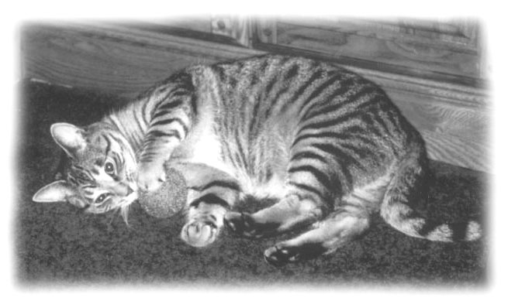
I Still Have My Second Mandy 2005
He’s a Puuurfect Cat
So how could I resist. Jack told me if by chance I didn’t want it after a few days to just bring it back. I brought the cat home and he didn’t make strange at all. He spent perhaps twenty minutes going from room to room to check things out and then hopped up on my lap and I could feel a thankful vibration, a big, big song from his thankful heart. He knew he had found a home. He is a grey and black Ocelot cat but I call him a “Lap-cat” as whenever I go to sit down he comes on the run. Many times he flies onto my lap even before I hit the seat. At first it seemed a bit much, but now I would miss him if he were not there.
He watches a lot of TV so I try not to watch too much violence. He does get upset when animals fight. Sometimes when there are cats, dogs or birds on the screen he jumps off my lap and sits up close to the screen on his hind legs looking in as if ready to jump. He proved to be a very loving cat, to me and to all my friends who come to visit. He loves company. While trying to think of a proper name for him I would forget and call him Mandy. Since he started to respond to Mandy I decided to keep the name although he is a male cat. .

Don The Computer Guy
Over the winter of 2002 /2003 I was having more than my share of computer problems. While trying to explain a problem to my friend Nevol Huddleston, he said he would ask Don Peever, a friend of his at work if he knew how to solve it.
Don works at the hospital and he loves to play with computers. Rather than try to answer the problem to Nevol he said he would come over and take a look at it. He arrived and in a few minutes my problem was solved. However as everyone knows when you are learning how to handle your computer you are going to mess up time and time again. So I found myself forever calling on Don to see if he could come over and help me with yet another problem.
I was embarrassed at the number of times I asked him for his help. I wanted to pay him for his service, but he would not take any money. So I invited Don and Nevol to go out to lunch and I picked up the bill. When I drove Don home he gave me a lecture saying that he paid his own way and I was not to do that again. He claimed that he enjoyed solving computer problems and all he wanted from me was my friendship. I realized then I had found a good friend.
At Christmas time I thought I would surprise him with a crisp one hundred dollar bill in a Canada Trust envelope along with a note thanking him for all the help he had given me the past year. Certainly he had earned it several times over, but he simply refused the bill on moral grounds, saying he just could not take it.
He told me he would like to look after my computer for me, but if he was to do this, he didn’t want anyone else to touch it, so things would stay as he set them.
Don truly has a great gift and he is exactly what every senior citizen needs when they go to buy their first computer, a computer guy along with every computer.
We work well together. I mess up and he fixes.
Life Moves On - New Friends – Old Friends
The years have rolled by and I find myself looking more often at the obituaries than the funnies. It is sad and perhaps eerie to see the names of people you once knew as capable, strong and vibrant leaders of the community listed among the dead. Perhaps the one good thing about getting older is that it is now easier to make friends. People trust older people, letting down their guard and enjoy a chat. It seems the people who live in condos tend to move more frequently than those who live in houses, thus it is always sad to make a new friend, only to find that they are moving to a house, out of town or even out of the province.
My friend Bonnie Holten had told me about her husband Bernie’s failing health. You see Bernie was born with Spina-Bifida. As a baby he was not expected to live. However with determination to succeed he had a very successful life and for a number of years was purchasing manager for Benson Hedge Tobacco Company before they shut down. Later he worked in Timken Bearing Company in St Thomas where he met and married Bonnie.
His health began to fail in the nineties. About the same times Bonnie also had health problem, so they were forced into early retirement and at that time bought a condo here.
Bernie had his mother, Ruth Holten moved in down from me. She is a great neighbour and every now and then arrives at my door bearing gifts of homemade goodies. It’s her motherly instincts; she can’t help herself.
In the few years I lived here I came to know Bernie well as I went down to their condo and shampooed and cut his hair and trimmed his beard for a number of years. Bernie’s health continued to worsen and in 2002 he was confined to a wheel chair. In January 2/ 2003 he passed away. Bonnie’s health continues to worsen and in the fall of 2003 Bonnie sold her condo and moved to an apartment in St. Thomas to be closer to her sister Jackie.
Ken and Bonnie Burke had moved in down the hall from me and we became good friends. Ken was working at a plant in St Thomas and drove back and forth every day. Bonnie it seems kept busy looking after her family and Ken, gossiping with the neighbours and buying yet another pair of shoes. Ken had a new motorcycle his pride and joy and he and Bonnie would often go on long rides out into the country. Their son also had a bike and often went along with them.
In 2002 they sold their condo here and moved to a house in St Thomas. The following year they moved to New Brunswick to where they originally came from. They have asked me to come down and visit them; some time soon I must do that.
In January 2004 my good friends Mike and Charlotte sold their home in Dorchester and bought a place in Fenwick. I am not at all happy about that, as I liked to have them close to me in Dorchester. However Mike has bought and sold places all his life. It seems he always hopes the next place is going to be home, but for some reason it eluded him.
At the time of writing May 21, 2005 Mike called me to tell me he had just sold the place in Fenwick after spending almost a year and a half remodelling it. He now plans to return to BC in search of his dream. Most likely to Osoyoos or the Okanagan valley area. I am glad I know where I want to be….here in London.
I feel that the years have been kind to me, as this fall Oct. 17th , 2005 I will be 77 years old. I don’t feel at all old.. I am contented with where I am in life and what I am doing. After all these years of travel it is important to arrive at your destination. I feel it has been, but a journey from 1928 until now 2004. A long wonderful journey. Now don’t write me off just yet; I plan to be around for at least another twenty years, err I feel I’m almost at my best now.
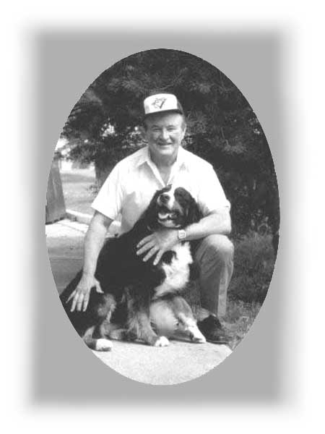

Friends
Jack and Daisy

For a number of years until she passed away
Daisy The Burmese Mountain Dog
At Susan’s Pet Grooming Shop, next door
Came to visit me at the shop every morning
“I think it was love”
Chapter 10

A TIME TO REFLECT

There are times when I sit in my lazy-boy in a silent world and contemplate. My thoughts wander back over the years to a time, a place or to someone I once knew, perhaps we shared a few moments or a few years. We each left our footprints on the sands of time. We can reflect on the past, but time itself marches forever on. I have found that life is but a journey that takes us from here to there. Life is also much like an echo. What you send out comes back to you, of that I am very sure. I am also aware that while I lost a whole dimension of life when I lost my hearing I was given something else in its place - eyes that both see and understand perhaps better than the average person and a memory that as yet, has not failed me.

People who hear seldom give thought to the wondrous gift they have; in fact they spend much of their time trying to turn it off. Thus they seldom really listen to what they hear, so turning themselves off, becomes a way of life for them
If they were to lose their sight they would listen to understand better what they hear. Thus when you lose your hearing, I believe you see more clearly and understand better what you see.
I know many of you will wonder how I feel about my deafness. I can truly tell you that at this time in my life I don’t waste much time thinking about it. I have accepted a Silent World, to me it is now what we call spilt milk. I have found my own ways of dealing with it, while it is not always easy, I have learned to cope.
However every time I see a deaf child my heart goes out to him or her, as I know the Silent World they are going to have to learn to live in. It is a world, which they will have to adjust to, as the world will not adjust to them. They will always have to try just a bit harder in life to prove themselves, as few people will accept them as equals. People seem to add the stigma of not being too bright to deafness. The deaf will always have to go that extra mile, as nothing much will come to them if they don’t do everything in life just a bit better then average.
Your friends and family will find it difficult and time consuming to visit or to communicate with you. People who claim to be your friends may wish you well but will not take the time to learn how to make a Bell Relay System (BRS) call. They don’t seem to understand what a blessing the Bell Relay phone system is to the deaf. To us it opens a door from a Silent World to the real world, but to many it is just a complication like a computer and they don’t feel they need it. So they leave you on your own in your Silent World.
In reality it seems, if you want to stay in touch with someone it will be up to you to make the phone calls and do the visiting. This sometimes can hurt your pride, so perhaps you have to develop a wee bit thicker skin. Whenever someone actually reaches out to you and wants to be your friend and keep in touch you will know he or she is a very special person. In them you have a friend indeed..
For the most I feel I have accepted my deafness as fate as I have had to so that I could get on with my life. Thus when I am alone in my everyday living I find I can all but forget that other people have hearing. Then something happens that brings me back to reality and I feel, well… lonely, lost, something is amiss. It was Helen Keller, who said,
“Blindness separated people from things, deafness separates people from people.”
From my personal experience I know it is true I have friends and family members I wish I could be closer to but they are busy and you only slow them down; thus your deafness separates you from them. It is wise to protect yourself. Never let your expectations or dependency on others rise too high, then you won’t get hurt or disappointed when you are left alone, overlooked or not included.
Everyday I count my blessings as I see many neighbours, my friends and family with real problems both physically and mentally. It is then I know I am blessed as I have health and security, and some true friendships old and new. This is something neither better hearing nor money can buy.
Life is but a journey that takes you from here to there. During that lifetime, every thing you have ever done, every one you have ever met, every experience you have ever had, rubs off on you and makes you, who you are. We in turn rub off on others, making life much like an Eternal River with no end.
Look at your grandchildren or the children of all those you have loved and rubbed shoulders with. It’s not only the way the children look but also the way they think, the way they talk or walk that reflects who they are. During their lifetime they will be moulded by all the people they come to know, by all the things they have ever done and all the experiences they have ever known from their past, into their future. Life on earth as we know it will end but the Eternal River flows on.
On the east side of Mitchell there is a beautiful large green cemetery. It has many trees and manicured lawns. There within a stone throw of my dad and mom’s old house on Arthur Street is a gravestone with my name on it.
When I started to write a few lines on my family history for my memoirs I had no idea that it would end in a book.

A Special Thank You
Special thanks, to my neighbours Fred and Muriel Halle for their encouraging words, which kept me pounding away on my computer keyboard.

To Don Peever, for the excellent and tireless work he did on my pictures. I know he was aware I would never ask him to do anything he could not do. Thus I often pushed him into doing the impossible. You did a great job Don, thank you.

Then a special thank you to Ralph and Eleanor Smith of Goderich for doing the proofreading of my book. For their guidance there suggestions and their encouraging words. You never failed me. Without you I would not have got the job done.

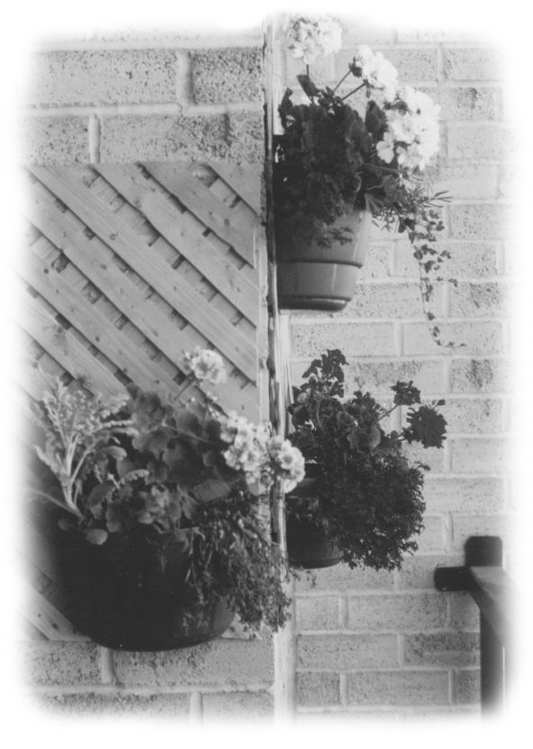

Jack’s Balcony Wall
Epilogue
The Long Winter of 2005

Writing this book has been a great challenge to me. While in many ways I am happy to have it finished, I have to admit it has been a labour of love. Perhaps the timing was also good as this winter I found out I have to start to watch my health.

I may be deaf, but throughout my life I have always enjoyed great health. As my oldest niece Linda Canniff told me just recently, she always thought of her Uncle Jack as being invincible. Nothing could happen to him or keep him down for long. After weathering my growing up years, and my deafness I believed it was true, somehow I would always manage to bounce back on my feet and come out on top. For some time now I was aware I had diabetes, but my sugar count reading was always what I thought acceptable. In early 2005 something happened to humble me, to remind me just how vulnerable we are to life’s problems In other words welcome to the real world, we may be lucky for a time but few, if any of us can escape it forever.

It was January of 2005 and for the third time in the last six months I had a sty on my right eyelid. I had read in a book that the only way to rid yourself of a re-occurring sty was to have surgery. I asked my family doctor about it and he flatly rejected the idea of surgery. He wanted me to continue with pills and eye drops.
Later, on a Friday night in early February, I could not sleep and I was walking the hall in pain. The next day two neighbour ladies came knocking on my door to find out just how bad it was. They wanted me to let them call the Ivy Eye Clinic.

I think perhaps my neighbour Muriel poured it on telling them I was already deaf and she didn’t want to see me lose an eye. So they said to rush me in right away. Ann Barns, another neighbour offered to drive me in. Within an hour I was flat on my back on a table, with two doctors peering into my face.
I remember one was an older doctor who coached the younger doctor about the procedure and what had to be done. Then he left the room. The younger doctor seemed very confident and I rather liked his style. When he went to put a needle in my eye he kindly told me it was going to hurt, but is spite of that I was not to move. I reasoned, that this made a lot of sense.

After he gave me the needle he left the room. Ann who had stayed with me and was seated close by held a note over my head saying, the doctor said he would be gone for ten minutes and when he returns he will give you a second needle.
The doctor returned and began slapping towels all about my head with wild abandon as I lay there thinking about that second needle, but it never came.
As I looked up through my bad eye I could make out that the doctor had an instrument in his hands much like an open paper punch. It had an open eye on one end and a hammer on the other. He slid the eye in under the eyelash and they turned on a long screw which pulled the hammer down onto my eyelid and pushed it through the open eye of his instrument. Then all at a sudden he flipped the thing up on my forehead turning my eyelid inside out ooouch!. It hurt a lot and I was very uncomfortable.
I still wondered about that second needle. Would I not feel it?. Was it possible he had forgotten it.?
“No no, after all this was, ‘The Ivy Eye Clinic’ and world renown.”

I still had blurry vision and much feeling, but I knew very well what was going on. The doctor took his knife and much like my mom use to cut the extra piecrust off the pie pan, the doctor cut the flesh off around the sty. I felt each and every cut, cut, cut, and I guess half way through I let out a low moan and Ann heard the doctor say ,
“Oh I believe he is in pain, I better give him that second needle.”
There are times when you should never say,
“Better late then never” and this was certainly one of them.

When it was over he slapped a huge amount of bandages and gauze and tape on my face making me look as if I had one of those extreme makeovers.
Ann needed something to steady her nerves after trying hard not to watch all this .Thus we ventured into the hospital’s Tim Horton’s. Somehow I fitted right in there with other patients all about me. Much more so than I would at just any Tim Horton’s out there in the city.

I slept very well that night. Perhaps it was just the feeling that it was now over and all I had to do was heal. The next day I had one of the world’s greatest looking black eyes. But at this time of my life I no longer take any pride in a black eye. It seemed the pain got worse over the day and the eye looked swollen, red and angry. The next night after the late news I decided I just had to get out of my condo for a wee while as I knew I was in for another sleepless night. So as Tim Horton’s is just across the street I thought I would do something really sinful to get my thoughts off my pain. I would walk over to Tim Horton’s for a coffee and a donut.

However when I went out the rear door I found out it was pouring rain. As I had been driving up until now and it was just before midnight with little traffic, I was sure I could drive over without a problem. I was very careful backing out of my parking space as I noted I could not see well to the rear or to the side. I was driving south off the lot when a small car backed out suddenly right in front of me. I braked fast but I was sure it was going to be too late. I sat still not wanting to take my foot off the brake as I might move ahead and come in contact with the car. While I had the right of way there is not much comfort in being right in such a situation. The car moved forward and I drove on. I will never know who it was.
Now a strange thing happened! Half way to the street, everything turned grey as if someone had turned off the light switch. I stopped the car not knowing what had happened. It cleared so I thought I would continue, but in that instant it went grey again. I knew something had happened but I didn’t understand it. I thought I better turn around and park the car. It was then I realized I could not see to the side well enough to turn around. It seemed I could only see straight ahead. So I reasoned I would drive to the street and make a u-turn and drive back to my parking spot.
I tried to do this but I was afraid to make that u-turn as I could not seem to see behind me. In the end I drove straight ahead through the green light to Tim Horton’s and had my coffee and donut and then back home and parked the car. That was the last time I drove my Mustang for weeks. It sat on the parking lot all winter.
That night the pain was so bad I could not sleep. My neighbour Muriel checked on me the next morning and called the Ivy Eye Clinic again and they said once more to bring me right in. Again it was Ann who drove me to the hospital. Two doctors looked at me and told me I had a stroke. They made an appointment for me to see a doctor, a specialist in ophthalmology at the University Hospital the very next morning.
He turned out to be a very grumpy little old man who seemed very unhappy with his job and his earthly burdens. His hall was full of sore and sad-eyed patients all … …..waiting…..waiting..

When he found out I was deaf he would not even look me in the face. Here was a man who had earned a wall full of plaques in his lifetime, but had never learned how to be comfortable with a deaf person. How sad. Whenever I spoke to him he answered by speaking directly to Ann. It was easy to see he was uncomfortable and had no patience for deaf people. He said that it was as stroke and he would arrange for me to have an MRI as fast as possible by putting me on an emergency list. I was to come back to see him on the Friday, three days hence.
You can imagine my surprise when I got an early morning phone call from the University Hospital the next morning asking me to be in at 11:30 am for my MRI.
Of course I said yes I would be there, but I had no idea how I would get in unless I took a taxi. Again it was good neighbours that came to my rescue. George and Betty Vezeau offered to drive me in. George had an MRI a couple or more years ago so could lead the way. They would stay with me and help me through it.

Two days later Ann drove me back to keep my appointment with the specialist. This time he was just a bit better. He told us that because of the stroke I had what is called 3rd. nerve palsy. Which means the 3rd muscle behind the eye is paralysed.
This time the doctor did put his hand kindly on my shoulder and said,
“I know you’re worried about this more then other people might be because of your hearing loss, but I assure you it will heal, although it will take at least six weeks, and then you will have to upgrade your glasses.”
The six weeks were of hard cold winter weather, which seemed forever in passing. I was house bound and bored to death. Driving the car was simply out. I could not see to use my wheels to go anywhere,. and the weather was too frigid cold to go out walking. I could not watch much TV,. and I had to use the computer sparingly. Although it was not exactly safe for me to walk about to the local stores I managed to keep things afloat. It was dangerous for me to go shopping in stores as it seemed I would cut corners a bit too short and bump into things. I’m sure the next day scratch and dent sales had something to do with me being in their store.

I have been back for my six week check up and it seems they think everything will turn out ok in the end. This week I was in for my eye check to upgrade my glasses to the tune of $350.00 just for the lens, o-h-h-h the pain. It seems the muscle behind the eye has been pulled and I need these special lens to help pull the eye back into focus. My new glasses would be ready for me in one week.

The week went by and the time came for me to pick up my glasses. Again it was Ann who drove me to the clinic. For so long now I had been seeing double, I was beginning the think I was rich as it seems I had two of everything. I had two Rio red Mustang cars and two very large plump tomcats and two rather lean wallets all of which made me, oh so comfortable, amid all of my new-found blessings.

I was not sure what to expect of my new glasses, but I had hoped for a miracle.. When I put them on my prayers were answered, I had my sight restored instantly.
I was handed one of those laminated pages to read. My eyes roamed from the top of the page to the bottom and the printed words leaped out at me all the way down to the small print in the very last line. I read that line off flawlessly. It seemed every one was surprised. Didn’t they think I could read?

Tuesday April 12th, 2005 I received word that Mrs. Carl Eisler had passed away. That was the mother of Bruce who went west with me in the fall of 1955. It was his sister Carolyn (Mrs Earl Paulen) who played the piano for me when I sang. There was a second brother Hugh whom I never really got to know very well. Visitation would be at the Lockhart Funeral Home on Wednesday the 13th. This would be the first time I had driven the car since the night of my stroke.

It went very well, and I was both pleased and surprised. The next day I even took the car to the car wash and got the winter grime washed off. There are times now that I almost forget I had a stroke or trouble with my eye. Life is good again.
Every day I greet the morning with contentment as I know I am one day better.
Spring is in the air and it is a time when all life is renewed. I feel in tune with nature as I watch yet another spring unfold. This one has a special meaning to me.

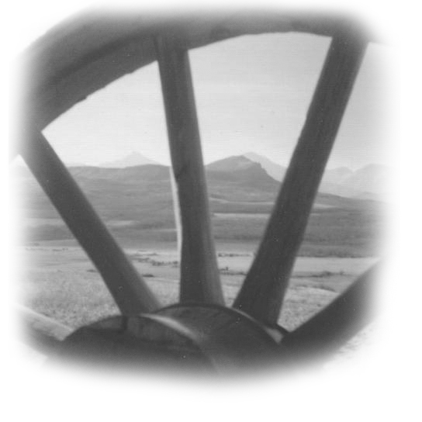

. The End

But boys cannot appreciate their priceless joy until too late

And those who own the charms I had will soon be changed to men;

And then, they too will sit, as I and backward turn to look and sigh

And share my longing, vain, to be a carefree boy again.

By Edgar Guest

