During the war brush cuts, bush cuts and crew cuts were the hairstyle. The army, the navy and the airmen brought this style home with them and they wanted their kids to accept the same style of haircuts. When I started cutting hair I would say well over half of the cuts were brush cuts or bush cuts. Brush cuts were flat on the top with the front standing straight up and longer at the crown. Bush cuts followed the shape of the head; a crew cut was sort of in-between. However change was on the way and not for the best. Kids started to reject their father’s short hairstyle and I had many a father-son disputes in the shop, usually ending with the father pushing his son into the chair telling him to,
“Shut up and get in the chair You’re getting a haircut.”
I would sometimes ask them to settle this dispute before they came into the shop, as it was not a pretty picture. More than once I cut Scott Barber’s hair the way he asked me to and when he got home his father would send him back to the shop to get more off. I remember Scott holding back tears and saying he would be glad when he was out of school and on his own as then he would have his hair cut the way he liked it. I was caught in between and I could not take sides or I would lose a customer one or the other.
I remember Cliff Inch, who’s father owned “Roy Inch and Son” heating and cooling and appliance dealership next door coming in to me telling me his son was coming home from University on the week end. He would be in for a haircut in the morning and he asked me to cut the son’s hair very short. I knew there was an on- going problem between father and son over the son’s hair. So I told Cliff he had to talk this over with his son before he came to the shop. Then I would give his son the haircut he asked for. I reminded him that his son was in university and both he and I should treat him as an adult not as a kid.
Jack and Bob Go West 1954
In 1964 Bob Scott and I took a trip west to Alberta in my 64 Ford convertible. First we visited the town of Oyen and then all my friends, the Bulls and the Sutherlands, the Snells and the Quains. The harvest was long off and the good weather prevailed on into fall so it seemed everyone had time for a visit.
I was rather shocked to find that Cameron Sutherland’s wife Lenora had left him and was now in Calgary training to be a nurse. No one wanted to talk about it so I thought it best not to ask too many questions. In this country everyone one way or another was related so they were very careful and kind with their words. Sometimes what they know and understand is more than what meets the eye.
From there we went up to Edmonton where for some reason we each went our separate ways. I was to pick Bob up at the Greyhound Bus Station at 4 o’clock. I remember him saying that if at any time we ever got separated, the person without the car should go directly to the Grey Hound Bus Station and wait for the other to turn up. Little did I know the value of that little conversation as it came in handy later on in the trip.
We travelled west to Jasper Park, wild in its rugged beauty, then south to the Athabasca Falls and on to the Columbia ice fields where we took a trip out onto the ice on one of their track vehicles. We stopped at Lake Louise and then drove on down to Banff. A mountain trip in a convertible gives you a wondrous view from up front and behind and up and down. I believe we had planned the trip to last two weeks and three days so we would not lose too much business at the shop. When I told the Tippings I was going to take this trip they had flatly said,

“No there would be no holidays the first year.” This attitude irked me so I decided to go anyway. Now on the way home I was not sure how I would be greeted when I returned to work. Would I find someone else behind my chair? While I felt pretty secure it did worry me a bit. The last few days coming home were of long days driving and we hoped to make Chicago that night. I remember driving into Chicago with its wide boulevards, signs and bulletins all around me but I was watching the highway number and traffic. In a strange city that alone kept one busy.
We needed a place for the night and as it was late. There were a lot of no vacancy signs out. I spotted an older hotel and pulled in and jumped out of the car to check it out. As I walked past a dark alleyway a man in shirtsleeves came out and put his hand on my shoulder and said,
“Come with me.” and tried to drag me towards the alley.
I threw his hand off my shoulder saying,
“Get your hands off me”
After getting a good look at him I realized he was a cop, but without a hat or jacked on he looked very scruffy, but then this was the sixties and cops and postal workers all looked that way. Bob went to get out of the car to come to my aid and the cop pointed his finger at him and said,
“Get out of that car and I will throw you in jail too”

I realized it was all a bad mistake of some kind, but the cop did not want to talk about it. There was a paddy wagon parked in the dark alley way out of sight and another cop waiting to open the rear door. I was pushed in even though it was already about full with a mixture of black, white and Indians of all descriptions. The paddy wagon was soon on the road and after a short drive arrived at a police station. We were all made to stand in line and wait our turn to approach a window. When I finally got there they asked me to empty my pockets, and they took my name down. If I tried to talk they hushed me up short. They were in no way interested in what I might have to say. It was like having your worst nightmare only this one was for real.
Apparently Bob had followed the paddy wagon to this station and he was on the other side of the glass asking to see me, but they would not let him in to talk to me. I spoke to him through the glass, but there was a lot of shouting and noise and he had trouble hearing me. I lip-read him as best I could. Then I told him to find a place for the night and come back in the morning and see what we could do.

We were taken deeper into the building through several great barred doors. Each had to be unlocked and then clanged shut behind us with much vigour so as to vibrate off the walls and dull our senses of any hope. There was an inner feeling of panic and despair that goes with the loss of one’s personal freedom and also a loss of respect for law.
I was put in a cell with perhaps ten or more people. The cell had a bunk bed on either side so I would guess it was meant for two people. The best one could do was to sit down on the bed beside someone else and try not to take up too much space, as there was not enough sitting room for everyone. There was one black with the rest and us, a mixture, which included several Indians. A couple of the guys were rather brutish towards the Indians and the black guy. All night long there were fights in our cell and the cells about us. Several guys got beaten up very badly and the blood flowed. At times someone shouted for the guards but no one came to stop it. I realized I was in a dangerous situation. Everyone had a bit of a story to tell. When I told them I was a Canadian on the way home from Western Canada they were very disgusted that this had happened to me in their country. They said the police should have understood the situation and sent us on our way. I am sure just being a Canadian that night saved me from getting beaten up.
You see in 1964 there were race riots in the streets of all major cities in the United States, re the plight and treatment of the black people who were fighting for equal rights. We had entered an area of Chicago that was under curfew. You could drive through but don’t get out of your car. It is sad to think though that the police would not use the head the good Lord gave them so as not to do an injustice to innocent people who were passing through. .
Early in the morning we were taken out of our cell and told we were to be leg cuffed in two’s. I noticed no one seemed to want to be cuffed with the black guy so I said to him,
“Do you want to be cuffed to me?” I could see the appreciation reflected in his face. We were all put back in the wagon and drove for miles to a courthouse. Once there the wagon backed up to a door and we were let out and asked to climb a long flight of stairs to a courtroom. One by one we were hauled before a judge that told us something to the effect that we had been found in an area where we should not have been and how do we plead. I remember simply saying,
“Not guilty” and the judge said,
“Case dismissed. ”
I stood there not believing what I thought he had said. Why go through all this trouble for this? The judge looked at me sternly and pointed to the stairway and said,
“Well go.”
I went down the stairway and there was a cop at the door, and I said to him,
“What do I do now?” he said,
“Well if they let you come this far go out the door.”
I replied, “Well that might seem ok to you, but they took my wallet away on me and now I have no money and no identification and I don’t have a clue as to where I am.”
He said, “That’s your problem, Out the door.”
I went out the door and it seemed about half the guys that had been before me had already disappeared. A taxi was sitting there so I went over to talk with the driver, I told him I had to get back to where I stayed over night to get my wallet and what ever had been in my pockets.
He said, “No cash no ride.” I was beginning to love Chicago. He did point to a tall building afar off and said,
“The police station where you stayed over night is in the basement of that building” So I began to walk keeping the building in sight. In two or more hours I arrived back at the station. Already a line had formed at the window where they had relieved me of my wallet. People that had been picked up the night before were now asking for their things back. After some time I reached the window, and the man says,
“Identification”
I said, “Please sir, I need my wallet back.”
He said, “Identification”
I said, “How can I give you my identification, as you took it away from me last night.”
“Well you can’t expect us to just hand over a wallet to you without identification. Why didn’t you at least bring someone down here to identify you.”
“I am a Canadian just travelling through when I got picked up and I don’t know anyone in Chicago except my friend who is out there in my car no doubt looking for me.”
The man looked beyond me and said, “Next”
So I walked out empty handed, with no money and no identification. I was wondering where Bob was with my car. I was thinking that he would probably find out that I was taken to that courthouse and would go there looking for me. So I started walking back to the courthouse. A couple of hours later I arrived back at the court house but no Bob. I talked to another taxi driver and he was sympathetic and said he thought I should go back to the police station again and try to talk them into giving me my wallet. He offered to drive me back, saying if I got my wallet I could pay him if not it would be OK. At last I found a civil minded man in Chicago.
By now the line had gone and I walked up to the window and the man said,
“You again”
I said, “Please sir, I have to have my wallet as there is a taxi outside waiting on his money, if I don’t pay him are you going to throw me back in jail? Look I can tell you every thing that there is in that wallet, there is even a picture of me in it.”
Reluctantly he got my wallet and piece-by-piece I told him what to look for in it and of course it was all there. So he handed it to me and as much as told me to,
“Go and sin no more.” I have never had any urge to go back to Chicago.
I paid the taxi driver and thanked him. Then I saw a young policeman standing beside his car so I walked over and told him my story. He said it made him angry, as it seemed the different police stations looked at the curfew as a contest to see which area could round up the most people and throw them in jail. He admitted that they should have explained the situation to me and just put me back in my car and sent me on my way.
I told him my friend would be out there looking for me but Chicago was a big place. He said, “If I wanted to say the car was stolen they could probably pick it up in minutes, but your friend would have to go to jail over night and appear before a judge tomorrow to get it straightened out”
I didn’t want to do that so he told me he would radio a couple of his buddies and see if they could help keep an eye out for him. Then he asked where I would be so they could contact me. A suddenly thought came to me and I said,
“At the Greyhound Bus Station”
So I went to the Greyhound Bus Station and sat near the main entrance, I noticed a Burns Guard watching me, and finally after a few hours he came over and asked me why I was hanging around. I told him what had happened and that I hoped my friend would think of coming here to find me and if not that the police might find him and send him here. He told me it was his job to keep people from loitering so asked me to move around a bit and he would ignore me.
An hour or two later he came to me and said, “Are you Jack Cooke?”
“Yes”
“Your friend is waiting for you at the foot of the escalator. ”
Never in a lifetime was I so happy to see anyone. Apparently Bob had found a place to stay over night and then over slept in the morning. He arrived at the police station after we had been taken to the courthouse. Then he had trouble finding the courthouse and arrived after I had left. Later in the day he had remembered the conversation we had in Edmonton about if we ever got separated to go to the Bus station and wait, so there he was.
I had not slept a wink all that night in jail, as I was afraid of being mugged. Then I had been under terrific strain all day and I had walked for miles. Letting Bob drive I climbed into the back seat of my car and I went right off to sleep. To this day I do not remember one mile of that trip from Chicago to Port Huron where Bob woke me to tell me we were at the border. After crossing the border I went right back to sleep and Bob woke me up again when we arrive back in London.
We arrived home in the wee hours of the morning and the next day we both were supposed to be at work. We had planned it so we would have a day of rest before going back to work, but as they say, “The best laid plans of men and mice.”
The Tippings, while glad to see me back from my holidays were quite upset with me. To make matters worse I had taken my barbering tools home for safety so they were not at all sure if I was coming back to work in their shop.
It was that morning that Jeanette told me that she was expecting their second child Allen and that she didn’t need this kind of thing happening to upset her.
Everything settled down, and my customers were glad the shop was open again.
“The Crazy, Crazy Colourful 60’s”
1964 over into 1965 saw haircuts getting much longer and a lot less clean. Teens and twenties everywhere wanted to distance themselves from everything adult and from parental authority, army haircuts and standard clothing. They started wearing snugger jeans with sleeveless tops or brightly pattern shirts. Teens rebelled against haircuts! They dropped out of school and church and many left their home. The downtown streets of London were packed with hundreds of young people from the city itself, and from the towns and cities near and far and even out of province. Nighttimes would find the entranceways of stores crowded with overnighters. Soon they became known as Hippies. Few homes were left untouched by this new craze and culture. The Gypsies of the sixties were colourful, defiant and above all free.
This of course was not good for the hair industry, for as the teens won their battle to grow hair the barber’s income took a fast dive. I remember a father bringing in his youngest son of four boys. This one had been my paperboy and I had learned to like him long hair and all. The father pointed to the chair as the boy stood back defiantly. The father said firmly,
“Get in the chair.”
“ I don’t want a hair cut.”
“Shut up and get in the chair. You’re going to get a haircut,” the father said.
This kind of situation makes for giving a very hard haircut, as a person who does not want a haircut does not help you by working with you, in fact they work against you. That is you push the head slightly aside so you can see to work better and it snaps right back at you. When I finally finished cutting I was going to hand him the mirror so he could have a close up look at himself. But he ripped off the chair cloth and tossed it in the chair and turned to me and said,
“Here’s your money. That’s the last damn haircut I am ever going to get.”
I was really hurt, as I had given him a good haircut and he did look so much better. Of course this was not so in his eyesight or the eyes of his longhaired friends. His father looked beat and said,
“Don’t let it bother you Jack. He is going to be 16 next week and he has this idea that after he is 16 he can do whatever he pleases legally.”
The boy quit high school and worked the pumps at a local gas station for several years. I often stopped there for gas but he never let on he knew me. His full head of unkempt hair grew down well below his shoulder blades. He had won his battle.

Bob had a sister Jigs who married Mike Chubak of Dorchester. Mike delivered Milk for Bordens Dairy throughout South East London and to the Tippings. One day he dropped by the shop for a haircut. He knew of me and exactly where the shop was through Bob. Thus began a long and lasting friendship, which I have to this day. Until then I had never met his wife Jigs. I was invited out for a Sunday dinner and I found her to be a wonderful happy-go-lucky type of person who loved life and people. We became great friends, the type of friend you will never forget.
Bob and Jigs had a brother Randy who worked at Kelvinator the electrical appliance manufacturer of fridge and stoves on Dundas East here in London.

The Executive House 362 Dundas

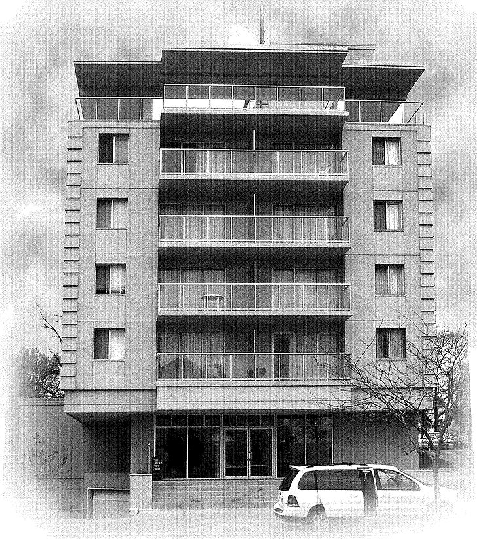

In the mid sixties the Executive House apartment building was built at 362 Dundas Street just east of Waterloo in downtown London. Bob and I decided to move in there. It was a very prestigious building and the first high-rise in the downtown area. It had underground parking and a roof garden. The old city hall was less than a block and a half away and the library about the same. Beautiful Victoria Park was within walking distance and the city Garden Market close at hand. There was no doubt about it Jack Cooke had arrived. About a year or so later an elderly couple across the hall moved out and we moved across the hall to a larger and more expensive Apt. on which we signed a lease.
My friend Mike came to see me one day in the spring of 1965. They had found a nice piece of property near Fonthill in the Welland area, which they would like to buy. It had a rather new, very nice looking red brick house and a small acreage of garden soil, about ten acres. About half of it was broken and the other half in willows or brush. They were asking $18,000 for it. Mike had just bought a brand new 1965 Plymouth Barracuda in the fall of ‘64 using up most of his credit and he needed a ten percent down payment to close the deal on this property. Now I did something, which I have never regretted, however it is something which one should not do except perhaps someone within your family. My credit was in the clear so I went to a loan company and took out a loan for the money Mike needed, and left him to make the payments on this. Mike had found a job at a near-by pulp wood plant. He not only never missed a payment but he paid off the loan well before the year was out. This was the first of many places Mike bought, fixed up and sold for a profit.
It seemed if Mike touched anything, it made him money.
Every year Jigs would make home-made strawberry and raspberry jam, preserves, pickles and chilli sauce and load my car up with it when I visited them in the fall, then thank me once again for helping them out when no one else would. Needless to say Mike is a wealthy man today and still one of my closest friends. Unfortunately Jigs passed away a few years ago with cancer. Mike and Jigs had three children, Shelly, Connie and Joe.
Hairstyles got longer, much longer. A lot of teens just grew hair thinking it was beautiful the way it was and that they would never have to get another hair cut in their lifetime. Many mocked the barbers by saying with a smirk,
“Eh! Mr. Barber how’s business?” and walked away laughing as if it were a joke. I always wondered what was so funny about having your income reduced to half of what you needed to live on. It hurt me deeply that they were so thoughtless and unkind for little did they know about how hard I as a deaf person had struggles to get this far. All I wanted was a place in life where I could earn a decent and honest living.
Help was on the way. Some say when a door closes on you the good Lord will open a window. All you have to do is accept it and for me it always seemed to be so true.
Regina Mundi College
In my clientele I had several priests from the Regina Mundi Residential College on Wellington Road just out over the 401 south of the city. All schools at that time found the long hair troublesome. One might only look to the army and note that they always insist on short hair, because it is easier to discipline men with short hair. The first thing they do to prisoners in jail or a prisoner of war is to cut the hair off because it humbles and subdues them. Hair in the sixties grew long in defiance of an older generation. Young people looking at the big picture, saw their parents, their teachers and their school along with all the rules and regulations a part that older generation which sought to mould them in their image. The hair problem would not go away easily. They would resist.
Regina Mundi however was a live-in school for boys and the school had almost parental control over the students. Rules and regulations governed the student’s behaviour and their dress at all times while on the school grounds. Hair was to be no longer than to the collar at the back and no longer then the bottom of the ears on the side. While this sounds liberal enough to us today the students did not think so in the sixties.
Father Mellon, a School Director for Regina Mundi College came to the shop one day for his usual haircut. He asked me a few questions about how I felt about people from other countries, places like Mexico, Hong Kong, The Barbados, Chile and others.
At that time this school for boys took students from all over the world and gave them a good education. They left the school more worldly, moulded into gentlemen who had learned the basics to succeed in life. I myself witnessed some very crude and uncultured lads turn into clean well-dressed, well-mannered gentlemen. I knew this school worked.
The school wanted to know if I would cut hair two nights a week, at the school.
This was heaven sent to me at a time when I was getting fewer and fewer haircuts and finding it hard to pay shop rent and my share of the apartment cost.
During those years I remember watched many barber shops close all over London for want of more business. I wondered how much longer I was going to be able to hang on. Sadly the public did not seem to share our grief; after all we were just barbers. I am sure if it had been the postal workers or the teachers or hospital workers there would have been a public outcry, but no tears for the barber. In fact it almost seemed as if they looked upon it with humour; after all we just cut hair.
I remember looking at the want ads in the Free Press many times wondering if there was some other kind of job out there for a deaf guy but nothing seemed to fit. In the end I thought it best to hang in there, “In my Silent World” and wait it out.

So this was a window God opened for me and I was truly thankful as it arrived just in time. The school had a two-chair barbershop in the basement. It had been closed for a number of years, but now it seemed an AT HOME answer to their long hair problem: SIMPLY reopen the barbershop on the premises. So every Wednesday and Thursday Father Mellon walked through the school with a pad in his hand and whenever he saw boys with hair he thought too long he would say,
“You and you are getting a haircut to night. Report to the barber shop 7:PM.”
The boys were not always happy when it came their turn to get in the chair but after a number of haircuts they at least liked me. They came to know that no amount of bickering or grumbling changed the fact that the hair would be cut at the bottom of the ear and at the collar. Most of the boys returned to Regina Mundi year after year until they graduated. Over the years I watched those boys grow up and mature, and change from awkward, insecure and sometimes uncultured boys into young men we could be proud of. I have nothing but great things to say about The Regina Mundi College and its staff.
Mrs. Murdock And Her Christmas Cake
Bob’s father had been in the Army and while his father was stationed in some places like Camp Borden Bob came to know his dad’s army buddies and their families. The army women often baby-sat each other’s children to help each other out. Quite often this formed a life-long bond between families. Bob wanted me to visit Jack and Phyllis Murdock who lived in the old army section north of Oxford near Highbury Ave. Usually it was just Phyllis who was home with several kids as her husband Jack was still in the army. The two Murdock children I remember the best were Jim and Bonnie. Bonnie sometimes called on us at the Executive House Apartments when she was uptown. At this time she would only be about sixteen and I suppose like all teens she had problems she needed to share with someone she knew, so Bonnie and Bob would sit and talk at the dining room table for hours. I always enjoyed going over to Murdock’s, as Phyllis was easy to chat with and was a wonderful cook. It seemed every time we went to visit she had just baked something great, and I would sit down and demolish it.
I must tell you about Mrs. Murdock’s Christmas cake. Every year she made Christmas cake for all of their army friends. In fact the recipe she used came right from the army’s barracks camp kitchen. It was so good that I was determined to make some for myself, so I asked for her recipe. She forgot to tell me to cut the recipe down for just a few cakes. It was just a few cakes I had in mind; I did not intend to feed the army. I had never shopped for anything like this before so I decided to follow through buying everything pound for pound and ounce for ounce. I soon realized that this cake was going to cost me a lot of money. Oh well never mind, it was something I wanted to do for the sake of doing. Perhaps I just wanted to prove I could. While mixing I had to change bowls several times as the batter or mixture grew and grew getting bigger and bigger. When I saw all this mixture I realized I was going to have to go out and beg and borrow or buy many more cake pans to put it in.
I was greatly relieved once all the pans were filled and in the hot oven. It was then though that I found out I had forgotten to ad the baking powder, so I called Phyllis and asked her if it mattered. She nearly had a fit, and she said,
“ Yes, yes, it matters. Get it right out of the oven and mix the baking powder in it as fast as you can.” It was a messy job but thankfully we were able to do that without too much trouble.
When it was done there was enough cake for a whole army I kid you not, but it was about the best Christmas cake I ever ate. I gave it away as a Christmas gift, to my neighbours and friends and sisters, everyone. No one escaped. But because of the cost and the work involved it was a one-time thing. Now if anyone of you is interested I still have that recipe. Just ask.

Some Strange Encounters
One evening near closing time at the shop a rather rough looking chap came in wanting a haircut. While I cut his hair he told me he was working for a certain man who had a brick cleaning business. I knew the man and also his two sons. When I finished the haircut he told me he could not pay me until payday the end of the week. Well we all know you can’t get blood from a stone. So I told him, he should have told me that before he got in the chair, and that I expected to see him at the end of the week. I realized by now he never intended to pay for his haircut anyway, so I was not surprised that he never came in to pay.
Several months later he walked in the door, again near closing time. He looked even rougher and tougher then before. I said,
“I suppose you want a hair cut?”
“Yes”
“You never came back to pay me for your last one did you?”
“No” he said, “ I have been out of work for a while.” I noted a pack of cigarettes in his shirt pocket so I said,
“Well I note you still have money for cigarettes.” He was embarrassed, so I said,
“Well do you have the money for today’s haircut?” to which he sputtered and said,
“Oh yea, I have the money for today’s haircut.”
These were hard times for many people and while I am compassionate I don’t like dishonesty. So I said,
“ Well you can pay me for today’s haircut and I am willing to forget about the other one under the circumstances.”
When I finished his haircut he got out of the chair and made a big thing of reaching for his hip pocket. Then with a great show patted down the front pockets of his jeans and exclaimed,
“You wont believe this but my wallet is missing.” He headed for the door saying, “I had it at the store just before I came here. It has to be somewhere between here and the store. I will be right back.” Naturally he didn’t come back.
Six or more months passed, then in the fall when it gets dark early, he walked into the shop along with another very rough looking character, and again right at closing time. Late in the fall when it gets dark early shop owners are very wary when strange rough looking people walk into your shop just before closing time. This is the time of year that there are many robberies. I had been going to the gym four times a week for some time now and I was looking very fit and muscular, but even then I felt this just might be trouble. I decided to meet it head on and not let them feel they had an advantage just because there were two of them.
I reminded him he had never come back to pay for his last haircut and he now owed me for two.
He said, “No just one, as you forgave me for the first haircut, don’t you remember?”
I said, “I made you a great deal if you paid for the second haircut I would forget about the first, but you ran out on the deal so now you owe me for two haircuts,” “Do you have the money for today’s hair cut?”
“Yes”
“Then give me the money and get in the chair,” He handed me a ten-dollar bill, at that time I think haircuts were five dollars. I put the ten dollars in the till and locked it. He looked at me and said,
“Well what about my change?”
I said, “There is no change. Hair cuts here will cost you ten dollars every time until you get caught up.” I knew I was on top of them and they never said another word. He never came back to the shop for another hair cut. They say it takes all kinds, but sometimes I wonder why there has to be …….his kind?
Now in all my barbering years I have never refused to cut a head of hair if that person needed a haircut for a good reason. It might be, to get a job or for the school prom or many other reasons. But I always feel an honest person will tell you before he gets in the chair that while he really needs his haircut today he does not have the money to pay for it right now. I have cut many teens this way and they always came back to pay me, all except for one Italian family who really pushed it, ha ha! That is worth telling.
This very great looking Italian lad about 16 came in and told me he needed a hair cut so he could apply for a summer job at a local inn, but right now he didn’t have any money to pay for the haircut. I liked this approach so I said it was not a problem. I will cut your hair now and you can come back in after you get the job and pay me, and if you don’t get the job just forget about it for now.
A few days later a second Italian boy came in. He was a dead ringer of the first boy but about a year or so younger. He said to me,
“Mr Barber I need a haircut to get a summer job but right now I have no money to pay for the hair cut. Will you cut me now and I will pay you later?” I was suspicious but as I said I like this approach and the kid was so darn cute about it, so I said,
“No problem, you can pay me after you get your job and if by chance you don’t get the job you can forget about the hair cut.” Now you can’t beat this kind o deal.
About a week later a very young Italian kid comes in about 13. I knew right away he was another brother as they were all dark, handsome kids and sort of like peas in a pod.
He says,“ Mr. Barber I don’t have any money but could you please cut my hair so I can get a job?”
I told him, “Look son I don’t think you are looking for a job but I do think you are looking for a free haircut. I tell you what I will do. If you can get your two brothers to come back in and pay for theirs hair cuts I will cut yours for free.” Of course I never saw the brothers at the shop nor the money for those haircuts, but I have no regrets. You live and learn and sometimes its worth it.
Of Friends and Friendships
One night Bob brought home a neighbourhood lad for a cup o coffee. He lived just a little over a block away on Queens Ave. His name was Nevol Huddleston. It seems that during your lifetime you will meet many people who will become just a passing friend and then there are those special few who will become friends for a lifetime. Such was the friendship I found with Nevol. Now after all these years we have a great friendship and make an effort to get out for lunch together at least once a month and also work in a visit.
Nevol’s mother had a cottage on the waterfront at Port Stanley and during the summer when it was hot in the city Nevol often drove to work from the cottage. Many times I was invited down in the evening to visit and we would sit out at the rear of the cottage and chat till late. Then Nevol and I would go for a long walk down the now cool sand on the beach, to the pier and all the way to the lighthouse. The waters of lake Erie are sometimes calm and sometimes rough with huge waves slapping the pier and spraying us and adding coolness to the night air. When we came back to the cottage we would see the glow of lights in the cottage window comforting and beckoning us, and we knew Nevol’s mom would have a pot of tea and some of her home made cookies waiting for us. I have many kind thoughts and memories of Mrs. Huddleston and my visits to the cottage at Port Stanley.
One hot summer day I stopped at an ice cream store just a few doors west towards downtown from the apartment building. A big sign over the door said Jumbo Ice Cream. Generations of local high school students from Beal and Catholic Central had frequented this place. Everyday at noon hour they stood in line waiting on their treat. Jumbo made there own ice cream right there on the premises and they gave you a great size cone of wonderful ice cream for your money. I walked out of the store with a huge triple deck, one any ice cream lover would die for. It was a beautiful sunny day and my day off. So carrying the cone well out in front of me I headed for uptown.
Just as I reached Waterloo Street the light changed and I stopped rather abruptly causing the whole triple deck to do a fancy flip flop and then a cur-plump at my feet. I was totally embarrassed left holding onto an empty cone out in front of me. A young man standing next to me started to laugh hilariously. At first I was angry, then perhaps provoked and then I guess I saw myself as he saw me standing there with an empty cone out in front of me and all that great ice cream at my feet. So I started to laugh too. We introduced ourselves to each other. His name was Rick Deluca and he lived in an apartment close by. Rick’s mom worked at 3M and had a house on Bond Street with a fantastic back yard. It included a deck and a large in-ground pool. Along the east side of the lot was a beautiful new 6ft. stonewall with a Lion atop on either end. There was some lawn at the rear and many colourful flowerbeds and flowerboxes. On a hot summer day it was an amazing retreat from the heat.
Rick invited me to go swimming many times that summer in his mom’s pool, and his mom and I became good friend. She invited me to stop in on the way home from work anytime for a cool dip and that was great especially in those hot dog days of summer when the steady heat gets you down. I would then go home refreshed. Rick eventually moved to Toronto but his mom who is now retired, lives in a plush apartment building in Old North London We remain good friends, always ready to help each other out whenever needed
I have made many long and lasting friendships within my clientele, and it is enjoyable to be able to meet and greet them where ever I wander throughout the city. I often run across them at the most unexpected times and places. At the car wash, at McDonalds, at the bank or in the malls, the parks or on the city streets. By their warm smiles and friendly hand shakes I know they are happy to see me because over the years we have developed a lasting friendship. It was not just because they felt good about their hair-cut, all this simply brightens my day. However for the most it seemed I always thought it best to keep my personal life and my shop and clientele separate. Thus it seems most but of course not all, of my closes friends are neighbours or people I have met by chance..
When I came to the shop in 1963 there was just wild grass and weeds growing out in front of it. Let us say it was very much in the rough, or its own natural state. I put in six-foot long cement curb stones from the shop to the edge of the roadside, for the cars to pull up to, then a flowerbed behind the curb stone and lawn beyond that. I also cut the roadside ditch to make the place look attractive colourful and neat. At first I used Tipping’s lawn mower to cut the grass but it was always out of gas or gave me too much trouble. In the end I bought my own green Lawn-boy lawn mower and ended the problem. It was a good lawn mower. I used it for years.
I decided to change the name of the shop from Southbreeze to Southdale Barber Shop as the shop was just south of Southdale Road. I thought that was good for business, as people would then know the location. I hung a new sign from two square cedar four-by-four posts. Under the sign I dug a large flowerbed about eight-foot square surrounded by large rocks. Things were looking up. While my neighbours, Roy Inch and Don Brown didn’t believe in cutting grass or tending flowerbeds they did keep their lots clean and neat.
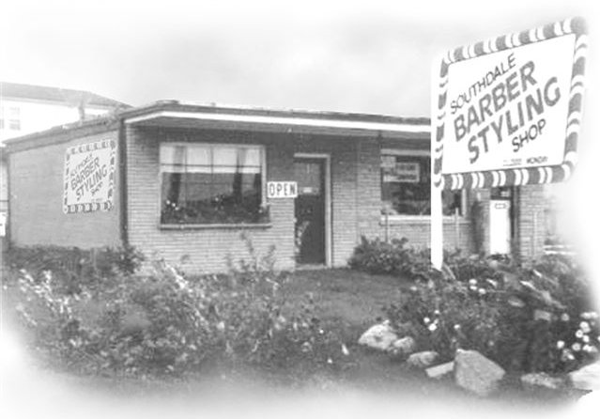
Jack’s First Barber Shop and Brian, Allan and Tracy
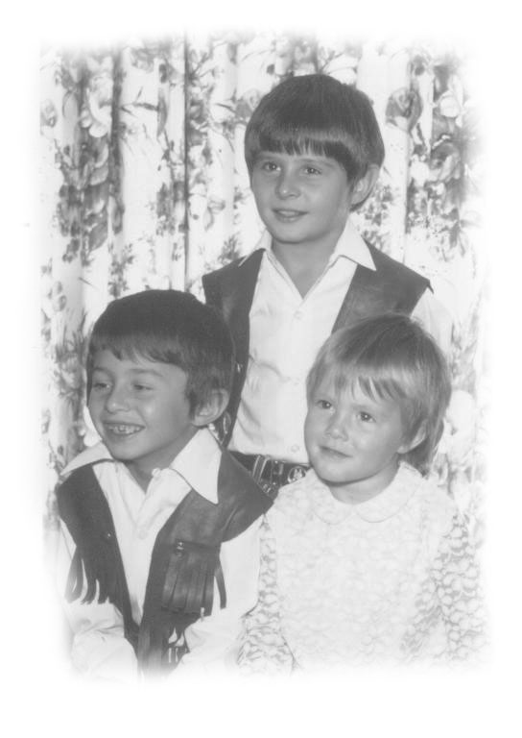
The two Tipping boys spent a lot of time visiting me in the barber shop. I could depend on a visit from Allan every night. If truth be told, I would have missed them if they did not come in. Jeanette was now a hairdresser and working and managing her shop in the basement of the house. This, along with looking after two boys kept her very busy. She dearly wanted a little girl but knew that along with the shop a baby now would be a handful. The answer seemed to be, to adopt. So in the mid sixties they adopted a little girl “Tracy.” The two boys were happy to have a sister.
“Jack and Allan have a Bad Day”
Early one Saturday morning I arrived at work well before my first customer of the day. I had my car trunk loaded with annual flowers that I had bought the night before at Mr. Wilson’s on Southdale Rd. Mr. Wilson worked at the old veterans hospital. He had his own home green house in his back yard and he grew great plants.
The flowerbed had been prepared the night before and Allan was waiting on me when I arrived. I remembered how my grandparents and mom had taken the time to show me how to plant things so they would grow. So I had Allan down beside me planting flowers. He seemed happy to help and took pride in the bed when it was done.
At noon I went out to Ritchies my favourite lunch counter for lunch. Two Greek brothers Jim and Louis Lathouris own it. When I returned from lunch I found my flowers pulled out and strewed all over the bed and dying in the hot sun. I felt very sad that anyone would do that to me. I quickly replanted and watered them as fast as I could and then covered them with newspaper to keep the hot sun off them for the rest of the day.
That after noon a young chap came in for a haircut and he told me he had come in while I was out to lunch and saw Allan pulling out my flowers. He had left without Allan seeing him, but he thought I should know about it. I was really hurt that Allan would do this. That night when I took the money to the house, I told Jeanette what had happened. She said she would deal with it. For about two weeks Allan never came near the shop and whenever I saw him I never looked at him or spoke to him. Then one night he came in at closing time in tears and asked me if I could forgive him.
I said, “Yes Allan I can forgive you because I love you but I thought you loved me too?”
Allan said, “I do love you Jack, but NOW I know it.”
The good part was I never lost a plant. That’s the beauty of having a green thumb.

“Unpleasant Encounters”
There was a local restaurant called, “The California.” A huge Greek man who drove a huge car and smoked huge cigars owned it. Whenever he came in to get a haircut he sat reading the newspaper and filled my little shop with cigar smoke while waiting his turn for the chair. When he finally did get in my chair he continued to smoke his huge smelly old cigar practically under my nose and held the newspaper up in front of himself thus guiding the smoke upward. If at any time I tried to carry on a conversation with him he would point his fat finger to his head and move his fat hand back and forth as much as to say,
“Just cut my hair.” When you operate a shop you have to understand that a city license is a privilege to own and you must serve all people unless you have a very good reason not to. This man came dangerously close to crossing the line. He was a man who had little respect for others except for his own. Many times mothers with young children would also be waiting and when a small child came near him he would flutter a huge hands at the child and utter,
“Go way, Go way.” At other times he brought in his own little over weight and spoiled grand children for a haircut and continuously fawned over them as if they were royalty. Thankfully I have kind thoughts of the most of my clientele. There were some people who didn’t know how to cope with a deaf person.
I remember a number of men, who walked in the door already talking as they entered and upon finding out I was deaf backed out the door saying,
“Oh you’re deaf, well fine fine, ok, bye.” and leave. I don’t feel for a minute that they wished me ill. In fact they probably wished me well. But somehow they had the feeling if they chose to give me their business they would somehow involve themselves with my problem, and more problems they did not need. So rather than help a deaf person to earn a living they chose not to get involved.

Mr. and Mrs Bull’s 50th. Wedding Anniversary
In January of 1967 I flew to Calgary to celebrate Mr. and Mrs. Bull’s, Fiftieth Wedding Anniversary held on Saturday January 21st. at the Legion Hall in Oyen. The ticket to fly out was a Christmas gift from my friend Bob Scott. He had also arranged to have Wm. Bull come to the airport to pick me up. There was a lot of snow and it was very cold that winter but it did nothing to dampen the celebration.
A turkey dinner was held for all of the family, which somehow included yours truly, Jack Cooke. Certainly I did feel very much as if I belonged to this family. Later at the legion hall there was a program with many of their many friends taking part, one being an old Scottish friend Bobby McCallum singing and also a song by myself, How Great Thou Art, with Olive Sutherland playing the piano. There were greetings from Prime Minister Pearson and leader of the opposition John Diefenbaker and also Premier of Alberta, E C Manning.

Barry White was Doing Well
Barry and Diane White were living in Oyen and by now they had two children. It seemed they were doing very well. Barry at that time was building a huge bridge over the Red Deer River south of Oyen. I found it hard to believe how it was that I had taken a fifteen-year-old boy out west, who was running away from the Salvation Army and now he was building bridges, not a small bridge, mind you, but a large one. Barry asked me if I would go down to the river with him one night, as a man from the government was to meet him there. At that time the Alberta government helped small Alberta contractors expand by helping them along financially as their project proceeded. This man was to inspect the work and see that it was proceeding as planned. I remember seeing giant pumps at work pumping river water out of forms where the abutments were to go. Great blocks of ice lay on the frozen river, some with fish frozen in them.
Barry continued to build and expand, build and expand, building all sorts of buildings from Grand Prairie to Calgary. Everywhere you went people knew of Barry, the kid who came west from Ontario and made good. Somehow I felt good about that.
When I arrived home the end of January I was amazed to find the snow all gone and the weather sunny and warm. Bob met me at the Airport with the top down on my 64 Ford convertible. Good times come to an end and I was back to work at earning a living.
By the fall of 67 the mileage on my 64 Ford was getting quite high so I thought it was time to trade again. This time I bought a 1968 Fury three Plymouth convertible with a dark red body and black top. It was a great looking car with a good ride and I was thankful it used a lot less gas then the huge motor in the 64 Ford. My dad was thrilled about my new car but my mother warned me I was going to loose all my hair riding around in convertibles. I guess I should have listened to my mother, but I kid myself. It was acid rain!

Two Hockey Greats “Sittler and Ciccerelli”
One morning two very vibrant young boys walked into my shop. They introduced themselves as Darryl Sittler and Dino Ciccerelli. They were both playing hockey for the London Knights. I have always felt honoured for being able to spend time with these two guys. I followed their careers over the years and every time their names came up I sense happiness for the contact I once had with them. In 1969 Darryl was first pick for the Toronto Maple Leafs
“A Fateful Tragedy”
Often, a friend and buddy of Joe’s, who was interested in skin diving, helped Joe on weekends in the Aqua Shop. His name was Mike Hatch. In the summer holidays Mark Moxham ran the shop for Joe during the day until Joe got home from work. Mark was a kid brother of Richard Moxham a long time buddy of Joe’s. In August of 1968 Joe and Jeanette and kids left for a few days’ holidays and Mike and Mark were to look after the Aqua shop. The last thing the Tippings did before they left was to tell me to keep a good eye on the back yard gates leading to the swimming pool; they didn’t want the neighbourhood kids to swim in the pool alone.
It was late in the afternoon near closing time and I was just finishing a hair cut when I saw the flashing lights of an ambulance making a U-turn at the end of the boulevard in front of the shop and turn in on our lot. My first thoughts were, “Did I check those gates this afternoon?” I was sure some kid had drowned in the pool.
When I rounded the corner of the Aqua shop I could see Mike lying face down on the grass with people standing around him. There were the two ambulance attendances and Mark, Richard and his girl friend. Apparently Richard had been barbequing supper and had called Mike who wanted to take a hurried dip in the pool to refresh himself before eating. Working in the Aqua shop was hot when the pump for the air tanks was working. When Mike dove into the shallow pool, he somehow broke his neck, vertebra and spinal cord. I watched as the attendant ran a sharp instrument from Mike’s neck all the way down his back, down the back of his legs, down his calves then down the bottom of his feet to his toes. Mike never flinched. I looked at the attendant and said,
“That’s bad, uh?” He looked at me and shook his head and said,
“That’s bad.”
I remember going up to the hospital a few times to cut his hair. I found him with steel pins holding his head straight, and strapped to a board. What a difficult haircut to perform, I cut part of it with him facing the floor then spun the board over and did the front part with him facing the ceiling. Mike went on and took a few courses at Western University to further his education. He got himself a computer a long time ago and keeps in touch with his family and friends.
Many times when I am feeling a bit down because of my hearing loss, or when something had happened that hurt me, I would pop in and have a coffee with Mike. He was always “up beat” and when I left I would think to myself, “If Mike can do it with his problem then I should be able to do it with mine.” Life goes on, but Mike and I know life is not always fair. Hopefully down the road, when God takes us home, Mike will walk and I will hear again.

“Time For Dad and Mom To Retire”
In 1969 my dad was 70 and my mom 68 years old so they decided it was time to give up the second farm and move into town. They had been on this farm for 8 years from 1961 to 1969. They bought it for $14,000 and sold it for $28,000. It had served their purpose well giving them a good investment and also a living.
Coveney, who had owned the chicken hatchery had closed down his business and torn down the many huge wood frame hatchery buildings. From this lumber he built himself a new home and a number of other houses on Arthur Street in Mitchell. My Dad and Mom purchased one of these homes for just under $12,000.00 in 1969. They also bought a 21 ft motor home and planned to do some travelling. While my mom loved her little house she was always ready to travel in the motor home.
Before they moved into their new home in Mitchell they came to London and I took them out to the Leon’s Furniture Store where they bought the new furniture for the house, kitchen table and chairs, chesterfield and chairs end tables and coffee tables, lamps and then new bedroom furniture. It was all delivered at once.
Much of their old furniture they gave away and lots of old things were burned in a huge bonfire down on the bank of the Thames River. Unfortunately unknown to me a lot of my stuff ended up there too. Sheets music and pictures I had taken over the years out west and boxes of stuff I had received from Uncle Fred and my Aunt Rosena all disappeared.
My sisters and I bought dad and mom all new everyday dishes and cutlery. It was good to see them so happy. That winter I painted every room in the house over in the colours they chose. Over the years they lived in that house I painted the outside twice. I put in flowerbeds all around the house and every spring I would arrive with my car packed full of Mr. Wilson’s flowers ready to plant. Dad would have the beds all dug over by the time I arrived. Then he would spend a lot of time grumbling about too many flowers, too many flowers to plant. But once they were in, they took great care of them and the little place was a showcase to all who drove by. No one took more pride in showing off the flowerbeds then my dad did. Whenever someone came to visit them they were taken on a tour by, yours truly, my father. I got a kick out of this because then I knew in spite of all his grumbling about too many flowers he did appreciate it. Those were good years for me and my dad and mom and it just seemed that finally things were going right for us as family.
“Bob Takes Leave”
For some time I had known that my friend Bob who shared the apartment was disenchanted with things here in London. I came home from work one night to find all of his things gone. There was a note saying he would write and explain things to me sometime later. Later turned out to be a couple of years when I got a post card from New Orleans. This left me with more rent to pay than I could afford as I had the shop rent to pay as well as the apartment. About then Randy Scott, Bob’s brother had a car accident on Springbank drive. The steering wheel of his car had punctured his chest. He came to see me and asked if I could do the work at the Victoria Order of Nurse Building for him until he recovered.
Little did I know that God was opening another door for me? For almost two months I looked after the VON building cleaning the offices every night and on week ends cutting the grass and doing whatever had to be done while Randy was recovering. When I did this I met all of the staff and they seemed to like me and were satisfied with my work.
Randy recovered and was back to work at the Kelvinator’s plant during the day and did the VON work at night and weekends. But Kelvinator had been plagued with strikes for some time and they suddenly decided to close down the plant here in London and move to Quebec and end their problems with their workers. Practically over night Randy found himself without a job so he decided to move to Niagara Falls to take a job there. He came to tell me he thought that if I wanted the apartment and job at the VON they would give it to me. I could not afford to stay on at The Executive House by myself so I put in a tender for the job. I was still cutting hair at the Regina Mundi College two nights a week so I knew I was going to be very busy.
A few weeks later the VON called me over to their office to let me know I had the job. We discussed the work and the free apartment and utilities and also the wages. When I asked about any benefits I thought I blew it. The lady in charge informed me very sternly that this was indeed the VICTORIAN ORDER OF NURSES, and no men were allowed to be more then casual outside workers. I didn’t even get paid holidays. If I wanted a holiday at anytime I had to find someone to fill in for me and pay them. However it was a good steady job, which I learned to appreciate as it paid me money and at the same time cut my cost of living at a time in my life when I really needed it. Many times I have heard people say they could not get the job because they were over qualified. I was never over qualified and I was only too happy to do whatever it took to earn an honest buck.
I rented a truck and Randy Scott and Rick Deluca helped to move me from The Executive House to the VON in the fall of 1969.
I remember the first thing Randy Scott did was to back the truck wheel right over top the neighbours little lilac bush and squash it flat, what a way to start off with new neighbour’s. Lilac’s though are very hardy and sometimes seem to thrive on abuse. It flourished into a mighty bush and grew many flowers. I always remember my Grandma Butson saying her lilac by the gate never grew up until her youngest son, my uncle Bob grew up and left home. It seems grandma cut many switches off the lilac to keep uncle Bob in line.

Chapter 6
LIFE AT THE VON HOUSE

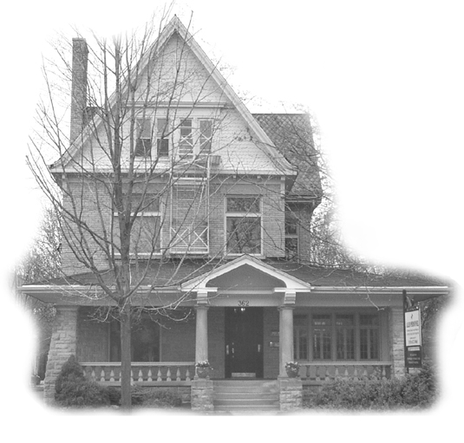
The VON House
362 Dufferin Ave. London
The Victoria Order Of Nurse Building (VON) in London sits on the north side of Dufferin Ave. just three buildings east of Waterloo Street. It was a magnificent huge old pale yellow brick house that still had its original slate roof. Four great round cement pillars abutted out in front, two on either side of the cement staircase. On the east and west ends of the veranda was a huge square bulwark of angel stone that held up a sturdy veranda with an elaborated roof. The house was built by an army officer who also built the next two houses to the east for his daughters. Something told me that even then the government leaked a lot of money to people in the right position. There were five outside entranceways on the ground floor and one on the third floor above the veranda. On the first and second floor there were many huge square windows with a half moon window on top of church-like coloured leaded glass, all still in perfect shape.
At the base of each of these windows was a large windowsill with a built-in door embedded in the sill. The drop-in doors had a drop-in brass oval type ring. Inside these doors were three sets of pull up wooden sunshades connected to ropes, pulleys and weights, ingeniously placed inside the window frame. The downstairs floor was the original, made of solid oak cut into small pieces and set to a design. Never had I seen such a stunning floor. It was a thing of beauty.
There were two fireplaces, one on the first floor and one on the second floor.
Across the rear of the lot one could see the foundation of what was once the carriage shop and horse barns. The driveway and rear lot was gravel when I arrived there but was later hard-topped. One thing I loved was a majestic great old horse chestnut tree about thirty feet out onto the lot from the rear door. Once a year it was covered with the most beautiful white blossoms, which was something to behold. But very late in the fall a ton of leaves and leaf stems came down to be bagged and carried to the curb. I never complained, though as I loved that old tree.

To get to my apartment on the third floor you entered through the front door, which was made of thick oak planks surrounded by an oak doorframe. Outside of this doorframe were narrow windows built in on either side, and then a large heavy oak casing surrounded all this on either side and above.
This front door entered into a large hall with an open wide staircase, a full size banister post and railing facing you, going to the second floor. Mid way the stairs did a sharp left turn. Then you walked down a long hall and turned right and there beside you was a door to a second staircase going up to my apartment on the third floor.
Being an attic apartment, the ceilings on all sides slanted down with the roofline to the walls on all sides, giving the place a rustic loft look. I backed my chesterfields against the wall and it worked out well. There was an open kitchen and living room with the railed-in staircase coming up in the centre. There was a huge walk-in closet and a bathroom along the living room wall then two bedrooms overlooking Dufferin Ave. at the front. The one bedroom I turned into a den or TV room. The whole place was warm and cozy all winter and easy to air condition in the summer
One of my biggest expenses was a new Moffat fridge and stove in avocado green for my kitchen from Don Brown appliances next door to my Barbershop. The two cost me $500.00. They lasted me for many years and in the end I got my money back, but I will tell you about that later.
My agreement with the VON was that while I could have friends come to visit me I was not to have any parties. I was to walk down to the front door and escort my company in and out of the building. If at any time someone came to stay longer than over night they had to be registered. This would be something not everyone could live with but it worked fine for me. The VON nurses came and went 24 hours a day so while they would be happy to know a custodian was in the building they would not appreciate meeting a stranger in the building alone late at night. Every night I was to check the premises before I retired to be sure it was secure.
For a short while I wondered if I had bitten off more then I could chew. While I wished I were busier at the barbershop I still had to stay and put in the time and always be there. The waiting on business to come in is something one never gets use to, and especially so when you knew there was work you could be doing elsewhere. Then there were the two nights I cut hair at Regina Mundi Residential School. It just seemed I was always on the run trying to catch up and was not making enough money for all the hours I put in. The answer of course was that I had to get myself organized and make better use of my time.
First I decided that since I could not do all things one might normally do because of my three jobs, I would eat a full dinner out at mid-day everyday at a restaurant, and more or less lunch every evening for supper. This set me free from making lunch to take to work and that in itself was a blessing. It also made it so I didn’t have to spend a lot of time cooking a supper as I had my lunch then, thus I was able to start my VON work earlier.
Soon I was organized and able to do the work in the office building in far less time. I would start the nightly office cleaning at the same place every night and end up at the same way. Gradually things started to work smoothly as I set up a schedule and time to do every thing. This made it hard for people to visit me as my work always had to come first. Luckily I was a night person to start with.

I also wanted to get into a gym and work out, as the sitting in a barbershop was not good for my health. I joined the downtown Y, leaving home at seven thirty each evening and I was back home again by nine. I worked out four nights a week really seriously. The brand new Y, was about two and a half blocks away so I walked down and I walked home. I always showered at the Y before I left as it saved me time. I tried to put one whole hour working out in the gym. Time was the name of the game. If I didn’t handle my time efficiently I would have to give some things up and I didn’t feel I could afford to do that.

First thing every morning I would have to go down and turn off the VON outside lights. In the winter there might be snow to shovel from the driveway entrance before going in to the shop. As a rule I shovelled the sidewalk and cleared the doorways and entrance to the drive the night before, usually about eleven PM or later. Many mornings a plough would drive by and dump a gift of snow in the drive before I got up. Overall the VON job was a good thing for me, but only because I didn’t mind the hours and extra work. If I had worked for Ford or 3 M I would have made more money in an eight-hour shift. I was actually always on duty at one place or another from seven thirty in the morning till near midnight seven days a week with no benefits, or holiday pay. For the most I was self-employed because certainly as a man I could not belong to the VON. Everyone thinks it’s great to be self-employed. Everyone should give it a try.
There was a well kept 23 unit apartment building next door to the VON House, and after a few weeks of coming and going I was aware that an older couple living on the third floor overlooking our parking lot watched my every move. He always sat on the north side of the window and she sat on the south side. Some time later I met him down on the lot. His name was Clark Buchanan and he owned the building. His wife’s name was Vera. To me, they were always Mr. and Mrs. Buchanan, the same as Mr. and Mrs. Bull had always been, Mr. and Mrs. Bull.
Mr. Buchanan came from Kincardine up the lake north of Goderich. He came home after the war and married and took over the family farm. His wife died a few years later and he decided to sell the farm and buy a 36-unit apartment building in Goderich. Some time later he met Vera who came from Whitechurch west of Wingham. Vera though was a nurse here in London. Clark took a mortgage on the Goderich apartment building and bought this 23 unit building next door to the VON House on Dufferin Ave. It is called The Berkeley Apartments.

Clark also got the job as custodian at the Catholic School around the corner on Waterloo Street. He was a very hard working little man, and a proud Scotchman. He had hired someone to do the everyday work at the Goderich building, but he drove up every week to do the big jobs such as painting, repairs and plumbing.
I found a wealth of knowledge in Mr. Buchanan, which helped me to become a better custodian. Whenever I had a problem with old plumbing, doors or locks he was happy to rescue me. We both took pride in our work, be it cutting the grass or tending our flowerbeds. The neighbour on the other side of the VON house, a Mr. McGregor joined us, keeping his place neat and well kept and soon we had the best-kept ground area on Dufferin Street.
I remember years later talking to a chap who told me that he never could think of the VON property without thinking of it as the place where the snow was shovelled a little wider in the wintertime and the grass was a bit greener in the summer time. That was the kind of comment one likes to be remembered by.
Mrs. Buchanan was a great conversationalist and I enjoyed chatting with her, but she was of a curious nature and just had to know everything. If I was out too late at night she always had to ask where I had been and what I was doing. Lots of times I really didn’t want to tell her. So I would say,
“ Lets not talk about it.”
“ But I want to know.”
“ Ruff.”
Mr. Buchanan would be sitting in his chair chuckling as he got a kick out of it. We became wonderful friends. Many times when I came home from work, she would hold a plate of homemade goodies at the window and beckon me to come on over. They waved me off to work every morning and were there to welcome me home each night. On Sundays I would go over for morning coffee.

During the first few years I was there the head office of the Canadian Girl Guides and an organization called Friendship In Action and the John Howard Society all shared the second floor in the building. It came to an end a few years later when the government told the VON it was going to have to expand its Home Care and take over a lot of different kinds of homecare work. So they asked the tenants on the second floor to vacate. The VON borrowed a lot of money to buy office equipment and more new cars so it would be ready for this new work.

Then the government changed hands and the extra workload never came. The VON was left with a huge loan to pay off and there was no way they could do it. They complained to the government and asked them to rescue them from this debt. The government sent an auditor to their office to go over their books. While doing the books they found out the custodian on the third floor received a free apartment and paid utilities. Apparently this was a no no. The VON had been declaring my wages but not the value of the apartment or utilities. So they came calling on me.
At first they told me that they were going to value my apartment rent at the same value as an apartment in Mr. Buchanan’s 23-unit apartment building next door. Then they would go back five years and ask me to pay income tax on this.
I told the guy if they did that, the VON would have to either give me more money in wages or I would leave. I explained to him that as a deaf person my chances of getting one good job that paid me a good living wages was nil. That, with all the hours I put in with three jobs I still did not make the kind of money that would please him or most people working for the government. I also pointed out that the VON could not rent an apartment like this out to just anyone, as few people could live with all the restrictions they placed on it.
He was actually very reasonable and in the end they only went back three years and they valued my rent at one half of what an apartment in the building next door cost. There were however no winners as I had to pay extra income tax. Then the VON offered me more money if I would stay. They wanted to keep me on as over the years they had all too many custodians come and go.
When I started working at the VON I made a pack with myself that I would stick this out for five years, with hopes that by then the barbershop would carry me so I would not have to work so many hours. At the end of five year I had bought a new car and some new furniture but for some reason I was not exactly happy with myself, as I didn’t really have one cent more saved to show for all this extra work.

About that time The Registered Retirement Saving Plan came into being, so from that very first year I began to put money into the RRSP. At first it was just the cash I received from the VON each month, then I decided to match it from my other income. Somewhere deep inside my head I would often hear my great aunt Becky’s voice saying,
“Jack its not the money you make, but what you do with the money you make.”

After a few years I decided on another more definite plan. You were allowed to put 20 percent of your net income into the RRSP each year, so in January at the beginning of the tax year I would go to the bank and borrow what I thought would be that 20 percent. The bankers were only too happy to loan you the money, as you would then invest it back in their RRSP. I always borrowed for only one year making twelve even monthly payments. Then when the loan was paid off I would borrow again the following January, always a year before I needed it. This way I always got the cost of the loan back plus some interest on that very first year. Best of all no mater what kind of year I had financially as long as I somehow made the payments on the loan at the end of every year I knew I was ahead as I owned my RRSP.
I was sure my little ole Aunt Becky was up there smiling down on me.

By now all my sisters had children, Laurine had six, Pearl had five and Jean three. As I was growing up I had two Uncles, which stood out, as examples of what I thought an uncle should be. That was my Uncle Loril Butson (mom’s brother) and Uncle Guy Starch (my dad’s sister’s husband). I wanted to be a good uncle to my sister’s kids. I wanted them to love me, but I soon found out it was not going to be an easy task. Some things you cannot beg, buy or demand, you had to earn it by being ever-patient and ever-loving and hopeful and in the end, win it. Once won it is a gift of love for a lifetime, which you will treasure for the rest of your life. Years or miles will only add to its endearment. I feel I have won all but one of my nieces and nephews. I miss that one, and I wish I could win her, but life is a two way street and you can’t go where you’re not wanted or not needed.

When I first arrived at the Barber Shop on Wellington Road there was a farm across the road with a huge red L-shaped barn and a two story white brick house set among tall maples. Every morning the sun rose, shining down on the barn and lot and it looking for the entire world a picture postcard. Far back on the farm there were clumps of trees dotting the countryside and I would often see deer travelling from one clump of trees to another or pasturing on the fields of winter wheat. When I looked southward I could see for miles all the way to 135 or Exeter Road. During the seventies all this was to change. Within a few short years the entire area was built up with houses, schools banks and plazas.
Kentucky Fried Chicken moved in next door to me, with a Restaurant and a carry-out service. They were the first of many more eating-places to come.
One year a few days before Christmas I got a word from Barry White in Alberta asking if I could meet his flight at the London Airport. When he left this country he was not on good terms with his dad or stepmother and now he was not sure how they would welcome him home, but he wanted to see his family at Christmas. I met the flight and he stayed overnight at my place and rented a car to drive up to Stratford and Gads Hill the next morning. I gave him a key to my apartment and told him that if things didn’t work out he was welcome to come back and to have Christmas with my folks and me. He never came back and never did return my key.
In October a few years later I flew out to Calgary on a late Saturday night flight to visit my friends at Oyen. I found myself on the bus going east out from Calgary in the early morning as the sun appeared on the eastern skyline. To the west the mountains greeted me, reflecting a mirror of colours on the first new fallen snow. There is always something good about watching a country come awake in the early morning hours that makes you feel a kindred spirit, at peace and at home.

When we arrived in Drumheller we were to have time for our breakfast. In those days most of the towns served you from behind a long counter. It saved them a lot of running around. I ordered coffee and my oatmeal cereal and there on the counter within easy reach was a large cream pitcher full of fresh thick cream. When I went to pour it I could not help but think of my dear old Mrs. Bull, as it was so thick you had to encourage it to pour with your spoon. In my mind I could see Mrs. Bull shouting at me faster, faster as I turned her cream separator in the little entryway of the old farmhouse. She always wanted the cream very thick. It probably tested at least 40 BF.
I had a visit with everyone, catching up on all the news as to how their grain crops turned out and how many spring calves were born and also everyone’s family news. I was more and more aware that forever I was going to be a part of these people’s lives. They had opened their hearts to me long ago and I was now very close to being called “family.”
Barry and Diane were now living in Red Deer and when they heard I was out they wanted me to come and visit them. To get to Red Deer from Oyen by bus you have to take a long trip around. Either you go back to Calgary or up to Edmonton. So I went back down to Calgary and then up to Red Deer. Barry had a grand new large home and two cars, and several trucks for his concrete forming company.
He was surprised that I was travelling by bus as he thought I would have rented a car. At that time I didn’t have any money to waste, and I knew I could drive one of Bull’s trucks while I was there.
Barry said, “ I will have one of my trucks cleaned up and waiting at the door for you in the morning.”
I replied. “Oh I can’t let you do that.”
“Why not? ”
“Well its just because I don’t usually drive other people’s vehicles.”
Barry said, “Jack, when I had nothing you were good to me. When I arrived in London not knowing if my folks would let me in, you took me in and gave me the key to your place, and told me to come back if things didn’t work out. I still have the key to your apartment. Now I can help you so please take the truck and go wherever you want It’s yours for as long as you can stay.” What could I say?
Everywhere I went people would see Barry’s name on the truck and ask me if I worked for him. It seemed everyone knew how he came west from Ontario with nothing and made good. Whenever they asked me about him I would proudly say,
“I’m the guy that brought him out here in the first place.” He made me proud.
Meanwhile hair in the late sixties and the early seventies was getting longer and longer. Styles had gone from the brush cut, the bush cuts and the crew cut, to longer style pompadour styles and weird flat top boogies with side burns and duck-tails Soon the hair cascaded over the ears and down on the collar. I had not been trained in Barber college to cut long hair, so when I heard there was a night course in men’s hair styling at Fanshawe College being taught in January 1971 I enrolled. The course was a big help in many ways but I have always felt it was a friend called Fred, a hair dresser who helped me more than any one by teaching me a better technique, one which I chose to follow.

Dad and Mom and Nancy Go West

In the summer of 1972 dad and mom hitched their trailer onto the car and headed west. They took my sister Jean’s daughter Nancy along. She was 15 turning 16 that fall. They visited my friends the Bulls at Oyen Alberta, where Nancy was able to practice driving a car and also my much-loved old Lizzie the truck in the field. The fields are awfully big out there, in fact several hundreds of acres and I have it on a very good report that she did not take out any fences while she practiced her driving. Still she has never been back for a visit and I keep on wondering why.

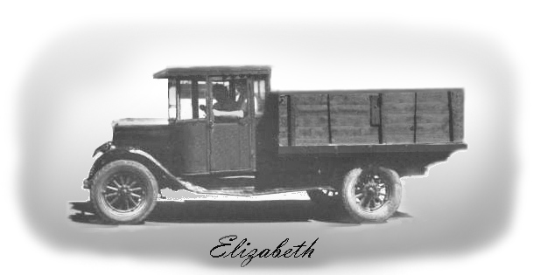

They visited the Skinners at Toefield who were old school friends of my mom’s. Then they drove to Jasper and down to Athabasca Falls and on to The Columbia Ice Field, then to Lake Louise and Banff. From there they were on the way to Waterton Park, which is on the Canadian side of the Montana border.
While passing through Pincher Creek they remembered I had a friend Lenora living there who was now married to Ron Oddie. They called Lenora on the phone from Pincher Creek and were invited out. That was the beginning of many years of great friendship between Dad and Mom and the Oddies.
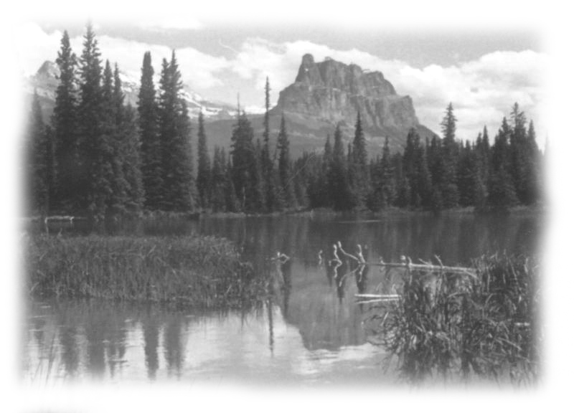

Photos of the Canadian Rockies by my father, John W. Cooke

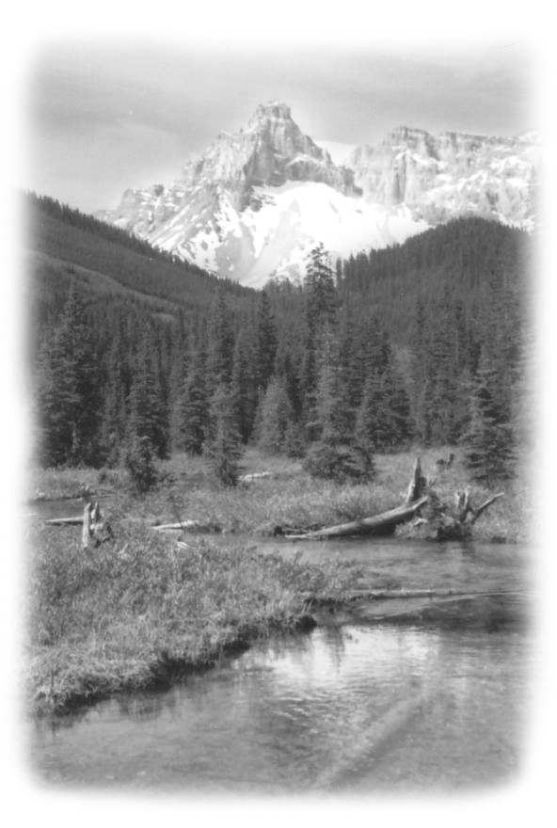
Nancy says she only remembers the trip in part. She remembers being at Bulls and driving the car and truck and of being in the mountains with grandpa and grandma. She is forever happy to have shared this with them. I keep thinking she was exactly the same age I was when I first took off on my first trip west on the Harvest Train all alone. I was fifteen coming 16 in October and all grown up.
The craze in the early Seventies was a razor cut. Everyone wanted you to razor cut his hair. Now some people’s hair looks great razor cut, especially the first time. But if you razor cut it every time you end up with split ends in your hair and many, many different lengths in your haircut. The short ends tend to be much stronger than the longer ends and it is a bit like combing your hair over a brush cut beneath. Sooner or later you need a good shear or scissors cut to get control over your hair again. But this kind of talk was a hard sell to kids wanting a razor cut.

The course also taught us to style hair with a brush and the use of gel and a hand held blow dryer. If you have a problem with unruly hair and you can’t handle it with a brush by stretching and turning it, then throw a wet net over it and blow-dry it through the net with hot air. The heat turns all the curls and rude ends under. When you take the net off spray the hair with hair spray. The hair is cushioning like, but hard. Do this too often and your hair will look and feel like sun-bleached hay. However the customer goes home looking great but after a day of sweaty labour and a shower he finds out he can do nothing with his hair himself. So in a short time he is back in to see his barber for another razor cut or he blames his barber for a bad haircut. I would try to sell him a scissor cut, telling him it will take two shear haircuts to outgrow the damage, which the razor cutting has done to his hair. But no, all his friends swear by razor cuts, so he will get another razor cut and blow dry and again he leaves the shop looking great and he feels good. But I know that tomorrow he is going to be cussing his barber, as he is sure it is entirely the barber’s fault.
The afro-hair-cut was a great hit with teens, especially those with kinky or curly hard to manage hair. The hair was pulled and combed straight out from the head with a wide comb called a pick and then cut to the shape of the head and sprayed with hair spray to hold it there. Some kids went for huge heads of hair. They spent hours picking their hair in front of a mirror and patting it with their hands to halo perfection. Then as if all this was not enough to get attention, bell-bottom trousers and outlandish loud pattern shirts and platform shoes came in style. It was like a crazy cross between a zoo and a sideshow, but somehow we all survived it.
Towards the end of the seventies some sanity returned to men’s hairstyles. It is the younger guys that always want change which lead the way to a different style. Each generation just does not want clothes or a haircut like dads. The guys that have the worst haircuts in the world today are those Johnny-come-late guys of the late sixties over into the seventies. They finally gave in and let their hair grow longer just as shorter hair came back into style. They think the Pierre Burton look of the 70’s is going to look good on them forever. They walk into a barbershop scared to death of getting into a chair and say, “ Just a trim.” They sit stiff as a dead man in your chair … praying you wont let their ears show. You know before you start that you can’t please them. It’s hopeless as anything off is too much. They can’t seem to see themselves as others see them. They just want to go on looking like Pierre Berton.
There are many stories I could tell you connected to the people I came to know through the Barber Shop. Some people become your friend just because you do a good haircut, and others because you took an interest in what they do for a living or their way of life. For a number of people though it is because they are New Canadians and everyone who they come in contact with on a regular basis is a familiar face among a mass of strangers. They are indeed in need of a friend.
The Sad Tale Of My Friend “ A New Canadian ”
One morning a very muscular well-built powerful looking man with a great head or salt and pepper hair walked into the shop. He had a warm smile and as he reached out to shake my hand, he said,
“My name is …….. I am Macedonian, I no speak much English.”
I said, “You’re Greek then are you?”
“No Macedonian”
“That’s would be something like people in our province of Quebec saying they are Quebecois and not Canadians” I replied.
“I suppose so, do you like Greek people?”
“Well you’re in Canada now. We don’t look at things that way. You treat me right and I treat you right and we will get along. Anyway I am stone deaf so we should get along just fine.” He saw the humour in this and quickly reached out his hand again to shake hands and said.
“We be friends.”
That was the beginning of a long time friendship, in which he shared many ups and downs in his life with me.
Mr. …. came to Canada in the 1970’s and went to work for his uncle at a lunch counter business on the southeast corner of Dundas and Maitland here in London. When he felt established he sent for his girl friend in Macedonia to come to Canada and marry him. She worked alongside him at the lunch counter for a few years. Soon they saved enough money to make a down payment on a house in Westminster Park in south London. Over the years they worked and saved to pay off their mortgage. They also had two children a boy and a girl. Mr. … opened one of the first sub shops in the heart of down town London on Richmond Street near Dundas, and it soon became a family enterprise. The family worked it in shifts keeping it open from early morning till 1 and 2 A.M.
This story took place over a number of years, but I would like to enter it all here.
One morning he came to the shop for a haircut and he was exceedingly happy. He told me he had just sold the house in Westminster Park and bought two forty- unit apartment buildings in the north end of London. When he told me where, I knew it was not the best part of town to own Real Estate, as you didn’t always get the best tenants. However the price was right and I didn’t want to damper his enthusiasm. He moved into one of his own apartments so he could do his own custodian work. He and his wife also put in long hours at the sub shop. Later as the two children grew up they to helped in the sub shop and all seemed to be going well for them so he opened a second shop on Dundas street east. I remember once when he was in for a haircut how he told me he planned someday to retire to Florida on the income he would make from his two apartment buildings. He said,
“Jack, I am on the way to somewhere, but whatever,” he reached out to shake my hand, “We be friends.” I could not help but like the guy.

Then his dreams all came tumbling down. This is what happened.
The boat people from China arrived by the hundred to Canada’s west coast. They staggered up on the beach half dead from hunger and seasickness. They told sad stories about what would happen to them now if they were sent back to China. Our government asked the cities across Canada to open their hearts and wallets and accept them. The city of London volunteered to take some of them. Of course they had to find a place for them to stay. Certainly they were not going to put then in expensive or even mid-priced apartments. The cheapest rent they could find was on the north end of the city. When they found there were a few vacancies at my friend’s apartment buildings they asked him to take in some of these boat people and this was the beginning of what destroyed his Canadian dream.
Several families were put into each one or two bedroom apartment. For a number of years more and more boat people arrived in the city and each time the city turned to him to accept more and more of these people. Mr. … did not want this number of these kinds of tenants. He wanted to be able to chose his own. After all, this was his investment not the city’s, nor the Province nor the countries.

It was he who had to keep the building clean and in good repair. These people were not use to counter tops in the kitchen, so they hacked on them and damaged them. They were not use to inside plumbing and with several families in one apartments the toilets were clogged and over flowed. The washing machines were broken down from too many clothes being washed at once. More and more children were born each year and only added to the problem. Kids fixed bikes on the tiled area at the front and side of the building and broke it up. They took their bikes up the staircase and down the halls marking the walls. Mr. … could not keep up with the damage and the problems. The city tried to enforce repairs and sanitation, but as quickly as he fixed things they soon broke down again. When in his broken English he tried to express his personal stand on all this, the city and the press took advantage of his limited English. He made the statement that these tenants behaved like pigs and of course the CFPL, the Free Press and one of the cities most prominent human rights personnel set out to chastise him.
Together they contributed to his downfall. It seemed the story they tried to get across to the public was that here was a wealthy man who owned two forty unit apartment buildings and he was a racist and didn’t want these people in his building. The truth was he was willing to help, but he didn’t want the full load.
When all this erupted on TV and the newspaper some people even went to his sub shop to cause him trouble and it affected his business causing it to dry up. All this happened because the general public was kept ignorant of the real problem.
Certainly the city dumped a huge problem on him, and it was the city’s problem to solve, not his. No private citizen should be forced to do what was asked of him. In the end he had to walk away from everything, his two apartment buildings and his sub shops. He offered his property, the apartment buildings to the city, but of course the city knew very well the problems they would inherit if they took on the building with these tenants. Mr. …. Came in for a haircut and told me about his loss, in tears.
He said, “I came to this country with intentions of being a good citizen. We have worked hard to get ahead and to have something of our own and see what happened. If this is democracy then I might as well go back to Macedonia.”
A few months later Macedonia became a country of its own separating from Greece. Mr. …. Came in to tell me that this would be his last haircut that he was leaving with his family for Macedonia. I remember asking him if he was sure he wanted to do this. He assured me that it had been his dream all his life that one day Macedonia would become its own country free of Greece, so we said goodbye.
A few months later he was back to the shop. He told me that while he and his wife would like to live in Macedonia, his two grown up children who were born here would not stay. They said they were Canadians. He and his wife of course would not stay without the two children as someday they hoped to watch their grand children grow up.
The last I heard of him was that he was driving a huge transport truck to and fro from California to make a living. I feel ashamed and sad that our Great Canadian System was allowed to do this to a good man and his family. Shame shame.
Just before Christmas in December of 1979 I received the shock of my life when Tippings came into the shop one Saturday morning serving me with a letter. The letter told me they had sold the property to Kentucky Fried Chicken next door and I had sixty days to vacate the shop. They tried to ease the situation by telling me they had not sold it as a business but just as Real Estate. I suddenly realized the value of a lease and Joe’s words came back to haunt me when he had said,
“ Now Jack if you don’t trust me, I will give you a lease.”
They had bought this property on Wellington Road in 1963 for $23,000.00 and sold it in 1979 sixteen years later for $170,000.00. This was a lot of money at that time. Word soon got out about the sale and some of my customers came in to congratulate me thinking I would have been able to sell my business to Kentucky Fried Chicken for a good thing. They were shocked when I told them I couldn’t because I didn’t have a lease. So the Tippings sold my business along with the house and the beauty shop and the Aqua Shop all together and called it real estate. Some local businessmen suggested I threw away perhaps $25,000.00, which I might have got from Kentucky Fried Chicken if I had owned a lease and had been allowed to deal with them myself. It is interesting to note that in January 1980 I got 17% for the money I put in RRSP. That money would have more than doubled if compounded in those five years. I really knew I had missed the boat all because I wanted Joe to feel I trusted him. If I had said I wanted a lease I would be a much wealthier man now about twenty-five years later. The oldest Tipping boy was now 16 and he came in for his last free haircut. He was concerned about what was going to happen to me. He was only 16 but had his own ideas about what was right and wrong.
He said, “Jack it is not right. I told dad and mom they should have given you a lease and let you deal with Kentucky Fried Chicken on your own.”
Jack Loses His Shop and Starts Out New
After searching all over the south end of London for a place to locate my barbershop, I settled for a space in a new Plaza at the corner of Jalna Blvd. and Meg. At that time all the money I had was tied up in RRS and the government will not let you use Registered Retirement Savings money as a collateral for a loan. To put in the new shop I needed about three thousand dollars cash. The banks at that time wanted 23% interest on a loan, so I thought surely after what had happened re my business I could just ask Joe and Jeanette for a three thousand dollar loan at a lower rate. They owed me at least that.
They hated to just come right out and say no, so they put me off for several weeks and then when I could wait no longer as I had to have an answer they said no. I found it hard to forgive them as I had given them no reason not to trust me. Well my credit was good at the bank so I took a loan of $3000.00 at 23% and somehow I managed to pay it off along with my RRSP loan.
Regina Mundi had two barber chairs in their shop and I was only using the one. I asked if I could buy the second chair for my new shop. They sold me the chair for fifty dollars, which was a very great buy.
The new shop was to open on the Tuesday of the first week of March 1980. I worked in the old shop right up until the Saturday night the weekend before. Nothing was going right over at the plaza it seemed. I just could not get the management to partition off my shop early so I could start to paint and decorate. The shop area then had to be partitioned off again to build a hallway back to the bathroom. Only when this got done could I proceed to paint and paper. I remember that on the Saturday I slipped over on my noon hour to see what was going on. I found them putting up the wall in the wrong place, giving me more space than I had leased. I called the owner and he said it was too late to change things now and that they would just let me have the extras space.
That after noon Arnold and Pearl dropped into my old shop to ask me how things were going in the new shop. I told Arnold that I had not been able to get them to proceed and get things done so I could start to decorate. There was no way I could get it all done, move in and open the new shop the next week.
Arnold said, “Then you could use a hand.”
“I could use a half dozen hands.”
Arnold told me he would see what he could do.
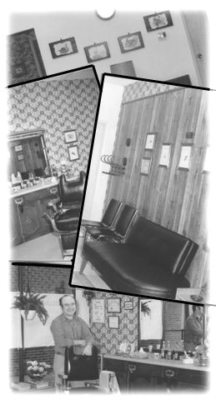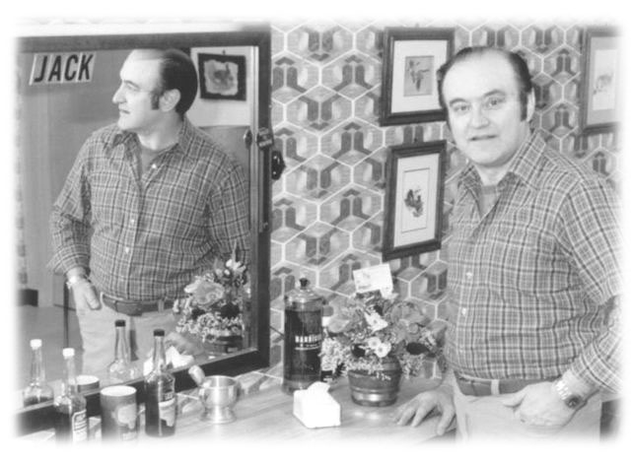
Jack In His New Barber Shop On Jalna Blvd.
The next morning, Arnold and Pearl and Bill and Jean came down to help me. I was never so happy to see them in my whole life as I was truly up against the wall. Time was not on my side. You could not imagine the work we managed to do that day. Bill and Arnold first put the oak panelling on the south wall of my shop, while Jean painted the front and rear wall, and I papered the north wall. Pearl papered the hallway and the bathroom, which even included the piping. Then Bill and Arnold put my bathroom vanity stand in and hooked up the plumbing. They also hooked up a basin in the shop area as required by law within six feet of the chair. At noon I took them all down the road to Ritchie’s lunch counter at the northeast corner of Wellington and Exeter Road for dinner. The Ritchie brothers fed them well knowing they were my sisters and brothers-in-laws When Sunday night came we had made amazing headway and things were well along the way so I could move out of the old shop and into the new one on Monday.
Bright and early on Monday morning my work crew arrived back in London. They also brought Jean and Bill’s son Wayne to help me. Jean and Pearl tackled the big front windows, which were filthy with both dirt and four letter words. Then we washed and waxed the floors before bringing in my new furniture from the vacant area next door where I had stored it. We hung my Glen Loate’s animal pictures in a grouping on the oak paneling south sidewall where they stood out beautifully. I remember Pearl and I went over to the mall to buy a clock to put on the rear wall. We found a beautiful one with an oak frame. Bill admired it right away when I brought it back to the shop. Looking at the rear wall I found that Arnold already had a screw in the wall waiting for it. I have that same clock hanging in my kitchen today, a pleasant reminder of time spent in my barbershop.
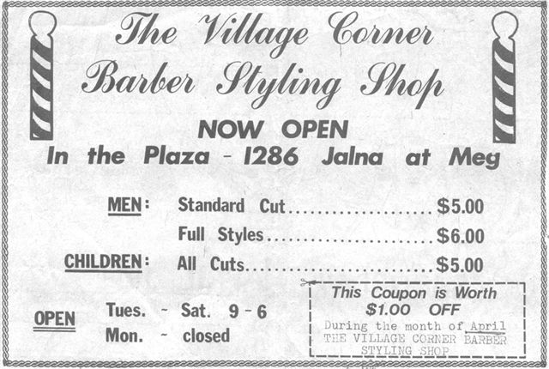
For My Grand Opening March 4th. 1980
My good friend Olga Filko wanted to come to my opening and look after coffee and donuts; she also brought a great looking arrangement of artificial flowers with a masculine touch to go on my cupboard They were just perfect for a men’s shop. I received several other potted flowers which I placed in the window along with a huge professional paper sign which said, Village Corner Barber Shop, Grand Opening Tuesday March 4th, 1980. When I had arrived that morning to open the shop I just could not believe it. Not only had everything got done, but also it was done to perfection. The guy who owned the plaza dropped in to congratulate me, and he said, “Tell me where can I hire a work crew like yours? I find all this hard to believe.”
I will never forget my family for being there for me when I needed them the most.

The Sign Over My Shop Door
In September 1963, I cut hair in my first shop for $1.25 for adults and $1.00 for children. In 1980 when I opened the new shop at Jalna and Meg I charged $5.00 for adults standard cuts and $6.00 for full cut with styling and $5.00 for children.
One day Joe Tipping’s sister came to the shop, partly to see the shop and partly out of curiosity to find out if what she heard about her brother was true. She wanted to know if it was true that Joe and Jeanette had more or less kicked me out without giving me a thing for my business. I told her that since I did not have a lease they didn’t have to give me anything.
She said, “Jack, I can’t believe it as they always made such a fuss over you. You helped raise those kids by always being there for them everyday. If it were not for you they would never have been able to hang onto that place. You literally paid the mortgage for them each month.”
All this may be true but it was not to be, so now I had to realize this and move on. I had never charged Joe for a haircut at the old shop, so now he only came in when his hair was very long for a much needed hair cut, and I could feel that things were not the same between us. Eventually he stopped coming in. In spite of everything that had happened I will always have a place in my heart for the Tipping family as we had many great times together. I was included in many backyards barbecues after work and also Christmas and New Years parties. However one never really knows anyone until the money comes into the picture.
For All of Us, “ Life Moves On ”
Mr. Buchanan was getting older and his hip gave him a lot of trouble. Caring for the property was getting hard on him. I tried to help out by cutting his grass when I did mine and shovelling snow from his sidewalk and entranceway along with mine. Later when I dropped up for a visit or a cup of coffee, he would say,
“Jack I polished your halo last night, thanks for cutting the grass.” I would tell him that that was good, as my halo could stand a lot of polishing.
When someone vacated an apartment, he would have to paint it before it could be rented out again. He would ask me if I would do the painting for him. He would pay me $6.00 an hour, which was above the government rate at that time. Over a number of years I painted just about every apartment in his building. Then he asked me if I could paint the whole inside of the building, meaning the halls, stairways and front and rear entrance ways. I said I could as long as he was not in a hurry. I would paint evenings and weekends. Now that I didn’t have the Regina Mundi haircuts to do I liked the extra work. Today I cannot imagine doing it.
I dug his flowerbeds and put in the flowers and flower boxes. I took off the storm windows and cleaned all the apartment windows in the springtime and again in the fall. I cleaned all the apartment windows and then cleaned the storm windows and put them on. It was a big and tiring job especially when I had the same work to do at the VON building too. Today I have no idea how I got it done. Somewhere along the way over the years my get up and go, got up and left me.
In the late seventies my dad and mom traded the trailer for a 21 ft. motor home. They were both in seventh heaven, as they just loved to travel on weekends or take short trips up and down the lake, to Algonquin Park or into Northern Ontario. They even spent a few winters with it in Florida. Mom told me once as much as she loved to go away in the motor home she loved even more getting back to her little home in Mitchell. Indeed it was a showcase with the house surrounded by shrubs and flowerbeds and a lawn that was always kept neatly cut.
They had been west several times over the years with the trailer and the motor home, but when dad announced they were leaving on yet another trip west in the summer of 1982 we hardly knew what to say. Dad was 82 in Oct. the fall before, and we did not want to destroy the faith he had in himself, yet we could not help but worry about them out on the road so far from home. We also knew that once dad made up his mind to do something he was not going to back down. So we sent them off with our best wishes for a safe journey, and begged them to be careful and to keep in touch with us. They made it all the way to Waterton Park Alberta and also visited with Ron and Lenora Oddie in Pincher Creek, then drove on to Oyen to visit with the Bulls. After several weeks they returned home safely. That was the last of their big long trips.
The Dream Car
The 1983 Z 28 Chev Camaro
In late fall of 1982 I thought it was time for a new car again. Like ever so many guys at that time I liked the Chev Camaro Z 28. After searching and comparing prices at many places I ordered a new black 1983 Z28 Camaro from the dealer in Aylmer, a small town southeast of London. I still have the bill of sale; it cost me $15,192.00 with tax. I sold my Dodge Magnum privately to one of my customers only a few blocks from my shop. I told them they could have the car in 6 weeks. That was when the car I ordered was to be delivered. Six weeks came and went and no car and my buyer wanted the car. I had to take the bus to work for two or three weeks until my car arrived and by now it was mid-winter. I can tell you if you’re used to riding in your own car to and fro from work it is no fun riding on a bus. When the Camaro finally arrived my friend Nevol drove me down to Aylmer to pick it up. Man! I was one proud guy driving my Camaro back to London that night. I remember stopping at the Wellington Rd. Southdale light and a kid in the car next to me looking over at my brand new black Z28. He inhaled and exhaled deeply and shook his head as if in a sort of dreamy daze and then smiled at me.
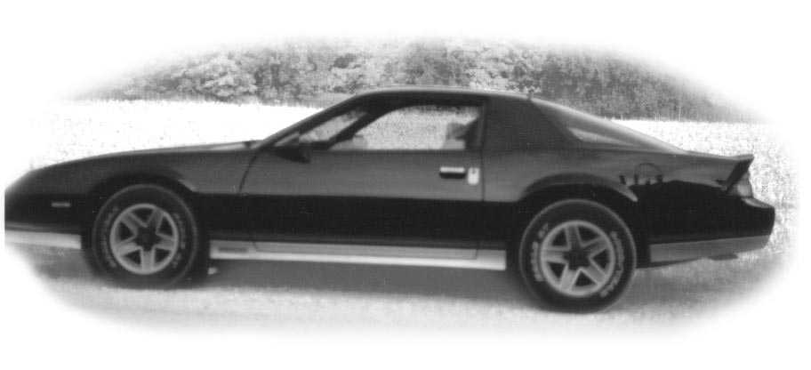
My 1983 Z28 Camaro
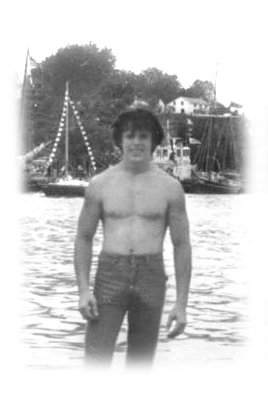
My Friend John
There are many people who come into our life’s temporarily, we call them acquaintances. Others come into our lives and stay. They are your friends.

The London YMCA Burned Down Jan. 1981
The old London YMCA on Wellington Street in downtown London burned down one terrible cold and stormy winter’s night in January 1981 and the new one opened the fall of 1982 on Waterloo Street at King. With all the new equipment and plush surroundings at the new Y. I was inclined to work out even more seriously. The great thing about the YMCA was that you became acquainted with many good people young and old and of all nationalities. There was one young guy there who worked out most nights with great energy. He stood out in the crowd. His name was John. As a rule he worked out with an older person who worked at London Life. We had chatted casually but I didn’t get to know him very well as with only a little over the hour to work out I didn’t have a lot of time to socialize. John was always there when I arrived for my workout and while his friend usually went home early, John himself was still there working hard when I left for home.
One day John came to me and told me his friend was going on a month long holiday out of town and he wondered if I would work out with him for a month. Well as he was only 17 at the time, so very much younger then I was. I was a bit flattered to say the least. However I told him that I noticed he was already working out when I arrived at the gym and he was still working out when I left and I didn’t have that kind of time to work out. Naturally he asked me why I had so little time. I told him about my second job as custodian at the VON. Building. He seemed to understand but he was not about to give up. He asked me if he was to give me a hand at night and on weekends, then, could I work out with him? I found it hard to resist, as he was so earnest I told him we could give it a try and see how it worked.
Over that month we became great friends and we are still friends today. John went on to take a sheet metal course at Beal, and after working for someone else a few years he started his own business on Hamilton Road called “Home Comfort.” It seemed he put the same energy into his work as he did to his workouts at the gym. I am proud to say while John is only 38 yrs old he is a multi-millionaire today. However to me he is still the young lad I remember meeting at the Y.

Barber Shop Tales
I had a great looking “V” billboard sign made and professionally hand painted advertising my shop and haircuts to put out by the curb. I carried it out every day and every night at 6 o’clock I carried it back to the shop so it would not get vandalized. A little kid called Johnny who lived in a townhouse across from the plaza watched for me at six o’clock and every night he would come running out across the street to help me carry the sign in. Actually if he let me do it by myself I could balance it by the middle to carry much easier. But who am I to spoil a little kid’s thoughtfulness? One night his kid brother who was carrying a peanut butter sandwich followed him on the run. As he approached us he stumbled and his sandwich fell apart on the asphalt parking lot, peanut butter side down. The kid stopped and looked and then with two fingers and great care he turned the one slice of bread over on the lot, then carefully picked up the other slice with two fingers, one on either side placed it exactly on top of the slice he had turned over. He then raised it to his mouth and took another bite. Johnny and I watched with humour, but when I saw him raise it to his mouth.
I said, “No! No! Don’t eat that” but Johnny spoke up and said,
“Don’t worry about him…. nothing can kill him.” So much for brothers.

For many years it seemed when you didn’t know what to buy your dear brother or uncle for Christmas you could always solve the problem by buying him yet another good lambswool sweater. For some reason I never could wear wool and every year I got more and more of these beautiful wool sweaters. My drawers were full, and no room for anything else. So one year just before Christmas I thought I would put up a table at the rear of the shop and sell them. I divided them into three groups and put a stick-on price on each sweater. I also had a few sweaters from a friend to sell. He was asking several dollars more for his sweaters so he put the price he wanted on each of his sweaters. This way even if I was busy with a haircut I could handle the sale. On a Saturday morning when I was very busy a dark man who looked as if he came from the Middle East looked at the sweaters after he had his haircut. He put a sweater in a bag and handed me a price tag, along with the money. After he went out the door the next guy that got in the chair told me that he saw the guy switch the price tags on the sweater he bought. I checked and sure enough he had taken one of my friend’s best sweaters and it was ten dollars more then I was charging for mine.
I waited for him to come back for his next haircut; he was always a very fussy customer and frankly I was going to be glad to be rid of him. Finally one day he came in and got into the chair, I put the chair cloth on him and gave him his usual haircut. I think he would know I was not my usual self. When I finished his hair cut I put the clippers in the centre of his head and I told him I knew he had switched the price tag on the sweater he took as one of my customers had told me that day right after he walked out the door. I told him it had cost me five dollars to pay to my friend as he entrusted his sweaters to me. I advised him to reach for his wallet very carefully and give me the ten dollars plus the price of his haircut or I would run the clippers down through his hair. Then I told him he was never to come back to my shop again. At that time I was all muscle from my work out at the gym so he didn’t argue with me. In fact he never uttered a word and I never saw him again.
There were many special times I have wished I could hear, as being a barber gives you a lot of insight into life and other people’s problems. While I manage to understand a lot, I only get a fraction of what is said. A lot of people just need a deaf ear to lean on, to shed their pain and sorrows or share their joy and happiness. Some little guys came in for a haircut with their daddies, brimming full of great and important news. They had so much to tell me. While daddy had tried to explain to them the barber was deaf, they didn’t quite understand, so they just kept on jabbering away while daddy rolled his eyes.

At times like this I try to fit in the right answer with,
“Oh! Is that so and right, right, and you don’t tell me” I keep hoping I get it all in the right place. If I get an odd look I quickly cover myself by changing my mind.
I remember this one little chap who was so very earnest in his conversation that I just had to ask his dad if he could explain to me what this was about. His dad said,
“No no, believe me it is best you can’t hear him.”
Thus I miss quality conversations with children, because I live in a Silent World.

“ Break-ins ” plague all small shops, and insurance rates climbed out of sight. All those years I had the barbershop I didn’t feel I could afford insurance on my apartment and contents and insure the shop too. So I just carried insurance on the shop. This might not have been a very wise decision as I had a lot of collectables, but it worked for me, as I was fortunate not to have had any great need for it.
We always felt that the “break-ins” were done by local kids, and it was petty stuff, as who with a brain in their head would break into a barbershop, especially so if they did not want your barbering tools. One good Oyster Clipper with tax is worth about two hundred dollars, the blades are worth about $50.00 each, and you must keep two large clippers and two smaller trimmers on hand at all times in case one stopped working in the middle of a haircut. A good pair of shears today can cost you $45.00 to $85.00.

However they came looking for money, so usually we left a small bit of change in the till with the hope it would satisfy them and thus they would not vandalize the shop. So they overlook almost a thousand dollars worth of tools and take home a few dollars worth of change. The first times it happens, you feel it is personal, but after a few years and a number of break-ins you know it is just some local kid whose parents have lost control and don’t know where he is late at night. If he is looking for excitement and cash, he could hardly take your clippers and barbering tools home to mother. He could easily vandalize your shop but doesn’t do it as he most likely knows you quite well and perhaps even likes you, but at this time in his life he would steal from almost anyone, even his parents.

There was a deaf lad about 17 who came in for haircuts and sometimes just dropped by to chat. I had heard he was trouble but I felt because we were both deaf we had a common bond between us. At six every night I would go out to bring my billboard sign in from the curb. One night when I went out I noticed him and two other chaps hanging out around the plaza, but I just didn’t give it much thought as I had often seen him on the plaza lot. To me he had a right to be there as he was one of the local kids. On returning to the shop with the billboard I noted only one kid was now visible. The other two had disappeared. The boy walked away as I approached the shop. On entering I saw the till had been pried open and damaged. My day’s proceeds were gone and the shop’s back door was now open.

I looked out on the lot and none of the boys were in sight. I knew the deaf boy hung out with another boy who lived directly across the street from the plaza. So I hurried over there and the mother answered the door. I told her what had happened and she called her son to the door and had him tell me where this deaf boy lived. I went directly to his home and his father (whose hair I cut) and mother were home. They were very upset as he was already on probation for theft and break-ins.
They were happy I had not gone to the police and said he would go directly to the mall to spend the money so in great haste they left for the mall to try to catch him before he spent it. They promised me they would be at the shop first thing in the morning with the boy and my cash.
True to their word they were at the shop the next morning and I got an apology from the boy and all of my money back. That may sound good, but I still lost in the long run as neither the father nor the boy ever came back to the shop for another haircut, so in the end I lost more money than I gained. However I think I handled it right, as I just didn’t want to have a deaf local boy locked up over me. I do feel the dad should have come back to me for haircuts as I had done right by that family, but I guess they didn’t know how to handle the shame and that is sad.

Mr. Buchanan next door was failing and needed more and more help each year. I was always there and ready to help him whenever he asked. I actually had a busy enough schedule keeping the VON work up but I wanted to be a neighbour. I painted whole apartments at nights and over weekends. I really didn’t enjoy doing the painting, as it was just too many hours work for me on a weekend. I would go back to work a little wealthier but tired from my weekend work.

In the spring and fall I went up on the roof and greased the ventilators. I cut grass or shovelled snow and all the time he would polish my halo. He had family up north near Kincardine but they never came near him to offer any help. I suppose they felt he could hire it done.
They had me over for Sunday dinners and many times for coffee, especially Sunday mornings. It was a great place for me to go to when I had a problem or when I wanted a second opinion. I knew I would always get the right answer but perhaps not always just what I wanted to hear. I felt more and more like a son to them.
Life through the mid eighties was more or less, more of the same. God never meant for me to get wealthy but I dare not complain as some how at the end of every month the bills got paid and my monthly loan payment for my RRSP made.
In 1986 my dear old friend and second mom Mrs. Bull passed away at 92.

Dad and Mom Sell and Move to Ritz Villa
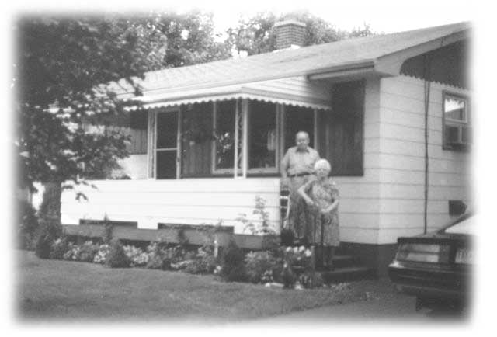
Dad and mom were not getting along very well at home. My mom was diabetic and her memory was getting very bad and she was confused. It was hard for them to sell that little house as they had a happy retirement life there.
I was up to see them on a Sunday, and dad said he was going to put a for sale sign out on the lawn the next day and he was going to see if he could get $50,000.00 for the place. The place had been well kept up inside and out. I told him I thought it was worth more and that he should ask $60,000.
Dad and Mom Seeing Me Off
From Their House on Arthur Street Mitchell

He put his sign out and it was sold within a couple days for $60,000.00. Dad was so proud of this and kidded every one he was going to start selling real estate. They bought the house in 1969 for $12,000.00 and sold it 15 years later for $60,000.00.
It’s called inflation and it is supposed to be bad for us. It was hard to see all their treasures sold off in an auction sale, but they held nothing back. I had bought dad all kinds of tools over the years for his birthday, Christmas or fathers day. I had often said,
“Oh well I can’t lose, I will get it all back some day as I am the only son.”
How very wrong I was as every tool was put in the sale, nothing held back.
They moved into Ritz Villa, one of Mitchell’s finest retirement homes. It took a while to adjust and settle in, but they seemed to make the best of it. Dad still had his wheels and that alone meant a lot to him. There was a bad winter or two and dad just let the car sit on the lot all winter. He was good about not driving at night as his eyesight was failing him. If he went out to visit he arrived home before dark.
I am sorry to say we sort of tricked him out of his driving license in the end, as we wanted him off the road before something bad happened. His birthday was Oct. 21st and his driver’s license was due for renewal on that date. We said,
“Well since you don’t care about driving on winter roads why don’t you take a six month licence and save money?” That appealed to dad. He thought that might be a good idea. However the next spring when he wanted to renew his license, he could not drive the car to Stratford to renew and that was just as we had planned it.
My sisters had told me not to give in to him if he asked me to drive him to Stratford. Sure enough one fine spring day he asked and he was very angry with me when I said I could not do it. He left the room in a huff and did not come back until I was ready to go home. As I walked out the door of their apartment I said,
“I will see you in a couple weeks.”
Dad said, “Well we will be here, where else would we be? We can’t go anywhere” It wasn’t funny for him, but I have chuckled over that many times over the years.
He got a fair price for his Grand Fury Plymouth car selling it right off the Ritz Villa lot and this seemed to help him to forget the pain of being without his wheels.
Wm. Bull Passed Away
March the 8th 1987 I got the sad news that my dear friend Wm Bull whom I had worked for so many years ago had passed away suddenly in the Red Deer Hospital of a heart attack. He and Alma had been visiting Alma’s brother near Delburne when Wm. had pains, so they rushed him to the Red Deer hospital where he spent the night. The next morning they were ready to release him but he suddenly took a massive heart attack and passed away. I grieved for Wm; he was a good man a good husband and father and had been a good friend to me.

My Friend Mike Returns To The West
In Search of His Roots

In the spring of 1987 my good friends Mike and Jigs took a trip west, to see the country and to visit Mike’s many uncles, aunts and cousins in the area far to the north west of Peace River, a place called Worsley. Mike, like all of us wanted to return to his roots, and to visit the old farm on which he was born and lived for the first few years of his life. When his dad and mom left Worsley with him in tow for Ontario, he remembers vowing he would return, and return he did, but many, many years later. Mike and Jigs had three children by now, Shelly the oldest then Connie and Joe. Connie was now living in Prince Albert BC, so after they finished the visit at Worsley they drove south into the interior of BC into the picturesque country of Prince George. It seems Connie had just recently moved there from the town of Creston a fruit and vegetable area at the south end of the Kookenay Lakes, and only ten miles north of the Idaho Border. She wanted her Dad and Mom to drive down there to see that area as she thought it would make a great place for them to retire to, when the time came.
When they reached the Creston valley it was love at first sight, and before they left they bought an empty piece of land out in the country south of the town and 6 miles north of the Idaho border. It was a bit less then 50 acres and a mixture of level alfalfa fields, bush, swamp and an ever running fresh water creek that winds it way down from the mountains. One day they would return to build here.
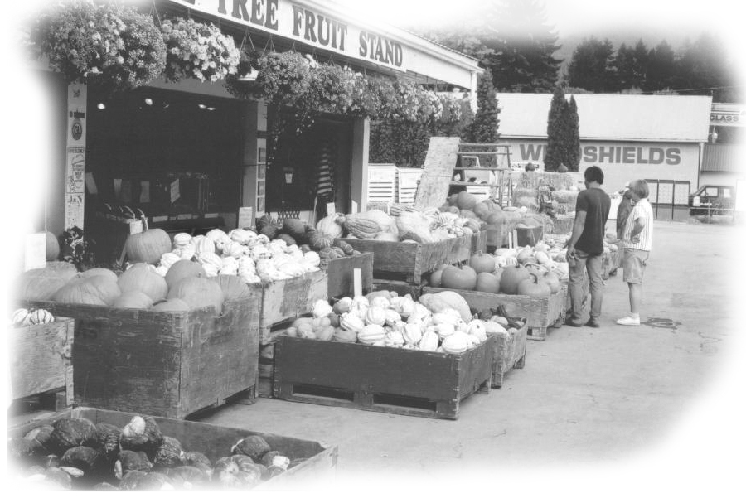
One Of Many Fruit and Vegetable Stands
In Creston BC

Lenora and Grace Travel East
September the 10th, 1987 my friend Lenora Oddie left Pincher Creek Alberta with a friend Grace Snell for a trip east to Ontario. They ended up visiting my dad and mom the evening of Sept. 19th. A few days later on a Monday they came to London and I took them on a royal trip down to Niagara Falls and area. Neither of them will ever forget the great effort it takes to get in and out of the back seat of a Camaro Z 28. They took turns grumbling as to whose turn it was sit up front and whose turn to sit in the back. I have never heard so much grumbling and grunting and groaning in my life and I was never been able to live it down.
While driving around Southern Ontario I have never felt a great need to consult a road map. They were constantly worried that I was lost. Actually I did get lost once when I took a short cut but men never admit getting lost to lady friends; it is not manly and it’s very unbecoming. These two women should never travel together as each one has a mind of her own. Once out of the car they walk off each in her own direction. Neither one will follow the other. There was a huge crowd at the falls and Lenore went east and Grace went west, I stood half way in between them calling, beckoning, pleading for everyone to stay together or someone would get lost. But they paid me no heed. I would hate to have to act as a guide for a busload of western women as unlike cattle they won’t follow the leader.
Lenore and Grace went back to Ritz Villa in Mitchell to say good-bye to my dad and mom, and that was the last time they had a chance to visit While Lenore was there, dad complained that he was not feeling well and was in pain. The ambulance was called and took him to the Stratford hospital. They found he had to have surgery for tumours in his bowels. The operation went well but a day or two after the operation he had a mild stroke. This seemed to rob him of his strength and will to get better. He pleaded with us to make them stop the recovery program, as he just had no strength to endure it. We told him it would mean the wheel chair if we did this. But he reasoned that a lot of people spent most of their lives in a wheel chair and he didn’t feel he had that many more years left to live. Right then all he wanted to do was rest and be left alone. So we gave in and let him do this.
When he came out of the hospital Ritz Villa was not prepared to handle people permanently in a wheel chair. So in a short time he and mom were separated when he went to Smiths Nursing Home in Mitchell. Mom began to fail a few months later and she was moved to the same nursing home as dad, but because of various problems they thought it best to keep them separated. This always made it difficult for us when we went to visit. Each wanted more of our time, as they were lonely.

