Rundle and a fantastic view of the town of Banff from high above. Soon we had to say farewell to the mountains, Banff and the park as we left for the Big City. …. Calgary.
In Calgary we found a huge McCloud Western Clothing Store, which sold everything from jeans, to shirts and cowboy boots. But it was a Stetson Cowboy Hat the boys wanted to buy before leaving for home. A hat cost us more than a week’s wages, but that was the way true westerners were. They would spend a fortune on their hat and their boots and five bucks on a pair of Wrangler or Lee jeans.
It came time for Dave Skinner to part with us and go back to Toefield to his uncle and aunts. I was surprised to learn that Earl Paulen had decided not to go home with us but to go back to Toefield with Dave. So we parted in Calgary.

I drove south towards High River with the rest the guys, Bruce Eisler, Glen Sykes and Earl Foster. Now we had actually regained room for our elbows in the car, two in the back and two in the front.
A few years before when I visited Wib Duncan at High River he had taken me to see the Prince of Wales Ranch near Longview and told me all about its history.

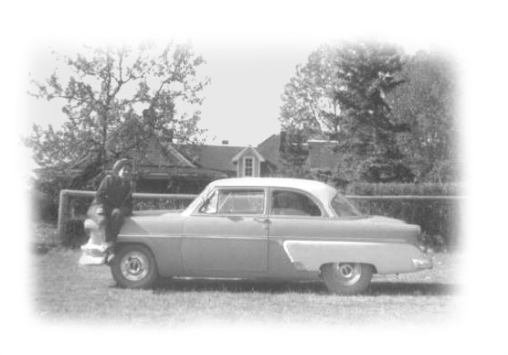
It is straight west of High River towards the foothills and is also very close to Wib’s own Ranch, just a few miles as the crow flies. So we decided to visit the E P Ranch.
In 1955 the Prince of Wales, or E. P. ranch was intact with hired workers and a few hundred head of magnificent white face Herefords. A beautiful log barn with a hip roof that extended out and over at its gable ends made an impressive setting within a fenced yard and topped by a white pole all the way around. A large low ranch house with two cape cod windows in the roof and vine covered verandas were set on well-tended lawns. An extension to the rear of the main house was a servant quarters we were told. There appeared to be no one around so we ventured onto the veranda and boldly looked into the living room and dining room windows. It appeared that everything was kept clean and ever so ready, ready for a Prince to come home someday and run this wonderful ranch. But that was never to happen.
Glen & my 54 Ford at the Prince of Wales Ranch

Wib believes this prime ranch country is perhaps the best in all North America, and I believe he is right.
The first breeding stock of 11 cows and a bull were brought in about 1873. It wasn’t until 1881 that leases were made available for individuals and also large ranch companies. One could lease up to one hundred thousand acres for one cent an acre. In spite of what sounds like a great giveaway today it took 21 years to sell all the leases. You were only to put one cow per ten acres of grassland. So if you wanted to run one hundred cows you would need a thousand acres of ranch land.
In 1919 after the First World War, Prince Edward heir to the British throne was sent abroad on a world tour. When he travelled across Canada he spent most of his time visiting veteran’s hospitals in large cities. While in Calgary he received an invitation to visit the Bar U Ranch at Longview. As a young man this must have appealed to him as a vigorous and challenging break from his royal duties. Like all of the royal family he loved stock, sheep, cattle and horses, so visiting a real ranch must have been a great adventure for him. Edward was very likeable and enjoyed being just one of the gang as he was when he fought in the trenches during the First World War. He rode a horse in the fall roundup and it is said he did very well herding the cattle. He was exhilarated by this life and sold on the romance of ranching. He arranged to buy a 4000 acre ranch near Longview. He kept the ranch until sometime in the 1960’s when it was split up and sold.
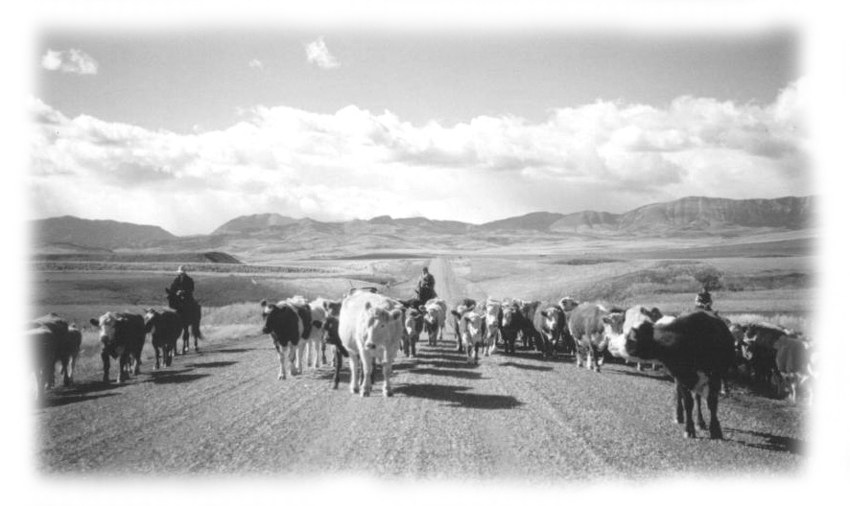
Cattle Drive in Southern Alberta
The duchess was not at all the ranch type, and did not share his dream. He was a young man who could well afford to make his dreams come true but he gave it all up for his love of the duchess. One can’t help but wonder what might have been if he had been free to live a normal life. Did he just while away his years in Paris living in luxury and boredom? Did he ever dare to dream again of his youth and his ranch in Alberta?
The trip home was made across Canada to Manitoba and then down into the US where we followed the same route we had come out on. All I do remember about the trip home was that the boys took up cigar smoking. While I might have enjoyed smoking one cigar, they kept on lighting up. I was sick from breathing in all the smoke and they were sick but too proud to admit it. I couldn’t get them to stop so as punishment I drove late, late, after dark, listening to them whine about being tired and wanting to end the day and yet still smoking. Finally they got smart and quit or ran out and I found a place for the night.
Over the years we have reflected back to this trip many times. As far as I know only one of these boys, along with his wife (Glen and Jean Sykes) ever returned to Alberta. Each of them married and kept on farming and now brag about their grandkids. Sadly Glen passed away with cancer in the late fall of 2004.
Upon arriving home I was surprised to find out that my Dad had bought a brand new John Deere AR tractor. I was rather shocked to say the least, as I had no idea he was thinking of trading up. Also I was not really a fan of John Deere. Then again I felt hurt because he did this without saying a single word to me. I guess it was just that I could not shake the thought that as a son I was in some kind of partnership and a part of all this.
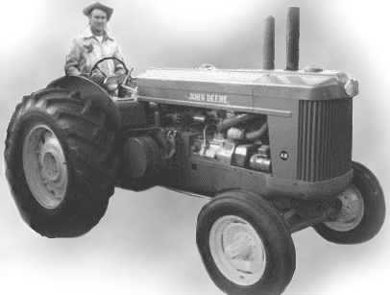
Jack on Dad’s New John Deere
The John Deere proved to be a great tractor and I soon loved it.

Dad and Mom Take A Boat Trip To England in 1956
In 1956, my dad and mom decided to take a trip to England by boat as my mom would never fly. They hoped to sightsee in both England and Scotland and to visit my grandfather’s family in Peterborough. My grandfather, born in 1866 was one of a very large family. His youngest brother, my Uncle Ted and wife Gussie had visited us several time on the Mitchell Road farm. Up until this trip to England dad and mom had scarcely ever, been away from home overnight since they were married. Such was the life of a farmer. After that trip to England they had only two other trips before they retired, both were trips to western Canada. This first trip was by themselves to England; the second to Western Canada with my mom’s brother, my Uncle Roy and Aunt Myrtle Butson. Len Butson the son lent them his brand new Dodge car to take the trip. They were overjoyed about this. The third trip was again out west with mom’s oldest brother my Uncle Loril and Aunt Pearl Butson. They would take these trips between seeding and haying time for about three weeks long; the trips could not be any longer, as the hay crops would be waiting on them upon their return. I managed to keep the farm going while they were away.
When they left for England in the early spring the cattle were still in the stable, calves were to be born, milking had to be done morning and night and stables to clean with the fork and wheel barrow and in my spare time I was to see that the land got worked and the grain crop put in. I also had to feed the hogs and watch the sows with little pigs, plus tend 500 baby chicks. Nothing went as planned mostly because it kept raining and raining all spring keeping me off the land and the cattle in the stable. The fields were too wet and soft to turn the cattle out, as they would ruin the pasture and turn it into a sea of mud. Calves that were supposed to be born outside in the pasture fields were born in the barn and were always under my feet. I had no space for them so I had white-face-calves tied up everywhere. They would grab hold of my shirttail or pants as I passed by them in the passageway. Nothing is as cute or more innocent than a white face calf.
I didn’t see much of my sisters all the time my folks were away. I know they were busy but I could have used a helping hand and was sorely in need of a good meal. I do remember that Pearl dropped by one day and left Ron her oldest son who was three and a half years old with me. I appreciated the company but I just didn’t have time to keep an eye on him. I remember telling him not to go near the 500 little chicks in the colony house. When he disappeared, I went looking for him.
I found him in the colony house playing with the little chicks. He never trampled any but they were piled a foot high in the corner and if I had not arrived just when I did they would soon have suffocated. I’m sad to say I gave him a real spanking that day, one that he remembers even though he was just three and a half years old.
He was the only one of my sister,s kids I ever laid a finger on. I have apologies to him as today they say spanking is not proper. Well Ron thinks it was the right thing to do as he was caught in the act and even at that age he says he knew he was not supposed to be there. Still he is my nephew and I feel sad that I did it. .
The crop went in very late, about the first of June and then grew like mad. I was very proud when I went to Stratford one evening to pick up my dad and mom at the train station. Everything was under control at home; the crop was in and looking good in spite of its lateness. All my calves and little pigs and even the baby chicks survived, but I myself lost over ten pounds of weight in two months. At that time I really could not afford to lose that many pounds. The neighbours told my dad that the lights were on in the barn when they got up in the morning and were still on when they went to bed at night. They didn’t think I ever had time to sleep or feed myself, …… and that was about the truth as the stock always came first.
That year the grain harvest in Ontario was very late and while the crop looked good in the field when threshed we found the grain seed had a lot of hull and very small kernels. We were thankful for what we had and although it was a big crop of many bushels the grain did not have the usual food value we were used to.
I should mention that mom was not going to get her usual flock of 500 baby chicks as she didn’t think I had time to look after them and the other work too. She was very surprised and happy when she arrived home to find she had her chickens.
As the 1956 harvest was very late. There was no thought of a trip west for me that fall.
Everything was back to normal for the rest of the summer of 1956 and into the winter of 1956 to 57. My evenings were again taken up with the Young People Union and Jr. Farmer’s activities; I also took a position on the Mitchell Federation of Agriculture Board. It seemed I enjoyed doing these things and found it hard to say no when offered a job. This would take me away from the farm work at times and my folks just didn’t see any point in it. Thus there was always some conflict over what I did that took me off the farm, yet there was always time for dad to spend 2 hours at the village store every morning gossiping with the neighbours. Nearly all my time off the farm was in evenings for community work not just to gossip.
Both dad and I had enlarged the number of sows we kept to raise little pigs. Dad liked to have me handle his sows and little pigs as I got along better with them. Thus when a sow was having her litter I know it was a comfort to her to know I was there to help. Since it seemed this was something I was good at, I wondered if there was not a future in a sow farrowing business. I spent a year or more doing research and talking to people in the business. At that time there were not many real farrowing barns as there are today, but they were already on the way with many new ideas for mass production of little pigs.
I talked all this over with our agriculture representative for Perth County, and to Beaver Lumber Co. in Stratford and together we worked on a building plan for thirty sows. In fact they came to the farm and worked it out on the kitchen table. Then I talked to the Staceys who owned the Mitchell Feed Mill and they were enchanted with the idea. I had won a lot of friends through my Jr. Farmer and Church and Young People’s work and they had confidence and faith in me. The Mitchell Feed Mill not only sold feed but also contracted out hundreds of little pigs to the local farmers at a said price. The farmers paid for the little pigs and the feed when they sold their fat hogs. Stacey offered to give me the feed in advance without having to pay for it until I had things up and running. This was a bonus. Then to top it off they would buy all my little pigs. This was a second bonus and a great thing. Now I had all the bases covered except one, the building?
I went to the bank and talked to Mr. McDougall the manager. I knew him because he belonged to the Mitchell United Church. He said the only way I was going to swing this whole thing was to get my dad to sign over the sixty-acre property to me. Then I would take a mortgage against the property to build the building. For several months now dad knew I was dreaming of building this sow farrowing business. He knew I drew up the plans on his kitchen table with the representative from Beaver Lumber yet he showed no interest in it. He didn’t say no, and he had not said yes. When I told him that Mr. McDougall said I would have to have the sixty acres in my name so I could proceed he scoffed and said no. He would not even talk about it. I could sell it to everyone else but not to my dad.
So I had to go back to everyone involved, Stacy’s, the bank and Beaver Lumber and explain to them all why I could not proceed. I realize now it was a good idea, but my dad was never going to change his ways.
Life was getting rather discouraging for me, as I also had a personal problem that I was alone with, one that is best not discussed here. I saw my friends getting married; taking over family farms or getting good jobs and for some reason I just didn’t seem to fit in. When you are deaf you some times feel like a sparrow caught out in the rain on a sparse tree branch. You wonder if you should just sit still and weather it out or if you should take a chance and fly away. I was getting close to flying away.
Western Trip 1957
Jim Bearss, Ross Robinson, Keith Stevens and Ron Patterson
Fall came in 1957 and I had yet another letter from Mr. Bull asking if I could possibly make it out to help him and Wm. With the harvest. They also had requests from several neighbours wanting help. How they loved those Ontario farm boys.
Word got around that I was going west to help with the harvest again. Ross Robinson was the first to see me, then Jim Bearss and Keith Stevens all were friends and lived on farms near the village of Anderson just southwest of Motherwell. Then Ron Paterson from Munro asked to go. That made five of us. Ron’s father Harold and my mother went to school together, so I was happy to have him along. As I don’t like driving with three in the front seat I told everyone else that called I had a full load. We all agreed to take the U.S. route via Port Huron to Manitoba. I was still driving my Blue and white 1954 Ford Galaxie.
I took the usual route to the ferryboat at the Strait of Mackinaw as in 1957 the bridge across the straits was still not built. However the boats ride in itself was always something different and enjoyable. We had great weather for travelling. As three of the boys were old friends from the same community they had lots to chat about while I drove the winding highways through N. Michigan and Wisconsin. As for Ron he was a very likeable lad and found it quite easy to fit in.
They had a chance to see Paul Bunyan and his blue ox that I was by now looking at as an old friend. After crossing the border into Manitoba I drove on to Cypress River and called on my boss and friends Marius and Bertha Aubry and family. They welcomed me with great heart and I did wish I had more time to stay and visit, but the boys were anxious to get on to Alberta and at the harvest. That night we stayed at a hotel in the town of Moosomin Saskatchewan.
Our next stop was at the Parliament Bldgs. In Regina Saskatchewan. I have some nice pictures of the boys sitting on a ring-like railing inside the building and also standing by flowerbeds on the grounds with the parliament buildings in the background. Another spot we stopped that sticks out in my memory was on the long low bridge that crosses over the South Saskatchewan River west of Outlook. We also climbed the northwest bank and got some good pictures. All these memories and pictures I treasure.
We arrived in the town of Oyen for supper and then drove out to the Bull farm. As always I liked to arrive coming over the crest of the hill, to see the farm in the valley before me, its well-tilled fields, its bright red buildings, the windbreak of blue spruce and lower shrub trees stretching for the whole mile across the front of the farm. Taller trees surround the inner grounds around the two houses and gardens. I was proud to tell the guys that this was the place where I worked. A number of people were looking for help and some I knew and others I didn’t. Mr. Bull however knew everyone for miles around and he was not going to let me place a boy at a bad place to work so the only problem was to try to fit the right boy at the right place. In the end everyone got a job and were happy with the people they worked for.
There was a great crop and a good year to harvest it. The boys worked hard all week and then on Saturday night I made the usual round and gathered them all up to go to town. On Sundays our bosses took turns having us all over for the afternoon and evening supper. The boys were given the respect they deserved and as always the hospitality they all received was beyond belief. To this day the guys all remember and remark about it. It gave us a lasting impression of the real west and its ties to its roots in the east and especially to “ Old Ontario. ”
I had told the boys about the Bad Lands and as the weeks went by they began to remind me as they hoped I had not forgotten about it. Eventually with the harvest well along the way and the promise of nice weather for the weekend we made our plans to go. We found out at the last minute that Jim Bearss had gone to visit a relative in Saskatchewan so he would not be with us.
Of course the Sutherland boys wanted to go along and be our guides. A friend of Colin, a Johnson boy also wanted to go. Colin went with the Johnson boy in his truck but (Deke) young Don came with us. I have some splendid pictures of everyone climbing and exploring about in the Bad Lands and also of our campfire supper that evening.
Late in the afternoon Wm. Bull arrived and managed to find us. I always wished he had told me earlier he would like to have gone along, as somehow we could have shuffled our load and found room for him. However he arrived in time to do a bit of climbing and sightseeing, then stayed to enjoy a real campfire supper with us. After supper William and Colin and I walked along the Red Deer watching its peaceful flow, taking in the quietness all about us. There are times in life when you share something beyond description with a friend or friends, a time when quietness reflects a mood, a time when quietness speaks and words fail us. Such was the time I spent that evening with William and Colin and my Ontario friends.
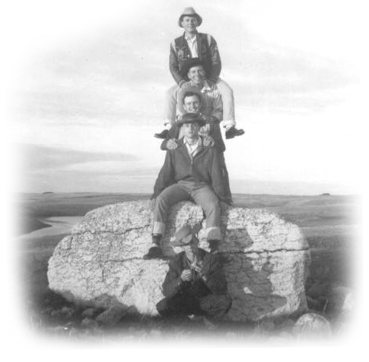
Top to Bottom: Ron Patterson, Keith Stephen,
Jack Cooke, Ross Robinson, Colin Sutherland

A few weeks later we were finished with the harvest and ready to go home. The boys all said their goodbyes and promised to someday return. As far as I know not one of them ever returned to Oyen. They all wanted to see Calgary before going home. As Jim Bearss had not seen the Bad Lands south of Hanna with us, he was fascinated with what he saw at Drumheller. The town was built right in the valley along the Red Deer River amid the towering hoodoos and hills. When you arrive in Drumheller you are greeted with huge life-like, man-made Dinosaurs in a small park setting. Soon we were back in the car again and off to the big city “Calgary.” Even then Calgary was a fabulous city.
We toured the downtown area to give the boys a true feeling of Calgary, and then I took them to the McCloud Western Men’s Clothing Store. The boys all bought their Western cowboy hats in multi colours and had them blocked in various design. Jim even went for a black and white leather jacket with a fringe hanging down the sleeves. They left the store looking like very classy dudes; they were now officially and finally honest-to-goodness……….cowboys.
We stayed at the old Hotel Empress at 219-6^{th Ave.} S.W. overnight where I had stayed several times before. It was a rather modest historic but clean, older hotel full of cowboys, farmers and Indians so naturally it appealed to me. Polished brass spittoons graced the entrance sitting room along with a few real leather upholstered chairs. A room for two would cost about $6.00. That will sound cheap to you today but remember we had been working for $5.00 a day all fall.
The next morning the weather turned cold and windy with flurries. It appeared winter had finally arrived. We decided it was time to head for home. There was a real winter blizzard before we reached Lethbridge. I have some pictures of us stopping to fill up with gas at a Husky Station, my car looking a scornful mess with ice and snow hanging from the fenders and door pans. I remember we stopped for a very short time to let Keith Stephens have a visit with someone in Medicine Hat. We arrived home safe and sound and the very next day Keith Stevens started to work at the cement plant in St Marys. Ross went on to farm. Jim farmed for a number of years and then sold Real Estate, and Ron went on to teach school.

Knowing that I was not going to be able to proceed with the sow farrowing business, I needed to consider my options. I think my biggest problem was not just that I found it hard to get a job because of my hearing loss, but also my deep feelings that this was my grandfather’s farm my only home, and that was where I belonged. Off it I had a feeling of being lost. It was the only home I had ever known.
I found out from the neighbours that the Mitchell Feed Mill was selling a great milk supplement powder for raising calves. It came in a bag with a small cup with measurements down the side. It was to be mixed with real warm water, not hot and certainly not too cool or your calves would get scours. I bought a hot water heater and some milk supplement and then I started going to auction sales barns to buy calves. There was one problem though; you see I could not hear the auctioneer.
However I would arrive early and pick out a calf or two I really liked and I was willing to out bid the competition for the calf. But sometimes I found the calf cost me a few more dollars than I thought I had bid. As a rule the calves would sell for some where between $35.00 and $42.00 so I nearly always came home with at least one calf.
Dad was rather fascinated with how well I managed to feed this supplement and do it just right. He knew other people who tried it and didn’t have much luck with this stuff. I knew success was all in how you followed the directions, especially the temperature of the water and how well you mixed the supplement. Dad switched his calves from milk to the supplement but he insisted that I do the mixing while he did the feeding. I always double-checked the heat on my wrist the same as mothers do with baby bottles before I passed him the pail.
In any spare time I had I worked for Albert Norman painting. Then I rolled the money I made over into calves. For a while dad didn’t say anything, but eventually, whenever he noticed that I put a bran sack in the trunk of the car he knew I was going to go to a sale and buy at least one more calf. So he started to warn me not to buy any more calves, as he did not have room for them. Then when I arrived home with yet another calf he would come out to the car looking annoyed, but as soon as I showed him a beautiful white face calf he seemed to fall in love with it. Then all was OK until the next time.
To bring a calf home in a car trunk, you put it in a large bran sack; first you pick the calf up with its back towards you and gather up its hind legs. Then with your free hand you slip the bran sack over the calf’s rear end and pull it up while the calf slips down into the bag. Now if you quickly gather the top of the sack around the rear of the calf’s neck and with pieces of twine tie it close, but not so close to effect it’s breathing. The calf can lie comfortably but not stand. You can easily put two calves in the trunk this way then tie the trunk lid down against a small block of wood to let air in. Warning! … It is best to be sure the calf has already been to the bathroom before loading. Bathroom accidents are bound to happen sooner or later.
I bought more calves in the fall of 57. I would be crowding the barn that winter and the pasture fields the next summer and that was not good. I bought some beautiful clover hay from Joe Taylor for the calves that first winter. I didn’t know just where this new venture was going to take me or if it might end. I knew dad was running out of patience with me and I could sympathize with him but I wanted so badly to do something to get a life of my own and to feel secure. I realize now that they had reason to be upset with me even much more than I’m willing to tell you here. Dad never set down with me for a heart to heart talk about my future. If I had no chance to farm, then what was I to do? I had more than once gone to plants and filled out applications for a job, but I actually knew when I walked out the door they were not going to hire me because I was deaf. When it comes to hiring, deaf people are not high on the list. Everyone wishes you well, but as they say, “Not in my back yard” as then they would have a problem too.
I was back working for Robinson’s Lumber in Mitchell off and on, I worked on a few jobs with Ferg in the early fall, but spending most of time just working around the mill. This pleased me as I enjoyed working with wood and tools, but once we got into winter they gave me the sad news that there was not enough work coming in for them to keep me on. I knew it was true, but it really hurt me as I liked the job and the Robinsons were great people to work for. We were however left with a great respect for each other and a lasting friendship.

I had been getting up early doing chores before going in to work up until now, so I was back to a better schedule. I was able to get a few day’s work in now and then with Albert Norman painting, but nothing steady. I did like Albert a lot; he had gone to public school with my mother so was actually an old family friend. I have always been thankful to Albert for teaching me the right way to paint. Most people do a very amateur job when they paint and all because they have never learned how to handle a paintbrush. One thing I really remember about Albert was how often he came home after work to find his supper on the table along with a note from his wife saying,
“I have gone to Wingham or Seaforth or Stratford to play Bingo,” he would say.
“I work hard all day to make a profit and she will spend it tonight on Bingo.”
As a rule Albert would contract the job and often things would go wrong and by the time he paid the wages it didn’t leave him a lot of profit. Still if you wanted to look for Albert on a Saturday afternoon you would go to the local Pool Hall.
I still bought a few more calves whenever I had a chance but I knew dad had reached the limit of his endurance. In the spring of 1958 I found a wonderful grass farm at Prospect Hill to pasture the yearlings, which numbered about 15 or 20. I believe the guy who owned the grassland last was named Rundle. The grass was about the best I had ever seen on a grass farm. It also had an ever-flowing creek that crossed it. I felt good knowing the yearlings would be happy there and grow.

My Uncle Frank McNee of Oyen passed away in 1958 after a lengthy illness. Aunt Rosena, now in poor health was taken to a hospital in Turtleford Sask. by her niece, Mrs. Stanley (Hazel Butson) Scott where she passed away in 1959.

A great tragedy was going to happen to the cattle in Ontario that summer. We started to see a new fly, which went for the cattle’s face. They later called them “Face Flies.” The fly seemed to want the moisture from the nose and mouth and eyes. They gave the cattle no peace; often the cattle would run madly to try to rid themselves of flies. The flies crawled up inside the cattle’s nose and lined the eyes lids with hungry sucking hordes. Some cattle which had rivers or ponds would spend hours submerged in the water systematically dipping their heads below water. The one thing the fly didn’t like to do was to go into the barn. When you brought the cows in to milk they would be covered with flies, and as they approached the barn door the flies would fly up on the side of the barn and wait for the cows to come out. When the cows knew they could find solace inside the barn they would come up from the field in midday and bawl to be let inside.
The cows spent more time fighting flies then eating. Thus their milk production dropped. Small calves gave in and let the flies walk across their eyeballs and suck the moisture out of them. In the end the calves went blind. Their strength was sapped and they grew thin and many blind. I watched all my beautiful yearlings and calves being destroyed by these monstrous flies. I felt I was ruined as no matter what I had to pay for the pasture, the yearlings were losing weight not gaining.

I drove west by myself that fall of 1958 in a perilous mood. Feeling totally unravelled. I had no prospect for a steady job, nor could I proceed to farm and my life was in shambles. I had nothing going for myself that was for sure. Some how I always found solace in the west. That fall I worked at the harvest for Joe Quain as Bulls already had a man.
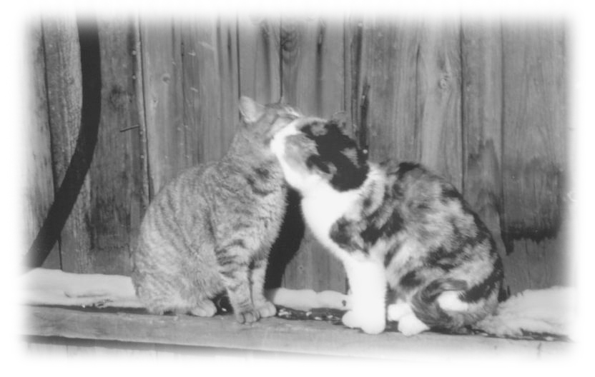
Joe Quain’s cats washing up!
When the harvest was off I wrote home and told my dad that I was not going to come home and asked him to sell all my sows and cattle and pay my bills and then put what was left in my bank account. In a way I like to think that my dad and mom might have been glad it was finally over, as no doubt they didn’t know what to do about me. They should never have had a son; it is better to have daughters, as then it is someone else’s problem.
Bulls had a cousin helping them for the summer that year and he stayed on to help with the harvest. As soon as the crop was off the cousin was off to college.

Joe Quain never married and lived with his father Will and his step mom who was his Aunt Bell. To keep the story short two brothers married two sisters. Will lost his wife and Bell lost her husband. As they were both in-laws and neighbours and both had children they helped each other out as much as possible, and in the end Will and Bell were married. Joe though always called her Aunt Bell, never mother but no mother ever had a better son or son a better mother.

On the Quain farm, every morning started out the same way. We milked cows by hand as Joe had two or three Hereford cows to milk. Cows that lost their calves often ended up being milked for household use. Any milk left over went through the cream separator, and the skim milk was often used to raise a couple of pigs. One morning as I finished milking my cow, nature called me. I walked quickly to the little house, which was mid-way between the house and barn. Morning had not yet broken and the lights within the house looked warm and inviting. I could see Aunt Bell in the small pantry window busying herself-getting our breakfast. She lifted her head and saw me cross the yard and gave me a cheery wave.
Everyone wore leather gloves on the ranch or farms in those days. That fall I had bought a brand new pair of what they called Kangaroo Tans from McLeod’s. They were of beautiful soft leather with high tops and I was very proud of them. As I closed the outer house door I realized there was no light in there, in fact it was pitch black. I took off my gloves and slapped them down on the seat next to me. I realized too late the seat lid was up and I had tossed my new gloves down the toilet hole next to me. It was not a happy moment, however first things first. When I finished my business I quickly ran off to the barn and returned carrying two long handled pitchforks and re-entered the little house. Aunt Bell was at her window looking on with great interest. With the aid of two pitchforks I recovered my precious gloves, a little smelly but otherwise none the worse. Aunt Bell was standing at the window taking it all in and laughing her head off. At breakfast she had to know all the details. It was a long time before I lived that one down.
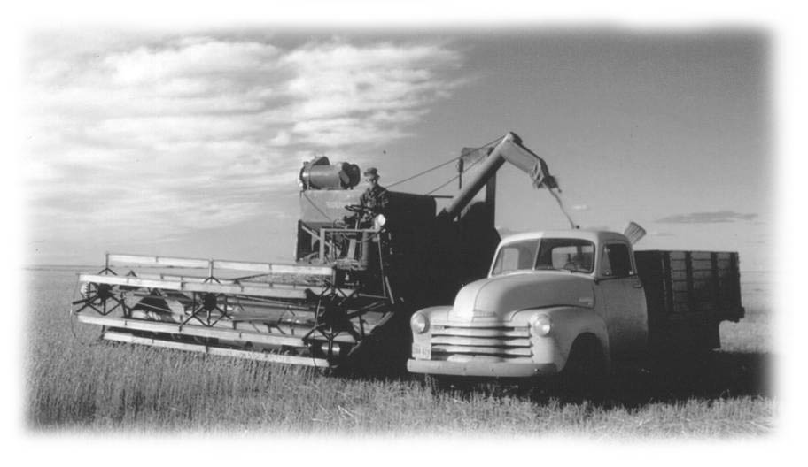
Joe Quain Combining in 1958
After harvest they wanted me to stay on for a while so they could take a trip to Calgary to shop and visit. They set up a list of things they wanted me to do while they were away. The first one was to paint the step’s railing and landing outside the kitchen entranceway door. After that I was to put green cedar shingle stain on the roofs of several granaries. It was nice weather and I rather liked the job, I naturally thought of my old friend Albert Norman, and it was comforting as it was because of him I knew exactly how to do go about this and how to do a good job.

However disaster was about to strike! I had just returned up the ladder to the roof with a fresh bucket of shingle stain. As I stepped off the ladder onto the roof my foot slipped and I found myself descending to the ground. Even before I hit I had this vision of exactly what was going to happen. I landed on my rear unhurt with a whole can of green shingle stain on my head. The paint can did the neatest flip and landed directly on my head. I had on my favourite grey flannel shirts and my first thoughts were for it. So I tore it off but I could see it was much too late to worry about the shirt. So I started to mop myself with it. I could see the hair on my chest and arms was green as grass. So in desperation I ran to the shed and grabbed a small can of gasoline and washed myself in it. While it worked very well on my arms and chest and shoulders I hesitated to use gasoline on my hair.

I remember seeing a fresh bottle of hair shampoo sitting by the sink in the little entranceway, so I though I had better try that first before I tried gasoline. I ran off to the house but I could not go up the kitchen steps as they were freshly painted that morning. So I ran around to the front door, which was seldom used, but found it open. I grabbed the bottle of shampoo and in great haste lathered my hair. I had lathered and rinsed it several times when I saw Mr. Bishop the mailman arrive. He always delivers groceries and mail right to the door. I did not want him to climb my freshly painted steps, so I open the door and caught him just in time. He stood there, stared at me and then started to laugh. He said I was the first guy he ever saw with pure green hair. Apparently he continued on his route telling everyone along the way that Joe Quain had a hired man with pure green hair. They still remind me about this happening out there today.

When I finished at Joe’s I went to Bulls to help them with the fall work, doing the summer fallow and bring in the garden stuff etc. Wm. And Alma and kids would be leaving for Calgary soon as Wm. Had been teaching a course at the Calgary Tech College for several winters. I was getting my five dollars a day for helping with the fall work, but I didn’t know what I would be doing next.

The day came when it was finished and I had to look for a job again. I had hoped to find something in the town of Oyen or close by. I answered an ad for a job on a dairy farm at Beiseker, which is between Drumheller, and Calgary and I guess I should have taken the job, but I hated milking cows and being deaf I hated to leave my friends in the Oyen area and start over again among strangers. Eventually my money from the sale of my stock back home was put in my bank account, about $3000.00. So I felt more comfortable. One weekend when I was visiting Don and Olive Sutherland, Olive sat down to chat. I guess she could see I needed to talk to someone and I guess you might say I unloaded on her.

She told me Deke was going to work for a Rancher down south of the river for the winter looking after cattle. She suggested that I spend the winter with them and decide what I wanted to do the next spring when jobs opened up. They really didn’t need a man but as Don and the boys liked to curl it would give them more free time and could work out well for everyone. I would get free meals and board and just be one of the family in exchange for doing everyday chores the same as everyone else. Every winter they joined a square dance club down at a river at a place called Bindloss. Olive said they danced till dawn and I found out it was really so, they did dance till dawn and then came home and did the chores and went to bed. My dad would think that was just plum crazy and perhaps it was, but I remember it as fun. Perhaps there should be time in everyone’s life to do something unusual just for fun. That just might be what living and life is all about, daring to do something a bit different and not falling into a rut. That was one of the best winters of my life. Young Don (Deke) was at home and Colin had just finished high school while Neil had just begun.
With the crop off and much of it already delivered to the elevators there was money in the banks and in the pocketbooks. This reflects well on the community, and especially the local town, everyone from the dry good stores to the car and truck dealers, wants a piece of it. So one day a beautiful lady from Calgary arrived in the area selling Mutual Stocks. She made her sales pitch mainly to the men in the family and she WOWED them all. First she called on them and warmed them up and then went on down the road doing like wise. Of course word travelled up and down the road neighbour to neighbour and it seemed everyone felt the need to invest, and everyone looked forward to another visit with this fabulous lady.
Wm. And Mr. Bull, Uncle George and Joe Quain all decided to make sizeable investments. She was pushing American Growth but also sold European Growth. I asked Mr. Bull if he thought I should invest my $3,000.00 in it. Well I know now he hated to advise me, but he said if I invested it might grow and if I left it in the bank I might just dribble away on it and lose it anyway. Well he didn’t say no?
So I invested $1,000.00 in American growth and $1,000.00 in European Growth.
This still left me with lots of money to tide me over the winter, as I had no need to spend a lot. Bulls were not exactly happy about my decision to spend the winter at the Sutherlands as they thought I should have taken the job on the dairy farm. When the time came to pack my suitcase to go I could feel the disapproval in the air. I though had a good feeling about it, so I made the move.
After a few days I started to fit in and was able to lighten everyone’s workday and all the time enjoy it.
Every evening we gathered in the front room reading or making music. We all took turns playing the piano the violin, banjo or guitar or singing. Then finally Olive would go out to the kitchen and make coffee and find something for lunch. It was never anything fussy, but for some reason it was always wholesome and good because she had made it. I loved to sit and listen to Don talk of the things that happened in this country where he grew up. He was born in Saskatchewan but was raised in the Oyen country. He had a deep affection for this land and this community, and a special respect for the families of all the original homesteaders.

I often milked one of Don’s cows out in the corral by hand sitting on an old pail as a stool. The lantern would be sitting on the ground nearby showing a mellow light over the area. I had my head against the cow deep in thought when suddenly the pail shot out from under me and the cow bolted. I didn’t know what happened for a few minutes. But when I looked at the pail I could see a bullet hole right through the middle and I realized it had been shot at. From behind a shed near by came an Indian lad by the name of Willy Little Bear who was working for Don’s brother Lorne across the road. He was laughing his head off as he thought it was very funny and no doubt it did look funny, as both the cow and I were in total shock. I tried not to make too much of it right then but later I told Don I was not amused. I didn’t like being shot at. So he told his brother to make the bullets scarce over there. The following year Willy Little Bear, a reckless lad was killed in an accident at the Calgary Stampede.

It seemed that it was always Colin who went into town with me on Saturday nights, although Neil went with us in midweek to the movie house in Cereal where we went now and then. Cereal was a small town on the highway just west of Oyen and about half the size. I always remembered this place, as the floor in the old movie house sloped sharply to the left where you sat to watched the movie. I am sure the place should have been condemned. However, building codes and such things at that time were much less rigid than they are today. After all, even if the building did slip off its foundation it had only about 3 feet to fall. On the other hand one got a pain in the side sitting for a couple of hours defying gravity. Then when everyone left after the movie you would think everyone had one long leg and one short because they all leaned to the right as they walked out of the show.
Deke would be in his early twenties by now and he often turned up on weekends. He had his own truck when he left home and he came home to pick up a few of his buddies and then do up the town He would come to the dance after the movie was over in Oyen and usually he and his friends had too much to drink. He also got into a lot of scraps. He and I got along splendidly; he seemed to have a special respect for me, and I knew he would be there for me if I ever got into any trouble. I hesitated to say anything to his folks about his excessive drinking because of our friendship. To get the mail we had to drive to Lanfine, a small village on the old railway track. Sometimes when I was hoping to have a letter from home I would volunteer to drive there in my car. It was on such a morning after a stormy night, that I found myself on the road to Lanfine. Deke (young Don) had not come home from his last night’s outing. I came across his truck a few miles down the road in a deep ditch. I stopped to be sure he was not in it or hurt. The truck was not damaged but in mud and he would need help to get it out. I opened the truck door and inside was several bottles of whisky and etc all open or as they say “broken on.” I thought if the RCMP was to find this he might get into trouble. So I took all the bottles out and put them in my car and went on to Lanfine and picked up the mail.

When I got back to Sutherlands I wanted to hide the bottles and not let Don or Olive see them. So I pulled my car over close to the shed and went in the side door and was hiding the bottles when Don came in view and said.
“Well, well, tell me what is Jack Cooke doing hiding his whisky at 11 o’clock in the morning?” So I was caught, and I had to tell him how I had found Deke’s truck in the ditch and these bottles on the seat, and I told him I was really worried about his son’s excessive drinking. Don said,
“ Don’t worry about him Jack. A man will never be a man until he learns how to handle his drinking.” I was a bit shocked. This was the first of a number of times I would be shocked by Don Sr. but you see this was his world, the world he grew up in, the world as he knew it from a child up, and he was a product of it.
With Christmas coming up I decided to treat myself to a special gift. I ordered an Underwood Typewriter typing course from the Eaton’s catalogue. In due time it arrived. Colin had taken a typing course in high school and he was a great help getting me started. I do remember though how he wanted to cover the letters on the keys, as that was the way it was taught to him at school. However I would like to confess to Colin’s now, I cheated.
Olive being a teacher undertook to see that I didn’t waste my money, so she set aside an hour every day for me to spend on my typing course with Colin. No matter where I was, or what I was doing, I was to report to the house at 11 AM every morning. I can see her now outside the kitchen door waving her apron to get my attention.
I learned one does not argue with Olive. You made a commitment and she is going to see that you live up to it and she very well knows when she is right.

Do you believe that there are times in our lives that God is preparing us for something down the road? Something yet unknown to us, but what we learn today will fit into our future needs? For me I know there were many times and many things, and certainly one was the typewriter. First came the Bell Relay TTY phone machine, which has a typewriter keyboard on it to contact the operator and to send messages. Then many years later came the computer with its keyboard all like the one I learned on so many years ago. I could not possibly do what I am doing to day if it had not been for Colin and Olive and their persistence; I have thanked them so many times for this gift they helped me achieve.

Christmas, 1958 was a joyful time in the ranch house, a time when they opened their hearts and home to all the Sutherland family and to neighbours and friends near and afar. While I missed my sisters and dad and mom and home, I certainly was not lonely. The house was filled with good cheer, music laughter and food.
After New Years 1959 the Square Dance Club started up at Bindloss, every other Friday night all winter. The days get very short in Alberta in mid winter so about 4.30 pm it is quite dark. We had a nice covering of snow and thankfully it was not moving about. Did you know that the Jack Rabbits in the west turn white in the winter? They think it odd that ours don’t. During the winter I spent on the Sutherland ranch there were thousands of jack rabbits in the country. Apparently their numbers seem to travel in a cycle, and certainly right then it was a high cycle. They surround the sloughs area where willow and buck bush grow and chew the tops off anything eatable. The roadsides were littered with dead rabbits. As they are white and hard to see they seem to jump out of nowhere into the head lights of a speeding car or truck and try to out run you. No mater, which way you swerve, they seem bent on self-destruction as they stay within the headlight beam until something bad happens.
We drove down to Bindloss dodging rabbits all the way. The crowd surprised me, as Bindloss is a very small town south of the Red Deer River far out in sparse country. These people all know each other. Most are old homestead family names from all over the country. After working hard all summer they enjoy being together again in the winter and mix with ease. It was true, they do dance till dawn, and then I could not believe it. They accepted an invitation for breakfast at a friends ranch nearby before heading home. Once home we did the chores up right away, as we knew if we hit the hay it would be painful to get back up. But this was how they did it in ranch country in the west and it worked for them. After we recovered and our vigour returned, we anxiously awaited the next Friday night when we would go dancing again.

One day Olive got a phone call that a Mormon piano tuner from Edmonton was in the neighbourhood and going from home to home tuning pianos. He was said to be very good so Olive asked him to call and tune her piano. He arrived one afternoon and it was suppertime when he finished. So Olive like a true westerner asked him to stay and have supper with us. After supper the wind came up and soon there was a real blizzard. In the west you never send anyone out on the road in a storm, it is almost a written law. So they asked him to stay overnight. We had our usual evening of music and talk and then coffee and off to bed. Don, and the boys and I were all up early and did the early chores and then came in for breakfast. The Mormon was very thankful to them so when we sat down to breakfast and were ready to eat, he spoke up and said,
“Do you mind if I say the blessing?” to which Don said,
“No not at all, but just say it for yourself not the rest of us, as we don’t believe.”
There was a silence and I was rather stunned, while I knew they didn’t say grace at the table I knew them as good people and I just thought it was natural that they believed in God. The Mormon started to object but Don cut him short by saying.
“This is my home and I have fed you and kept you over night because we like to feel we are good people not because we believe in God. If you insist on preaching God to us I will have to ask you to leave.” Olive didn’t have a word to say. Perhaps it was something they had talked about and reached this conclusion. As for me I was still speechless. The Mormon looked incredibly helpless and sad as he left. I am sure his intent was golden, as he had enjoyed his stay, and hoped to affix a blessing upon this household.
Back in the horse barn an hour or so later, Don came to me and said,
“Jack you looked a bit shocked by what happened at the table this morning.”
I confessed that I was, and Don said,
“You don’t believe in that stuff too do you?”
“Yes, everyone in my family believes in God and so do all my neighbours and friends. I can’t imagine thinking otherwise.”
Don said “Drop it Jack as it will only hinder you in your life. You can’t depend on God. You can only depend on your self and your family.”
This frustrated me and I was deeply concerned about this, so I said to Don,
“How can you be so sure you can’t put your trust in God if you don’t let him into your life?.”
Don said, “Believe me Jack I have tried it and it does not work.”
So he told me this story.
In the thirties when it was so dry in central and Southern Alberta that the farms and ranches were being literally blown away, many left for the Peace River country because they heard that they were able to grow hay and crops up there. He had taken a homestead and built himself a shack. One clear and starry winter night he decided he just had to get out to town to fight boredom and pick up a few groceries. He left his shack walking northeast by the stars that guided him. He could also see the reflection of the town of Peace River against the night sky in the distance. It was cold but very calm and as long as he kept moving he stayed warm.

Later when he started out for home, he again took his bearings by the stars and walked southwest from town. He now was carrying groceries and along with a few other supplies, so walking home was heavier. After a few miles he noticed clouds coming in from the northwest and soon it started to snow. He could no longer see the stars to guide himself. Then the wind came up and visibility became zero. Soon he found himself stumbling over rocks and sagebrush and he lost much of what he had purchased in town. He became very aware that he had lost his sense of direction and would die out there in the open before daylight came.
So he said, “Jack I prayed, and I prayed and nothing happened. If I had not gathered my wits and used my head I would have died out there.”
“Well what happened?”
To which he said, “What do you mean what happened?”
“Well obviously something happened or you would not be here today.”
Don said he stumbled onto a barbwire fence and as there were literally no fences up there at that time, so he reasoned that if he followed the barbwire it might lead him somewhere. He came to a line shack which had a stove and wood and some supplies so he had saved himself.”
I said, “Saved yourself Don! How can you say YOU saved yourself? God answered your prayer, its plain to see.” “ What did you expect a limousine to come and pick you up?”
I remember seeing a strange reflection in his eyes, and then it was gone.
After chatting some time about it, he told me I could believe anything I wanted to believe but I was not to preach this to his boys. I asked him what I was to say if they asked me. He said that I could tell them what I believed but do not tell them what to believe.
Later Olive wanted to talk to me about it. I could see that it was a topic that troubled her but she didn’t want to disagree with Don. She said they had decided that her boys didn’t need religion as they had given their boys all that they needed. So I asked, “Just what is that?”
“You are what you are because of your ancestors, and it is up to you to live up to your ancestry and to your family name and that’s all that is expected of you. ”
I knew that in many ways what she said was true, they were so very proud of their family name and their true Scotch history on both sides. This they taught to the boys in all possible ways, yet I feared what might happen in the lives of these boys if they denied themselves God.

In January the days were bright and sunny and brittle cold with the temperature dropping down to – 40 F. The local elevator at Lanfine was open to receive grain so Colin and I started to haul some wheat to the elevator. On the third load just as we turned off the road to go into the elevator we felt a sudden shift in the load. On getting out we discovered that the axle had broken and the rear wheel and axle on one side was a foot out. We hastily put a jack in under the axle and then called Don to come and pick us up. The Sutherlands had many trucks and tractors and pieces of machinery over the years. Unfortunately most of it was “at rest” down by the slough, meaning it was not in working condition. There was a truck down there by the slough that had the same axle in it as the one sitting with the load of wheat on at the elevator in Lanfine.

Colin and I were off to the slough with tools to take the axle out and then take it to Lanfine and put it in the truck there. This was just like having to do the job twice, take two out and putting one back in. What made it worse was the intense cold. I was never a mechanic; in fact I have no liking for the job, but there I was lying on my back on a windswept road in the centre of Alberta with the temperature hovering at – 40 below handing Colin tools. I remember saying,
“My mother never told me about days like this.” Through frozen breath and chattering teeth Colin said,
“Stay out in this country long enough and you’re going to find out that there are a lot of things that your mother has never told you about.” We did get the axle in and somehow I felt good about the whole experience in the end, as I had proved myself to Collin and to myself. Maybe I didn’t like it but knew now I could take it if I had to when the going got tough.

Several times I would be invited down to Don’s younger brother Cameron and Lenora’s for dinner or supper. It was always an enjoyable time. Many times I had morning coffee across the road with Lorne and Isabelle Sutherland, Don’s older brother and sister in law. All these people treated me as family; they were a joy to associate with and were my friends.

In the winter Curling was the name of the game. It seemed no one minded going out late at night at any unearthly hour, or in the pre-dawn to curl. You would find them standing around on frigid ice in a long, low, un-insulated shed at – 40 degrees below. These sheds were often built at some lonely spot away out in the middle of nowhere. They gathered together to hurl round rocks down a lane of ice to see who could keep the most rocks on the target at the end of the game. So many of the locals wanted to play that there was a great shortage of ice time. It was nothing for the boys or Don to be called in at any hour around the clock to play their scheduled game. Just inside the door at one end of the shed there was a small room with a pot bellied stove that was kept going around the clock. This little room was kept so hot, I am sure hell would bring one relief. The few who came to watch the game would look out from this little room through a dirty, hazy glass window, which people had forever forgotten to clean. The other poor souls had to go out on the ice to curl. I went out a couple of times, to try to understand the game and offer some support. I was not sure which was the more punishing, the heat in that little room or the cold on the ice. As you can guess I never did pursue the game, but they claim it’s, FUN?

Getting a letter from home always made my day, but in my letters mom often told me of how hard it was for dad to manage all the chores and farm work with out me. So once after reading my letter I guess Olive could see I was troubled so she asked me if there was any bad news. I told her it was just that mom says dad is having it hard doing all the work alone. Olive spoke quite sharply to me saying,
“ Now Jack don’t let them do this to you, as you have asked them to share the farm so you could work together and they flatly refuse you.” “ They had a choice.”
When spring came I was back working for Bulls for the whole year from spring right through till fall. One of the great things I remember about that summer was, it seemed everyone in the community wanted to adopt me. Will and Bell Quain became my Uncle Will and Aunt Bell and Mrs. Bull’s brother George Snell and his wife Lucy became Uncle George and Aunt Lucy. I got invited out almost every Sunday to someone’s place for dinner or supper. During the week there were many evenings with the neighbours. Talk about good old western hospitality. The country was full and overflowing with it.
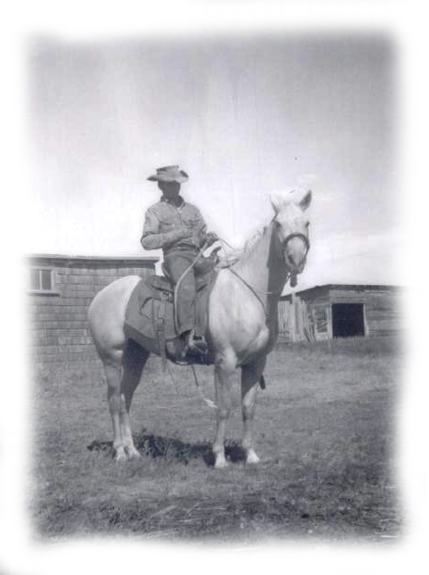
Deke was now herding cattle for Red Jacobson south of Bindloss and next door to the Old British Block (now called Suffield C. F. B.) The story goes Red came home after the war and took over his father’s ranch. In late 50’s he had reached the place where he had more cattle than he had pasture for. If he sold cattle to buy more land then he wouldn’t need it, unless he bought more cattle All the time there was pasture galore over the fence in the British Block going to waste. So one day Red cut a hole in the fence and drove his cattle in. Right where he was there was a long valley, which broadened out as you travelled west. On the west end of the valley was a row of hills and far beyond the hills was the army base and training fields. There was also a long finger-like lake of water stretching down the centre of the valley on the east end. It was a near perfect place to run cattle and hire someone to herd them every day.
Deke On Ace
Deke was in seventh heaven; everyday he was out in the valley on his palomino horse Ace, herding white face cattle. It seemed the cattle worked their way west to the line of hills everyday and everyday Deke rode out to the line of hills and slowing drove the cattle to the east end of the valley. There were many coulees where the cattle would wander in to graze. He had to be sure to find them all and by evening you would find all of the cattle lying along the south side of the finger lake bedding themselves down for the night.

Late in the fall after most of my work was done at Bulls, Deke asked me to drive down south and spend a few days with him herding cattle in The British Block. I knew this was a chance of a lifetime for me to see the old west as it once was. So I accepted the invitation. Deke stayed at the ranch house and the Jacobsons, gave me a hearty welcome. They were akin to so many other ranchers I knew in Alberta, tanned, strong in character, warm and friendly and great hosts. All day we leisurely rode our horses down the valley finding the cattle hiding in the coulees and headed them east. We were to not actually rush them, as they were to more or less graze their way back to the lake area. All day we crisscrossed the valley, first doing one side and then the other Deke was thorough and none could escape him. Red felt that as long as he kept his cattle under control and in the valley the army would not complain about them. After all he was a veteran.

I found out there was another reason Deke wanted to see me. He had met Cathy Campbell, the daughter of Happy and Mary Campbell the owner of a huge ranch along the south side of the Red Deer River. All day it was Cathy this and Cathy that. “I tell you he had it bad!” Cathy could outride and Cathy could out rope everyone. She knew cattle and she knew horses, and he wanted me to meet her before I went back up to Oyen. So on the Sunday before going home I was invited to Happy Campbell’s ranch for dinner. Deke was one happy young guy, he loved his horse Ace; he loved cattle and he loved his job and no doubt most of all he loved Cathy. He could not feel anything but good about life, and I was truly happy for him. I always appreciated that he cared enough to want to share this with me.

On our ride back to the east end of the valley I noticed four large round holes in the ground all spaced exactly the same distance apart. I knew just by looking it had to be man made, but why? It looked quite out of place away out there in the middle of the valley where there was nothing but grass to see. To satisfy my curiosity I asked Deke about it and he said,
“Maybe God put them there.” I know he thought this a great joke.
I found out later from Mr. Bull that it was where the land surveyors had set up their equipment when they surveyed the land and if I had looked I might have found an iron stake in the very centre of the four holes with the section numbers on it. .
Every evening from a flat top hill on the south side of the valley overlooking this land locked lake there was a sight to behold below us. There were about a thousand cows with calves quietly, bedding down for the night along the lake below us.
We had seen a number of antelope but Deke kept telling me that there was a main herd here somewhere and he wanted me to see it before I went back to Bulls. On the last evening I was there we came over a rise and there before us was a herd of hundreds of pronghorn antelope. I remember thinking, “Gosh there are more antelope in here than cattle!” At that time we estimated there were a thousand in the herd before us. We startled them as we came upon them and they raced off down the valley going east. In a short time they noticed we were not giving chase so the ones on the rear stopped with their white tails held high. Slowly the whole herd stopped from the back to the front all with their white tails held high and their bodies facing east but their heads turned back looking at us. Never had I witnessed such a sight, with their white tails and the pronghorns and their face markings. It was picture perfect and I was without my camera.
We would arrive back at the ranch each evening to cheerful greeting and a wonderful meal. I remember enjoying what I thought was some of their very own beef for supper. After the meal Red asked me how I had enjoyed the meat we had for supper and I assured him it was very good. He asked if I realized it was antelope. I could not believe it, as I am not one to enjoy wild meat, not even venison, duck or geese. The antelope we had for supper was good, but they told me it was all in the way you cooked it. I think that goes for all wild meat but I think I’ll stick to my beef!

On Sunday we arrived at the Campbell Ranch in Deke’s truck for dinner. Greeting us was Happy and his wife Mary and eight attractive and very healthy and active children. It was easy to see that this was a happy home as there was much love and respect all around. This was the first time I met Cathy and one could tell that she too was as much in love with Deke as he was with her. Like Deke she was a bit on the short side and like Deke every fibre of her body spoke of strength and knowledge of her world and ranch country living. She was a petite and lovely girl and I liked her from the start. I had always been under the impression one cannot have a perfect life when you deny God. Yet here was Deke with everything going for him and mocking God. I could not help but wonder what life held for these two people. But that is another story.
Unfortunately many years later their marriage ended in disaster, which was followed by a tragedy and their family separated and was torn apart.
Happy took me on a tour to see his ranch buildings and then the boys wanted every one to follow them to a grove of poplar trees to see their invention, a bucking barrel. This was the first time I ever saw a bucking barrel. There were four old car or truck inner tubes placed high up in the poplar trees with four ropes dropping down and tied to rings welded onto the barrel. A saddle was placed on the barrel and when you got on and ready, four guys, one on each rope would heave up and down on the rope and at times jack-knifing it, while in motion to buck you off. They claimed if you could ride the barrel then you were ready for the Calgary Stampede. I remember it as a day of fun and interest and I was touched by the closeness and respect of all members of the Campbell family. The day rushed by all too soon. They expected us to stay on for supper, and after supper Happy told me he wanted to show me something.
We walked over to his open Jeep sitting in the yard; this would be my first ride in an open jeep vehicle. Happy drove on a well-worn path or trail going west from the ranch buildings up through some treed and rough and hilly areas. Then we came out atop in an open area high above the Red Deer River flats. He wanted to share this view with me at this time of the evening. The day was ending and long shadows were descending from the hills out onto the river flats below. In several coulees along the flats below small channels full of water crossed the flats flowing to the river. Happy explained that every once in a while they dammed the channels and flooded the flats and in that way they grew a lot of hay down there, but they also shared the coulees and flats with deer and other animals that he spoke of with interest and concern.
As he spoke he pointed out several deer emerging from the coulee out into the open. It was getting late in the evening and shadows deepen, and then darkness descends quickly and silently on the flats below. I have heard of Happy Campbell many times over the years from my friends but have never seen him since that day. I have always felt honoured to meet him and that he cared enough to share that evening with me.
In June 2003 I heard Happy Campbell celebrated his 90th birthday. Unfortunately Mary passed away a number of years ago. I heard 80 members of Happy and Mary’s family sat down at his Birthday party, their own eight children and all the grandchildren and great grandchildren. What a wonderful “Happy” legacy.

In a letter from home I heard that Albert Norman had been inquiring about me as he had a couple of churches to paint that winter of 1959 over to 1960. So I thought I would venture home for the winter and paint for Albert. Certainly I could not afford to sit out two winters without pay, as when you work on farms or ranches you have no unemployment insurance when you get laid off.

There was not much of a welcome for me when I arrived home and I was very uncomfortable with that. I could feel that even my sisters felt that at my age now I should not have to depend on my dad and mom for anything. I don’t think anyone of them ever looked at my deafness as a handicap that kept me from getting a job. Perhaps in some way they knew me even better then I knew myself as I proved later in life I could do well at most things if only I got a chance to prove it. The problem was how do you get your foot in the door when they won’t open it for you? Albert was happy to see me and soon I was back painting again. We painted a large church in Stratford and a Catholic church on the 23 highway north of Mitchell.
Ron Smith had got a job working in a huge Box Plant in St Marys. They made corrugated cardboard boxes for everything from beer to vegetables and soup. Ron offered to help get me hired. This worked and soon I was getting a good pay check.
I found it a bit strange working inside and between four walls after being out on the prairie, but in a few weeks I started to enjoy it and of course earning a good pay check was wonderful They hired me as a part time employee. I know now that I would never have been hired if it had not been that Ron had gone to bat for me. As a part time worker my hours were 11.00 pm till 7.00 am. They were busy so they had me working a full shift every week for several months, thus I earned the name of, a full time part time worker and I was beginning to feel secure. I was sure very soon I would be re-classified as a full time worker. When you’re a part time worker it always meant they could easily let you go when there was not enough work, but I was confident if I worked hard and did my job well, I would eventually get hired full time.

These hours were a bonus too as I arrived home from work in the morning just in time to milk the cows. Then I had my breakfast, after which I cleaned stables and fed the cattle at noon. After eating my dinner I went off to bed and slept till six when I got up for supper. At seven we milked the cows again and by eleven I was back to work at the plant. This was a tough schedule but I was actually happy for the first time in my life as I felt I was earning my true worth with a real paycheck. That winter I saved a nice bit of money as I had little time to spend it.
In 1959 my Uncle Frank in Oyen Alberta died and in early 1960 Aunt Rosena passed away. That spring I received a check for $1,200.00 from their estate, I added this to my bank account. I still had my two thousand dollars plus some gain in my mutual stocks. I was feeling very good about things for the first time in my life as things were going very well for me.
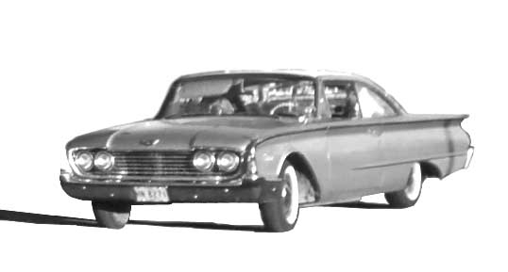
My 1960 Starliner Ford

There was a most beautiful Ford car in the window of the Ford Dealership in St Marys. It was a special model and a bit more expensive then a standard Ford, but that was the car I wanted. So I thought I was now in good shape to trade. This was what they called a Sunliner Ford, actually a hard top with a sweeping roofline on the rear window with three round suns on it. The colour was called Orchard Grey a sort of soft lilac colour. When I drove the car home my mom had a real fit and said it was a funeral colour and never in all the years that I had that car would she ride in it. Dad on the other hand took it for a drive and liked it and thought it was a good idea to trade up before my old car got too old. Besides things were looking ok money-wise for me so I could afford it The car cost me $3,600.00 and that was a lot of money in 1960.
In June my dad’s oldest sister my Aunt Bertha was up visiting us from Detroit We had just sat down for breakfast when two cars full of people drove into the yard. They all got out and looked around hesitantly as if unsure of themselves. They looked just a bit strange to us for the moment, but then we realized they were a very large Mennonite family. We had no clue as to why they came to visit us. It seemed a St Marys real estate agent had been chatting with a number of local older farmers in the area about retiring and selling their farms. For most of the neighbours the timing was about right, but dad was only 6l and had not seriously thought of retiring just yet. Still he wondered just how much money he could get for the farm. They asked for permission to walk back over the land to see what it was like. These Mennonites were from Steinbach Manitoba.
We found out later that there were about eight or ten Mennonite families doing the same thing right at that same moment, all over the community. They were all supposed to pick a farm they liked from a list and just walk over it that morning. Then they would walk away and think it over and come back at a later date. It was Mr. And Mrs. Aaron Penner and nine of their eleven children that visited us that morning. They stretched out evenly across the 100-acre farm walking from the road to the backfield and then into the bush. From there they crossed over to the sixty-two acres and came back stretched out walking across it back to the road. They chatted with us for a wee while and left as mysteriously as they had arrived.
My Aunt Bertha who loved to tell fortunes and to predict the future, told us the farm was sold.
For the first time ever my dad asked me a serious and important question,
“If I get offered enough money for the farm do you think I should sell?” I realized by now at 61 years old he was facing retirement in a few years and he needed what ever he could get for the farm to live on. So I said,
“ If you can get enough for it perhaps you should sell and I will try to get on full time at the box plant.”
The very next week I went to the office and told them my dad was selling the farm and that I would like to get on full time with them. I didn’t think there would be any problem over this as I got along well with everyone in the plant and I was confident I was doing my job well. In a few days I got a notice that I was laid off, without any explanation. It was a disaster and I could not believe it. Ron told me that it was not that they didn’t have enough work it had to be something else.
Apparently there had been a rumour spread in the plant by someone with a great imagination that because I could not hear I almost got squashed in a big press machine while it was closing. That was not true, as I never worked on or anywhere near this press.
Almost every week I went back to the plant to check and see when they would take me back. Then one day my foreman whom I had liked came to me and said,
“Jack I hate to see you wasting your time coming back here every week as they are not going to hire you, you know.”
“I thought I was getting along well and that they liked me,” I said
“We did like you and you were doing a good job, but do you see that sign out side the front door, the one that says- “We Have Been So Many Days Without An Accident?” “Well they think more of that sign than they do about giving you a job.” “They won’t hire you full time because you’re deaf and you may get in an accident and that would raise our compensation fees, in other word cost us money.”
So this is my story and this was the way the deaf were treated when they went out looking for work in the real world. This was the part that my Dad and mom and sisters never seemed to understand. They didn’t seem to realize that as far as the public was concerned I had a handicap. Perhaps it was because they knew me as a capable person they didn’t see me that way, but slowly I was drifting into a lonely silent world, which I felt was all of my own.
First the deaf were more or less kept in the dark as far as a higher education and then we were expected to be satisfied doing odd jobs, to be on hand when needed and disappear when not needed. Somehow this did not appeal to me. I had to find a better way.
I continued to help dad until the harvest was off. Then I was able to work a few days now and then painting with Albert. Late that fall my brother-in-law who did some backhoe work asked if I would help him with some work in Thamesford a town east of London. He was putting some drains in for the town. It was getting quite late in the fall and very cold and wet and apparently the help he did have had left him. It was a muddy wet dirty job down in a ditch levelling the bottom and laying drains. As he was my brother-in-law I was willing to help him get the job done. One day when it was very miserable a man came to see him from the town and asked him if he would extend his job and clean out a number of catch basins before he left. Oliver hesitated and then agreed and the man came out with,
“ Thanks, I don’t expect you to do it yourself but have someone with a strong back and a weak mind do it.” After saying that he chuckled as if he had said something smart. That was all I needed to make me jump out of that ditch, as there I was covered with mud, cold and wet, and this guy who was all dressed up warm and comfortable would made a statement like that. I said,
“Well I am the guy that will likely have to do it and I do have a very strong back but I also have a very good mind. I want an apology from you for that statement!”
He looked at Oliver and Oliver looked at me. Neither said anything.
I said, “I am serious, if I don’t get an apology I will quit right now.”
Neither Oliver nor the man said a thing so I walked off and drove home. To this day I feel it was the right thing to do. Never in my life have I let anyone talk down to me.
I feel Oliver should have told the man that he was sorry but he did not hire men like that and perhaps this man should consider doing the job himself. From that day forward things between Oliver and me were never the same. This I know caused some grief for my sister and her family, and I am sorry for that, but I accept no blame. That winter I painted for Albert off and on as he didn’t have enough work to keep us both busy.
The Old Farm Was Sold In - 1961
In the spring of 1961 the Mennonites from Steinbach Manitoba were back and very serious about buying farms. It was now just a matter of price. We were told later that they were all to go out to the farm of their choice and told to close a deal that day so no one would be left holding a farm while others went back to Manitoba. They also were not to bid against each other only on the farm of their choice. My dad had decided to ask $32,000.00 for his 162 and half acres. Of course he didn’t expect to get his asked price. They finally agreed on $28,000.00
After the farm was sold Aaron Penner came to me and asked how I felt about my dad selling the farm. I remember this conversation clearly as it really meant a lot to me. I said,
“Well I was not going to be able to farm it anyway and now I’m not sure that I really want to, but it is my home the only home I have ever known.” Aaron said,
“Jack I wont take your home away from you.” “ I want you to know that you can come back home to visit or walk the fields any time you feel the need to.”
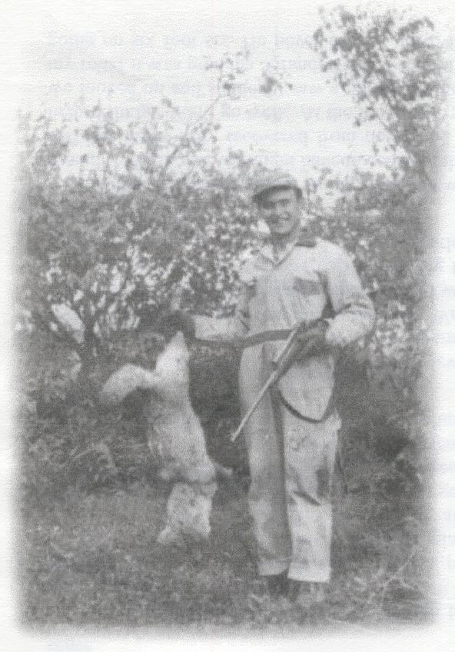
I hope he knew how much that meant to me. I still like to go back at least once every year to sort of feel my roots. Aaron and his wife Elsie have both passed away now as I write this. Their sons have honoured their dad’s words and I am always treated royally whenever I go home to visit.
When Bulls in Alberta found out my dad had sold the farm they asked if I would work for them that summer and if I could also find Joe Quain a man. Getting a farm lad in the spring was quite different than getting one in the fall when the work was all done up. So I put an ad in the Stratford paper. One day when mom was home alone a very young chap knocked on the door and asked if he could have the job. For some reason my mom liked him and took the liberty to say yes even though he was very young and I had not had a chance to meet him.
His name was Barry White and he gave his address as Stratford. Some friend drove him out to the farm and would bring him back the morning I was to leave.
Jack The Mighty Hunter
On the way out west I found him good company and easy to talk to, and I think he felt the same. He told me the truth about himself. His dad owned a gas station and garage in the village of Gads Hill a few miles north of Stratford. His mother had died and his father remarried. He and his brother could not get along with their new stepmother so they more or less left home and ended up on the streets in Stratford before being picked up and looked after by the Salvation Army. At that moment he was 16 and running away from the Salvation Army. This of course alarmed me, and he begged me not to report him. So I told him that then he had to remember that he never told me anything about this.
It was a long hot summer and because I was there to help, Bulls broke a quarter section of land they called the CP land (Canadian Pacific) and also another piece at the rear of the home farm. They had a new piece of machinery called a Graham Plough; it had interchangeable blades or heads on a heavy spring-like teeth and dug deep into the ground and rolled great rocks large and small to the surface. Today they have rock pickers but in those days they had Jack Cooke and I am sure there is a huge rock pile out there somewhere with my name on it as I know I picked half the rock in all Alberta.
Every now and then in your life there will be a moment, an hour a day, a time a place when you will be so happy, or so low, so exhilarated or so afraid that you will remember that time and the place for the rest of your life. Such was one day when I was working picking rock in the huge field at the back of Bull’s home farm. The newly broken land had been worked down deep with the Graham Plough to pull up rocks. The land and rocks themselves reflected the heat from the hot sun above. Every step I took I sunk to my boot tops, just walking alone wore one out, but picking up the endless crop of rocks tore the fibre of every muscle and your body ached from head to toe. The hot dry sun bore down on you with even more punishment than your mind and body could endure. I suddenly realized this was not the kind of work one wanted to do for a lifetime. I felt as if (pardon the pun) I had hit rock bottom. I wanted to find a place in life where I could work and enjoy my job and still make a decent living, I also wanted dad and mom and sisters to be proud of me.
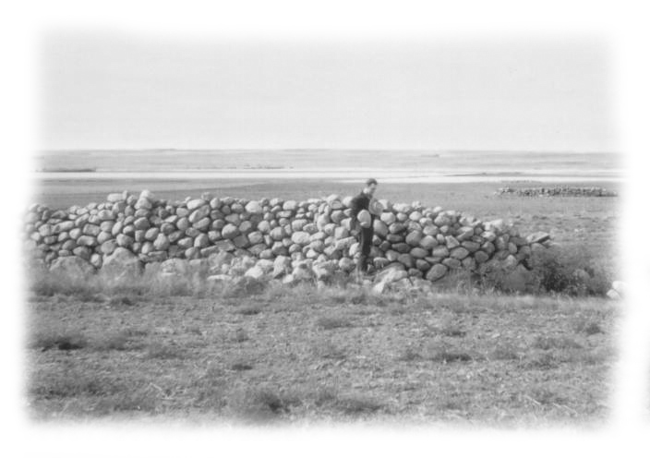
Jack Picking Rock at Oyen
That was the summer I first heard of, and saw Cattle Oilers, a gadget made by a small company in Medicine Hat to keep the flies off cattle. It actually worked very well. A five-gallon tank was set on top a wood post with a spring like feeder valve into a burlap wick surrounded by a curled steel coil. It was attached first to the top of the post and then to a lower iron stake that was driven into the ground. The idea was that cattle love to scratch and they soon found the steel cleats on the coil felt very good to scratch on. Then they realize that that strange smell they got from scratching on this thing kept the flies away. So soon they would arrive every time the flies took an interest in them. So I wondered how this would work on these face flies in Ontario. I wrote to the company McIntyre’s, and he assured me it would work well and that no one was selling his Cattle Oilers in Ontario.
Barry White and Diane
Meanwhile my new friend Barry had been busy. He had found a very nice little girl in Oyen and spent all too many evenings and on into the night in town arriving back home at Bulls ill prepared for the days work. I loved hearing his boss tell me of how he went to check on Barry one day when he was supposed to be summer fallowing. After sitting at the road for a long time waiting for Barry on the tractor to make its round, he drove his truck into the field to look for him. He found Barry sound asleep under a tree by the slough. What could they do. It seemed Barry had stole their hearts as he was a likeable guy and they only saw the humour in this I had told Barry I was thinking of going back east with a few of these Cattle Oilers in my trunk and see if they would sell. He told me not to go without him. I had met Diane and liked her and I rather hated to break up what looked like a good match. So when the time came for me to go home I decided to go without Barry.
To get to the highway I had to pass the farm where Barry worked and there he was in the front field summer fallowing. When he saw my car he waved at me frantically to stop. So I pulled over and waited for him to approach. He of course knew that I would not be going out onto the highway early in the morning unless I was going home. He wasn’t happy that I would go back without telling him.
I said, “What about Diane? I just didn’t want to hurt her by taking you back.” He said, “ I’m not running out on Diane, we have talked it over and I am going east to get a job and a place to live, and when she gets out of school she will come east.”
He got his things and then we drove to the high school and asked for Diane. She told me that she trusted Barry and that this was what they had planned. I remember asking them if they were going to get married or just shack up. They said they would get married as soon as they found a minister, so I told them about my great friend and minister the Rev. Robert Watt.
We first drove down to Medicine Hat to the McIntyre’s company and I was able to put a couple of Cattle Oilers in the trunk. He said if they sold he would ship any number I wanted to Mitchell where I could pick them up.
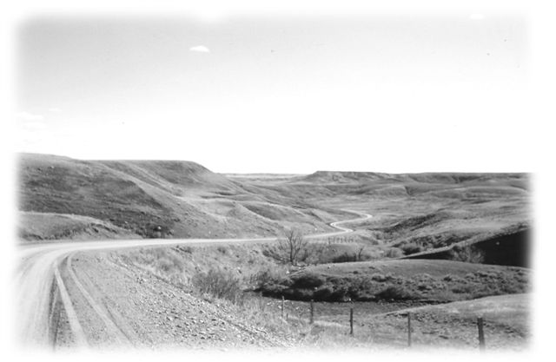
Cypress Hills in Saskatchewan
We drove east from Medicine Hat and then south through the Cypress Hills to Montana. I found the Cypress Hill country spectacular in its own kind of rugged beauty, around every bend and over every hill. I guess I kept on saying,
“Look at that. Look at that.” So finally Barry said to me,
“ Jack you keep saying, Look at that, Look at that, and I look but I don’t see anything but hills and a bunch of damn trees.”
So I thought to myself, “I may be deaf but God gave me the gift of eyes that really see beauty, and a mind with a sense of appreciation for nature, in my silent world.” So perhaps in that way one might say “I am blessed.”
We arrived home but neither of us had a place to go. Barry was not sure he was welcome at home and the Penner’s were now on the old farm. Dad and mom were now staying at Bill and Jeans until they decided just what they should do. I think dad realized that he could not afford to retire until he was 65 and had his pension. Dad had spent his time that summer driving tractors for farmers out in the country and mom was left alone a lot in town and she was not very happy.
Barry got a job at the Durisol plant in Mitchell the same plant that I had applied for a job several times and didn’t get hired. We also found him a huge empty dark apartment above Mert Pugh’s poolroom and lunch counter. Mert, like my mom took a liking to Barry and was soon mothering him. I introduced Barry to Mr. Watt the main street United Church minister and he assured Barry he would marry him and Diane when she came east. Eventually Diane came east and Mr. Watt married them in the Mitchell Main Street United Church and I stood up for them.
About now I ran into my cousins Ivan and Betty Lou Norris and as they knew my folks had sold the farm they wondered just where I was going to stay. I told them that apparently my Dad and Mom and my sisters had all decided it was time I looked after myself and were not going to offer me a place to crash. I think at the time they considered it a sort of tough love. I didn’t really blame them but I didn’t know what to do about it. I hated applying for jobs when I already knew they were not going to hire me. Ivan and Betty Lou said to come and stay with them while I set up this Cattle Oilier sales business and then surely something would come up.
I set about trying to find people that were interested in selling the Cattle Oilers. I ran ads in all the local papers from Wingham, Strathroy, Aylmer to Woodstock and many others. I sold oilers and chemical to each one of these guys who wanted in on this to sell oilers for me on a commission. I thought if I got a large area set up in the fall it would be up and running when the flies came back the next year.
Needless to say McIntyre’s were very happy with me and I got a letter from the company saying my future was safe with them. I was looking forward to cashing in on a big thing the next spring when the flies came back.
Fall turned to winter and now I was going to have to find a steady job as any money I had was tied up in Cattle Oilers, so I was about out of cash. I have never been able to thank Ivan and Betty Lou for their kindness, for being there for me.
It always seemed it was Albert I turned to for a job. He was willing to hire me part time, as it was the best he could offer That of course saved me from chaos.

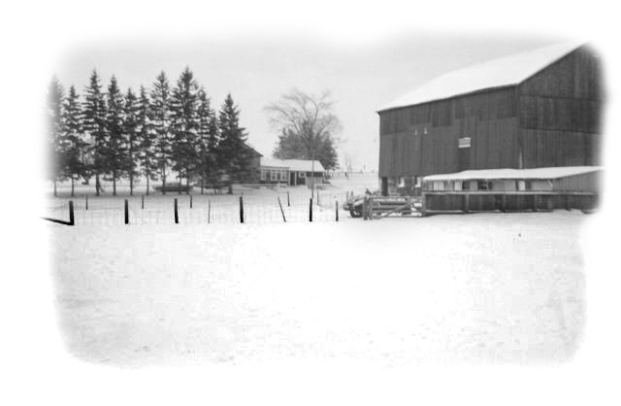
The Taylor Farm
Dad and Mom Buy The Taylor Farm
Mom had served dad an ultimatum, telling him if he was going to be out in the country working all the time then they would find a small place and move back out to the country for a few years. Late that fall they bought the Taylor farm on the Mitchell Road just south of Fullarton. This was one of the best things my dad ever did as he was a just 62 years old and could not afford to retire until he had his old age pension check coming in. In other words he needed an income and also a safe investment for the money from the sale of the old farm. He didn’t know it then but all things were going to work out for the best for them. He paid $14,000.00 for about 90 acres, 17 of which were across the road and next to the Thames River. They made a good living off that farm. Dad bought feeder cattle in the spring with the extra money he had from the sale of the old farm and pastured them across the road on the 17 acres. He raised little pigs in the barn from several Landrace sows and he grew some cash crop. Mom of course had to have a few hens. They stayed on the farm from 1961 to 1969 eight years and sold it for $28,000.00 doubling their investment and all the while making a living on it over those years. I think those eight years were dad’s most rewarding years.
But I am getting ahead of myself here….. I’m not sure just how it happened but mom asked me if I wanted to come and stay with them on the Taylor farm. Maybe they missed me after all. So I moved from Ivan and Betty Lou’s, cattle oilers and all to the Taylor farm. I do remember mom telling me she wanted me to feel it was home. I appreciated that, but that place was not home to me. When spring came and the cattle were out on the pasture the first few flies arrived again and I started getting orders from all over the area for my Cattle Oilers. For a few weeks I was wiring The McKenzie Company in Medicine Hat from the Mitchell Railway station every few days. I needed many more Cattle Oilers. Then for some reason things started to quiet down and we suddenly realized there were very few flies around. As mysteriously as they came the flies vanished and I was left holding onto a number of oilers and no buyers, not to mention a very large number of disenchanted sales persons. All my work and plans were for not, as without flies there was not any need for Cattle Oilers.
Thankfully that summer Albert had a lot of painting to do. He even hired Dean Robinson, a Mitchell high school student and one of the lads who was in the Sunday school class that I taught. Dean’s dad and Albert were good friends so we all worked well together. I had many long chats with Dean over the summer. He was a very likeable young lad and I will always think kindly of him. He later worked for the London Free Press and then the Stratford Beacon Herald. He married Judy Brown the daughter of one of my Motherwell friends, Roger Brown, and they continue to live in Stratford.
Fall came and Albert took a job of putting asphalt shingles on Dick Thorne’s house in Mitchell. Dick owned the shoe store on Main Street in Mitchell and to all his friends he was Dickie Thorne. My grandfather, my dad and I all at one time or another bought shoes from Dick or his father before him. He was a good guy who knew his shoes and he was never lacking for words. It was very late in the year, possibly the end of November or even on into December when I found myself up on Dickie’s house roof putting on shingles. Dick wanted to help but said he was afraid of heights. I told him to just sit at the top of the ladder for a while and get used to it. This seemed to work and soon he was working beside me.
Dick always had a sincere interest in young people so he was soon asking me about my work and my plans. When I told him that with my hearing as it was, I just could not seem to get a steady job anywhere and I needed something secure.
A new barber had just came to town and moved in across the street and not far from Dick’s shoe store. He had gone over to welcome him to town. Dick was telling me all about the new barber and his shop. Then he said he remembered I had once told him about my grandfather’s brother my Uncle Fred Butson, a barber in Winnipeg, and he asked me if I ever thought of barbering. I told him when I was with my Uncle Fred I had given it some thought.
Dick said,“ Jack it is darn cold up here on the roof and winter has not yet begun. Just think, in a barbershop you would be nice and warm all winter and you could work in air-condition all summer. It sure beats a job like this, and it might work out well with your hearing problem as you would be working more or less with one person at a time.”
The seed was planted; and to this day I thank Dickie Thorne. Now I only wish I had started to barber ten years sooner. It would have saved others and myself a lot of pain. I came home thinking about it. I told dad and mom about this conversation with Dick. Dad seemed to think it might be a good idea but my mom didn’t seem to think there was enough money in it to make a living. Right then people were working for about $1.25 an hour with a ten-hour day plus four hours on Saturday morning. Forty-four hours a week at a dollar twenty-five is $67.50 a week.
Haircuts were $1.00 for adults in Mitchell but $1.25 to $1.50 in cities like London.
I found out Droulard’s Barber School was in London, so I wrote them a letter in which I explained to them about my hearing loss. In a short time I receiver a letter back from Mr. Droulard himself in Windsor. While he owned the schools in London he wanted me to come to the Windsor School if possible. He wanted to find out how he could best teach the deaf a barbering course. If he could succeed to do this he might then be able to get the government involved with deaf students and his school, and of course both would benefit. The school had an admission fee in which they included a small cardboard suitcase or satchel, with a haircloth and all the tools that
were needed plus textbooks; there were also two beautiful white uniforms.
I had been teaching a boy’s Sunday School Class right up until I departed for Windsor and Barber School. The last Sunday the boys gave me a set of silver cuff links and matching tie clip. I still have them today and every now and then I look at them and remember those guys. They all grew up and made me proud.
Albert was happy for me and he went along with my decision to go to barber school. He told me he would bring my unemployment insurance up to date and see if he could get me some help. I knew he was supposed to be paying money into (unemployment insurance) as they called it then but as I worked for him so off and on over a number of years I just never gave much thought to it. Whatever he did he managed to get me a few dollars a week for several months. I don’t remember how much it was but I know it was a great help to me to pay my bills.
To start Barber School there was an upfront fee to be paid in advance; this fee covered your kit of tools a haircloth and two white uniforms and your textbooks. Then a monthly fee had to be paid on the first of each month until you graduated. I had gone to the manager at the Bank of Commerce in Mitchell, Mr. McDougall, and he gave me a thousand dollar loan against my Mutual stocks. I hoped this would see me through the course. A thousand dollars was a lot of money in 1962.
Everything was settled so January 1963, I was off to Windsor and Barber College.

Chapter 5
January the 7th 1963 “ Off To Barber College ”
I arrived at my cousin Dorothy Williams, 148 Bertha Street in Riverside (which is now a part of Windsor) for a short stay until the school found a boarding place for me. Dorothy’s grandmother and my grandmother were sisters. She was married to George Williams and they had one son Mark who was twelve and Penny a beautiful, loving Collie dog. Dorothy’s mom, my Aunt Em was living with them at that time and I soon found out that it was she to whom I had to answer. I had to learn to toe the line. For me a confirmed bachelor and coming from farm stock it was not the easiest thing to do, but like it or not I was about to be citified.
It is not easy for a barber or young barber students to find a boarding place because of their long working hours. The school hours are exactly like barber shop hours. That is they opened at 8.00 AM and you worked till the last customer goes out the door. My dad’s sister, my Aunt Maude who was a hairdresser in Detroit said to me,
“Are you sure this is what you want to do Jack? Being a barber or hairdresser is a life of service and it’s not for everyone. It means you often have to give up your noon hour or work late at night as busy men often want to get a hair cut, on their noon hour or after work. Then you have to keep your shop door open until closing time even if it means working very late. Service comes first before yourself. If you can’t do this then do not think of being a barber.”
At that time barbers did not cut by appointment, but always on the first come first served method. You do not give preference to anyone nor do you ever juggle customers, as it was unforgivable. This system had worked well for barbers for generations.
My thoughts were of my Uncle Fred and his shop in Winnipeg. I had seen the pride he took in his work and the mutual respect between him and his clientele. I was sure this was what I had wanted all along, a steady pay check, no more cows to milk or rocks to pick, no more hot summer sun, or winter cold weather to fight. True as my mom said there might not be a lot of money to be made at barbering but at least you didn’t get laid off every winter and maybe I could someday be my own boss. Somewhere in the background I could hear my Aunt Becky in Vancouver saying,
“Remember Jack, it’s not the money you make, but what you DO with the money you make.”
The first day of school we were all taken to a classroom where we met Mr. Drouillard who owned the school. We were all given a small black cardboard kit about 16 in. long and 12 in. wide and 4 in. deep. In it we found all the necessary tools we would need to start out on our journey into the world of barbering.
Everything in the kit was of quality, and I think this was a part of our training, to always buy quality tools. Of course the first tool we were drawn to was the great and powerful-looking black Oster Clipper with two detachable blades. One was size #1 and the other #000. Later everyone bought a # 2 blade.

There was also one tube of clipper grease and a small can of clipper oil.
There were two sets of C Mon Cadillac shears
One set of C Mon thinning shears
Two black C Mon Combs
One large Wahl brush cut comb
One white Chair cloth
Two C Mon chair cloth neck clips
One whisk

After the class Mr. Drouillard asked me to stay so he could have a talk with me. He wanted to know how he could best teach me this course, as he wanted it to succeed. I assured him I was here to learn and would not be fooling around, but I would appreciate it if the instructors didn’t make a big thing out of my deafness and especially not to pop a question to me in front of the class as I might know the answer if I only knew what the question was. I told him they could help me a lot by using the black board when possible. Then if I didn’t understand something I promised to ask. So we decided to try this approach and see what happens.
Over the next day or two I met the director and the teachers.
Director D Bannon. Teachers’ Ron Zatine and Stan Tofflemire.
There were about fifty some students in the school when I started. It seemed to be divided into three classes. Our first class was the largest, then the intermediate class was next and then the senior class the smallest, was on the second floor. As it might be expected a number of students would quit after a few weeks when they found out they just could not do a decent haircut. There was not a single person in school that I did not like; they were all great, and the director and teachers too.
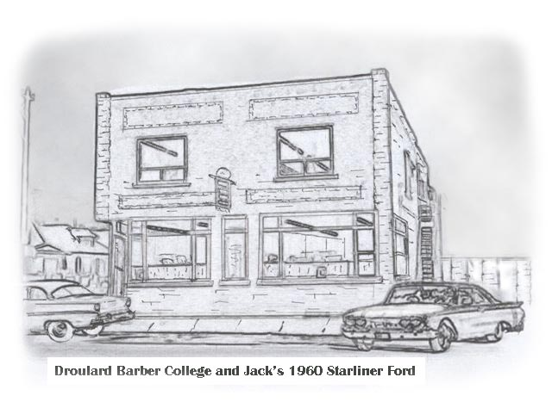
The school was purposely situated on University Ave. a few blocks from the Ambassador Bridge in an area where there were large French and Italian families whose children were in need of a good or not so good, low-priced haircut. They came in hordes after school, and on Saturday they would sit forever waiting on a 35-cent haircut. Adults however were 60 cents.
On the second day of school we were told we were going to do our very first haircut with hand clippers. We all wondered though just how we were going to get our first head of hair into our barber chair for that very first haircut.
Thus enters Mr. Drouillard who in a loud voice to a room full of longhaired kids says,
“Who of you would like a nice free hair cut?” about a dozen kids all put their hands up and shouted.
“Me.”
“Go down the stairs and into the classroom.”
We all followed the kids down the stairs into a long narrow basement room where a dozen empty barber chairs set waiting. The kids all scampered aboard anxious to save themselves 35 cents. Little did they know what was about to happen, as to the kids we all looked very much like real barbers in our freshly starched white uniforms. Mr. Drouillard went from chair to chair handing out hand clippers. Some of the children let out a moan. Mr. Drouillard put his hand on top of his hapless victims head bowing it and then started clipping up the back of the kids neck with his hand clippers. The hair fell in an orderly manner in great locks; first curling and then rolling down his clipper hand and finally fell silently to the floor. He quickly and expertly did the back and then both sides. Then he stood back admiring his work and then invited us to do the same; I must admit these kids were either very brave or foolish and all for 35 cents, as soon great clumps of hair were falling as clippers ran wild and deep. Sometimes too deep and some kid would shout, “OWW, that’s my ear.”
In the end it was not a pretty sight. There were buckets of not too clean hair and kids with scruffy haircuts and great red welts up and down their necks. Soon however the teachers came to the rescue and added a few personal touches so that the poor kid thought he got a decent haircut. The kids were let out the side door and rushed off to spend their money. Again Mr. Drouillard asked the crowded room,
“Who all wants a free hair cut?” “Go down the stars to the class room.” We would go through it all again. According to government regulations the school had to start us off using hand clippers before we could use the electric clippers. I don’t think any one of us ever did a decent haircut with the hand clippers and we were happy when they got us started with out electric Oster clippers. I stayed with Oster clippers all through my barbering career; they are a great, reliable clipper. On the other hand in all my years of barbering I never did do another haircut with hand clippers.
One of the guys on the second floor was Floyd “Bud” Hillman of Kirkland Lake one of four brothers who all player on National Hockey teams. That winter of 62/63 Bud left class to go to Europe with the Windsor Bull Dogs to play Olympic Hockey and the team brought home GOLD for Canada. Needless to say we were all very proud of the Windsor team and we at school were especially proud of our “Bud Hillman.”
It was rumoured that the boys spent a lot of Canadian Tire money in Russia.
You might be asking yourself why a guy who had been playing National Hockey was going to Barber College. Well at that time there was no money in playing sports, even Joe Louis the famous boxer ended up poor. You played sports for the joy of it. Then when you got older you had to find yourself a real job. In Bud’s case he hoped his hockey fame would bring him a lot of customers so he could make a decent living at barbering.
George, Dot, Mark, Aunt Em and Penny decide to “Keep Me”
After a couple weeks the school found a boarding place for me, but when I told George, Dot and Mark I had a place to go, they baulked at the idea as they wanted me to stay on with them. They claimed even Penny would miss me. As for Mark I am sure he enjoyed having me around as a sort of older brother. I also knew that he wanted to keep my 1960 Starliner Ford in the driveway. I couldn’t help but notice how many times he looked at it with great affection. Then there was Aunt Em; she still had a lot of work to do on me before she had me totally housebroken. Would you believe it as everyone here worked or went to school they had a rule: You had to make your own bed. I never made a bed at home because that’s what we all have sisters for. I hauled the wood and I pumped the water, and I milked the cows but I did not do beds. My thoughts on this were as long as you were going to sleep there tonight why bother to make the bed. In spite of my common sense approach and all my protesting I learned how to make my bed along with many other things.

So it was decided that I was going to stay on with Dot and George until I either graduated from school or they kicked me out, which ever came first. Dot had no idea what she should charge me for room and board but we settled for a dollar a day. It was undoubtedly one of the best deals of my lifetime. As I got a clean unmade bed, lots of great food and late night snacks, and in the summer many back-yard BBQs.
My laundry was done to perfection and every morning I was greeted with a freshly starched white barber uniform. I tell you those were the days! I got a lot for my dollar.
Winters in Windsor and area are very much milder then the ones I was used to up at Mitchell. I drove my car to school for the first month but it became obvious I could not afford to spend a lot of money on gas. So I started to take the bus. As Dot lived mid-way down Bertha St. and a boat canal was behind the houses across the road, I had to first walk down to Riverside Drive at the river and then cross over the canal bridge and back up the street on the other side to catch my Wyandotte St. bus. It turned around there and went straight back up town. Every morning when I walked towards the river I would see a number of people walking the other way and crossing the ice, on the canal to get to the bus. It was much shorter so naturally I had to give it a try. My Aunt Em and Dot were not very happy about this, as they didn’t think I should trust the ice. Weeks went by and all was OK. Then one night it turned very mild and that morning I debated the wisdom of crossing on the ice, however I did. Upon arriving home that night I found out about an hour after I crossed the canal a neighbour lady fell through the ice and almost drowned. That put an end to my short cut and I had to again take the long route.

School was going well for me and I was getting good marks in everything. Every night I would sit at my desk in the basement and study. I would go back over what we had taken that day and pre-read what we would take the next day. You would never believe the stuff they ask you to study to become a barber - things like bacteriology, sterilization, sanitation, personal hygiene, and the skin the scalp and the hair, and then comes shaving and haircutting, barber ethics and shop management and more. My year’s average for all subjects was 98 percent or the second highest marks ever made in Droulard’s Barber School.
Believe me when I say all this did not come easy to me as my sisters stole all the brains in the family, I had to do it with study. Mark had his desk across the room from me and he astonished his dad and mom by taking a renewed interest in his school work and keeping me company by studying every night. His grades improved so much his mother actually stopped worrying about him. She was afraid he was going to give her more then a few grey hairs. Mark and I liked to doodle in our spare time and we got a kick out of what each could do. I specialized in sketching horses and country and mountain scenes and Mark would be forever drawing cars.
Mark is now an artist for the Ford Motor Company. His huge murals cover the walls at Ford plants and the walls in Walkerville and the city of Windsor. He is also very talented in doing magnificent life-size bronze work for Ford and the City. Although he credits me for inspiring him, he alone deserves the recognition for his achievements.

Every night when I came home from school Penny the dog would be at the gate waiting on me. I would sit on the rear steps and listen to her lovingly whine to me. Every few weeks I drove up home to see the folks who were now comfortably settled on the Taylor farm. They talked to Dot on the phone regularly and I’m sure she gave them a rather glowing report. It was good to find that they were actually happy for me and I could see that dad was very proud. I was dong well in school. I think I was more settled and happy than I had been in my lifetime. When I drove back to Windsor it was usually quite late when I arrived at 148 Bertha St. and Penny would be at the gate patiently waiting for me. Because I had been away for two days she poured out her heart to me. While I could not hear I could feel her whimpering cries telling me how much she loved me and had missed me.

When spring arrives, Riverside Drive comes alive with flowering trees, shrubs and bulbs. The big boats are again heading up the river to the lakes leaving a wide wake behind them. While the rest of Ontario is still locked in winters clasp, spring has sprung in Windsor. Every now and then I afforded the luxury of driving my car to work just so I could take in the Flowering Crab and Flowering Cherry trees and the striking view of Riverside Drive, the Detroit River and the Detroit skyline, I was beginning to love this city.
When the warm weather arrived we took boat rides to Peche Island in the mouth of the Detroit River with the neighbours Norman and Elva Speirn. Once there we would dive off the boat into the shallow waters off the Island. At that time the river was very clean and we could see the clean sand at our feet. It was like visiting a little paradise Island all of our own. When we arrived back home we would have a BBQ out in the back yard and eat out there at a table under an umbrella. I tell you for a buck a day I was living very well indeed.

Dot has a sister Bae who worked with the Red Cross in Windsor; she married Bill Stoddard. That summer as cousins we all grew very close, visiting back and forth a lot. Bill asked me early in my Barbering Career if I would cut his hair. Well in all truths Bill didn’t have much hair to cut. He was the kind of customer that keeps the barbers very happy. Anyway Bill wanted to be my very first paying customer so I cut his hair in the kitchen at Dot’s. He gave me a whole one-dollar bill. Later I framed it and hung it on the wall in my first shop but one night I had a break-in and it was stolen.

George and Dot and Mark and Aunt Em always ate an early supper and I would arrive home later or whenever I got off work at the school. If I were lucky catching the bus it would be sometime between six thirty and seven but sometimes even later. However every once in a while someone at the school would want me to do something or go somewhere with them after school and I would get home very late for supper. This was a no no as Aunt Em would be keeping my supper warm in the oven. Micro ovens had not been invented yet. Aunt Em would meet me at the door looking very stern and very much like my mother and I knew I was in trouble.
She would say, “If you think for one minute I am going to keep your supper warm for you all night while you gad about, you had better think again?”
Then she would say, “Now sit down and eat your supper, it’s getting cold.” She would then fuss over me making sure everything was just so. I knew she loved me so while she gave me a tongue lashing her anger could not last long against me.
Mark got a kick out of this and told me I got away with all sorts of things he would never even dare to try.
Everything was going along fine until one day I got a letter that my unemployment insurance had run out. I went to their office and talked to them but there was nothing they would do. A few weeks later I got a letter from my bank in Mitchell and it seemed my Mutual stocks had lost a lot of its value and would not cover my loan, so they could not give me any more money. I was in dire straits.
I talked it over with Mr. Drouillard and he begged me to find a way to finish my course as he said I was going to make a good barber. He wrote a letter for me to give to the bank manager Mr. McDougall telling him I was one of the best students in the school and to please help me finish the course. Dot even offered to help by cutting her board money to six dollars a week.

That weekend I went home not knowing for sure if I would be back to school or not as I was out of funds. On the Monday I went to the bank in Mitchell and gave Mr. McDougall the letter from Mr.Drouillard. I am sure I put him between a rock and a hard place. My only hope hung on that letter from Mr.Drouillard. In those days the bank manager had much more say about who got money and who didn’t. After reading the letter Mr. McDougall said he would see me through my course by extending my loan to cover.
Before you can graduate from Barber College you must put in so many hours behind the chair cutting hair, I had never missed a day in school since I started in January so in a few weeks I would have my time in. My timing was going to work out very well for me as the very next government exams were to be held at Droulard’s School in Windsor. The exams were held every six months at different locations from one end of the province to the other.

I enjoyed everything about that year in Windsor, the city itself, the school and above all my boarding place, which was more like an extended visit. It cemented my love and friendship with Dot and family and Bill and Bae “cousins forever.”
Sometimes Mark came down to the school on the bus to have me cut his hair. I would give him the royal treatment, a scalp massage and hair treatment, shampoo and haircut and facial all for 35 cents. He was pampered and spoiled rotten for a couple of hours but I didn’t hear him complain. I think he was a happy camper.

One of the things as a senior student you were expected to do was at times become a guinea pig for the younger students. When a class was going to give its first shave you might find your name on the list to be shaved the next morning so you would be asked to arrive at school unshaved. Getting a first time shave from a student barber is not exactly prime-time entertainment. Just the thought of lying in a chair with an unskilled student looming overhead with a straight razor is enough to send chills up some people’s spine. It was on such a morning that Bud Hillman the hockey player found himself in my chair talking to me reassuringly. I remember him saying,
“Now Jack just stay cool and c-c-calm down, -d-don’t be afraid.”
I remember saying, “Eh Bud I’m calm and I’m cool, but you are the guy who should be afraid.” All went well. Bud Hillman was a very brave man and he survived my very first shave. I didn’t even nick him.

Sometime near the end of August the day arrived for the government exams and thirty some barbers from all over the province turned up. I was really scared stiff as I knew I had to pass this the first time and some of these guys were telling me they were back for the second and third time. Things went very well and when it was over I had the feeling it was going to be OK.
The next day Mr.Drouillard told us that only two out of the thirty barbers that tried the exams, passed. That was a guy called Ken Rowly from Ottawa and Jack Cooke from the Windsor school. It was a great relief to know I had made it, and now I really was an Honest to Goodness Barber.
.
One of the guys in my class Bill Kells had left school two weeks before the exams to take over a shop in South London at 873 Wellington Road. Since he had not passed the government exams he could not operate a shop so he had to give it up. He came to me and told me he wanted me to take a look at it and take it over from him. He felt since I was the only one in the Windsor school from up north it should be mine if I wanted it.
I made the trip up to London and found the shop closed as Bill had already left. It was just a small flat-topped shop made of cement blocks with an angel stone front. A big sign hung on two posts calling it “Southbreeze Barber Shop” While it sported two chairs, the previous owners Ozzie Aubin had only worked the one. He and his wife Kay a hairdresser who operated a beauty shop in the basement of the house behind the shop had left London for Orlando Florida. They sold the house, shop and business to his brother and sister in law Joe and Janette Tipping.

My First Barber Shop
The new owners Joe and Jeanette Tipping with a son Brian who was less then a year old lived in the house and were in dire need to get the two shops up and running. They had a hairdresser hired to operate the beauty shop while Jeanette herself was attending hairdressing school. As soon as she graduated she would run the beauty shop herself. They spoke of Bill Kells very fondly even though he had only been there for a short time; I had the feeling that while they desperately needed someone to run the barbershop I was second choice.
While they were showing me the shop a high school boy who lived close by came in. His name was Scott Barber and he asked if I would cut his hair. I had my tool kit in the car. While cutting his hair he convinced me that everyone out in this veteran’s sub division wanted this shop to succeed. This was the southern end of the city and the last barbershop out and the bus service to go up town from there was not at all good. So I decided I would take the shop.
The Tipping offered the shop to me for seventy five percent of the daily proceeds, and I was to charge $1.25 a haircut. They would pay all the bills. That is they got 25 cents out of every dollar I took in and they paid for the hydro and the gas heat and the business and property taxes. They even offered me the London Free Press delivered to the shop each day. I felt it was a very good deal. However they told me they did not want to give me a lease as they looked at the property as real estate and if the time ever came they wanted to sell they didn’t want to have to be concerned about a lease. Truly at that time I didn’t know what benefit a lease could be to me or if I should have one. Actually I was afraid it would only mean that if I didn’t make a go of it I was tied to it anyway, so I readily agreed to no lease. Then they wanted to know where I would stay when I came to London. I said I would have to look for a place. They told me that Bill had stayed with them as they had one extra bedroom so if I wanted to do that they would give me room and board. This seemed a good idea, as here I was right at work so it was agreed.

Joe had a large white sign about six feet long and a foot high with bright red letters on ready to hang out in front above the window that said “OPEN. Soon customers came flocking in, actually more then I could handle. The worst was that this area had been township until just recently when the city expanded and took it over. Ozzie Aubin had cut hair, free of any city regulations as far as price hours or days were concerned. I had a hard time to close the door at six o’clock, as they were used to coming in any time that they found Ozzie in the shop. I would turn the sign in the window at six PM to close, but it was as if they could not read. They just came in and sat down. I tried pulling the blind and locking the door and they would knock and become angry if I turned them away as Ozzie always let them in. It was not that I didn’t want to cut their hair; it was because the city by law said I had to close the door at six o’clock, and I didn’t want to get into trouble so soon.

I would find customers at the door at eight o’clock in the morning waiting on me to open up, and at noon they came in on their lunch hour. I would have to wait until I had a break then dash to the house and eat whatever Jeanette left for me. When I got back to the shop twenty minutes later it might be 2 o’clock and some one would ask me,
“Why don’t you eat your dinner at noon as the shop should not be closed at 2 o clock.” Well I learned there was no way you can operate a one chair shop to please the public so you just smile and cut hair and do the best you can.

A student barber from Windsor dropped by one evening to see how things were going for me. His name was Eric Kehl and as yet he was not working. Joe wanted me to let him have the other chair in the shop and cut hair along with me. I didn’t really want to do this but, as I didn’t have a lease or any kind of written agreement, I had to accept it. While I knew there were more heads of hair than I could handle right now I was sure it was just because the shop had been closed for a while. In the end I agreed that he could cut hair when there were extra customers waiting and right now he needed a job. For a few weeks we cut hair together, but true to what I had thought things started to slow down after a few weeks and Eric was not happy with his share of the haircuts. There was an ad in the Free Press for a barber needed at Wolsley Barracks the army base here in London. Eric left to cut hair there and I have never heard from him since. I do hope things worked out for him.
Jeanette (Mrs. Tipping) did not like house cleaning. At home her mother had kept a spotless house and had forced Jeanette and her sisters to do house cleaning as they grew up. Jeanette swore that once she had a home of her own no one would tell her how or when to house clean. Her mom though had different ideas and would arrive most weekends with a bucket in hand and nothing could stop her from cleaning the house from top to bottom. Her mother was a very short little Scotch lady not much over five feet high with a sharp tongue and the ambition of a whole Scotch Regiment. She picked up, she scrubbed, she dusted and when she left everything would be clean and in its place. Then in a week’s time it would be a mess again as the Tippings had many friends and liked to party. One night when they were out I decided to wash the kitchen floor, as it was very dirty. When I pulled the drapes away from the wall there was puke on the floor behind them. Joe and Jeanette came in just as I was finishing up and instead of saying a thank you they told me,
“It was not that bad, don’t ever do that again.”
I said, “Well I had to do something about that puke behind the drapes,” Jeanette said she had been sick on the weekend and did it and then forgot to clean it up.

I had been very spoiled in Windsor with everything spotless around me at all times, and do you know what? I grew to like it that way. So I thought I should start to look for a small place of my own sometime soon when I was more secure.

Joe Tipping had helped his kid brother to open a Skin Diving business at the back end of his brothers Harold’s TV cable business on Adelaide Street. This was away back when James Bond was making his first movies, flouting skin diving wet suits and equipment and the teens were enchanted with it. The kid brother was doing well giving night courses at high schools and selling equipment and air from his shop. He also took groups of young chaps out to a site and showed them how to do it right. On such an outing one summer’s day in the early sixties he met his fate in a quarry near Woodstock and drowned. Joe, having an investment in his kid brother’s business automatically inherited it. For a year or more he tried to keep his welding job at Canadian Pittsburgh and run the Aqua Shop on Adelaide St. after hours and on weekends. In about 1965 he built a small extension onto the Barber Shop and opened the Aqua Shop there. This proved a good idea. I believe it was the first shop of its kind in London. It was actually good for my business too as it drew more attention to the lot. So we co-existed happily.

One day I was shopping in Eaton’s when a young chap approached me and asked if I came from up north and of course I said yes. It seems his father had owned a small grocery store and gas station in the village of Ruseldale and he had put gas in my car a few times. His name was Robert Scott and he had a job working at Simpson’s and lived in a rooming house on Wellington Street. After a few weeks he came to the shop and told me he had found a nice small apartment and wondered if I would share it with him. It was in the uptown area so he could walk to work, but there was a parking place for one car, so I went to look at it, and while it was small it was very clean and tidy and the rent was right. So I decided we should take it, as I did want a more private place then I had at Tippings.
Most of my first furniture was bought at Sayvette’s and Kmart. I remember one of the very first things I bought was a black and white 17 inch Westinghouse TV. Regardless of its quality I think everyone remembers their very first, house or apartment. It didn’t take a lot to make you happy, as it was all your very own.

I had been making payments on the loan for my barbering course quite regularly. However everyday I was watching the stock market plummet down and down and my mutuals slipped lower in value. This had been my first venture onto mutual stocks and I was afraid of losing it all. If I had known then what I know today I would have ridden it out as when you miss selling on the high market, never sell good stock when it bottoms out. You still own all your shares and someday their value will return and go on to make you more money. This is especially so when you’re young as time is on your side. However I decided to sell and take what I could get. I got a little over $800.00 for the $2,000.00 I had invested. If only I had just walked away for thirty and forty years that $2000.00 would have made me a lot of money in the American Growth Fund, possibly several hundred thousand dollars. I took the money and paid off my bank loan.
Once free of the loan and the shop doing very well I decided to trade my car in for a new 1964 Ford Galaxie 500 convertible in a robin egg blue and black powered top. It had a powerful V 8 motor with 352-horse power. It was also the first car I owned with bucket seats and console and powered windows and locks.

Yes, I know now, I did everything wrong about this, but that is the great thing about being young, you can actually live with and enjoy your mistakes, as long as you feel it is worth it to get what you want. It’s one of life’s blessings or curses?
Things quieted down a lot at the shop but it was still fairly steady. Like all Barber Shops I would have my early birds waiting at the door when I arrived in the morning, then once I got caught up I might not have anyone in for some time. You could never leave the shop during the noon hour, as men like to sneak in to get a haircut on their noon hour and they expected to find you there. There is usually a lull in mid afternoon and then after school the kids would come in followed by men coming in on their way home from work.
On several occasions I noticed a car sitting just beyond my entranceway with a man sitting in it. He appeared to be watching my shop. One reason I noticed it was because no one is supposed to park on the shoulder of Wellington Road. Then one morning a man walked into the shop wearing a blue jacket with the seal of City of London on it. He said there had been a complaint so he had been watching my shop and found that I was flouting with the city by-laws in regards to the closing hours of six o’clock in the evening.
I explained to him how I had just taken the shop over that fall and that this area was recently township with no such by-laws. My customers were not yet used to the change and kept coming in after hours. They got very upset and angry when they found the door locked and as I was just out of Barber School I couldn’t afford to lose them as customers. He told me that he was going to let me off this time with a warning but next time I would get a fine. It took a long time for my customers to come to terms with this. I am sure many just walked away in anger never to return. Rural people do not like to accept change or city bi-laws.

