I was young and energetic and my community life was very full. There was the local United Church Young People’s Union and Jr. Farmers and our Motherwell Community club, parties and dances, and of course Sunday School and Church.
I took my place in all this activity even though I struggled with my hearing. Our local Motherwell United Church Young Peoples Union met every Sunday evening in the basement of our Church and our county presbytery met once a month, most often in someone’s home from one end of the county to the other. I took my part and had a great interest in all these activities. Eventually I worked up to preside over our local Young People’s and moved on to become a member of the board of directors of the Perth County Young People’s Presbytery.
Mitchell Jr. Farmers came next, and after serving in almost every office I became the president of the Mitchell Jr. Farmers. I served as president for a number of years. While I was president, Mitchell became the largest Jr. Farmer’s organization in Perth County. The membership more then doubled. This was largely because I had a great team of people who were so willing to work hard for me. I demanded a lot from them, I knew it then and I know it today. Yet I believe they enjoyed the results we received by working together. There are times when they share their memories of this with me with pride. On the other hand my dad and mom took no interest in any of the things I did. They did know that it sometimes messed up the milking schedule. Or at times took me away from my farm duties. I did feel guilty about it because sons were supposed to be dutiful to their parents and not think of themselves. This was of course selfish of me. I also knew that as a son I had broken almost every code in the book.
The County Jr. Farmers were asked to present a half hour TV program for the Wingham TV station. As I had been writing local events in the Mitchell paper on Young Peoples and Jr. Farmer activities, they asked if I would write a document on poultry in Perth County, then act as commentator for the show. This was a tall order for me, as at home we didn’t own a TV set yet. However I wrote the document and did the show with the help of Ivan Norris and Jack Fisher of the Mitchell Jr. Farmers. I also should credit fifty baby chicks donated to us for the show by Roe’s Hatchery of Atwood. I still remember the first few lines of the document. It read -
“It is a far cry today from the first time a cock crowed in the jungle of Burma to the modern poultry houses of Perth County ” I still think it as a good line to open with.
In Mitchell a large number of our Jr. Farmers were seated in the gym watching the show. What made me sad though was that while my neighbours the Smiths had a TV set and were going to watch the show, I could not get dad and mom to go to the Smiths to watch it. They purposely would not watch it just to agitate me.
One of the projects our Jr. Farmers took on was a mailbox sign. At the time few farms had a professional printed name on their mailbox and trying to find some one could be difficult to say the least. People might refer to your place as the farm with the big red barn or the one with the large stone gatepost. Believe me I have heard it all. We decided to try to cover the whole township with mailbox signs to fit on the top of your box with a couple screws. I took my clue from the many other members and had my dad’s name put on it and then added, “and son.” Big mistake, my dad would not let me put it on the mailbox as he said,
“There was no “and son” about it, the farm is mine.” Suddenly I didn’t feel quite so selfish anymore. Many times in the winter when I felt discontented with myself I would take the shotgun and go for a walk in woods. While I did like to hunt on a rabbit drive, more often it was just an excuse to wander the woods alone and find some inner peace.
I bought my first set of Skis from Ruth (Nairn) Morrison who lived next door. On Saturday afternoons in the winter after the barn chores were done and if there was no rabbit drive, I would go Skiing with Ruth or her sister Norma. We usually skied on the hillside banks of the Thames River at Motherwell. They weren’t exactly the Blue Mountains but they served the local purpose. No one drove far to ski in those days, as it was thought of as the sport of the well to do. If it had not been for those old Motherwell hills and Ruth and Norma I would never have learned how to ski. All winters though come to an end, and the first sign that spring is on the way is when the farmers start to tap their maple trees once more for the syrup season.
I took my Uncle Hughes’s syrup pan to the bush and dug a hole through the centre of a large beach knoll and lined each side and far end with rocks. Then I shovelled the surrounding earth from the knoll back against the rock thus making an earthen fireplace about two feet high. Then I put some iron bars and steel fence posts across from side to side to rest the pan on. On the rear end I stuck in a stovepipe with a damper and mudded it all in with stones and earth. On the front I put a piece of galvanized tin sitting on a brick on each side so as to make a draft at the bottom. It worked well and I think I boiled syrup there for two or three years. No one ever helped me, but that was OK, it was my project and I was happy to do something on my own.
My agreement with dad was that I could cut down any dead trees or clean up any brush from trees he had cut during the winter, so I usually took the bob sleigh or wagon and horses back with me. That way I could gather the sap in milk cans on the sleigh or bring wood to my fire, and besides the horses were great company. Something can be said about being alone in the bush with your team of horses and especially so after dark. If you watch them you will note that their ears and nose are constantly on the move picking up sound and scent that we are not aware of. They can also get impatient from standing for long periods of time and stomp their feet or snort to let you know it’s time to call it quits. At times there can be a lot of communication in silence and especially so when you’re out there alone in the woods.
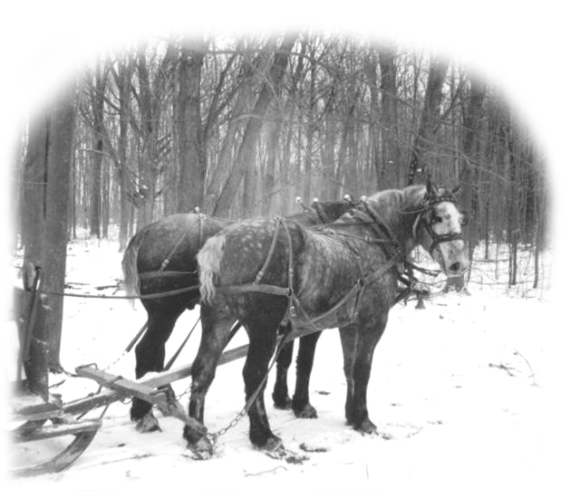
The end product of the day was usually a little over a gallon of syrup. When dad and mom got all the syrup they needed for the family I could sell the rest that I made. Syrup in the late forties was selling for $4.50 to $5.00 a gallon depending on its quality. Pan syrup is darker from more boiling than evaporator syrup and has a stronger flavour. I actually like it better, but it does not get the grade mark that evaporator syrup does so it sells for less. How do you know when the syrup is ready to “take off” as they call it? You have a special thermometer and when the temperature reaches 220 degrees F it is syrup and ready to take off. Handle it carefully as syrup is very hot.
Gathering Sap in the Sugar Bush
After a couple or three years of boiling my own syrup my neighbour Norman Morrison came to visit me. I remember how he propositioned me.
“Jack how many gallons a day do you make here?” I told him that on a good day if I had a good run of sap, I might make two gallons of syrup, but I usually averaged a bit over a gallon. He reminded me that when it gets cold and the sap doesn’t run you won’t make anything, and on rainy days you will find it hard to work out here in the open, so you would find it hard to average a gallon a day in the end. He wondered if I would leave this and instead work for him. He would give me a gallon of syrup a day or five dollars which ever I wanted. So I talked it over with dad and he thought it would be best if I worked for Norman.
It was the beginning of many years of making maple syrup for the Morrisons. They were happy years as we were the best of neighbours; I also loved the bush and the horses. Norman was a good guy to work for and I could talk to him about anything, from maple syrup to religion and get a straight answer. Norman was a good farmer and at that time I was sure he was making lots of money. For some reason after kidding him about his money, I told him that the Bible tells us that it is harder for a rich man to go to heaven, than it is for a camel to go through the eye of a needle. I heard him chuckling over that, one day when he was talking to my dad. He was not sure how he was to take that. I noted he never did give his money away, but I am sure someday I will meet him there in heaven. I will tell you a little story about him so you will know just what kind of guy he was.
On the way into St Marys one day Norman dropped in to see my dad about something. Before he left dad asked him if he would mind taking fifty dollars to town with him and depositing it in his bank account as he had a payment due on a note. This would save him a trip into town. About two weeks later dad was in town and a man asked him if Norman ever found that fifty dollars he lost. Of course dad knew nothing about it. A few days later when dad saw Norman he asked him about the lost fifty dollars. Norman said that a few days later the money turned up so everything was ok. He said he had been to a machinery dealer looking at some new machinery and he thinks he bent over to look at something and the envelope with the money fell from his shirt pocket. When he arrived at the bank he found the money missing, so he retraced his steps to the machinery agent to look for it, but they could not find it. A few days later the machinery agent was showing someone else the same piece of machinery and he found the envelope and fifty dollars lying on the ground. He called Norman to come and pick it up. This was the way people were then; there was an unsaid trust.
Dad said, “You did put fifty dollars in my account.”
Norman said, “Yes, of course, you entrusted fifty dollars to me and I lost it.” That was the Norman I knew and the way I will always remember him.
It seemed my dad soon found out very early that he could trust me with money, that just because he gave a few extra dollars I was not going to be in a rush to spend it. So almost every time I was ready to go out, he would say,
“Do you need any money?” Often I might say,
“ No I think I’m ok” and dad would hand me a few more dollars and say.
“Well take this just to be on the safe side”
He was always very good with me that way. It seems that over the years my friends have thought that somehow I must have money, as they have never caught me broke. It just might be that I hear that voice of my dear old Aunt Becky saying,
“Its not how much money you make Jack, but what you” DO” with the money you make.”
I worked hard all summer and played even harder, thus often I would be rather late in getting home. My dad was always at me saying I should not be burning my candle on both ends. I loved to drive up to Grand Bend on Sunday evenings and go roller-skating. Many of my friends would be there from near and far. It was Ruth Nairn that introduced me to the Grand March on that roller rink. Ruth was good at guiding me, as I could not hear the instructions. No one had their own roller skates in those days, as the skates just strapped on to your shoes.
“ Fall Fever and Westward Ho ”
Every time fall came around I would feel the call of the west. In my mind I would see those great fields of waving wheat and the rolling hills of prairie grass, with its cows and calves. After two years at home I needed to go back so I put my name in for the harvest excursion once more.
This time I just took my one large suitcase and a handbag and every thing went much as before. On the train I was seated beside a lad from Gads Hill a village just north of Stratford. His name was Bill Rose. We decided to team up and go to the same place. When we arrived in Winnipeg I really did want to see my Uncle Fred but we were going to be put on a bus and shipped out right away. As the grain crops usually ripens in Manitoba first, before Saskatchewan or Alberta they would not send us out any farther until the crops in Manitoba were harvested.
Again they took us to a large empty area and called out names to places we had never heard of before. We both pictured a far off place with a strange name so when they called out, ten men for Cypress River, I told Bill that sounded good. He agreed so we both put up our hands and we were ushered away together and put on a bus. Neither of us had any idea where we were heading, but then that adds to the excitement. It ended up that is about 95 miles west of Winnipeg on the number 2 highway towards Brandon.
We arrived in the late afternoon in a well treed but sleepy little town well off the number 2 highway. It had a railway track and a row of grain elevators on the south side of the street and a row of shops and stores on the north side. As we pulled up we could see a group of farmers jockeying to be in the front at where they thought the bus might stop. They were desperate for harvest help and they actually rushed up and put there hands on you and tried to pull you away as they asked you to come with them. This man put a hand on my arm and said,
“This one has a bit of muscle. Then he added, “They sure don’t send then out like they use to.” The war was over but there was still a shortage of mature men to work at the harvest so most of these workers were very young men and boys.
Bill and I went with this man. His name was Marius Aubry, and he spoke just a bit different. He said that he wanted me to work for him and that his neighbour had asked him to bring him a man if possible. When we reached this neighbour’s place he stopped at the road and looked at Bill and said,
“Now look this is up to you, if you feel you want to stay or not?” then added, “Things are just as bad as they look, so be careful.”
We drove into a yard of mud and rooted dirt. What a sight to see. The place was in shambles. A small sun bleached grey frame house with chickens all about the door and pigs running free rooting all over the yard. There were cans and boxes and boards and machinery parts scattered all over. It looked like the remembrances of a mad twister. The farmer and his wife came out of the house to greet us. We debated the rest of the fall as to which was the dirtiest, the pigs or the farmer and his wife. Bill cowered down in the back seat and said,
“I’m not staying here,” to which Marius said,
“OK, I understand I will get you out of this”
This was one of the few Scottish farmers in the area and he said,
“So you brought me some help did you?” Marius told him not many men came in on the bus so he could not get a man for him. At first the Icelandic farmer seemed a bit taken back and he told Marius,.
“You cannot take two men for yourself as I have to have one.” So Marius told him the second man was to work for his two brothers. They were going to share him, which for a short time proved true. We left much to Bill’s relief.
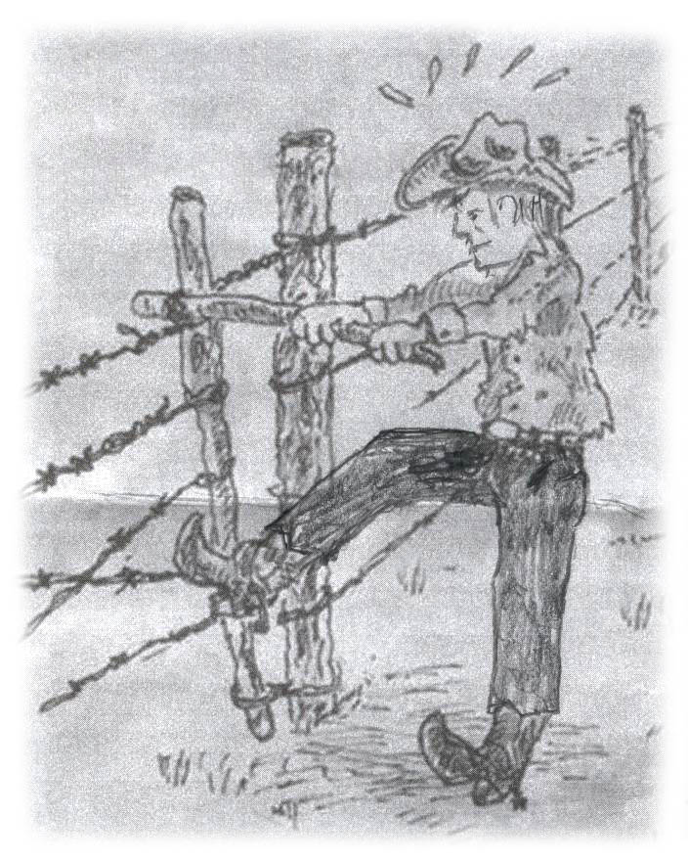
Down the road a way we pulled into a lane with a barbed wire gate across it…one of those you only saw in the west with a stick and chain on, to tighten it. I jumped out to open the gate and Marius drove through. When I got back in he sat for a few seconds and then turned sideways to talk to us. He said,
“Now I don’t know what you guys are use to, or what you are expecting. My place is not fancy but it is clean.”
I already liked the man. He seemed honest and open and I respected him for that little speech he gave to us before he took us over the hill. I thought it was a show of a proud and solid character, and of courage and honesty. It turned out that every word of what he said was positively true. We couldn’t see
Getting the Gate by Jack anything from the road, just a winding roadway going up around the side of a hill. As we drove farther on we could see the roof and then the front of a nice looking red-hip roof barn coming into view. Soon we could see the whole of it, sitting at the far end of a large yard, which was surrounded with a growth of shrub trees.
At this end of the yard and nearer to us was a small-unpainted clapboard house, its rear and far side huddled up close to the shrub trees in the hillside. The yard was clear of debris but no lawns or flowerbeds in sight. The packed earth spread all the way from the house to the barn and beyond.
Out of the house came a rather beautiful full figured lady, with a great head of dark hair and a smile that was quick, the kind you would always remember. The instant she welcomed us I knew things were going to be OK here. It was late afternoon by now and they knew we had been on the road for a long time. So they suggested we go into their front room and rest until the men came in from the fields. The men were busy cutting grain with the binders and stooking sheaves.
Once seated in the front room I was aware of the big-framed picture of the Virgin Mary, which dominated the room. I also was sure I had heard a few French words spoken between Marius and his wife Bertha. Suddenly I wondered just what I might have got into. Although I was English, all my life I had lived in a Scottish community. I had heard stories galore about the terrible French, and yet I had never met a true Frenchman. Then I was born in a solid Protestant community and all my life I had heard about the terrible Catholic. What had I got into? Soon we could smell coffee, such as I had never smelled before, and to this day I swear the best cups of coffee I ever had were made by this French woman Bertha. I would give anything for another cup of that coffee.
Shortly after six a group of dark, sweaty but talkative men entered the large farm kitchen. Bill and I were called to sit with them for supper. The food was plentiful and wonderful, but the conversation was in French so Bill and I sat in silence. Suddenly one young man spoke up and everyone turned their heads and looked at us. Then without an explanation everyone was talking English.
This young man who spoke up was Jerry Baltesson. He was a normalite school teacher that year teaching at a local public school. He was boarding at his Uncles Marcel’s who was Marius’s brother. There was a third brother John there also and they all worked together to make a threshing crew. An older man was at the table too. He was Emile Aubry, the grandfather of the Aubry clan and very much a Frenchman.
Jerry and I remain friends to this day. He is now a retired schoolteacher and lives in a beautiful penthouse in downtown Winnipeg. I asked him what happened that day at the kitchen table. He said that the men always talked in French when their grandfather was present, as he had never learned to understand English very well. When he made them realize we didn’t understand a word they were saying, they switched to English for courtesy reasons.
Marius and Bertha had two daughters, Gaby the oldest about thirteen or fourteen and Loraine perhaps twelve. Loraine was one of those children who would never grow up. She was big, heavy set, good natured and playful, but she would never be more then a big baby in her mind. She took a liking to Bill for some reasons and he was a scared to death of her. She would run straight at him only to dive past him at the last minute. Everyone thought it was funny except of course poor Bill. He was sure he was going to get squashed to death sooner or later. She liked me too I know, but never bothered me the way she teased Bill. Everyone was good to Loraine, but it was easy to see she was a heavy load for Bertha her mother. Yet they never complained; they took her along where ever they went never trying to hide her. These people were honest and accepting to the core and I respected them greatly for that.
One Sunday after I had been working for them a few weeks, I walked out to the field as I could see Marius’s brother Marcel working on the threshing machine, servicing it and making sure it was ready to go on Monday morning. While working away he asked me a few questions about me and about Ontario. He was born in Cypress River and had never been out of the province. He said,
“Jack I understand down east where you come from there are no French or Catholics. How do you feel about coming out here and staying with us?”
“That would have been a big question, a few weeks ago when I first got here. At that time I would not have known the answer, but now after spending a few weeks with Marius and Bertha I had made up my mind about a number of things. I am never going to judge a person by his nationality or his religion again. I was a stranger to them just a few weeks ago and they have shown me they care about me and when I watch them with Loraine and see how they watch over her and love her, all I know is, whatever God they believe in, it is the same God I believe in.”
A number of years later my dad and mom were driving through Cypress River and stopped by to meet the Aubrys. Marcel told my dad and mom about the time he asked me that question and he would always remember the answer he got, and that it made him very happy and that of course made me happy.
I was given two beautiful sorrel Belgium mares to drive; they were actually sisters from one of brother John’s mares. Marcel owned the one and Marius owned the other. They both named their mare Lady. They were beauties, exactly alike and they responded to me with loyal affection. I could walk back to the threshing machine without having to climb back up on the load and drive the wagon in. I would walk ahead and they would each put their head to my shoulder, one on either side and would follow me everywhere I went. Everyone thought this was great, and they all took turns asking me how the Ladies were.
Bill eventually went to work for a neighbour, the Diehls, a German family. He left for home before I did and I have never seen him since Cypress River. Some day I think I will drive up to Gads Hill and look him up and find out how life treated him and if he ever got back to Cypress River. Snow came down just before we got the last of the crop off, and I became rather house bound. That wasn’t all bad as there was lots of great coffee and homemade bread and buns.
One morning after breakfast Marius asked me if I would mind hitching Gaby’s horse up to the buggy for her to drive to school. The school was a good distance away and she used a horse and buggy every day. Of course I said yes, and off I went to the barn. The truth was while as a kid I had ridden in buggies I had never put that kind of harness on a horse nor ever hitched a horse up to a buggy. There is a great difference from hitching a workhorse to a wagon then a driver to a buggy.
I didn’t want them to think I didn’t know how to do it so I went about trying to do the job, hoping I could muddle through and in the end get it right. I managed to get the harness on the horse all right, and took it out into the yard and backed it in between the shafts on the buggy. Ah! Now what do I do with those strange loops on straps hanging down on the harness, Well the logical thing to do it seemed was to put the tugs through the loop before I fastened the tug to the whipple tree. I did that on both sides and stood back to admire my work. Mmm something seemed very wrong here as the shafts were still lying on the ground. Mmm now what do I do about that. Mmm - Big question?
About then Gaby arrived and she looked at me and she laughed. She had a lisp at times on some words. She was bent over with laugher as she said,
“What is the matter with you? Are you thoopid?” She quickly unhooked the tugs from the whipple tree and pulled the tugs free of the loops, then pulled the horse forward and dropped the loop over the end of the shafts. Then she backed the horse up again and fastened the tugs to the whipple tree.
Boy, I was a great help that morning and they never let me forget it. Years later they still laughed about it. Yes I guess I was “thoopid.”
They all thought this was a great joke on me, and everyone told everyone else how Jack harnesses a horse to a buggy. I have told this story to many of my friends and every now and then when they try to explain something to me, and I don’t seem to see the point, they say,
“What is the matter with you are you thoopid?” and we all get a good laugh.
The weather in Manitoba stayed wet and cold, so I said a sad farewell to all my new friends at Cypress River and left for home. There were still a few days of threshing left in the fields but with luck they would be able to finish it later. I left by bus for Winnipeg and visited for a couple days with Uncle Fred. He was expecting me and I was happy to see him again. It was a long trip home alone on the train I remember though Southern Ontario looked good to come home to.

Home Again
As my dad always said, I was always burning my candle at both ends. I was always trying to get just a bit more out of life then twenty-four hours or seven days a week offered. I enjoyed the Jr. Farmers organization and the Young People’s Union and the church work. Through Jr. Farmers I met Earl and Allan Paulen who farmed just east of Mitchell. My mother and Mrs. Paulen had been school friends and it seemed only natural that Earl and Allan and sisters Betty and Marion and I should become great friends too. The Paulen family was all very musical playing the violins, guitar and piano. I was never good at playing anything really well because of my hearing loss, but I did play the piano by ear. The problem was if I could not hear well I could not play well. However I did sing, and they never seemed to tire of my singing. Betty played for me many times when I was asked to sing somewhere. Later Earl’s girl friend Carolyn (Eisler) Paulen played for me.
Through the Paulen boys I got introduced to the Mitchell United Church. They had a wonderful minister at that time, Rev. Robert Watt the youngest of five Watt brothers all of whom were United Church Ministers. He was packing the church full every Sunday, with his wonderful sermons. When I said packing I mean even the balcony and at times people sat in the aisle.
One day after church, Earl and Allan introduced me to Mr. Harley the church organist and music director. They wanted him to hear my voice. Of course it was a little embarrassing to have it happen this way. However he liked what he heard and had me sing a solo in church the very next Sunday. This was the first of many; many times I sang solos in the Mitchell United Church. I joined the choir so I could work closer with Mr. Harley, as he was also a music teacher and there were many things he could suggest to help me sing better. My dad and mother never heard me sing in the Mitchell United Church.
Besides singing in the choir I sang at weddings and funerals. I have sung everything from O Perfect Love, The Holy City, The Lords Prayer and The Birthday Of A King; my favourite for funerals remains “Beyond the Sunset.”
All this got me introduced to the many wonderful people within the church and Sunday school, and soon they wanted me to consider teaching a Sunday school class. It appears they had a class of boys all about 15 that needed a teacher. The boys were supposed to be hard to handle. Well I had no problem with any of them. I am happy that every one of those boys made good. I will have to admit that one of those boys gave me a lot of help to get the others to respond. His name was Dean Robinson.
Dean went on to do great things. I believe one of his first real jobs was working for the London Free Press, then with the Stratford Beacon Herald. He also taught journalism at Doon Campus of Conestoga College. Dean has many great books to his credit. I like to think that perhaps somehow at one time I helped him.
After a couple years of teaching Sunday school, the board asked me if I would accept the job of Sunday school superintendent. This was quite an honour as the Main Street United Church had a huge Sunday school. I spent two years at the job.
I tried to balance all this with the farm work at home. If I had a brother it might have helped as my dad and mom relied totally on me. Dad and mom took no delight in what I did off the farm. In a way I can understand, it was just the way we were and what was expected of you at that time. Your work on the farm should always come first. On Sunday mornings in the winter I would be up before six AM and clean the stables, bed the cattle and have the milking done and be at the church in Mitchell by 10.00 AM for Sunday school. Dad was left to feed the cattle at noon. Some parents would have been proud of their son for doing this, as it was church work, but I was made to feel guilty.
Today I see parents who hesitate to ask their kids to even cut the grass, or shovel snow, while they shell out thousands of dollars for their kid’s educations. They don’t feel their kids owe them anything beyond being a good kid.
Friends To Remember And People I Worked For
Does everyone in his or her lifetime, know someone that years later, when looking back is remembered as a humorous wonderful friend or colourful character? I found such a friend in an older friend of my dad and mom. He was called John G Scott. Everyone referred to him only as John G. John G married Mary F and that is what everyone called them John G and Mary F. They lived in a modest little house in the village of Russeldale, the kind you see in every little village across Ontario with a neat little lawn and flowerbeds and a garden. John G was what in those days was called a drover. This meant he made his living by going from place to place buying and selling. If you had little pigs to sell he knew a buyer. If you needed one more milk cow he could find you one. He loved to barter, but in the end you nearly always could make a deal with him. He was as honest as they came and always stuck to his deal and expected you to do likewise. If you needed help to buzz wood or any kind of trucking job he would be there for you. No job was too small or too big and his price was always fair and right and often free.
One of his more steady jobs was trucking fat hogs to the White Packing Plant in Stratford. He would arrive at our place with his beat up old truck, the rack held together with rope and black wire. Chances are he might need a pail of water for his radiator, or some rope or wire to hold his rack together. He would back up to your loading door. Ours was always the doorway to the horse stable. John G always had this problem backing up as somehow the barn always came up a bit too fast. He would smack into your barn wall hitting it with zest. Backing into a stone barn wall is not the kind of thing most people want to do more than once in a life time, but John G did it every time he came.
We would help him pull out his loading ramp from under the rear of his truck, then get the gates off the side of the trucks where they hung. Then we would place a gate on either side of the ramp and we were then ready to load our pigs. Everything was in ill-repair, but capable of doing the job. This was John G.
He always carried a can of black tar with a shingle stick in it. By drawing the tarred shingle across the fat hog’s shoulder or rump he left a mark on your hog so that when he reached the packing plant he knew whose hog was whose.
He brought us all the neighbourhood news and he was never in a hurry to take leave. If you had a problem, he had the time to help you. When he left you knew you had a visit from a friend, not just some trucker making a call. He loved a good joke. One time my dad hired him to truck our wheat to Ferg Levi’s mill in Mitchell. Roy Russell, a neighbour had one of the first combines in our area. It was a pull type, which means you pulled it with your tractor and it was driven by the power drive shaft from the rear of the tractor.
One man would have to sit on a platform on the combine and put bags on the bagger of the storage bin. When the bag was full they would be tied and placed on a platform, which was about four foot square. Two bags placed one way and then two went the other way so they would pile firmly and neatly. Every time you made a round and came to the corner where the truck was parked you put your foot on a trip and the platform dumped the bags off. They would roll off onto the ground.
This was one of the first times I had been close up to a working combine and I didn’t know anything about dumping the bags, so I climbed up on the platform to be with John G and rode a round of the field. As he neared the corner he said,
“Why don’t you sit up there on the bags out of my way?” So I made myself comfortable and watched him tie bags. As we rounded the corner suddenly I went flying off with the bags. He had dumped me. I could see John G laughing with glee as the combine continued on around the field. He laughed about that for a good many years, but somehow it only endeared him to me.
Every fall after the harvest was off I would either find a job locally or go west to help with the harvest. I have always felt that I received a great reward working at various jobs I took as I was always learning something. I was able to use what I learned many times over for the rest of my life.
I worked for Ferg Robinson of Robinson’s Lumber Mill in Mitchell for two falls. I had met Ferg by chance when I was quite young, maybe sixteen. A neighbour, Les Brown’s barn had burnt down and Robertson’s Lumber was building the new barn. All the neighbours turned up to help with the building; I had always been handy with a hammer and Ferg noticed this so he put me in charge of a group of men, most of whom were old enough to be my father. Ferg praised me in front of my dad several times for my ability. For once I thought I saw a glimmer of pride in my father’s face. Perhaps there was hope for me yet.
One fall a few years later I asked Ferg for a job, and he hired me right off. My wages were the very best in town, and I was extremely happy, as I liked Ferg and all the Robinsons, my job and my pay check. I got one dollar and twenty-five cents an hour. I worked from eight AM till six PM with an hour off at noon five days a week, and on Saturday morning from eight till twelve noon. This was forty-nine hours a week at a dollar twenty-five. My weekly pay check was $61.25. WOW!. I don’t remember anything being deducted from it at that time. Ferg was a good guy to work for and we got along well. He was building a lot of machinery sheds and pole barns at that time. While I was happy in every way, I knew my hearing was a problem for him. Several times I would be working high up on the barn and he would have to climb up to tell me about something, as I could not hear him shouting to me from down below. I knew this was not good but Ferg never complained all the time I worked for him.
There was a small job he took on one fall that I have never forgotten. Just west of Mitchell a barn had burnt down leaving a forty-five foot silo. Since the farmer was now without a place to store his grain he wanted Ferg to build a roof on this silo so he could use it to store his grain. Ferg had a 45 ft ladder that would just reach the top. We pulled all the lumber up by rope from the inside and then built the framework for the roof. It was to be capped or covered with aluminium. All was going smoothly until we came to the very last sheet of aluminium to be nailed down. It was cut to fit at the very peak, but I was now working on the outside of a very steep roof with nothing to hold onto. From the very peak it was well over fifty feet to the hard ground below. Believe me it was scary but I was no chicken. I had to be very careful not to start to slip, as there was nothing to stop me from falling all the way to the ground. No! No! We didn’t have any unions at that time, and they didn’t interfere with the work of small businesses. In fact we didn’t even wear hard hats.
I will never forget the trust I put in Ferg that day. He was on the ladder, which was just under the roofline. His head was jutted up and over the edge of the roof. He spoke very calmly to me and said,
“Now Jack I want you to let yourself slide down very slowly to my hands.”
“Don’t slide fast as I could not stop you from going over the edge.” So I did a slow slide, butterflies all aflutter in my tummy. Then he said,
“Now you will have to come down over the edge on the inside of me to the ladder. Let your feet come over the edge of the roof and I will help you find a ladder rung.. don’t lean back. I can balance you but I could not hold you, so go slow and don’t lean back.” I put my trust in Ferg that day. I don’t think either of us ever forgot it.
All car manufacturers had stopped building cars in 1939 in order to build everything from jeeps to tanks for the war. The first cars built after the Second World War was in 1946. I well remember that one of our neighbours Alex Morrison; a brother to Norman bought a new Chevrolet car for one thousand dollars. A thousand dollars was a vast sum of money in 1946. Now something was about to happen over the next few years with our economy that had never happened before or since on such a scale. Canada came out of the Second World War deeply in debt, but full of hope and high on energy. Once again it seemed Canadians had faith and a future. The boys came home tired of war, eager to marry and settle down and raise a family and get on with life. They took out long term veteran loans and 20 and 25 year amortization mortgages on homes and farms and small businesses at five and six percent. A new house in the city would cost you about $6,000.00 and a 100-acre farm about the same. While the older generation was still a bit timid the young were full of hope, convinced the world was about to change and they were going to be a part of it. Little did they know at the time but for the most their dreams all came true.
In 1946 a kid with a nickel had big purchasing power. It would buy you an ice cream cone or a bottle of pop. It would also buy you an O Henry, Sweet Marie or Nelson chocolate bar. But in 1947 the price for pop and candy rose to eight cents or a sixty percent jump. This was disastrous for a kid with only a nickel. The price of a movie at the local “show” for children jumped from eighteen cents to thirty and for adults from forty-eight to sixty.
Factories, which had been making war equipment, retooled and were soon turning out stoves, fridges, and washing machines and selling them to the new homeowners, “The Veterans.” A great miracle was about to happen. We call it inflation, and we are told it is a bad thing…but was it for us at that time?
My neighbour drove his Chevrolet car for several years and then sold it to me about three years later for more money then he had paid for it. I bought it for $1,100.00 with only forty six thousand miles on it. I in turn drove it for three years and sold it for the same money I paid for it. This is called inflation. Over the next fifteen to twenty years the veterans sold their $6,000.00 homes for $12,000.00 to $13,000.00 and bought newer and bigger homes for $16,000.00 to $18,000.00.These are the homes you have to pay $130,000.00 for today, so this is inflation.
Everyone’s net value was increased by inflation; our ever-increasing worth in real estate, material things and dollars also increased our credit. Canadians went on a huge buying spree, which kept the factories busy and the pay checks full as better jobs and better pay were always on the upward spiral. Income tax had been invented in 1917 but limped along until after the second war when it was enforced. First it was imposed on office and factory workers wages and then finally extended to the farmers, especially those with milk cheques. The government hired inspectors who roamed the rural countryside forcing reluctant farmers to file income tax forms or go to jail More than one got run off the farm with a shot gun. But in the end they had to pay. The great miracle was that we paid off a monstrous war debt from taxes on the great increase of our personal worth all because of years of inflation. It is hard to tell that generation that inflation is always bad.
July 9th 1949 my oldest sister Laurine married Oliver McIntosh of Motherwell.
The First TV Set
One morning in the winter of 1951 my sister Laurine’s husband Oliver McIntosh came to visit us right after breakfast. He wanted us to go to his place to help him raise an aerial for his television. Now up until right then I had not even heard of a television. I had no idea what it was. So I asked him, “What is a television?” He tried to explain it to me. He said he had this square box with a screen on it, which would sit in the living room, and then there was an aerial sitting atop these water pipes he had welded together. This aerial would pick up the picture and sort of throw it down some wires into the box and then we all could see the picture on the screen. He said all this with a very straight face.
Well now I didn’t believe in magic, and it’s hard enough at times to believe in God. I found it hard to believe my brother in law would spend his money on such a wild idea as this. Well we had to humour him, so dad and I went down to where he and Laurine first lived in a little house across the road from the old McIntosh homestead. Oliver had welded several old water pipes together and they were lying on the ground on the north side of the house. The foot of the pipe was against the house foundation and the top straight out to the north.
He had the aerial fastened on the top of the pole and off the ground by putting it in his trailer box. One wire went over the back kitchen and was attached to his tractor tow bar. What he wanted dad and me to do was keep a wire tight on either side of the pipe as it went up so it would not jackknife one way or the other. All went well and some how we fastened the pipe to the side of the house and several guy wires fastened to iron stakes in the ground
Now was time for the hour of truth. We all went into the house and sat in front of the box. When they turned it on, it went crazy, with lines going up on the screen, then down on the screen and some times across and every which way, and another. See, I knew the stupid thing would not work. Dad and I left in disgust and started our now late barn chores. About an hour later Laurine phone to tell us they now had a picture. Their Television set was an Admiral. I am not sure of the size but I think fourteen inches and they loved to watch Hockey Night In Canada and I love Lucy shows. This was the very first television I ever saw. It was hard to believe.
Soon after that my neighbours Ed and Joy Smith received their first T V set from their son Ralph who was now teaching school. I often went to visit them in the evening. It was better than the movies as you not only saw a good movie, you had great company to share it with and lots of free coffee and dessert. Joy earned a little pin money on the side by cutting the neighbour men’s hair. She charged about fifty cents a haircut. Getting your hair cut was really a nice social evening. It included the haircut and a movie and coffee and lunch. Now that is pretty good all for fifty cents. After a hair cut one evening Ed and I were sitting watching T V with our feet in the oven of the kitchen stove. We were absorbed in a good movie and I think happy in each other’s company, when Joy said,
“I smell smoke” The kindling smouldered in the oven and as our feet were resting on it, our socks got a good scorching to. Joy laughed and laughed and said,
“You two would just sit there and catch fire if I didn’t come and rescue you”
On May 5,1951 my sister Pearl married Arnold Graver of Rostock. He was a good mechanic and an even better husband and father and Grandfather.

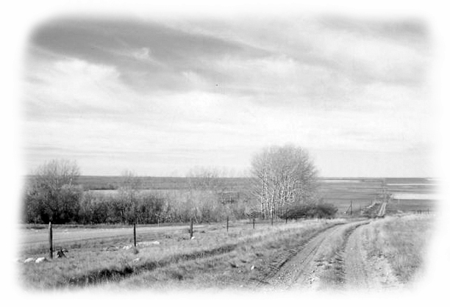

Chapter 4
The Real West

As the summer waned towards the fall in 1952, I got a letter from Mr. Bull telling me there were great crops all over the west and they would need help to harvest it. He wondered if I could come out and help him. He also asked if I could bring someone to work for his neighbour the Sutherlands. When word got out I was going to drive west in my car a neighbour friend Bill Stephens asked to go.
This would be my first trip driving a car to Western Canada as up until now it had been the train or the bus. In a way this was an all-new and exciting trip, but one I would take many times over the next number of years. My dark green 1947 Chevrolet sedan was in top condition for the trip. I had decided to go west via the
States, as it was the shorter route. We crossed the border at Sarnia to Port Huron and arrived at Mackinaw Strait late in the after noon. There was no bridge across the strait at that time so we had to wait on a ferry. The cars and trucks are all stowed in the bottom of the ferry and there was a deck above where you could sit and enjoy the trip. We arrive at St. Ignace in Northern Michigan and drove on quite a number of miles before finding a motel for the night.
The next day we drove through Duluth and on to Bemidji, where we stopped to say hello to Paul Bunyan and his famous blue ox. That night we drove late and had trouble finding a vacancy, but a motel manager found us a place out in the country far off the highway with a French family. They were very happy to have a Canadian guest. The next day we crossed the border to Emerson Manitoba and instead of taking the highway up to Winnipeg we turned west to Cypress River.
We had only intended to drop in on the Aubrys for a short visit and then continue on our trip to Oyen Alberta. When a neighbour of the Aubrys heard I was visiting along with a friend he phoned to tell us he needed some help as his son had somehow dislocated his shoulder and could not stook grain. They had a huge crop that year and were in dire straits. They knew we eastern farm lads knew how to stook and as I had worked for Marius one fall he knew we would be good workers. So he offered us $10.00 a day if we would stay and stook for him.
This was great pay at that time so I made a phone call through to Bulls in Oyen to ask if they needed us right away, or if it was OK to stay a few days in Manitoba to stook. Bulls were not at home to take the phone call and when it rang several times Olive Sutherland the neighbour answered it. She assured us that it would be OK to stay, as the crop was not quite ready in Alberta yet. It was not uncommon on those party lines for people to do something like this. In a sense they were just looking out for each other. I always got a kick out of hearing later that Olive called Bulls that night and told them,
“That Englishman you are expecting to work for you called, and is in Manitoba.” It was apparently my voice that made her think I was English; I had never realized it was so obvious. Over the years I have often been asked where I came from. This farmer’s name was Hutlet and they had a family of five, George, Guy, Annette and two younger twin daughter; all were very much French.
Guy was the son with the bad shoulder. He would bring out coffee, lunch and water to the field while Bill and I stooked grain under the warm sun. I remember the air was exhilarating and fresh and pure. The sheaves we were stooking were free of weeds and neatly bound and we were quite happy to be working out in the field. We also knew we were being very well paid. When Guy came out to the field I remember singing to the tune of the old “Southern Song” that black people use to sing while working in the fields many years ago.
Up in the morning, out in the sun working like the devil
For my days pay, but lucky old Guy (sun), has nothing to do.
But roam about the stubble (heavens) all day.
I was able to see the Aubrys and Jerry Baltesson and family and other friends I had made here on my previous trip. Bill and I enjoyed our stay at Cypress River and left with more money in our pockets than we started out with from Ontario. So we felt we were getting off to a very good start.
In recent years Bill and Anna had visited Cypress River and found George living on the old farm. In March 2005 George and his wife Myrtle came east to visit Bill Stephens and Anna on the farm near Anderson and then came to London to visit me. After 53 yrs it was great to see him once again and to meet Myrtle
When we left Cypress River we drove on to Regina and north to Outlook, Rosetown and Kindersley. Throughout this central area we saw some of the most amazing crops of wheat we would see in our lifetime. Ahead and behind us, great flat fields of wheat stretched to the horizon and then beyond, mile after mile of waving wheat ready to be harvested. We crossed the border at Alsask to Alberta and were now only about thirty miles from Oyen and our destination.
This was the first time I had driven a car out to the Bull farm and for some reason I turned down one road too soon. This road soon disappeared into a dusty trail and seemed to lead us into a farmer’s pasture field There we came upon a lonely farmhouse where we pulled in to ask for directions. We found a very friendly and talkative farmer by the name of Howard Davies. He was curious as to where we came from in Ontario. We told him near Stratford thinking he might know where that was. He told us he had once been an English homeboy and when he came to Canada he was put on a farm owned by a Mr Montieth at Sebringville just west of Stratford. He said Mr. Monteith had a daughter, who married a Mac Simpson. Would I happen to know him? It is a strange world, as I not only knew Mac Simpson but also his wife and all of his family. They lived just down the road from us. A few years later Howard came east to Ontario and visited the Simpsons. This Montieth was the Honourable Nelson Monteith a Conservative politician and Minister of Agriculture and would be I believe an uncle to Waldo Montieth our Health Minister during the days of Prime Minister Diefenbaker. Mr Davis spoke well of the Monteith family and also of Mac Simpson of Motherwell.

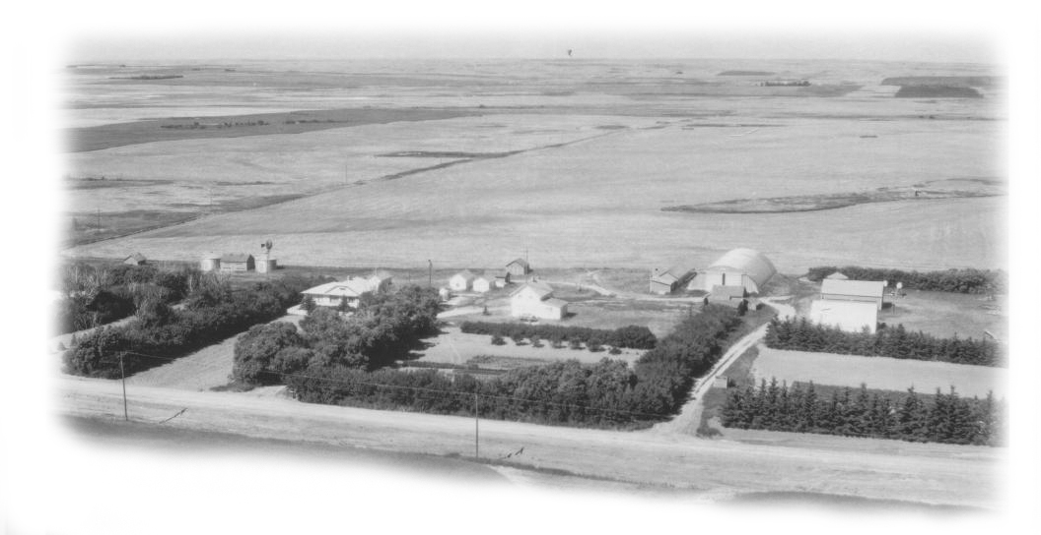 Harry Bull’s Farm (Oyen Alberta) 1952

Howard directed us to the Bull farm. This time I arrived not as a stranger, not even as a hired man, I actually felt more like a guest. Whenever some one dropped by, or when we visited a neighbour Mr. Bull would introduce me proudly as, the man from Ontario whom he works for. They had one son Wm. who married Alma McGowan Oct.15th 1949. He and Alma lived across the lane in a new house they had built. They eventually had three children Barbara, Karen and Brian. Wm and his dad farmed all this land together, each owning their own land but shared the cost of machinery. This worked well for both of them.
The McNee’s, Uncle Frank and Aunt Rosena had by now sold the farm to Earl Regan a local lad whom I already knew, and moved into Oyen. They seemed very content and comfortable in their little cottage-like place, about three blocks east of Main Street. For once Aunt Rosena was able to tend a few flowerbeds and a wee garden with ease. I visited them some evenings and weekends Somehow though I wish I had understood better then what old age was like, and maybe I could have given them just a bit more of my time.
Both Bill and I settled in with ease at our place of work, Bill at the Sutherlands and me at Bulls. At the time neither Bill nor I knew just how much the Bulls and the Sutherlands would mean to us as the years rolled by as we both became a part of a family, Bill to the Sutherlands and I to the Bulls. Over fifty years later we still keep in touch, sadly now all of that older generation has by now passed away.
Harry Bull was an Englishman born in London, and he remained an Englishman all his life. He had that little bit of something that made him stand out in the crowd. At 18 years of age Harry left England for Canada in 1910 much to the disapproval of his family. They wanted him to stay and take his place in the family business, which was Tooke’s manufacturer. Tooke’s made some of the world’s best men’s shirts. Anyone who could afford a good shirt at that time owned at least one Tooke shirt. But Harry wanted adventure not necessarily wealth, so he left on a boat for Canada.
He met up with his older brother William in Ontario and together they headed to Western Canada. They got a job working on the grade for the CNR railway across Saskatchewan and on into the Oyen Alberta area. Although he did not come from farm stock Harry loved this new country of Canada and Alberta. He found himself scouting ahead of the grade work whenever he had time off to search for a homestead. About 12 miles southwest of Oyen he found what he was looking for. He quit his job with the railway and walked one hundred miles to Brooks to file a Homestead. He and his brother built a wood shack 10 ft. by 12 ft. and a stable for the stock out of sod that first year. Then with the help of three oxen and a mule they broke 20 acres before winter set in. They often travelled the 100 miles to Brooks for farm supplies and food, and at times took a job in the Brook’s area to earn some money. Trying to earn some extra money was how he met his wife Irene Snell. Harry took a job of picking rock off newly broken land for Mr. Snell.
Irene Snell was born in Seaforth Ontario and came west with her parents first to Saskatchewan and then in 1910 they took a homestead south west of Oyen. On January the 24th of 1917 Harry and Irene got married and moved into a new house Harry had built. They lived in that little house all of their lives until Harry passed away. It still stands proudly but empty on the old farm today.
Now in the year 1952 after such a modest start in 1910 they were farming about 1600 acres, half of which was summer fallow and the other half in crop. I was hired for five dollars a day rain or shine and twenty-five cents an acre. This meant if I stayed until the crop was all off I got a bonus of twenty-five cents an acre on the 800 acres of grain crop. As a rule it took about 6 weeks to get the crop off, as there were usually a few wet days or you might also have a few breaks on your combine.
One might visualize my pay if all turned out well something like this: If we worked six days a week for six weeks at five dollars a day I would earn 6x6=36 days x 5 dollars = $180.00
800 acres of grain x 25 cents an acre = $200.00. If I finished the harvest I would get $380.00
Wm. loved machinery and had about the best-equipped farm in the country. In 1952 he had a brand new Massey Harris combine and a Ford Truck with a lift box on it. The box held just about 200 bushels of wheat, which was thought a lot of grain at that time. The combine had a 14-foot straight cut header on it, and a storage bin that held 45 bushels of wheat. On a good day one might combine 60 to 65 acres. All this may not sound very impressive today but at that time in 1952 it was very much so.
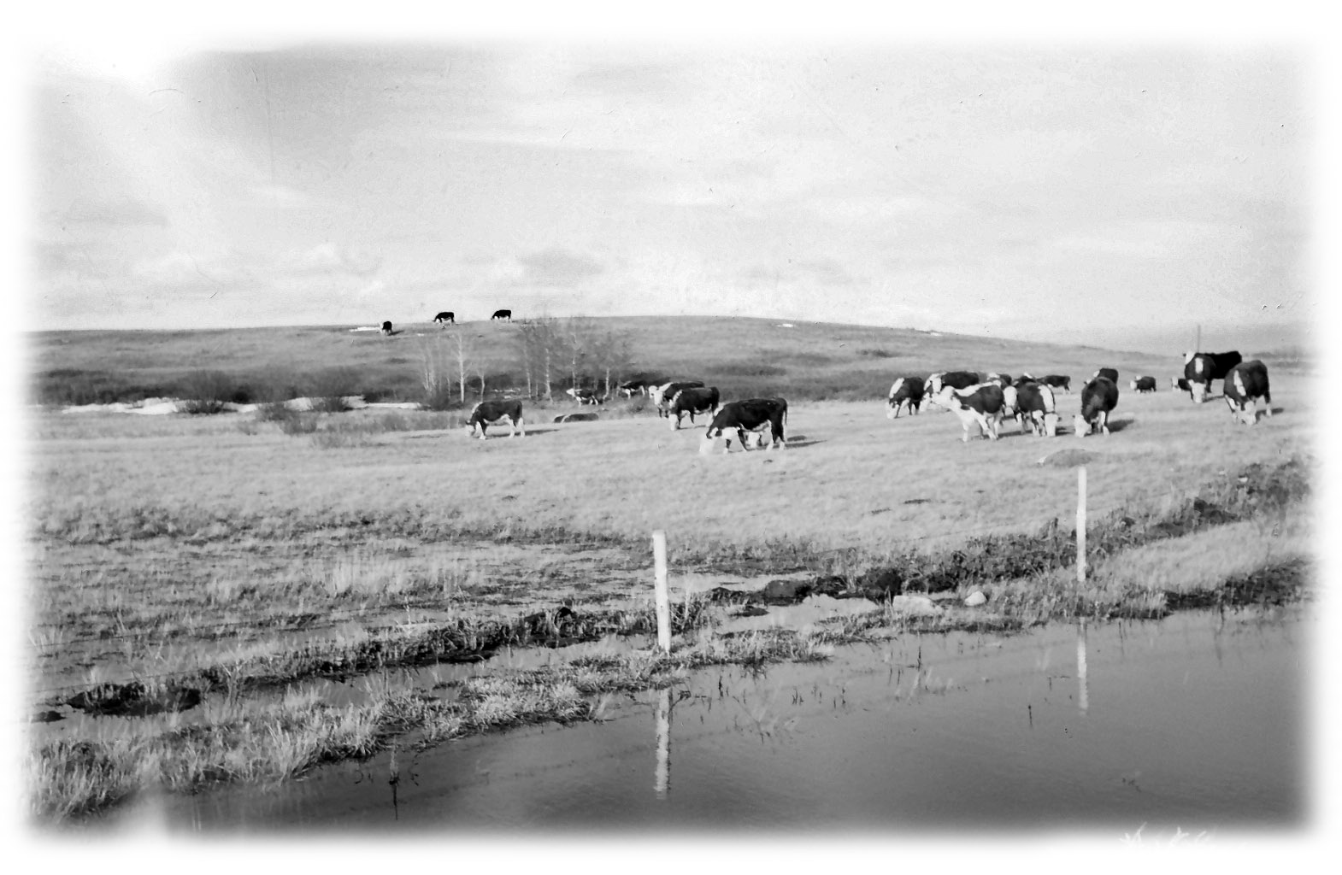
Sutherlands Cattle, on the Range at Oyen
Over fifty years later I was back to visit on the Bull farm. Mr. Bull’s grandson Brian is farming the land now. He has I believe nearly 3000 acres of land; his combine has a 30-foot header (they have them up to 45 foot now) and the combine grain bin has the capacity to hold 300-bushels. On a good day he could combine 200 acres of wheat. He has two huge grain hauling trucks the largest of which holds 600 bushels of grain. Now that is impressive!
The Sutherlands by choice were more ranchers than farmers; their first love was their white face cattle and their horses. They grew grain more because they needed the revenue from it than the love of field crops. In fact one of the Sutherland brothers told me once when I mentioned that his summer fallow was getting green,
“I will not sit on a tractor and eat dirt,” thus weeds were taking valuable moisture out of his land while he spent his time watching his cows and calves and mending his fences. For many this was a way of life to which they had been born into. The world around them at this time was still afar off and the idea that change was inevitable was not always well received. Even I at that time was very much aware of the romance people had with this country. It was in the noonday heat and the evening sunsets. It was in the clear starry sky at night or the early morning air full of promise, pure and exhilarating
Bill Snell’s Dried Up Slough
This area was a broad flatland between ranges of rolling hill angling from the northwest to the southeast on either side. Down through the very centre was an off and on alkaline slough, which filled up on the run off of melted winter snow and the spring rains. In wet years the slough grew and in dry years it shrunk. If you happen to own some of both, flat land in the valley for your grain crops and some rolling hills for your cattle you have the best of two worlds You can be a grain farmer and a rancher. Having a hand in both was a great benefit to many in dry years as they had their cattle to fall back on when the grain crops failed.
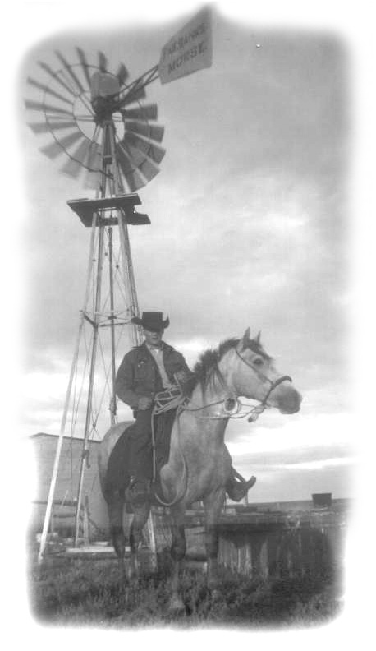
Bill worked for Don and Olive Sutherland, a very proud Scottish couple whose parents on both sides came from Old Ontario. In the west you often heard people say Old Ontario,. I would like to believe it was a sort of endearment much like I heard my grandfather speak of his, dear old England.

Don and Olive had three boys, Don Jr. (Deke) 15, Colin 14, and Neal about 5. Don Sr. was an easy guy to like. I enjoyed chatting with him immensely about cows and calves and horses the land and ranching. I would listen for endless hours to the stories he told about those early years in Alberta and how he remembered them. He was however very set in his western ways and ideas. He had been born and raised in the Oyen area of Alberta and had never been outside of the province in his entire life. He didn’t think the outside world and especially Ontario had anything to offer. He was very much down on the Federal Government and the east in general yet he never met a person from Ontario he couldn’t like. I would say this of him. I feel honoured to have had the chance to know him. I think fondly of him as a friend, but he was a man with a very set mind.
Deke at the Windmill
Olive Sutherland had been a schoolteacher for a number of years, and carried herself like a schoolteacher all her life. She took a few years off from teaching to raise her boys. Olive had a great head on her shoulders and flair about the way she looked and dressed. When you chatted with her you could talk about anything from books to cattle or politics and you were soon very much aware she had her homework done. Olive was more open to ideas and to change than Don was. She played the piano wonderfully well, filling the house with music. Don Sr. and Don Jr. both played the violin and Colin played the guitar and the piano. Neal eventually took a liking to the banjo. Each night the house overflowed with music.
About ten thirty Olive would disappear to the kitchen and Colin would take over the piano. In fifteen or twenty minutes we would smell the fresh coffee brewing. Soon Olive would call us to come to the kitchen for lunch. It would usually be something wholesome and good, perhaps home made bread or buns, or scones with Olive’s own homemade jam or jellies, the kind of things you would expect to find on a ranch. One night at coffee time Don and Olive spoke of The Bad Lands, and of course a name like that draws attention. I had never heard of The Alberta Bad Lands. Olive was well informed so she set about to enlighten us. The Bad Lands are found along the Red Deer River, and one of the best places to see them was about fifty miles south of Hanna. At that time only the local people knew much about it. Today it is a provincial Park called Dinosaur Provincial Park. This is what Olive told us.
The Alberta Bad Lands are best described as a miniature version of the Grand Canyon. It is carved out of the prairie itself; every part of it is below the flat prairie land that surrounds it, thus you can not see it as you approach. Eighteen thousand years ago as the ice age retreated an immense amount of water was released and carved a drainage channel down through the soft rock on both sides of what is now the Red Deer River. This soft rock was left exposed to the wind and rains, which carved and moulded it into a kind of moonscape. There are walls to scale and caves and sinkholes to explore and endless miles of river to see.
Bill and I decided we should drive down to see The Bad Lands the following Sunday. The two Sutherland boys young Don and Colin would go along with us. They had been down there before so they would act as guides. Don Sr. advised us on some of the things we should take along to play safe, things like a flashlight each to explore caves and rope in case some one fell in a sinkhole, and an axe to cut firewood. We would also take a large container of water and matches to light a campfire to cook our supper. Olive would pack a box with some dishes and cutlery, a coffee pot and a frying pan. All this appealed to us as something adventurous and exciting to do. We decided on bacon and eggs and toast and coffee for supper. I was to bring the eggs. Now I feel a bit guilty telling you about this, but all week long I visited Mrs. Bull’s hen house and sneaked off with a couple or three eggs a day and put them in my car. By the end of the week she was complaining that her reliable old hens were just not laying enough eggs. Whatever was she doing wrong.
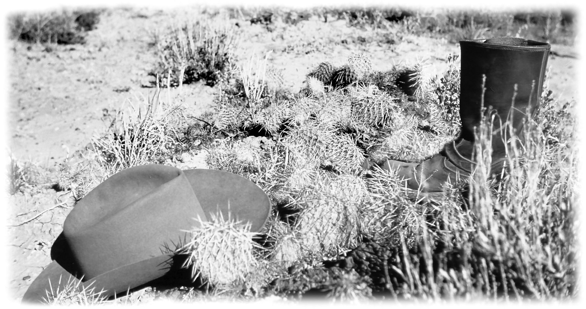
Pin Cushion Cactus In The Badlands
Sunday eventually came. We packed the car with our strange gear and boxes of food and water and were off. At that time the roads going south from Sutherlands or Bulls were not great for cars, and especially for strangers to travel. When it was dry it would be a dusty trail and when wet, full of mud holes and wheel ruts. So we travelled the long way around, taking the number nine highway towards Hanna and then south on the thirty-six. I remember the drive south through dry flat prairie ranch land with the ranch buildings scattered far apart. There were not any signs giving us directions on how to reach the Bad Lands, so we followed young Don’s directions when it came time to turn east off the highway and we arrived at our destination.
Just as Olive had told us, the prairie suddenly opened up, and before us was a very strange land “ The Bad Lands.” After spending weeks on the flat prairie it was awesome to see. We found a good place to park the car and set about to explore. We decided to stick close together for safety. Olive had warned us to watch out for snakes, rattlesnakes, and Don added a warning to also watch out for hoop snakes. I asked him how I would know a hoop snake when I saw one. He said you would always know one when you saw one as they put their tail in their mouth and roll towards you. At that point everyone laughed and I realized I was on the butt end of a very old western joke, which was sooner or later told to every green easterner.
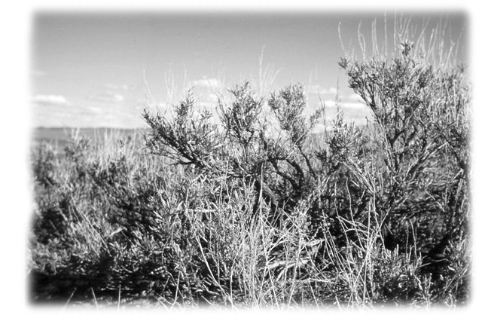
Sandstone hills and coulees lined the walls on either sides of the river. Each coulee eventually ends at a wall of sandstone or a hole. We ventured into some of the larger caves-like holes always carrying our rope and we always left one person on the outside in case of trouble. Most caves would end with holes in the ceiling where water from the flat prairie above poured down through the roof when it rained. Many had a pit or sink hole perhaps ten or twelve feet deep at the entrance of the cave where the rain water pours out of the cave churning up and washing away the sand stone. We found more then one cave with animal tracks on the well-packed floor, along with a few bones.
Sage Brush
There were many tall monuments like sand stones capped with a layer of shale lying flat on its top. They come in all shapes and sizes and are called Hoodoos, by the Indians and the locals. The shale on the top keeps the wind, the rain, and the snow from wearing the sand stone away. We climbed the tallest and took some pictures, which I still have today. Later we ventured down closer to the river and found yet another world of huge Cottonwood trees, which seemed entirely out of place away out here on the prairie. Along the river there was an oasis of grass and shrubs and vegetation for the pronghorn antelope and mule deer and all kinds of birds. The Red Deer River late in the fall looked lazy and cool as its quiet waters wound its way amid the walls of sand stone. All this added together made a strange and spectacular view.
Between the sandstone walls and the river are some open spaces, which are almost desert like. Here sparse grass grows amid the sagebrush and huge beds of the most beautiful pincushion cactus. There is also prickly pear cactus. There’s a wealth of discoveries to be made in the Bad Lands but our time was getting short as the darkness descends early down below the horizon along the river. The evening sun sets on the prairie above and the eerie quietness descends. This quietness seems so very fitting for this strange land along the river. We gathered wood, which at that time was plentiful under the trees along the river. The wood was bone dry and eager to burn. We drove a stake on both sides of our fireplace and a piece across from stake to stake on which we hung our coffee pot. Soon we were frying bacon and eggs and along with home made bread and coffee we enjoyed a traditional campfire meal, which was fit for a king. This day was a lasting memory for us all; perhaps it was the food; perhaps it was the company of good friends, or perhaps it was the enchantment of the campfire and a meal by the Red Deer River in The Bad Lands.
With the grain harvest over and the good weather lingering on, life returned to a more leisurely pace. There were bundles (sheaves) of green cut oats to be brought in and stacked to supplement the bales of slough grass hay for the cows in the winter. I rather liked the job as it required skill and in the end you found great pride in building a good stack of green feed. Picking up potatoes though has never been high on my list of social activities for the year but like many other jobs on the farm someone has to do it, but why me? Mr. Bull manned the old hand-held horse plough, which was hitched behind the Ford tractor and Wm. tried to drive in a straight line down a row of his mom’s big Red Plymouth potatoes. There was much shouting, and cussing and flaying of arms as it seemed no one was happy with this job.
The potatoes were picked in five-gallon pails and emptied into burlap sacks. When the job was done we loaded the potatoes onto the old steel wheel wagon and with the Ford tractor pulled up close to the kitchen door. A trap door in the kitchen floor led to a steep wood stairway down into the cellar. While I had seen the door open a number of times I had never been down there. It seemed like Mrs. Bull’s private domain, and unless you were invited you had no business being down there. With a bag of potatoes in my arms I backed slowly down the narrow wooden steps into the dark coolness of the cellar. The single light bulb showed me that the house sat on a cement foundation about two or three feet into the ground. The basement though had been dug on down into the cool dry earth so that there was enough standing room. There were no windows and without the light bulb it would be absolutely dark. It smelled of earth and was so very, very cool.
Everything down there was stacked in neat rows on shelves in a showroom like condition. I felt privileged to have this chance to see all this canned food Mrs. Bull had preserved. It was her pride and joy, her entire year’s hard work. There were jars of Saskatoon berries that were picked down by the river, strawberries and rhubarb from their very own garden. Huge half peaches and large whole crab apples from BC and all kinds of home made jam and jellies. As a rule they always raised a pig every year and killed it in the fall. Mrs. Bull made lots of canned pork meatballs, and also canned chicken. I would give anything to taste all of this once more. The potatoes were put in a wood plank bin. The carrots and parsnips were cut just so and stored in boxes of black earth so they would stay solid far into the winter. Later after a frost, the turnips would be put in a bin next to the potatoes. The onions were pulled with the tops on and spread on the floor of the old shed to dry. Later when dried they were braided by their tops one by one into binder twine until they hung down two feet or more long, the dried tops holding them firm. Later they too would be hung in the cellar. They learned a lot about survival in their pioneer days and then passed this on to their children.
I spent a number of days on the Oliver tractor pulling a Graham Plough around and around the field “eating dirt” while working the summer fallow. However with all this good weather Bill and I were anxious to leave on a holiday trip we had planned, first in Alberta then to the coast before heading home.

Mr. Bull said an early “ Good Bye “ and then went for a walk in the garden. I found out in time be hated goodbyes, thus he usually came to you well before your departure and then disappeared. As an Englishman he was not allowed to get all misty in front of friends or family. One had to be proper at all times.
Bill was packed and waiting for me, but before I left I got out my camera and took a picture of the Sutherland family- Don, Oliver and the three boys. It is not what some might call a beautiful picture, it has the bare packed dirt yard as a back ground and everyone was dressed for the day’s work, but I cherish that picture because it is so honest. It is the way I found them - hard working, hard playing and their hospitality was only outdone by their honesty. Even now in my mind’s eye I see them as a real model of a western ranch family at that time. Weathered by hard times, and nourished by their proud Scottish ancestry they survived many tough years and now stood proudly side-by-side as a family.
The day before we left there had been a prison break from a prison near Edmonton and everyone was concerned because we would be on the road travelling to Toefield, a small town south east of Edmonton. It seemed several members of the Boyd gang had escaped. They were bank robbers that had made quite a name for themselves. So we told everyone we would not pick up any hitchhikers and promised to be careful.
First we were to drive to Toefield to call on some friends of my mom’s who came east and visited with us a number of times. They had asked me to come and see them after I finished the harvest at Bulls. My mom had gone to school with these people years ago in Ontario. It seems two Frances brothers had married two Skinner girls and then gone west to grain farms in the Toefield area. We found their farms without any trouble and spent a couple of enjoyable days with them. One thing of interest was our visit to a surface coalmine in the area. I also remember a conversation with one of the Frances boys about a lake of tar sand found in the wooded areas north of them. At that time no one knew much about the sand tars, or if they had any value, but we are hearing a lot about it today.

From Toefield we wandered west to the Edmonton / Calgary highway, then drove south. I well remember driving through Red Deer when it was just a small town stretched out along the gravel highway and railway track. Its grain elevators were its skyline. It was many years away from the beautiful and great city it is today. We drove on down to Calgary and then south to High River. In those years everyone who travelled afar came home with silk cushion tops for their mom it seemed, so I bought a cushion top in Red Deer and Calgary and one in High River. Many years later I got them all back when mom passed away and I still have them today. I understand they are now a collector’s item.
It was late evening when we found ourselves on the road west of High River on the way out to Wib Duncan’s ranch. We were driving into a setting sun beyond the mountains It was hard to see the road clearly, as it was just a dirt trail across open fields and in places not at all clear. I remember we came to a place where the road turned sharply to the right and a faint un-travelled looking trail went straight ahead. I was sure the path or trail straight ahead was the right way to go. I made a hurried decision and drove straight ahead with the dying sun in my eyes. Suddenly the car fell through the roadbed and stopped dead in its tracks leaving me spinning my tires. .
Bill looked at me in great despair and exclaimed with open hands,
“What do we do now!” almost as if at a time like this he expected a civil answer.
I was rather short with him right then, and I have always been sorry for that, I said,
“Just let me think!”
Darkness was coming on fast as it does when the sun goes down in the mountain country. We didn’t have long to sit and think for out of the darkness, far away across the field we saw two headlights heading in our direction. In a few minutes a large tractor came roaring up and made a wide circle and backed up to us. A man with a broad smile on his face got off the tractor carrying a logging chain in his hands. He said,
“ I thought you might need some help, I was working away over yonder when I saw you fall in. Where are you heading?” to which I said,
“Wib Duncans.”
I don’t think we were in there much more then five to seven minutes before this man was unhitching his logging chain and saying good bye to us. I said,
“Thank you, and how much do I owe you?” to which he replied.
“You owe me nothing, a friend of Wib Duncan is a friend of mine” and he jumped on his tractor and left. That was not the last time I was to hear, a friend of Wib Duncan is a friend of mine. What a wonderful way to be thought of and to be remembered.
As to the roadbed, it seems the area had always been part of an on and off slough. In the past year there had been more then the usual amount of snow and rainfall and it filled the area again with water. All summer people had just driven around it. Now while it had dried up on the surface, it was still very wet underneath.
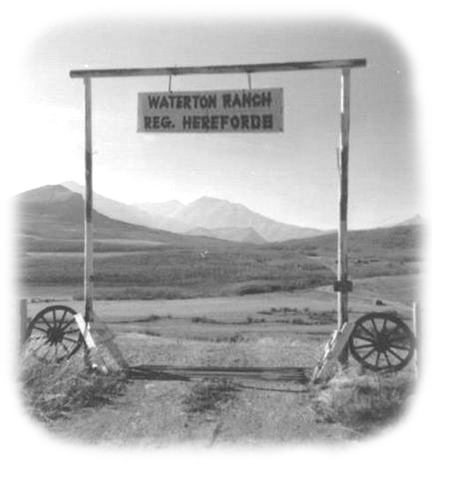
Gateway to a Ranch in Southern Alberta
Wib, Nell and Charles, gave us a warm welcome, and we spent a couple of days looking at cattle, drinking coffee and chatting. Wib was familiar with the names of many of the older homesteaders in the Oyen country. He knew of the Sutherland family so he and Bill got along just fine. We found lots to chat about.
We had decided to take the backcountry road from High River through the Turner valley and on north to the Banff Highway. We arrived in Banff that day with lots of time to tour the park and walk the main street. The town of Banff is unreal as it is seems too picture perfect. One would think they built the town first and then placed the mountains around it. Banff Park was the first national park in Canada, set aside in 1885 right after the last spike was driven into the Continental Railway line. When you look at the Banff Springs Hotel it is hard to believe they finished building it in 1888, three years after the Park was made. Even in 1952 it was just amazing to see it sitting there in isolation amid the mountains. It reminds you that there were men and women with great vision, who looked afar into the future when Canada was very young. In 1952 the shops in Banff, where nearly all owned by the local people, who had opened their stores and watched them grow. Banff then was truly unique. Banff was then totally a different Canadian scene.
Late in the evening we checked out the motels and found them a bit too expensive for our taste. As we wanted to drive all the way to the coast we thought we might save some money if we slept in the car. We found an out of the way place well back off the road where we thought it would be safe to stay. Bill got in the back and I tried to sleep in the front. Late at night nature called me so I quietly opened the door and stepped out into the darkness, I know I hurried as I imagined all sorts of large and furry things might be close at hand. When I got back in the car I saw a movement out in front so I hastily turned on the headlights, and there right where I had been standing a few seconds ago was a massive bull elk with “totally” the biggest rack of horns I had ever seen.
We were settled down again when suddenly there was a rapping sound on our window. It was a park warden in uniform who wanted us out of there. However we pleaded as only boys know how, and he was forgiving, as he understood when we told him we found the motels too costly for us. He said he would ignore us and let us stay as long as no one reported us. Early the next morning we left for Lake Louise. The tall mountains along the way filled us with awe; never had we seen anything so wondrous before. It is a place that lifts the spirit and enriches the soul; as the mountains make you realize just how small man really is. That all the things man has done is nothing, when compared to the wonders and greatness of the mountains.
It was getting late in the fall and we found Lake Louise quiet and very cool, its great hotel “The Fairmont Chateau Lake Louise” looking empty and quite out of place so far from people. The lake itself was wind swept from its glacier source to the beach beneath our feet. Its beauty is in its cold aloofness cradled on all sides by majestic mountains.
Travelling westward through a high mountain pass just north of Lake Louise, we were now on our trip to the Pacific Coast in earnest - first to Golden then on to Revelstoke. In here somewhere we came across what I would call a semi-arid desert. There was no grass on the hardpan earth, but great clumps of silver green sagebrush that grew to great height, twisted and weathered and looking as tough as an old rail fence. The one thing I remember was that we came across two beautiful mules walking one behind the other along the north side of the road travelling west. We stopped and they stood still letting us pet them. They were well mannered and it was almost as if they felt the need of human contact. When we left I looked in the rear view mirror and they were again plodding on westward one behind the other. I hope they got home in time for supper, as there was nothing edible there for them.
We were now at the northern end of the Okanagan valley country. From here it’s a beautiful drive south through Vernon, Kelowna, Penticton, and to Osoyoos. As we traveled southward we saw a great change in the countryside, as there were more and more garden products growing and orchards of apples and pears and plums. While today there are a lot of grapes growing throughout this area I don’t remember seeing grapes there in 1952. Perhaps most of all I remember our arrival at Osoyoos the best. We arrived high above the town and the lake; below us were small square checkerboard patches in different shades of green. Each square was actually an apple orchard; an ever-winding road wind back and forth taking us down; down and soon the small patches took shape as rows and rows of fruit trees. Their fruit burdened branches propped up with stakes kept the laden branches from breaking down. This is one of the greatest fruit growing areas in BC and it is truly magnificent to view as you pass through.
Driving on to Princeton and Chilliwack we found ourselves following the Fraser River in the evening with a setting sun before us. The whole country had that peaceful, quiet yellow mellow look of fall. There were many dark skin people walking along the streets and roadway wearing strange clothing and turbans. I had the feeling that I had somehow been transplanted to another country as the scene was played out all about me. Somehow Bill and I just didn’t fit in; it was as if we were the foreigners in a different land. There were a large number of people from India living here along the Fraser River.
We stayed over night just east of Vancouver and early the next morning I drove down Davie Street past my Aunt Becky’s beautiful old white clapboard house. By now my uncle and dear aunt had both passed away. That was the last time I ever saw the great old house as along with many other houses it was torn down to make way for the many expensive high rises that rose along English Bay. We drove on into Stanley Park and to a special parking lot at the south end of the Lions Gate Bridge. Bill and I sat and watched great boats on the Burnard Inlet coming and going under the Lions Gate Bridge. We were in a happy mood as we had achieved our goal we had made it to the coast and now we were homeward bound.
We had decided to go home via the States, as it would be a faster route. I believe we crossed into Washington State at Blaine and then east on number 20 highway. At one point we could see Mt.Baker to the southwest of us. We drove east to Spokane and across Idaho to Butte Montana. As all this happened over fifty years ago and I can’t remember where our days ended but I do remember the route. We turned southward into Yellowstone Park, Wyoming and yes we did see “Old Faithful” erupt. We spent most of a day driving about the park. It is beautiful and it is big. We filled up our gas tank and decided to drive out of the park onto a road going homeward.
Now things really got complicated. I had done well getting about ever since I left home, but somehow I got lost and we wandered about trying to get back onto a main road. It was dark and we could not get our bearings. We drove aimlessly about hoping to end up somewhere at a place with a name. But there were endless winding mountain road all the time driving southward with no roads going east. Finally a car with a spot light surprised us and pulled us over. It was a park warden and he was looking for guns. I guess he first thought we might be poaching in the park; he searched the car then told us we were really lost. He was good enough to draw us a map that would take us south to Rock Springs Wyoming east of Salt Lake City. We found a place to stay for a few hours’ sleep, but were back on the road early the next morning on Highway 80 that crosses the country like an arrow all the way south of Chicago and on to Toledo, then followed a great expressway to Detroit.
The highway was straight and my foot was heavy and we were after all homeward bound. I opened the car up and we flew across the states. One could see ten or twenty miles in every direction so there was little chance of us getting a ticket. We only stopped for gas, food and the bathroom. But we drove from Rock Spring Wyoming to Detroit that day. Late that evening I pulled into my dad’s sister’s place on Alcoy St., Detroit Michigan. My uncle had a hard time believing we had driven from Rock Springs that day. We stayed over one more day resting and visiting with my aunt and uncle. The next night when my Uncle Guy came home from work he told me that the guys at work told him there was no way I could have driven from Rock Springs to Detroit in one day. I rest my case and you can ask Bill. From there Bill and I drove home.

Over the last fifty some years Bill and I have had many chats about this trip, the things we saw and the people we came to know. We have kept in touch with each other and also with the Bulls and Sutherlands. Bill married a very good friend of mine Anna May Thompson of Motherwell, who along with her brother Vernon and sister Helen use to walk to school with my sisters and me. Bill and Anna have visited and kept in touch with the Sutherland family over all these years. Harry and Irene Bull and Don and Olive Sutherland have all passed by away. However they are not forgotten.
“ There is common ground that kindred walk, that forever binds the soul ”

When one leaves the west in the late fall you have the feeling that winter is close at hand or knocking at the door. Upon arriving home in Ontario it seems you step back into fall again and you’re given a gift of perhaps a month or more of good weather before snow flies. As always upon returning from the west it takes a few days or even weeks to get oriented again. Very soon the cattle will be in the barn for the winter and I will be back milking cows and cleaning stables. During the winter months the work is at a quieter but steady pace and very much the same from day to day. After the milking is done and breakfast over dad heads off to the village store and I head straight out to clean the stables. This is the way it will be every day. By now I know about how far on I should be with the chores by the time dad gets home so as to keep him happy.
Both dad and I were having great luck with our sows raising large litters of healthy little pigs. Dad usually kept his little pigs and raised them to fat hogs at 200 pounds or more I would sell mine as wieners or chunks to neighbours or friend or yes, to John G. Scott. I always raised great looking pigs and never had a problem selling them for top price. By now I had three or four sows and I would manage to average twelve little pigs a litter. To do that I practically had to live with them the first few days. To this day I love old sows and little pigs …… especially the little pigs.
In the fall of 1952 I had three litters of little pigs ready to sell. At six weeks old we called them weaners. If you wean then from their mother and feed them a special pig feed for a few weeks they would get bigger and were then called chunks. That winter I cleared over four hundred dollars from my little pigs and in 1952 that was a nice bit of money. Of course this money was burning a hole in my pocket. By now my dad had sold his old 38Ford and was driving a black 46 Chev. I had been offered a good price for my 47 Chev and I was itching to sell and move up. I knew my mom would have a fit if she knew I was even thinking of doing this. Somehow I was sure it would be OK with dad.
The Henry J Kaiser Fraser
A number of young people I knew often stopped in for coffee at Sweetzir’s Garage and coffee shop at Rannock at the south end of the Mitchell Road. Sweetzir’s had taken on the agency for the Kaiser Fraser cars. Kaiser Fraser had made the original Jeep for the military during the Second World War and made a big name for them. They also made the “Willy” a sort of no nonsense ugly small car that looked like a box. After the war Kaiser opened a plant at Willow Run Michigan where they made the Kaiser Fraser, the Henry J and the Willy. The Kaiser itself was a head turning car, with fleeting lines. It was truly a luxury car and perhaps a bit ahead of its time. The real problem with it though was its huge price. On the other hand the Henry J Kaiser was a smaller version with a four-cylinder motor, one of the first truly mid size cars and it too was perhaps a bit ahead of its time.
One night when I dropped in for coffee there was a beautiful maroon Henry J Kaiser sitting in the show room. I was sold on it. The priced was $1,900.00, there was no special tax on cars at that time and GST and PST had not been invented yet.
I had been offered eleven hundred dollars for my 47 Chev, which was the same price I had paid for it. With the four hundred dollars from my pigs I would only owe a bank note of $400.00 on the new car.
When I told my dad about it he took it very well, and at the breakfast table he spoke to my mom about it, and naturally she got very angry with me and said,
“ You don’t need it, you just have a big head.”
Dad said, “ Let him have his new car, if he doesn’t spend the money there it will dribble away on something else.” Later, he told me that once I had a new car I should trade up every few years and avoid the car problems he always had This was the first of many new cars I have owned. Except for my first two cars I have had ten brand new ones, and I loved every one of them.

The Henry J was a great little car in many ways and I was very proud of it. Because of its mid size and new style it drew a lot of attention and favourable comments. All cars then were big monsters and every year it seemed they kept getting bigger. This car was a step in another direction from what the big three were building. However when winter came I found out I had a problem. The Willy Jeep Overland four-cylinder motor was just too heavy on the front end. If you touched the brakes on a slippery surface the car would spin around, because of the weight up front. It seemed the front end stopped while the rear end spun around.

In the fifties every one put snow tires on their car in the winter. Most snow tires would be what we called re-caps. Places that sold new tires would save your old tires if the walls on them were good and send them in to a tire re-cap plant. In the winter these tires with huge grabbing treads did a good job of getting you wherever you wanted to go. All cars including my Henry J were rear wheel drive back in those days.
Many evenings when I left home to do up the town, I would have to drive out our snow filled lane onto the slippery snow packed road. To get to the road I would have to keep up a fair speed or I would be stuck before I got there. Then just when I thought I had made it I would sometimes feel the need to touch the brake so I could turn when I reached the road. With the Henry J the minute I touched the brake the rear end came around and I would slide across the road into the ditch backward with the front end facing the road.
Every time I went out on winter nights my dad would look at me in a painful way and say,
“Please don’t go into the ditch tonight,” and of course I said I would be careful, but chances are I would go into a spin as I hit the road and end up in the ditch. Standing beside my car down in the ditch I could see my dad watching from the little kitchen window, and I knew he would soon go out to start the tractor to pull me out. Now few people winterized their tractors at that time, so the first thing he had to do was to go to the hand pump on the well and get a couple of pails of water and carry them out to the tractor. You dare not put the water in until you found out if the tractor would start or not. Those old tractors had to be hand cranked and believe me they did not start easily for in the wintertime everything was frozen stiff. When or if, it started you quickly put the plug in the radiator drain hole at the bottom of the radiator and poured the water in.
Now I can’t tell you how much I loved my dad for always being there when this kind of thing happened to me but I always hated this moment. Dad would come roaring out the lane on the tractor and make a U turn and back the tractor up to my car. I would stand there all dressed up and not wanting to get dirty and dad would have to crawl in under the front end of my car and hook the logging chain onto the car frame. He then got back on the tractor and pulled me out. Then back under my car to unhook the chain. Jumping back onto the tractor he roar back up the lane. He never said a word to me; I would have gladly taken a cussing. Just maybe I would have felt better as certainly it was not a happy outing for poor dad.
The next day it was never mentioned. Not until the next night when I headed out the door to do up the town, he would again look at me, oh so painfully, and say,
“Jack, pleeease don’t go into the ditch tonight.”

My winter was taken up with the usual farming chores and community activities. Then spring came with maple syrup time in the Morrison bush. Once spring came it seemed the work was endless until fall. Always just as you were about to finish one job another was already waiting on you. On top of all this, the cows were always reluctantly waiting to be milked morning and night. Pigpens were most often in need of cleaning and were often left for rainy days or Sunday mornings. I was sure if I ever farmed it would have to be a straight cattle ranch or a strictly cash crop farm in Alberta, thus ending all these never ending little jobs.
Jr. Farmers and Young Peoples and an active part in the Mitchell United Church, filled in much of my time off the farm. I also enjoyed doing some writing for the Mitchell Advocate on Jr. Farmer and Community news. The editor Mrs. Mounteer was always encouraging me to write.
When fall came again my dad and Ed Smith teamed up to thresh grain with my dad’s threshing machine. Somewhere my dad had picked up a very old railway red Sawyer Massey wooden threshing machine. Other people prefer to call them a grain separator. We spent days inside it during the winter and spring making repairs. There were many tight places where dad sent me in to fix, as he just did not fit in there. I am not a mechanic and I hated being inside the machine working in tight quarters. I happen to like elbowroom. Actually I thought the machine was a kind of joke as it was so very old, huge and cumbersome and very hard to move. I was sure it might fall apart en-route to the Smiths when we took it down the road. Once there, getting it up the gang way and into the bank barn was a dangerous mission in itself. Westerners always find it hard to believe that in Ontario they actually thresh the sheaves on the barn floor right inside these huge hemlock board bank barns. We do this because we need as much of the straw as possible inside the barn for bedding and feed. Dad used a long extension tongue to push the machine up the gangway and into the barn on the front of his big Model L Case Tractor. Sometimes the tongue would jackknife so we always had to be ready to block the wheels on the threshing machine. It was a dangerous job. But once set up and made ready to go, there was a great feeling of success of a battle won.
In 1953 Jerry Baltesson Came East To Visit
Jerry Baltesson, the young schoolteacher and nephew of the Aubrys in Cypress River, had written me a letter to ask if it would be OK if he came to visit us the end of July into August of 1953.Of course dad and mom said yes. Jerry arrived on the bus in St Marys. He had just taken a one-way ticket to Ontario as he was hoping he could ride back with me if I drove out. He knew I had received word from Mr. Bull that they had yet another great crop in Alberta and that they needed help with the harvest. Ed and Joy’s second son Ron wanted to go west with me. He was young but a good worker and I knew there was a good place for him to work at Joe Quain’s who was Mrs. Bull’s nephew.
Jerry made himself at home, and even pitched a few sheaves onto the wagon in the field when we were threshing, both at my folk’s place and at the Smiths. My dad and mom liked him very much. A number of years later Jerry and his wife and two children were on holidays here in Ontario and mom and dad baby-sat their two children while they attended a play at the Stratford Shakespearian Festival.
Harvest time was a busy time for us to have company, but Jerry fitted in well and we all enjoyed him. On weekends I would take him out to see whatever I thought he might like to see. We spent a day at Niagara Falls, and visited at Queenston Heights, we even climbed Brock’s monument. As a teacher he was very much familiar with history of this part of the country so to visit these places was a plus for him. Another weekend I took him up to Penetanguishene on Georgian Bay to visit the Martyr Shrine and then to Wasaga Beach to swim. Of course we also visited Ipperwash Beach and Grand Bend and he loved all of them. I took him down to Port Stanley to see Lake Erie, and we visited a tobacco farm.
One night I asked him what he would like for lunch before going off to bed. He asked if he could have a Denver Sandwich. I was not really into cooking in my younger years and my limit at that time was coffee and toast if you were not too fussy. So I had to tell Jerry I never even heard of a Denver Sandwich. He offered to make them for us. He asked for the frying pan, eggs and milk and onions He chopped some onions and beat the eggs then added milk and onions and beat it all again. It was of course what we call a Western Sandwich here in Ontario. I got educated that night as do you know that all three Prairie Provinces still call a Western Sandwich a Denver? Jerry was having a good time and it was about two weeks before he got around to writing a letter home to let his folks know he had arrived safely and all was well.
Ron Smith, Jerry Baltesson and I Drive West
Finally the day arrived when Ron and I were to leave for Alberta. Jerry would return home to Cypress River Manitoba with us. Ed and Joy, Ralph and Gordon Smith all came to our place to see us off. I remember the morning as if it was just a fall ago. It was such a wonderful sunny fall morning and ideal to start out on a trip. We followed the same route that Bill and I had taken and stopped to see Paul Bunyan.
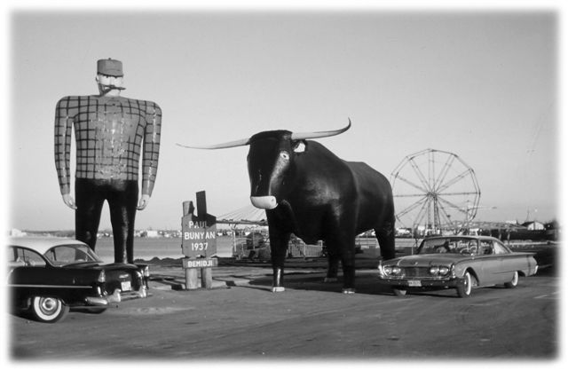
Paul Bunyon and His Blue Ox / My 1960 Starliner Ford
I will always remember what happened when we arrived in Cypress River, Jerry’s mom came flying out of the house taking Jerry in her arms and exclaimed,
“Oh, Jerry I just got your letter this week and I have been worried sick about you being down there in Ontario with all those English Protestants.” Then I could see she realized she had said this out loud and was quite embarrassed. I remember telling her.

“It’s OK, don’t let it bother you as I understand. It was just a short time ago that I was out here all alone with all you French Catholics, and at first I was more than a wee bit concerned. I think this has done Jerry and me a lot of good, we are now friends and not going to dwell on English, French, Protestant, Catholic kind of stuff, ever again. We look forward to being friends for a long time, maybe forever.”
We stayed over at Jerry’s place for two days. We gave the Henry J a good cleaning as we had found lots of juicy bugs and dirty roads on the way out. Leaving Cypress early one morning we drove to Regina and on to Pasqua just east of Moose Jaw to Jim and Eva Howe’s. By now we were seeing field after field of grain standing in water. It had been raining for days before we got there and it was still raining and even more was predicted. Jim and Eva advised us to not to continue on, as many roads were partly under water and all heavy trucks had been ordered off the highway. This did nothing to discourage Jack with his Willy Jeep motor in his Henry J. The luggage in the trunk was a plus as it added the extra weight for traction, and I had lots of power, but still I didn’t know what lay ahead. We took the road north to the Qu’Appelle Valley, then north again through Davidson to Kenaston, then west to Outlook, Rosetown and Kindersley. We crossed the Alberta border at Alsask and on to Oyen our destination.
All these roads at that time were made of upgraded earth from the ditch, capped with a small amount of gravel. They were getting soft and in many places holes and ruts and worse still, many places were under water. Every now and then we came upon a low stretch of road covered with water. A mile or so down the road we could see the other end of the road coming up again. We had no idea how deep the water might be. For miles on end I travelled in second gear. Truly my Henry J acted just like a jeep with its powerful four-cylinder engine, which behaved wonderfully in mud and water. Time after time I plunged into the water driving only by my mind’s eye in “dead centre” of the road. Then once more we drove out of the water onto the roadbed ahead. We would pull into a gas station for gas and a crowd of people would venture over to look at this mud covered little car “that could.” As there was literally no traffic on the road they marvelled that we could travel. All the hotels and motels were full with truckers and salesmen and travellers. No Vacancy signs were out all day and night. So we kept the gas tank well up and travelled on through the night.
We arrived in Oyen at dawn, just as the sun was coming up. To my horror I found the streets in town flooded with water. Not a foot of black top had been laid in Oyen at that time. The streets at their best were dirt in dry weather and mud when it was wet. I remembered then, I had been told they were installing gas lines on every street in Oyen that summer. Apparently they had dug up most of the town and after the digging was done along came the rain. Everything was like a bowl of soup. A deep trench was dug across the front of my Uncle Franks place so I could not drive in. I was afraid to stop the car in case I would be stuck. I wanted to park the car on solid ground and out of the water. At the end of a street near my Uncle Frank and Aunt Rosena’s, I could see a great high mound or hill of sand, maybe twenty feet high. This was to be used to fill in over the gas lines. I aimed for the hill and drove up near the top. At last I was high and dry.
What a welcome to town. Ron and I donned our boots from the trunk and walked back to my uncle and aunt’s place. We had been on the road now for almost 24 hours and in second gear most of the time. My Aunt Rosena gave us breakfast and then sent us off to bed. I don’t remember how long we slept, but I think till almost noon. Uncle Frank came to tell us that we were the talk of the town. There was a great crowd down at the sand hill looking at this strange little car “ that could. ” It was of course plastered with mud. Everyone in town knew of it, but no one in town knew anything about it, whose it was or when it came or why it was left sitting there. “ Me Thinks,” I should have sold this story to Kaiser Fraser at that time.
The rain stopped that day and Ron and I were able to drive out to our place of work. Ron went to Joe Quains and I to Harry Bulls. Things dried up and the rest of the fall was good harvest weather. We worked hard all week and then went into town on Saturday night. First we would take in the movie; then after the movie was over they would push the chairs aside and hold a dance. They did this every Saturday night, and to this day the folks talk about the great and wonderful times they had at these dances. It was the ideal way to meet and get to know many people in the community. I found people were easy to get to know and eager to be a friend. By now I had made quite a number of friends from the previous years.
At that time the road east of the Quain farm ended at a barbed wire gate a half-mile beyond, at foot of a very high hill which overlooked the country side. The area around this hill and far beyond was hilly and rough and covered with natural prairie grass. It was a paradise for the herd of white face Herfords that claimed it as home. This high hill was called Buffalo Bird Hill. Atop the hill is an Indian grave beside a mammoth rock. Almost everyone I took out west climbed up there at least once. From here you could view the whole valley to the northwest Most of the taller hills throughout this area have Indian graves on them. It is sad that many of them have been disturbed.
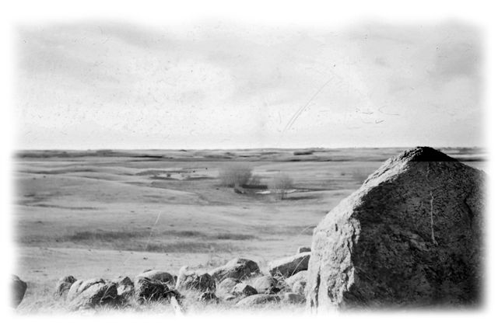
The View From Blue Bird Hill
When the harvest was over and it was time to leave for home I thought it only fair that Ron should see the mountains. So we left for Calgary and up to Banff. We did the usual sight-seeing and then in late afternoon for some reason we decided to climb a small mountain. Well we thought it was small until we were well up on it. You might ask why would we do a thing like that? I guess the only answer to a question like that is the usual one “Because it was there.” Ron was young and nimble and got quite a ways ahead of me. When it started to get dark Ron thought it best to turn back, which was a smart idea, but somehow we passed each other. Ron went down and I continued up. I knew, as it was getting dark I should be going down, but I didn’t want to leave Ron up there alone. I called for him but of course I would not hear him even if he did answer. Even now I remember how amazing Banff looked at night in the dark from above with its town lights coming on. It was just so dazzling. The air was cool and getting cold, but all about was calm and tranquil in my Silent World.
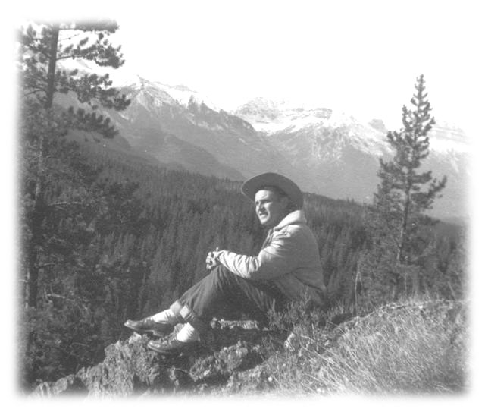
Jack in the Mountains 1953
Meanwhile Ron had returned to the car and blew the car horn until the battery was low hoping that I might hear it and realize he had gone back down. Of course from up on a mountainside I was too deaf to hear it. Somehow Ron contacted a Park Ranger and he sent out for a searching party. Meanwhile Ron and the ranger started back up the mountain, hoping to find me before I had an accident and fell and damage my hair. While it was beautiful up there it was getting cold fast, and I was really worried about where Ron was.
I saw two flashlights coming up behind me so I found a place where I would be out of sight. I didn’t really want to meet any strangers away up here on a mountain so late at night as I was sure it would not be the Avon Lady. When they were almost upon me I recognized Ron. So I said,
“Are you guys looking for someone?”
Ron said he almost jumped off the mountain that night as the Park Ranger had just been warning him about bears, and said,
“If you hear or see anything and think its a bear, go down the mountain as fast as he could as a bear rolls when he goes down too fast.” When we got down, the searchers were ready to start up. We caught hell with a good talking to about just setting off to climb a mountain. We were told you must register before you start out to climb in the park, and never start out late in the day. One more lesson learned. I have learned a lot, the hard way. They say you learn from your mistakes so I knew that I was designated to become a very smart man. After a short trip to Lake Louise we turned around and headed homeward.
We drove south down to High River and stayed over a day at Wib Duncans. Driving south again we crossed the US border at Coutts into Montana. The number two highway goes all the way across the northern states, Montana, North Dakota, Minnesota, Wisconsin to Northern Michigan and the Strait Of Mackinaw. Home again. Life went on for another year, but I was feeling very unsettled.

The following year Ron went back out west with me again, but only as far as a cousin’s farm somewhere north of Outlook or Rosetown Saskatchewan. I left him there and drove on alone. I remember once back on the road I missed him. Ron had been good company.
That fall I spent a lot of my Sundays with Don and Olive Sutherland and family. I had met Don’s brother Lorne and Isabel who lived just across the road and a younger brother Cameron who lived with his dad and mom on the old home place north of Dons place. Grandpa and Grandma Sutherland were more or less retired on the old homestead farm, and Cameron was working it. I found Grandpa Sutherland very distant, but he was very deaf, so maybe he sought sanctuary in the quietness and just felt safe getting away from it all.
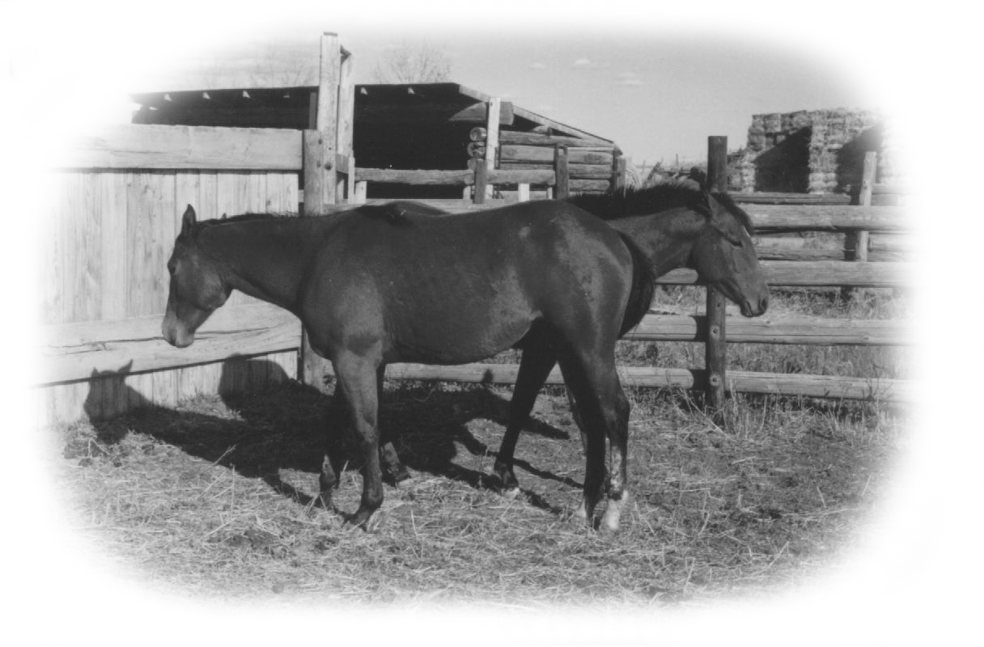
Sutherland’s Horses
On the other hand I found Grandma Sutherland a great personality and a joy to know. She talked about the early homesteading days in Alberta and of the Old Ontario she knew. She never forgot her Ontario roots and liked to chat with someone from back home. I remember more than once she invited young Don or Colin and me for a Sunday dinner. Her table was set for royalty with her best silver and linen and china. I felt it was an honour to dine at her table. There was one other member of the Sutherland family I would like to mention and that is her daughter Maxine who was a schoolteacher. In many ways Maxine was like her mother that is she liked nice things and had her very own flair in ways to dress. She is still living right now as I write this and is in her nineties. She lives now of all places, on the east coast instead of the prairies. I just cannot visualize her so far away from her western roots.
I was to the local store in the village of Lanfine a number of times. The store served as a post office as well as a place to buy basic groceries. There was a very nice young village girl behind the counter and her name was Lenora Robart. Everyone was made aware that she was Cameron Sutherland’s girl friend. In those days it seemed that people thought it was great that a daughter of one old pioneer family and the son of another old pioneer family should marry. They sort of assumed things should proceed along this line and discouraged everyone else standing in line. Whether they were indifferent to each other was not to be questioned, not even by them. Their neighbours, their friends and family had already cut the deal.
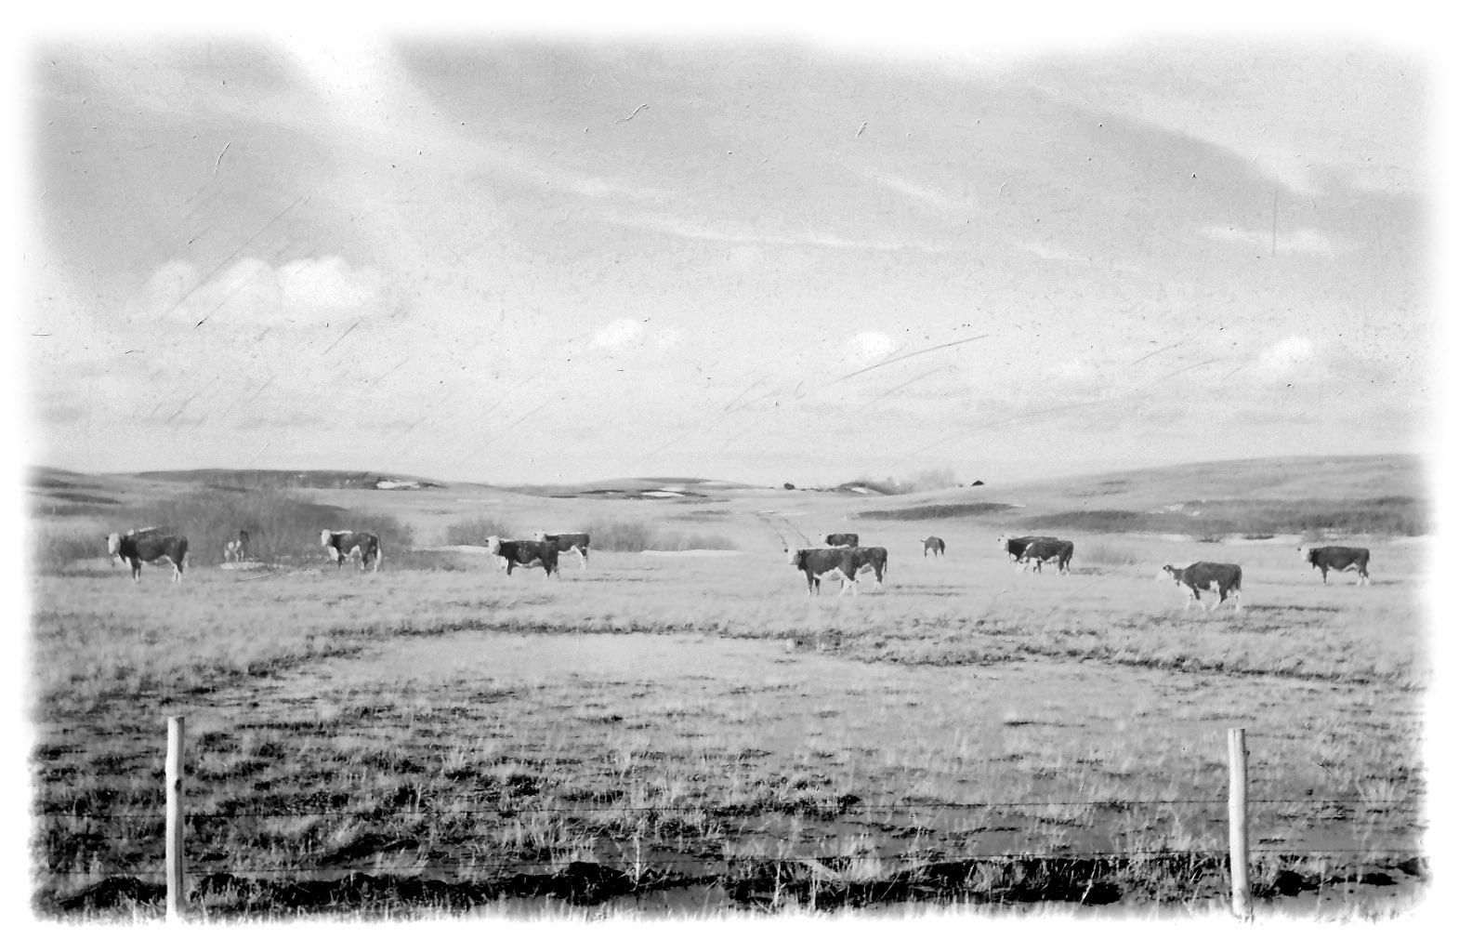
Sutherlands Cattle on the Range

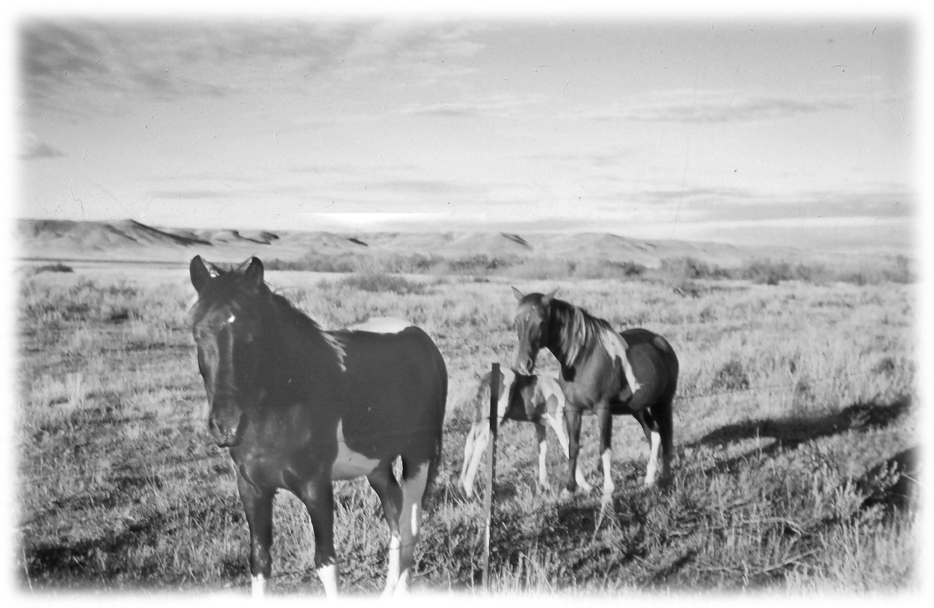
Cameron and Lenora were going to get married that fall of 1954 and Cameron was building a new house down the road north of his dad and mom’s farm. Young Don (Deke) and I spent a few Sundays working on the house with him. I remember going over one morning and finding a skunk had fallen into the basement. Cameron was wondering what to do.
We decided not to do anything; just leave some planks down from the basement windows onto the floor hoping it would climb out by itself over night. The next morning it had left. Never mess with a skunk if it can be avoided.
Harvest was over and the fall work was winding up and soon I would be heading home. Pinto Horses In The Bad Lands
We decided to drive down to the Bad Lands in my Henry J. for one last special outing together.

There was Cameron, Lenora and young Don and Colin and myself. I still have a snapshot of us all gathered around a campfire eating our supper. Cameron is sitting on a small cream can in which we took down water, and the rest of us are kneeling about the fire. There are a couple of frying pans with bacon and eggs along with a coffee pot on the ground. Memories are made of special times with special friends, and good memories should last a lifetime.
I arrived home without much fanfare. Ron was already home and settled back to his usual farm work and social life. It always took a few weeks for me to adjust. It was as if my body was here but my head was still out west. Soon, hopefully they would get together again.
Amos Graver and Maple Island
Late that fall Amos Graver, a friend of my dad’s and an uncle to my brother-in- law Arnold Graver asked if I would go north with him as company to deliver the hunting equipment to Maple Island for the Mitchell Hunting Club. Amos worked for Coveney Chicken Hatchery in Mitchell. Coveney donated the truck, and Amos his time after hours to do this delivery. It was plain good business on their part.
I always knew Arnold loved his Uncle Amos and I could see why. He was a friendly easygoing talkative guy, who had a way of making everyone feel at ease. This was the first time I was ever to Maple Island, but through a twist of fate I would return some day.
It would be in late November and very cool when we left Mitchell. At that time of the year the days are very short. I’m not sure the time of day it was when we got away. I just remember it was still daylight for a couple of hours or so. I could carry on a conversation with Amos as long as I could see to lip-read him. Once it got too dark I could no longer, as I always say, “see to hear.” This must have been very hard on Amos as everyone knew he loved to Chat.
I was almost asleep when Amos reached over and shook me awake saying,
“Wake up Jack we are almost there.”
In the distance I could see a bright white light bulb showing up a long white storefront. The ground stretching ahead of us was covered with a sift of white snow. Standing on the east side of the store was a team of horses and a wagon waiting for us. There were a few welcoming handshakes and then we unloaded the hunting equipment from the truck onto the wagon. It was dark and we travelled on a very rough trail. I remember it really shook me up and by the time I arrived at the clubhouse I was wide, wide, awake. I can never quite remember just where we ended up or how we got there, but it seemed to me we travelled east or northeast. I do remember though that when we arrived at the Hunting Club I recognized the long white building as one from an army base. After the war many of these military buildings were sold for all kinds of community purposes.
They fed us and the men started to talk. I think they talked well into the night and no doubt Arnold’s Uncle Amos would be very happy. As for me I could hardly stay awake and they pointed out a bunk and I was asleep even as my head hit the pillow. It was the smell of coffee and bacon that awoke me in the morning. I had a great night’s sleep. After breakfast we were ready for our return trip to Mitchell. I remember Amos telling me he was going to take a longer route home, as he wanted to show me something he thought I might like to see. That was Amos, and I was happy about this.
He drove to Burks Falls where he took some great pictures of me and the falls, then along the Magnetawan River. I have never forgotten that trip, but it was actually years later that I found out exactly where I had been. Amos passed away a number of years ago.
Years later Arnold and my sister Pearl bought a cottage up north on the Magnetawan River, and although they had told me it was at Maple Island. I didn’t connect it up to the place Amos had taken me to visit or the Mitchell hunt Club. But that’s another story. I will take you there later.
The Henry J had performed so well on the trip west and back and I had all but forgotten about how it behaved on slippery winter roads. Then winter came again and I was faced with the same problem. I just could not keep that car out of the ditch. A friend of my dad’s, Percy Laurence of Stratford sold cars for the Ford Dealer in Stratford and one day he dropped by with this almost brand new robin egg blue 1954 Ford Galaxie. It had white rear fenders and a matching white roof …. it was fabulous. It seems a lady teacher had ordered it and a down payment made, but now she decided they should buy a house instead and wanted out of the deal. Percy offered me a very good deal on the Henry J and my dad thought I should take it, as he did not want to spend another winter pulling me out of the ditch. I have a soft spot in my heart for that Henry J because it never left me stranded in all that mud and water, but it just could not handle slippery roads because of that big heavy motor. The 1954 Galaxie Ford cost me $2,300.00.
July the 4^{th 1955} my sister Jean married Bill Butler of Munro. (It was the best deal he ever got.)

Western Trip 1955
Earl Paulin, Glen Sykes, Bruce Eisler, Earl Foster
I made several other trips west at harvest time and I want to mention them briefly as these trips and the people involved are a part of my life story. In the fall of 1955, I got letters upon letters from the west telling me there was a great crop and they needed help so could I find a farm boy or a young man for them. While not everyone out west likes the east for some reason they all liked the Ontario farm boys. They found them to be of good character, honest and hard workers. The fall of 1955 several of my best friends wanted to go west with me. They were, Earl Paulen, Glen Sykes, Bruce Eisler and Earl Foster.
When I took a group of guys on a trip like this I knew there would have to be some road rules. So rule number one was. When we stop for gas everyone goes to the bathroom whether you need to or not, as we can not make time driving if we have to stop every half hour to let some one go to the bathroom. Rule number two. Everyone had a say in where or when we should stop to eat or where and when we should stop for the night, but in case of a dispute….the driver was always right. Rule number three was everyone had to help to keep the car clean. Litter went in a bag and your feet were always kept on the floor. I reminded them they were travelling in a good car and I wanted them to respect that. This was not a problem with these guys.
The boys wanted to see Winnipeg, so I drove into the city so we could cruise the Portage and Main area. Then we visited the Parliament Buildings and walked its well-tended lawns. I also took advantage of the opportunity to have a short visit with my Uncle Fred, perhaps a couple of hours. The time was all too short, but Uncle Fred understood the situation. We couldn’t expect the boys to wait around for long while we visited. I will always remember that when we left he insisted on filling the gas tank on my car. That was such, an uncle sort of thing to do and I thought it was kind and generous of him. We travelled on to Regina and there again, we visited the parliament buildings.
Upon arriving in Oyen I drove all of the boys to their places of work We seldom saw each other all week but on Saturday night I would make a round trip picking them all up so they could go to town together. Then I would have to make the round trip again to take everyone home. I didn’t mind this anyway as these were all my very best friends. Getting together like this gave us a good chance to compare our bosses, our working conditions and our wages, etc. We didn’t have anything to really complain about as these were all fine people we were working for. They appreciated that these boys had come a long ways to help them and so they got the going wages. Perhaps the best was every home was super clean and the food was great, and the boys were treated kindly and with due respect.
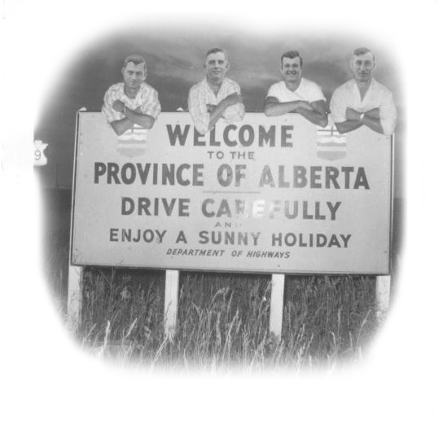

Earl Foster, Glen Sykes, Earl Paulen and Bruce Eisler
On Sundays the boys were often invited to one home or another for dinner or supper. It was simply good western hospitality. The Bulls loved to have the boys come to their place, so it seemed we met there most often. Wm. Played a violin and a banjo. He preferred to play the banjo and Earl Paulin would play the piano and Bruce Eisler the violin and Glen Sykes and Earl Foster and I would sing. We knew just about every song that was out, so the music went on for hours. Then when it was time to go home, Earl always played, “Good Night Irene Good Night Irene,” as Mrs. Bull’s name was Irene. There were tears of appreciation in her eyes for the boys as she said good night. I would have to drive them all home to where they worked. Each would have personal problems to discuss before they left the car and it was often late when I got back to Bulls.
After a few days of rain, which held up the harvest, we were glad to be back in the fields working again. The weatherman was predicting more rain by the first of the week but Sunday was going to be sunny and dry. A few of the neighbours in other years had started to work on Sundays. However the Bulls and the Snells, the Quains, Harry Dell, the Whites the Robinsons the Parenteaus or Sutherlands all honoured and respected their Sunday. For the first time in 1955 it seemed all these people got together and decided they would ask their hired help to work on the Sunday. On Saturday we were all told by our bosses that they were going to work the next day, Sunday and they would need us to help.

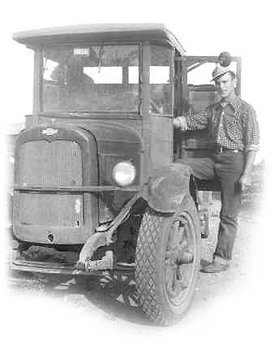
Me and Ole Lizzie err I mean ( Elizabeth )
We all went into town together that Saturday night as usual, so we had a chance to talk about the pros and cons of this. At home our parents would never even think of harvesting on a Sunday. While it was true, in Ontario we would do barn work on Sundays we looked upon it as caring work to keep our stock clean and comfortable. So we decided to all stick together and tell our bosses that working on Sundays was not the kind of thing we wanted to do, as it was against our Ontario up bringing. Mr. Bull and Wm. Both took this very well but they still put in a rather small, uncomfortable day combining. I do remember going out to help Mr. Bull several times when I saw the truck come in with a load of grain to unload, as I didn’t want him shovelling grain and overdoing it. He was a wonderful man and I cared about him. I don’t remember that they ever worked another Sunday that year, but that was a start and from then on everyone worked at combining seven days a week whenever it was dry and ready.
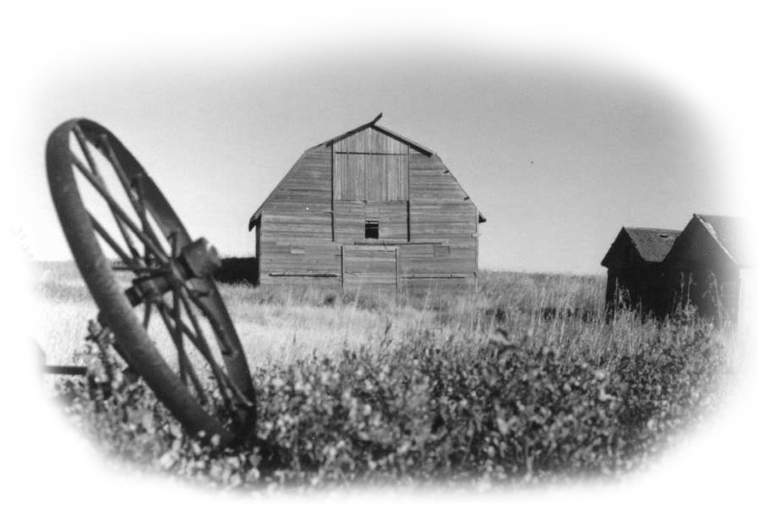
The Old Barn on the Fowler Farm
Good weather prevailed, the harvest was finished, and we were ready to move on.
Earl was a cousin to my friends the Skinners at Toefield, so when we finished the harvest at Oyen we drove to Toefield and called on them. A nephew, David Skinner from Mitchell was visiting and working for them at the harvest. He was naturally very happy to see his cousin Earl and friends from the Mitchell area. When he heard we were going to drive on to Jasper and down to Banff he wanted to go with us. With five guys in the car plus luggage we really were already feeling a bit crowded. I didn’t want three in the front seat as I felt it unsafe for the driving. Earl however begged me to take his cousin and I knew it was a chance of a lifetime for him to do this with Earl Paulin and friends, so in the end I could not refuse him.

Driving west we skirted the southern end of Edmonton then took the number 16 highway west. This would be my very first visit to Jasper. The mountains were already capped with snow and looked cold and overpowering. The trees and vegetation were well advanced, and almost over their fall dress and colours. Most places of business were already closed down for the winter.. It seemed a very short season for Jasper in those days. We found a place to stay over and the next day after filling the gas tank found that the highway south to Lake Louise and Banff was already closed for the winter. What were we going to do? We realized we had come a long way to see this and at our age we were not going to give up so easily. We could see on our map that there were very few places where we might be able to stop for gas or food. We reasoned that with luck surely we would find at least one gas station happy to sell us some gas. If not we were sure we could make it to Lake Louise on our tank of gas. We had no idea of turning around and going home without seeing the Rockies. So we decided to drive around the road barrier and drive to Banff.
For a time we forgot everything, lost in the beauty that surrounded us. We stopped to view the mighty plummeting waters of the Athabasca Falls. Its roaring milky waters funnelling itself through deep cut lime stone gorges on its way to the Athabasca River. We saw the river and its milky white waters rushing north to its destination wild and free. Ice fields large and small clung between the mountains on the west side of the road.
Farther on the azure blue lakes lying at the foot of great mountains along the route to the west astounded us. We were captivated by a world of wonder such as we had never seen before. Its grandeur in size and beauty staggered the human mind and makes us ever mindful just how small and powerless we really are.
Far ahead there appeared to be a wall of mountains white with snow blocking our southern journey. It grew larger and larger as we drove south towards it. When we finally arrived we realized we were looking at the Columbia Ice Fields, huge, cold and foreboding. Tours of it were of course closed for the winter. As yet we had not seen any sign of life along the highway. We were apparently very much alone.
Our gas gauge was definitely getting low. The one thing we had not taken into consideration was that we now had one more passenger and this was mountain driving so we were using far more gas than when we were driving across the prairies. It was getting on in the day when we found a road crew just ending their day’s work. They were naturally surprised to see us as the road was supposed to be closed. It was I believe actually unlawful for us to be on this road travelling. They had part of a gallon of gas, and offered it to us. I needed a funnel to get it into the tank, so we spilt much of the gas pouring it in. We drove on and on and it seemed our gas tank just kept on giving us gas, but at any minute we expected the motor to sputter to a stop. Then what would we do high in mountain country at night, hitchhike?
On the west side of the highway we saw a building and a Forest Ranger’s truck. We drove in and it was a Park Warden’s office. He was not happy to see us, but he must have been young once so I guess he understood that young people don’t always make the right decisions. He told us that he was going for a walk and that he had forgotten to lock the gas pumps. If we should happen to fill our gas tank and he didn’t know anything about it, he would not get into any trouble. We offered to pay for the gas, but he told us he could not sell the government gas. So he left to go for a walk and after a minute we drove over to the pumps and filled our gas tank up on the Canadian Government. Somehow I don’t feel very guilty today about this.
We arrived at Lake Louise, and walked down to the shoreline of the cold sky blue lake. There is something so overwhelming about this place that words cannot begin to describe it. It is as if nature created something so beautiful then hid it here between the mountain ranges out of sight to be kept unspoiled, and now we have intruded. We stood for a long time facing the ice field with the Chateau behind us looking quiet and empty. On each side the tall mountains enclose this historic scene, an intact paradise. I think every Canadian at least once in their lifetime should stand here and witness this beauty and greatness.
It was late when we found a place to stay in Banff that night and everyone was very tired and I think a wee bit cranky from being in such cramped quarters for so many hours. The next morning we toured Banff the town and the surrounding area of the park.
We saw the Banff Springs Hotel overlooking the Bow Valley. In 1955 the hotel looked historic and entirely out of place in this fairytale setting. We stopped to see the Bow Falls on the Bow River not far from the Hotel. A few years later a movie was made there on the Bow River and at the falls with Marilyn Munro. We went up the mountain on a chairlift and had more or less a bird’s eye view of Mount

