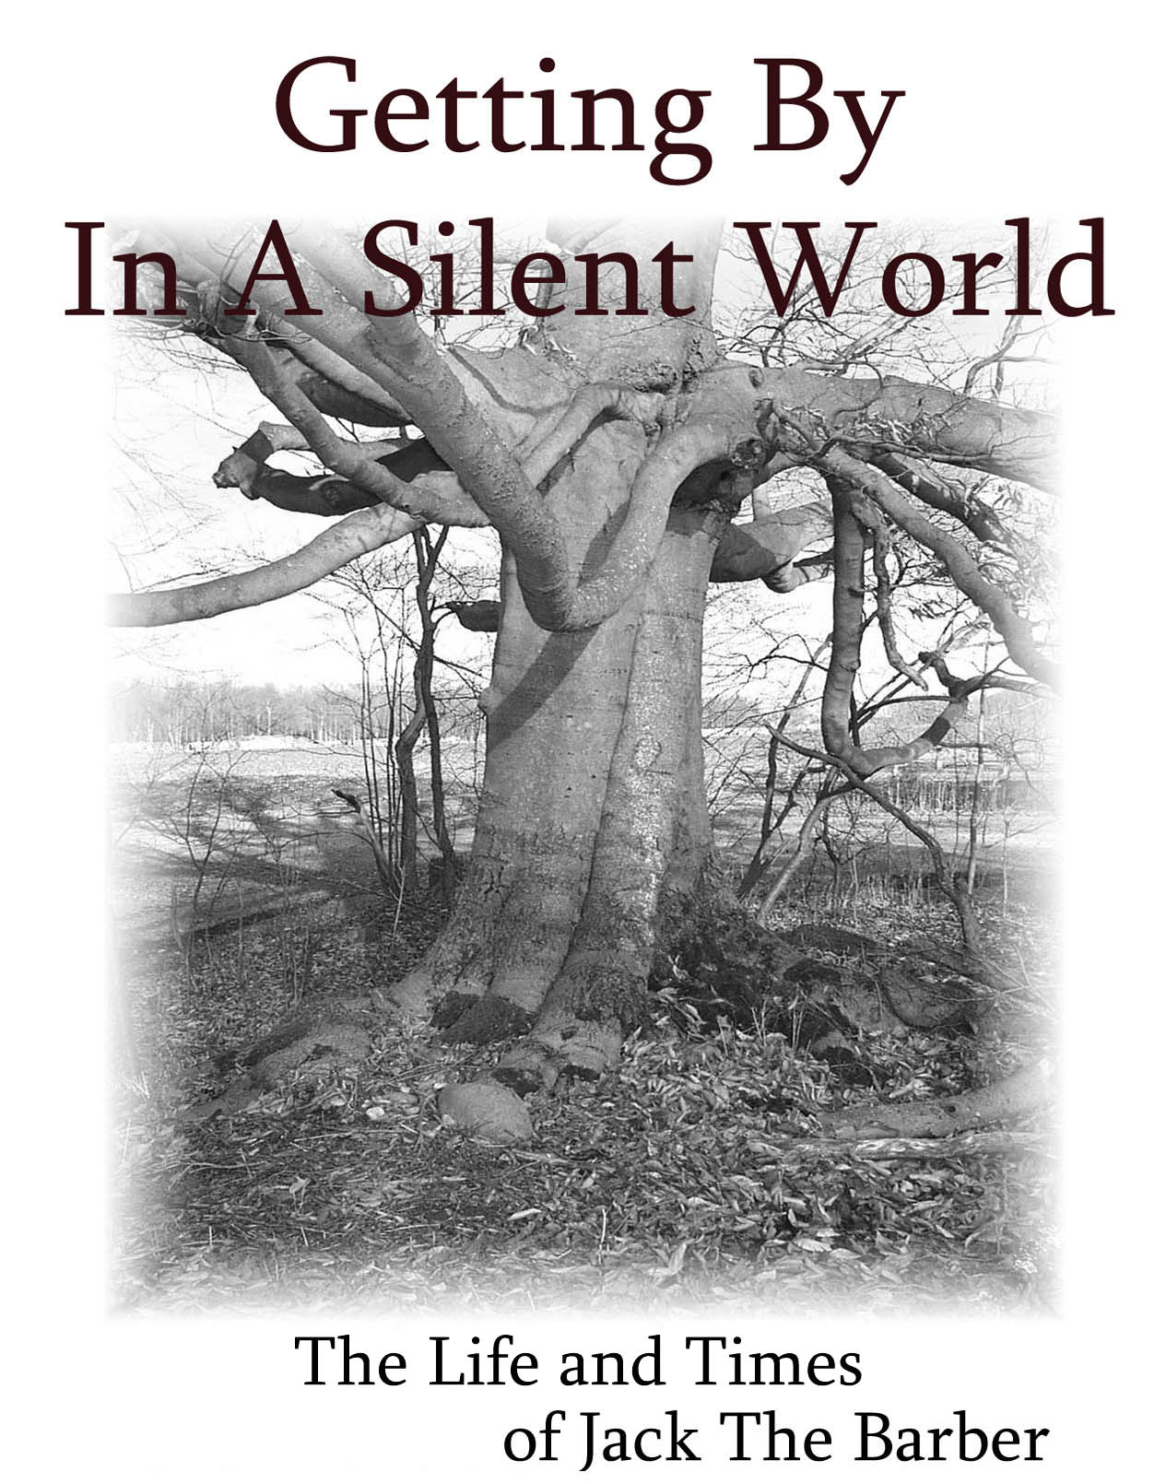

By Jack L Cooke

1 |  | Contents | 3
2 |  | Preface | 7
 |  | Chapter 1
3 |  | Happiness Is The Journey | 10
4 |  | A Bad Experience | 14
5 |  | Surviving The Heat | 14
6 |  | The Tornado In The 30’s | 18
7 |  | A New Fury Friend | 20
8 |  | Rabbits | 21
9 |  | The Orchard | 22
10 |  | Tramps Of The 30’s or Someone’s Son | 23
11 |  | A Wondrous Gift | 25
12 |  | Cold Winters and Cutting Wood | 25
13 |  | Winter and Car Care, Roads and Travel | 26
14 |  | Going To School | 29
15 |  | My School Days | 30
16 |  | “ A Lesson Learned “ | 35
17 |  | Motherwell Village by The Thames | 37
18 |  | Sunday | 40
19 |  | Horse and Buggies, Cars and Radios | 42
20 |  | My Dad and The Butcher Knife | 47
21 |  | Farm Cats | 49
22 |  | Life as “ The Only Boy “ | 50
23 |  | Len My City Cousin | 52
24 |  | The War Years | 55
25 |  | Saturday Nights | 50
26 |  | My Grandfather Cooke | 57
27 |  | My Grandpa and Grandma Butson | 58
28 |  | Fur and Feather Barn Pest | 59
29 |  | I lose My Hearing | 60
30 |  | Making Maple Syrup | 62
31 |  | The Day We Player Hooky From School | 62
32 |  | High School and The Aftermath | 63
33 |  | Shirlyan My Kid Sister | 65
34 |  | The Long Trip Home | 66
 |  | Chapter 2
35 |  | Those Early Years The Booming 40’s | 66
36 |  | I Meet my Uncle Fred Butson in Winnipeg | 71
37 |  | I Meet Uncle Frank and Aunt Rosena Mc Nee | 77
38 |  | Wib and The Duncans Of High River | 87
39 |  | My Aunt Becky ( Norris ) Kiel | 91
 |  | Chapter 3
40 |  | Growing Up and Times To Remember | 96
41 |  | My First Car Accident | 100
42 |  | “ Fall Fever and Westward Ho ” | 106
43 |  | Home Again | 111
44 |  | Friends to Remember – People I Worked For | 112
45 |  | The First TV Set | 116
 |  | Chapter 4
46 |  | The Real West | 118
47 |  | The Henry J Kaiser Fraser | 134
48 |  | Jerry Baltesson Came East To Visit | 137
49 |  | Ron Smith, Jerry Baltesson and I Drive West | 138
50 |  | Amos Graver and Maple Island | 145
51 |  | A Western Trip 1955 | 147
52 |  | Dad and Mom by Boat To England | 154
53 |  | A Western Trip 1957 | 157
54 |  | The Old Farm Was Sold 1961 | 181
55 |  | Barry White and Diane | 184
56 |  | Dad and Mom Buy The Taylor Farm | 187
 |  | Chapter 5
57 |  | Off To Barber College | 189
58 |  | George, Dot, Mark, Aunt Em and Penny | 193
59 |  | My First Barber Shop 1963 | 198
60 |  | Jack and Bob Go West | 202
61 |  | “ The Crazy, Crazy Colourful 60’s ” | 207
62 |  | “The Executive House” 362 Dufferin Ave | 209
63 |  | Regina Mundi College | 210
64 |  | Mrs Murdock and Her Christmas Cake | 211
65 |  | Some Strange Encounters | 212
66 |  | Of Friends and Friendships | 215
67 |  | Jack and Allan Have A Bad Day | 218
68 |  | Unpleasant Encounters | 218
69 |  | Mr Mrs Bulls 50th Wedding Anniversary | 219
70 |  | Barry and Diane White Are Doing Well | 220
71 |  | Two Hockey Greats Daryl and Dino | 220
72 |  | A Fateful Tragedy | 220
73 |  | Time For Dad and Mom To Retire | 221
74 |  | Bob Takes Leave | 222
 |  | Chapter 6
75 |  | Life At The V O N House | 224
76 |  | Dad and Mom and Nancy - Go West | 232
77 |  | The Sad Tale of My Friend “A New Canadian ” | 235
78 |  | Jack Loses His Shop and Starts Out New | 238
79 |  | For All Of Us Life Moves On | 241
80 |  | The Dream Car My 1983 Camaro Z 28 | 242
81 |  | The London Y M C A Burned Down | 243
82 |  | Barbershop Tales | 244
83 |  | Dad and Mom Move To Ritz Villa | 248
84 |  | Wm. Bull Passed Away | 249
85 |  | Lenora and Grace Travel East | 251
86 |  | My Mom Passes Away | 252
87 |  | Mike and Gigs Chubak Pull Up Stakes | 252
88 |  | I Trade My Z 28 For A Grand A M Pontiac | 253
89 |  | The V O N Decide To Move | 255
 |  | Chapter 7
90 |  | The Berkeley Apartment Building | 257
91 |  | A TV Caption Machine | 260
92 |  | At 92 Dad’s Health Was Failing | 260
93 |  | Carl Quits As Custodian | 262
94 |  | Stranger Than Fiction | 263
95 |  | Jack Takes On A Garden | 265
96 |  | Getting Taken | 265
97 |  | Mandy My Manx Cat | 268
98 |  | Mr Buchanan Comes Around | 268
99 |  | Mr Buchanan Has A Stroke | 270
100 |  | Mrs Buchanan Passes Away | 270
101 |  | My Aunt Maude | 272
102 |  | The California Holiday Trip | 274
 |  | Chapter 8
103 |  | “ Coasting Thru My 60’s ” | 289
104 |  | On Reaching 65 | 291
105 |  | My First Old Age Pension Check | 297
106 |  | Mr Buchanan Passes Away | 297
107 |  | I Think About Buying A Condo | 298
108 |  | Yvonne Has A Deal | 300
109 |  | “ A Friend “ Olive Sutherland Passes Away | 301
110 |  | Deke and Cathy | 301
111 |  | I return To Oyen | 308
112 |  | Don Sutherland Sr. Passes Away | 314
113 |  | Bill and Jean and Jack Fly West August 1998 | 315
114 |  | Buying a Condo | 316
115 |  | I Bought A Computer | 321
116 |  | Yvonne Moves To London | 323
117 |  | My Manx Cat Mandy Dies | 326
 |  | Chapter 9
118 |  | A Great Canadian Holiday Trip 2001 | 328
119 |  | I Drive North To Fort Mc Murray | 341
120 |  | Time For Another Kitty | 352
121 |  | Don The Computer Guy | 354
122 |  | Life Moves On | 354
 |  | Chapter 10
123 |  | “ A Time To Reflect ” | 357
124 |  | A Special “ Thank You ” | 359

Preface :In A Silent World

I was born a child of the thirties thus I view a much larger dimension of life than those who were born after me. I know the difference between the necessities of life and the luxuries. I am better able to appreciate the good things life offers us today, yet able to mourn the loss of what we left behind.
There was a time when no one locked their doors, a time when milk was delivered to your house every morning, a time when the mailman picked up letters and delivered mail to your door or mailbox six days a week. A time when the simple words, “Going to town” made your heart race. I remember when the whole family followed friends or uncles and aunts all the way to the car to see them off, to say “Good byes” because we knew we loved them.
I was born at a time when your work always came first before yourself, when one dollar a day was good pay if you were lucky enough to find a job, and the word ‘holiday’ was only for the rich and not yet in our vocabulary.
While I am aware now there were hardships at that time, we did not feel oppressed by it. It was simply the way we were. This was life, as we knew it in our home and in our community. Our family, friends and neighbours all shared the same problems, the same joys, sorrows and accomplishments.
A motto on our Perth County billboard as you enter our county said,
“Together We Rise” ….. and we did.
Now when I look back I know that in spite of all we have today we had something then which is missing in our lives today. Perhaps it is simply the joys and appreciation of little things we did for each other or perhaps just the satisfaction of doing things “well ” the hard way, of hearing or saying the words “Thank you” and knowing the true meaning of it.
No one thing changed my life so much as my hearing loss due to scarlet fever when I was twelve years old. All plans for a future were suddenly dashed. The world at that time, more so than today would not accept a deaf person. It won’t adapt to you. Somehow you have to learn to deal with it.
This is the story of a boy entering a Silent World. Then of a young man struggling to find a place in that world against the odds. It is also the story of the people who touched his life along the way and made that world more manageable in one way or another for better or worse. I have few regrets.
I know now, “Life is but a journey that takes you from here to there.”
What you find at the end of the journey depends a lot on the road you had to travel, and whom you met to influence your life along your way. At the tender age of fifteen my travels took me afar from home to Western Canada at a time the country was still very young. I travelled its dirt roads and crossed its muddy streets; I rode horse back in the hills looking for cattle. I have spent days under the hot prairie sun picking rock from newly broken land. I have dug goose pits and climbed mountains. I know the intense pride the west feels of its past history and I am very much aware of its vibrant pulse and its impatient heartbeat for its future. I loved the west then and I still love it today, but my journey led me back to beautiful old London on the Thames River in the heart of South Western Ontario. It is here I found a place I feel I can call home, but my first home, the place where my heart will forever be is on the old farm on The Mitchell Road, the place where I was born and raised.
Those years of growing up in the thirties and forties are well documented in the first few chapters of my book, followed by those in between years of my teens and twenties. For a time it seemed my life was an endless tortuous journey from east to west and back home again searching for my place in life. My love for Alberta and the west and my ties to my home, the old farm on The Mitchell Road were always in conflict. I realize now I was led on a long journey, a journey that moulded and enriched my life.
It was my old friend Albert Norman, the painter in Mitchell who hired me in the late fall of 1962 when I arrived home from the west with no job and no place to stay. It was also that fall that Dickie Thorne the local Mitchell shoe store man planted the seed for me to become a barber. My only regret might be I wish I had started to barber ten years earlier as I had finally found my calling – a place in life where I could earn a living and at the same time enjoy my work. It was a place warm in the winter and cool in the summer.
For about forty years through good times and bad I managed to keep my shop operating while time took its toll on the many businesses all about me.
Now in my later years I could not imagine my life without that journey which brought me in contact with all those I learned to love and respect. I have tried not to lose track of the many people I have met on my life’s journey, but many have passed away and the rest of us are getting older.
It is to you my dear friends and to my sisters and families I dedicate this book, for the many ways you touched and enriched my life. God Bless.

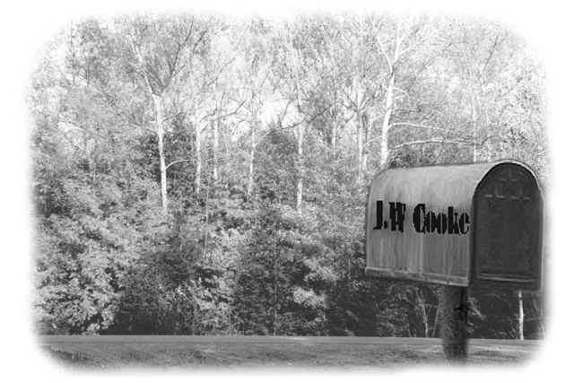

There was a beginning and there will be an end.
Our yesterdays are our history,
and our tomorrows
remain a mystery.
Today is a gift.
Author Unknown

Chapter 1

HAPPINESS IS THE JOURNEY

“ Milestones ”are seldom recognized along the way as we live our daily lives. It is only when we get older and look back, that we will recognize them. Looking back now, I see a whole generation that for a time was stripped of hope and plans for a future, afraid to enjoy the present for fear of jinxing their future. By assuming nothing good will ever come your way again you will never be disappointed, never have your hopes dashed again. The thirties did this to many people and perhaps it took a war to make them rise above it.
Although I left the farm a long time ago I have never regretted that I was raised on a farm, living and sharing in a farm community. It left me with a different vision than most city people have in many ways and that vision has enriched my life. When I drive down the highway or out into the country I don’t just see trees, I see the maples the ash the oak and walnut, and I see that the elms are making a comeback. I see the hawthorn and the willow, and the locust. I look at the field crops and I see the winter wheat and the barley, oats and the corn and soybeans, and canola. I don’t just see grass, I see timothy and alfalfa, clover and grass and more. I recognize dozens of kinds of weeds, flowers and shrubs, all because I grew up with them on the farm and they were our everyday language.
Farming was actually more than just a job or occupation, it was a home and a way of life. Each morning you wake up not only to your family but to your livestock and to your whole community, with commitments to all. No clear line separates your work from your community commitments. It is an old model of living, which has been handed down for centuries. You don’t just own the farm, you own an active place in your community. When you are born on a farm you will learn to love the land under your feet, and it will always be the place you will call home, the place where you were born.
I was born in a rural area of Southern Ontario, October 17th in 1928. I didn’t realize the years were drifting by so fast until now as I grow older. Sometimes I stop to wonder, just how I got from there to here, for when I look back to those early years I remember a world so much different from the world we live in today. My thoughts drift back to a long, long, time ago to the old farm on the Mitchell Road where I grew up in Fullarton Township in Perth County, Ontario. My grandfather George Cooke came from Peterborough England in the late 1880’s. He first farmed in the Woodstock area and then rented this farm on the Mitchell Road in 1899 from Wm. Bothwell. He later bought it and the sixty acres to the south, which had a lot of bush and swamp on it.
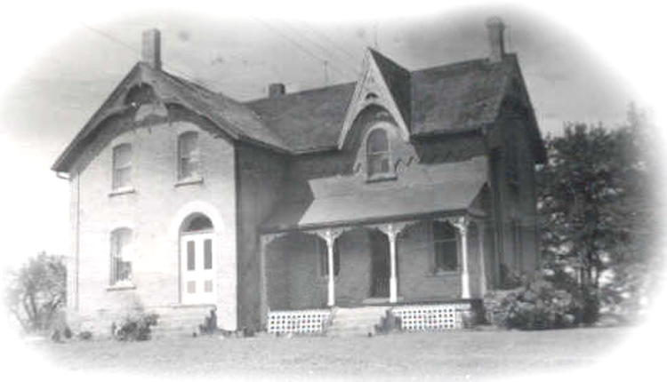
The Old Cooke Farm Home on the Mitchell Road
The earliest memories in my life were of long hot sunny summer days with the smell of wood smoke constantly in the air. My grandfather who owned the farm was clearing land and burning brush and stumps down on what we called “The Sixty.” Many great trees of ash, maple, elm and oak that were thought not straight enough logs for lumber were piled and burnt. In the evening I would walk with my grandfather going from stump to stump checking them to see if they were burnt out enough to pull with our team of horses using a logging chain. Many a tug or whipple tree got broken while clearing stumps and rocks from the land. Perhaps it was then that I learned to love the smell of wood smoke and earn my lifetime love and admiration of horses
Dad, John Wilfred Cooke was born in Woodstock, Oct. 21, 1898.
Mom, Mary Reta Butson was born at Cromarty or Staffa area July 10 1900.
Sept. 30th 1926 my dad John Cooke married my mom Reta Butson, and they worked the farm along with my grandparents. Laurine was born Oct.10, 1927 and I was born Oct. 17/1928. Like all young folk my dad and mom longed for a place of their very own. So in 1929 they bought the Barr farm that was actually the other half of grandpa’s sixty. They delayed moving into the house because they were able to rent it to a friend Jack Young. They simply needed the income so it seemed the best thing to do. In the year 1930 my dad caught polio, and came very close to losing his life. It was many years before he actually made a full recovery and regained his health. The great depression of the thirties descended on everyone and by 1932 they had to give up the new farm. They sold it back to Mr. Barr. I would only be four years old but I remember my mom crying, as she felt her hopes and dreams were dashed for a home of their very own. They didn’t enjoy sharing the house with older folks; they wanted and needed something of their very own.
March 15, 1931 my sister Pearl was born.
April 21, 1932 my sister Jean was born.
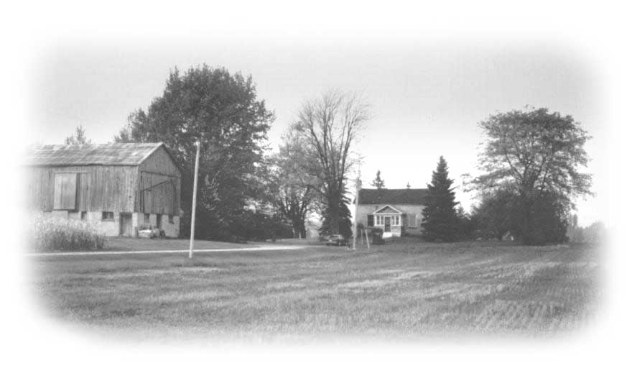
The Barr Farm
Springtime an then summer were seemingly a long and endless time of great joys for me. Each spring my Uncle Georges bush across the Mitchell road from our house and barn would announce that spring had indeed arrived once more. We watched as suddenly the bush sprang forth in a shade of green which deepened into foliage each day. Wild crab-apple trees burst forth in bloom attracting busy bees. Soon the he whole bush resounds with the croaking and thrilling of hundreds and hundreds of frogs, throbbing a chorus of happiness Every now and then the bull frog added a rich loud crock perfecting a country in harmony as we knew it. First the spring calves would be born and I would greet each one with great affection and they would respond to my touch. Then there were little pigs. I use to scratch behind the mother sow’s ears and made good friends with them. Thus I was not afraid to enter the pen to pet the little ones. But not all mother sows want to share their family with you, so take care. Don’t make them squeal or you might have to make a hasty retreat!
Cats and kittens were another thing, and it seemed that our mother cats came from a long line of great lovers and the neighbourhood toms had a very happy and carefree nightlife. Our farm cats often had two or three litters a year. It was kind of sad to see these beautiful kittens born knowing you cannot keep them. The sooner they were made to disappear the easier it was for mother cats and little boys too.

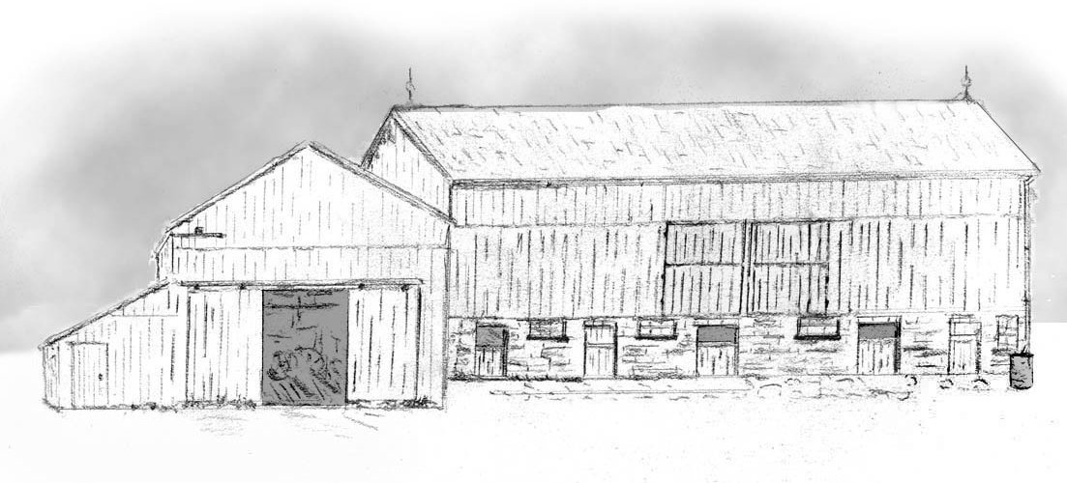The Old Farm Buildings on the Mitchell Road – art by Jack
A trip to The Village Store was always a wonderful treat and a break from the farm. I still remember the great roll of brown paper sitting on the counter and the white string hanging down from the ceiling. There was a bobbin of white string sitting near by from which the string went up to the ceiling and through an eye, then across the ceiling above the roll of brown paper and through another eye, dropped and was left floating in the air. It was great to see the store owner pull on the brown paper from the roll and wrap your purchase and while holding onto it reach for the string and somehow the package sort of make a circle on the counter before your eyes and a tie was made and your purchase handed to you all in one smooth movement.
We bought most of our gas at this village store. The gas pump was out in front of the store veranda. It was a two-glass chamber atop a towering bottom. There was a white globe on top of the glass chambers telling you the brand name at Motherwell was White Rose, other brands I remember best were Texaco, Supertest, B A. . A long handle was attached on either side of the tower, and you swung the handle back and forth to pump the glass chamber full of gas. Each chamber held ten gallons of gas and had numbers and lines on the side of the chamber. One chamber held number one gas and the other number two gas. You just took the hose off the side of the tower and put it into the car gas tank and squeezed the handle and watched the gas lower itself in the chamber until it touched the line or number you wanted. Everyone always thought they got a full measure of gas for their money.
A Bad Experience
One beautiful sunny summer morning when I was perhaps six or seven years old a group of neighbour men arrived at our farm in a jolly mood. I knew several of them as they had helped my dad from time to time as farm people did at that time. I had no idea what was going to take place, but I always enjoyed it when company came so I was out there to welcome them.
I was not ready to see what I saw that day, but I realize now it was just a part of farm life, as little boys had to grow up and accept such things as life and death. They came out of the barn in a group and the one man had a rope in his hand. The other end of the rope was looped around the hind leg of one of my dad’s fat pigs. By pulling the rope to the left or right they could guide the pig and make it go in the direction they wished to guide it. You can lead a horse or cow, but you cannot lead a pig. You drive or follow it.
By now I had noticed this strange rope and pulleys hanging in the maple tree. But I didn’t have a clue what it was for. The men were in a jolly mood, laughing and prodding the poor pig that was squealing like mad. I remember the morning was still so fresh and full of promise for all living things. The warm sun shone down upon the farmyard below and I stood in the shade of the great maple witnessing the intrusion upon a small boy’s life. What was about to happen would live in my mind’s memory forever. About mid-way across the yard one man took out a huge butcher knife and put it under the pig’s throat and drew it across. Blood gushed out so bright, so red. The clear shrill squeals it had been making ended with horrid gurgling sounds! To add insult to this terrible scene one man jumped on the pig’s back and rode him to his death.
As a little kid I stood there in shock. I felt much, much too young to witness death in this manner. I could not understand the joy these men seemed to find, “ in the killing.” They pulled the dying pig over to the block and tackle and pulled it up by its hind legs until it was off the ground. I was still standing frozen to my spot. The man took the knife and slit the pig down the belly and all the insides rolled out onto the ground. I had seen enough. Too much for a small boy, but such was life, on farms in those early years. It was all a part of growing up. I think back now and I wonder if my dad should have sent me to the house until it was over, as I would much rather have lived my life, free of this memory.
Surviving In The Heat
Most farms did not have a refrigerator. A few had what was called an icebox, which looked like a fridge and was kept cool by a block of ice. This worked very well, but there was a lot of work involved in getting and keeping ice. In the winter men would go to the Thames River and cut huge blocks of ice. I have seen the ice ten to twelve inches thick on the Thames River. They sawed the ice with special handsaws into twelve-inch squares and called them “ Blocks. ” They lifted the blocks out of the water with great ice prongs and piled then onto bob sleighs. Then with a team of horses drew it home. It would be a very heavy load and the team of horses were allowed to stop every so far to catch their breath.
The gravel roads were usually snow packed most or all of the winter, so bob sleighs could travel down the road most of the winter without a problem.
Once home the ice was put in what was called an icehouse, often when possible built into the side of a hill. Wood sawdust was then shovelled over the ice as it was piled in the icehouse layer by layer. The sawdust was also put down between the blocks so they would not freeze together. Sawdust is a wonderful insulator and the ice would keep in the icehouse all summer.
Freezers had not been invented yet so the farmers out of necessity invented what they called beef rings and pork rings so they could have fresh meat each week. It worked like this. A number of farmers agreed to each raise a pig or a steer to a certain weight to be ready to slaughter on or about a set date. Now there are just so many correct cuts in either a beef or pork animal and you would receive one of each of these cuts until you had used them all up, and then you were out of the ring unless you put another animal in. These rings were used mostly in the hot summer, when it was impossible to keep meat very long in the heat. I remember my mom always kept the best cuts of meat for the grain threshing gangs, as men needed good food when they worked hard. In the winter one could manage to get by with perhaps pork in a wood barrel of salt brine in the cellar or maybe culling out a few fat hens, which had gone into retirement and stopped laying eggs.
The summer of 1936 was very hot. In fact, it was one of the hottest heat waves ever recorded by Environment Canada. For twelve days the temperature exceeded 40C or near 110F. No one had air conditioning at that time, and many people died of heat exhaustion. Records tell us 1,180 lives were lost in Ontario and Manitoba that summer. In 1936 that was a lot of people from our small population. The heat meant that our cattle and farm stock needed more water, and our barn well could not keep up with the demand. Two Clevis and a Neck Yoke
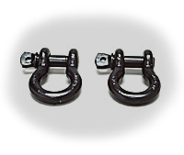
Grandpa and I got the job of hauling water from the house well to the barn. We put two wood barrels on a flat stone boat. Every farm had a stone boat in those days. Its main job was just that, hauling stones off the fields, but it came in handy for many other jobs. It was usually made of rock elm lumber, as it had to be tough and made strong. They used two elm wood skids or runners about eight feet long placed about three feet to forty inches apart with heavy boards spiked down across them. Then the front and rear boards would be of heavier elm plank bolted to the skids to hold it perfectly square in spite of heavy loads and rough use. A hole was bored in the centre of the front plank into which a clevis with a heavy steel ring was placed. A second clevis was attached through the ring to a wippletree, which was then pulled by one horse. If you used two horses then you used a double tree, to which two wippletrees were attached.
I remember that grandpa had a long down drainpipe like the ones, which came down from the eave troughs on the corner of the house or barn. He attached the elbow over the pump spout and the other end into the barrel. It worked well. When grandpa got tired pumping I took over for a while, and sometimes we both pumped together. When we had both barrels full we draped a burlap sack over the top of the barrel and then dropped a barrel hoop over each to hold the water from slopping out over the top. This worked well. We usually kept a third horse around for small jobs as the team might be in need in other places. Older, more or less retired horses earned their keep doing these kinds of odd jobs. In our case first it was old Frank then old Doll that got the job. Two barrels of water were a heavy pull for an old horse.
The summer of 1936 I remember the house was so hot at night that I slept out on a cot on the front veranda, and in the morning I would count the mosquito bites. However one night I got attacked from within. It seems a bumblebee had made a nest in the old mattress on the cot and I was crowding him a bit so he stung me on the bum. It was then I learned just how come they were called.... bum-ble bees.
During the hot, hazy mid-summer days when the heat was extreme the cattle would find relief from the sun in the shade of the great elm trees which dotted the country side. The farmers usually left at least one of these large trees in every field, just for the purpose of shade for the cattle and horses. If you searched for the tallest of all these great elms within your eye sight you would most likely see a Red Tail Hawk perched on the tallest branch in the centre of the tree. They surveyed their territory and only he and his mate were allowed in that area. We often watched as these hawks drifted high in the sky, drifting around and round in great circles hardly ever having to move a wing.
The great trees are long gone because of the Dutch elm disease that crossed the cities, towns and countryside a number of years ago. We lost the hawk to pesticides about the same time. Both are sadly missed. The elms you see today are seedlings from the trees we lost, and it will be many, many years before they reach the height of those majestic trees of yesteryears, probably never in our lifetime.
In the late afternoon you would find the cows under the great elms trees contentedly chewing their cud, and not wanting to be disturbed. Sometimes cows will come when you call them, but it is usually only when they feel there is something special in it for them. To call the cows you shout. “Co boss. Co boss,” (don’t ask me why) about a thousand times. Every now and then you would send the dog to round them up. The dog is usually only too eager to do the job, and at times he feels a lazy cow needs a little nip here and there to hurry her along. A cow with a full bag of milk cannot run very fast. A good dog usually just nips on their heels. The next time you go for the cows and call “Co boss Co boss” the cows would be more likely to come, but cows like little boys have short memories and without fear of punishment they don’t always do as they are told.
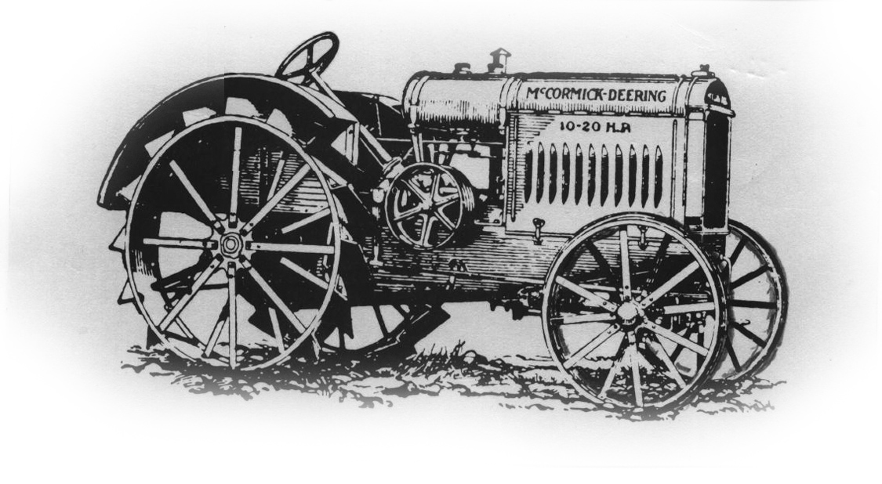Dad’s 10 / 20 McCormick Dearing
My dad had a tractor for as long as I can remember. The first one I remember was a10/20 McCormick Dearing with steel wheels and lugs. It seemed there were many of these tractors all around the country, and I never heard of an unhappy owner so I think it was a good tractor. Farmers though had a love affair with their horses and they could not believe the day would come when there would be no need for a workhorse down on the farm. The team worked great in the bush, getting around trees and certainly as long as they had a threshing machine the team of horses worked better picking up sheaves from the stooks than a tractor. The first change came when they cut the wood spokes on their wagon wheels down and put on steel rims and rubber tires. This made the wagons much lower and better to load hay or pitch grain sheaves onto. The rubber tires also made the loads much easier for the horses to draw, but it took great courage to finally cut the wagon tongue short and hitch the tractor to it.
The Tornado - In The 30’s

It was in the mid 1930’s that I witnessed the awesome and destructive power of my first ever tornado. We had no early warning of it as at that time the battery powered radio was used reverently for little else then the evening news.
The day dawned much like any other summer’s day in the thirties, hot and dry. My grandparents who lived in one part of the house had asked dad to drive them to Woodstock to visit with my grandma’s sister, my Aunt Miami. My mom was going to stay home with we four kids. It was a wise decision I would think as dad and mom along with four kids and my two grandparents would make a crowd.

In the early afternoon the sky to the northwest started to darken up. Soon we heard long rolling thunder amid flashes of lightning. I remember standing on the sidewalk with mom and my sisters watching black rolling clouds approaching from the north west. As the weather had been hot day and night nearly all the windows in the old brick house were open. When a storm approached the first thing you had to do was rush around to every room in the house and close all the windows.
My mom ushered us into the safety of the house and then ran up the staircase to shut all the windows throughout the house. This gave me a good chance to get back outside to watch the action. I was fascinated at that time by a good thunder storm as I still am today. I stood on the veranda hugging the post next to the steps. I had little fear. God was putting on this great show just for me. The rain poured down and the wind roared as it picked up debris and tree branches and hurled them through the air. What a show. I was simply thrilled from head to toe until my mother grabbed me by the shirt collar and literally tossed me into the kitchen.

I am sure by now my mom expected it was more then just the usual summer thunderstorm so she probably expected the coming of a tornado. Mom knew the old back kitchen built onto the house was not the safest place for us to stay, so she herded us into the front hall where we all sat on the lower steps.
Soon we heard a terrible banging coming from the dining room. After a second and third and fourth bang we all left our sheltered spot and ventured close behind my mom into the dining room to find out what was making the noise. When we looked out the dining room window onto the front veranda there was Billy our huge old billy goat who had been on a chain pasturing in the laneway. We kids were afraid of him as he always was mean tempered and ready to charge us if we came close. He was now terrified by the storm and wanted inside. He banged his head on the front door as only a billy goat can do. Mom knew he would break the door down and come in, if she could not get him to go away.

There was a large pot of very hot water on the back end of the kitchen stove. Mom carried the hot water to the dining room door and opened it and threw it on poor old Billy’s head. He dashed off the veranda shaking his head and we didn’t see him again until after the storm.
A loud crash came from the back kitchen area and we could feel a cool draft flowing into the house. It seemed to be coming from the woodshed door off the kitchen. Mom opened the woodshed door and found that the old apple tree which had stood near the rear of the back kitchen had blown down and the top of it came through the woodshed door. Of course I was excited and not a wee bit unhappy, I would not have missed all this for the world.
Now with the tree in the woodshed mom took us back to the front hall steps. It grew dark and the wind howled while the house shook. Then suddenly it was over.

Going out the kitchen door onto the veranda, I was shocked to see the roof of our driving shed lying on the sidewalk which extended from the veranda steps. The north east end of the barn roof had just disappeared. Everywhere I looked trees were uprooted and damaged. Once a row of tall spruce trees lined the south side of the laneway and maples on the other. All of the spruce were now downed and only a tall lonely pine tree survived. It still stands on the old farm to this day. The maples were very badly damaged. Our once great orchard which my grandpa had been so proud of had been hit hard. Over half the apple trees were uprooted.

Meanwhile dad and my grandparents were driving home from Woodstock. Apparently along the path of the tornado. They were wondering just what they would find when they arrived home. They saw much destruction along the way, barns flattened and houses destroyed, trees uprooted or with broken limbs. When they finally arrived home I think they were actually relieved to find the barn and house still standing. I remember all the neighbours turned up the next day to cut up the downed trees. My dad and grandpa went to the bush and cut a number of straight long poles and flattened the one side to be used on the roof of the driving shed. I think they salvaged most of the sheeting from the old roof on the lawn. I can still hear the pounding of the many hammers on nails as the neighbours worked diligently side by side on the roof. Soon it was done and time for the shingles to go on. The wonderful aroma of the new cedar shingles filled the air. I know all the neighbours came and worked together for free. That’s the way it was, the way we were. Such tragedies always brought out the best in everyone in the community. It takes years to recover from the damage done to trees from a tornado so it is best to go right out and plant a number of trees. Someone down the road will enjoy them

The billy goat survived and was soon enjoying the pasture along the lane once more. The many huge flat top stumps left from the trees that were cut down along the lane were his domain. He stood on top of the stump and reared and shook his angry head and challenged anyone who dared to come near.

A New Furry Friend

Farm boys soon earned the job of “Getting the Cows” I was very small when I was first told to Go... Get the Cows and the cows were very big. The odd one would challenge a small boy alone, so a good dog was a real help. I had Toby a wonderful cattle dog and a good friend. He was like most farm dogs at that time, tan and black with a splash of white on his face and throat. These dogs were referred to as farm dogs and they were everywhere. When they first arrived here in Canada from England and Scotland they were not recognized as a breed. They were not at all like today’s border collies, but were a much heavier and a more muscular dog. They were very protective of children and live stock and also very territorial. As yet there was no dog food, as we know it today so along with skim milk at milking time they were fed table scraps, stale and left over food. They caught the odd rabbit and hunted for mice, to complete their diet.
These dogs proved to be an ideal farm dog, staying happy and healthy. For some reason they were a popular dog up until the 1940’s to 60’s when they started to disappear.
One evening when Toby and I went to the field for the cows we met the most beautiful black cat in the lane. She wasn’t actually that big, but square set with short legs and large paws and green eyes. I think what I remember most was her luxurious coat of short coal black hair. She was plump and healthy and very friendly. We made friends right away. Perhaps she had wandered too far and got lost and now needed a home. We went on to get the cows and the cat followed me closely, then back to the barn together where she seemed to fit in right away. She got along well with the dog and all the other cats. I named her Tiny I think mostly because of her short legs. She spent much of her time hunting mice around the buildings and afar in the fields, the kind of cat a farmer really needs to keep his buildings free of mice. We called them “mousers.” Thus she earned her keep and always remained in very good condition, and sadly this in the end was what got her killed.
In early spring my mother got her usual flock of little day old chicks. There is nothing so beautiful as baby chicks - just a ball of warmth and fluff, totally innocent and unafraid, they seem to be born without fear. We all know chickens spook, but that is something they learn later. At first they were put in a Colony house, with a brooder stove in the centre. A brooder is a kind of pot-bellied stove with a steel hover fitted over top of it to keep the heat down on the floor. The first ones I remember were coal fired, and had to be watched very closely as it was easy to get the colony house too hot or let it get too cold. A huge thermometer hung on twine from a nail in the rafter to just a few inches off the floor next to the hover. The temperature down there was supposed to be kept over 80 degrees. The little chicks would settle into a ring around the hover area to sleep. If it got a bit too warm they crowded out from the circle and if it got cool they crowded in. Ha! Life seemed so simple to a baby chick. You dashed out from the heated area to get a drink of cool water from the water fountain, then grabbed a free meal from the hopper, took a quickie poop and dashed back under the hover area again to keep warm.
When they grew too big for the colony house we put them in what they called shelters in the field. These were actually just roosts on wire with a v roof on top. The droppings fell through the wire and collected below. Every so many weeks you had to tip the shelter over and fork the droppings into the manure spreader and spread it out on the pasture field. At first you enclosed the area where the shelters were with chicken wire held up by wooden or iron stakes, which were driven in the ground. After a few days when the chickens got use to calling the shelter home, you could raise the chicken wire giving the chickens freedom to run a bit farther afield from home. For a while you had to watch to see that they all returned to the shelter at night. I can see my mom out there now with one hand on either side of her apron shooing chickens in under the wire fence, so they would go into the shelters for the night. Once they were all in you shut the doors on either end of the shelter. This was a nightly job; one mom usually did by herself.
She did however let me carry water several times a day out to the fields for her chickens. To this day I always say I got my long arms from the thousands of pails of water I carried to those darn chickens!
We began to find dead chickens at the shelters almost every morning. Something was killing our chickens. After some thought my grandfather said, “ It must be that fat cat Tiny as all the other cats are lean.”
Tiny must have felt that something was not just right as she kept her distance when my Grandfather and my dad tried to catch her. Grandpa asked help from my sisters and me but we declined, as we loved that cat. But in the end they caught her and she was killed against the barn wall, amid the wails of us children. Tiny was such a loving and beautiful animal, a pitiful ending for such a good and loving cat. Needless to say, the killing continued, and in the end they found out it was skunks visiting the shelters during the night, and pulling the chicken out through the wood slats in the doors. I have never forgotten this ill ending, for such a loving and beautiful, hard working cat.
Rabbits
A distant cousin gave me two white rabbits. They made great pets but it was some time before I would trust Toby alone with my rabbits. I had often seen him chase down and catch many jackrabbits and cottontails and shake them senseless by the scruff of the neck and then devour them with great gusto. To him I felt all rabbits white or not, were food.
For meat farm dogs were expected to catch their own. Most dogs lived on table scraps plus bread and milk. Needless to say many dogs were always hungry and suffered from maltreatment and malnutrition. Toby though was breed apart from many dogs and was a plump and loving dog, with a luxurious coat of hair. He did have his pride, so he would have nothing to do with my pet white rabbits and they grew very bold and often nipped him on the heels. After he got use to the rabbits, and the rabbits got use to running free. I no longer locked them in at night. So as rabbits, they were free to do, whatever it is that rabbits do, when free to do as rabbits do. But like all rabbits, come morning, you should find them home asleep ... exhausted from doing whatever it is that rabbits do.
Toby had this special spot where he liked to spend his time sleeping at night, which was in front of the door of the little shed where my dad stored his barrels of gas and fuel oil. In the early morning the sun would shine down on the door and reflect the heat and add to his comfort. I would look out of my bedroom window first thing in the morning and see my two white rabbits snuggled up against Toby, taking in his warmth over night and then the warmth from the early morning sun. The rabbits looked for all the world, at peace and safe, comfortable and happy. But the minute Toby heard some one up in the house he was out of there, as he well knew, no self respecting farm dog got caught in bed.... sleeping with rabbits. The rabbits eventually disappeared but I am sure Toby had nothing to do with it. Secretly I think he grew to enjoy them.
The Orchard
Our orchard as I remember it had many large old and over-grown apple trees. These were trees that really looked like apple trees. By that I mean trees with large trunks and low spreading limbs, which invited children to climb and play. These strong limbs were also just right for swings of all sizes. As a small child I spent many hours lazily dreaming while sitting on a swing under the shady old apple tree. My grandfather had at one time shipped many wooden barrels of apples to England from these trees. Unfortunately he did not understand how to manage an apple orchard very well and most of the trees were non-productive. Grandpa was a true farmer and he liked livestock and field crops. While he did enjoy his garden with a patch of rhubarb he was not interested in growing apples or other fruit.
Every spring I would anxiously a-wait for the blossoms to appear. As a child I looked upon this with wonder and delight. There in our orchard for a number of days each spring were ever-blooming clouds of blossoms from one end of the orchard to the other. Robins sang cheerfully as they made their nest or fed their young amid the great bundles of blossoms. Fragrant scents drifted down to us under the trees. We walked under the white blossoms and their many shades of pink, which in the distance drifted off into a soft purple hue. The drone of busy bees and happy song of birds filled the air and made all this seem, … a promise for a fruitful year.
For some reason most or the trees never bore fruit. However there were always all the apples we needed for ourselves. Spies for pies, harvest apples for applesauce and moms great apple pudding, Snows for early eating and Thomas Sweets and Russets, which kept well all winter. In the mid summer there was a wonderful eating apple we called Yellow Transparent and in the late summer a red apple called St Laurence. Almost every farm in our area started out with an orchard, which over the years grew old and” slowly died off.
“Tramps of the 30’s or Someone’s Son
During the thirties there were a lot of people without jobs- many boys in their teens and young men in their twenties and even husbands left home so there was one less mouth to feed. The only way a woman could get what one might call welfare today, was if there were no adult males living in the house... so many sons and husbands in great despair left home so the family or wife and kids could get a government check to keep them from starving. This government regulation broke up many families, and put so many men out on the road to nowhere. It only added to the country’s despair, as there were no jobs to be had anywhere.
These young men and others not so young were put out on the road, and this perhaps brought out the worst in some of them. True there were some that were not to be trusted, some even dangerous, but for the most they were just some one’s son or husband that had no other choice. There were no jobs and no such thing as Unemployment Insurance at that time for them. When one of these poor chaps came down the road and the men were in the field or away, the women, alone in the house with children were afraid to open the doors to them. We called them tramps. Many were desperately, hungry and had no food, no money and no place to sleep at night. Most people were afraid so locked their doors and pretended not to be home when a stranger came a-knocking… In cold weather some would steal into your barn late at night to sleep near the livestock for warmth. Unfortunately nearly all men at that time smoked, and they liked to smoke just before they slept so it was thought that many barn fires were caused by these so called tramps.
One evening in mid summer as we were doing our evening chores, a man (a tramp) walked in the lane from the road and asked if we would give him supper or some food. He didn’t look like the average tramp. He looked like some one’s son, and we felt sorry for him. That didn’t mean a free meal as most people had trouble just feeding their own family. My dad said if he cleaned out the horse stable while we were milking the cows he could have supper and even stay the night with us if he wished. Our horse stable was about six single horse stalls long, but only four were in use.
In the summer the stable’s work often got left while men worked in the fields so there was a nice pile of manure in each stall. My grandfather got a kick out of the way this guy went about cleaning out the stable. It was easy to see he was not a farm hand to start with as he started at the door and worked back to the far end of the stable. To clean out horse manure (buns) most farmers used a special home made tool. One was called a push board and the other a huge rake with wood peg-like teeth. Both were about 16 inches wide and 6 inches high, to which was fastened a long wood pole handle. I don’t ever remember seeing these tools sold in a store, but many of the neighbour farmers also had them so I expect they were home made. You sort of raked the horse buns from the straw then pushed them into a pile and lifted them with a fork into a wheelbarrow. But a farm hand would never push the manure away from the front door and then load it into a wheelbarrow and carry it back towards the door out onto the manure pile. You always cleaned stables from the far end and worked towards the door. It just made sense.
Mom saw that the young man had enough to eat and after supper he noticed mom’s piano in the dining room. He asked if it would be OK if he played it. This was the first time I ever saw a man play a piano. Men played mouth organs, guitars and the violin, but few played the piano. I still remember the way he played that piano. He made it rock! Later we all sat around listening to the radio for a while and then the evening news. It was getting late and we were soon going to be ready for bed. The man got up and walked out the kitchen door. It seemed a natural thing for him to do as we thought he went outside to relieve himself before retiring. At that time we didn’t have inside plumbing so we didn’t think anything of it.
But we got anxious as time passed and he never came back in. Our real concern was that we hoped he had not gone to the barn to spend the night as he smoked and we didn’t want him smoking in the barn. We had no hydro or electric power at that time, so my dad lit a lantern and he and I went off to the barn to search. Now my Grandparents lived in one half of the big farm home, well not exactly half, actually a bedroom, kitchen and the front parlour. They used the front hall and door to come and go.
I remember, walking close to my dad who was carrying the lantern and I was scared to death that we might have to confront this young man and I was aware my dad had never fully recovered from polio, and I was not very big to be of great help if things didn’t go well. At the foot of the stairway to the upstairs of the barn we looked up and suddenly saw a dark movement. Dad raised the lantern, and to my relief it was grandpa. Grandpa was a small English man about 5 foot 8 or 9 in. going on six foot six. He never backed down from anything and no matter what was done, cleaning stables, cutting wood or stooking grain; he always had to be the best man, after all he WAS English.
He often demonstrated how he could take a dry Canadian thistle and crush it in his bare hands, as his hands were so callused from hard work from using hand tools the thistles would not penetrate them. I have seen him do this many times. So there he was in the dark at the head of the staircase going into the up stairs of the barn to look for the tramp, all alone. I have often thought ... how brave he was for a small man and so very plucky, but then again maybe it was not really such a smart idea to go there in the dark alone. We never saw the young man again. I often wondered what happened to him. Somehow I felt he was OK. I wished him well as I am sure he was just someone’s son.
A Wondrous Gift
Do you believe that there are times in life, when you may witness something, you can’t explain to others something so pure, so wondrous that it will stay with you all the years of your life? In your heart you have this strange feeling that just for the moment or for a few minutes God granted you a gift, of a wondrous vision of beauty that would be yours to keep for as long as you live. When I was perhaps 10 or 12 years old, I was awakened in the night because of the brilliant light shining in the bedroom window. Looking out the second story window of the old farm house into the little field between the house and the road I saw the most beautiful shafts of moonbeams coming down from all sides between the rows of spruce trees, which edged in the little field. The moonbeams seemed to be setting a stage for the perfect central scene... Then, to the orchard side beneath the spruce I saw two fawns emerge very slowly and cautiously into the shafts of moonbeams. It was as if the beauty of that wondrous light that surrounded them enchanted them too. Soon they felt safe and they began to dance, to jump and run amid the moonbeams. How can I describe it to you? It was heavenly. I know I witnessed something special that night. I tried to tell my dad and mom about it in the morning, but I know they felt it was just a kid’s dream, but I knew it was for real.
Cold Winters and Cutting Wood In The 30’s
Winters in the thirties and forties were quite another thing, it always seemed that Christmas came almost half way into winter as the snow came down so early and stayed so late, until spring finally arrived. There were huge banks of snow piled up everywhere around the buildings. Only the tops of the cedar fence posts projected out of the snowy fence lines, while most of the fence itself was hidden below in the snow. We used Fahrenheit to tell the temperature in those days and for weeks on end the temperature would drop to minus 35 or 37 below. This today would read well over minus 50 C below.
I remember how happy my dad was one day when he came home to tell us the good news. He had won the contract to supply the local school with a large number of cords of wood for the school furnace the following winter. This meant a great deal to help us out with our farm income. A cord of wood could be cut in lengths of, one foot, two feet or four feet long, but when it is piled to measure it should measure four feet high and four feet wide and eight feet long, this is one cord or 128 cubic ft. Most school had wood furnaces that burnt wood cut two ft. long. The wood would be split open with an axe and steel wedges, and then piled with great care to dry all summer. Late the next fall it would be taken to the school and piled in cords measurement, some in the school basement and the rest behind the school. I always loved the smell of dried firewood in the basement.
That winter my dad hired a young man to help him do barn chores in the early morning and then cut wood for the rest of the day. But when the temperature went down to minus 36 F he thought it was too cold to go to the bush to cut wood. The young man said,
“Well that’s all right but I have to get paid just the same or I will need to find another job,”
My dad told him,
“Well if you have to be paid, then we have to cut wood,” I was very young not more then six or seven but I clearly remember seeing them off to the bush. They donned their bush clothes in the horse stable. There, great heavy winter overcoats hung on wood pegs. They didn’t have the kind of winter clothing we have today. These very heavy felt winter overcoats made of pressed wool were donned over jackets and sweaters. Under it all was their heavy wool winter underwear; two pair of wool socks in rubber boots, which were standard winter wear for farmers.
The last thing they did was to cut holes in burlap sacks to put over their heads to keep their faces from freezing while walking from the barn to the bush. They found that once they got deep into the bush and out of the wind they didn’t seem to feel the cold as long as they worked. So as the hired man had to work hard to stay warm, my dad got a lot of wood cut that winter. One evening I remember they brought up a couple of beautiful pheasants that were frozen solid. It was a cruel winter for nature and during those cold winters in the thirties most of the pheasants and deer died from the cold and too much snow to reach feed.
Winter and Car Care, Roads and Travel
When the first frost arrived car radiators were drained of their summer water and filled with a combination of alcohol and water. Then it was tested so it would withstand cold winter temperature as low as -35 to -40 degrees below F. For some reason it had to be checked constantly as it boiled over, evaporated or just plain disappeared. Soon after the last spring frost was passed everyone drained the car radiator and the car motor block with great care and re filled the car with water. They would try to save this radiator fluid for the next winter. Often it was poorly stored in dirty or open cans and by fall it was terrible looking stuff to put back in the radiator. It was nothing to see car radiators boiling over just because of poor radiator maintenance.
Most cars in the early thirties did not have a heater and a trip into town in the winter meant stamping your feet on the floor boards to try to keep them from freezing. Buffalo robes kept the upper part of our body warm in the back seat but your feet always froze. Eventually the old buffalo robes went out of style and car blankets became a big hit and everyone carried one on the back seat of your car winter and summer. All cars then were rear wheel driven and the tires were made of a very hard rubber, which were not good for winter driving. The hard rubber gave them poor traction, so a set of car chains for your rear wheel was an absolute necessity in the winter, as most roads; especially side roads had lots of snow on them.
When you got stuck and spun your wheels you would easily break a chain link, thus you must always carry some black wire and pliers in the car trunk to fix your chains. There is nothing more provoking than being all dressed up in your Sunday best and having to get out of the car and fix those darn car chains. It was a wet, cold, dirty job in the best of times. There were times when it would almost drive you crazy driving into town hearing those chains bang bang banging on the underside of the fenders, all the way to town and home again. Some times I thought my dad was much deafer then I was, as he didn’t seem to mind.
We were lucky we lived on a county road as perhaps once or twice a week a truck with a snowplough on it would eventually come and “Open the road.” News of the arrival of the snowplough travelled fast on our party line telephone.
“The plough is coming, the plough is coming,” and everyone would start to look for it. In some places the huge banks had to be hit several times before the plough could get through, and there were times of defeat and some roads just had to wait till spring before they got ploughed out.
The roads we enjoy travelling on today have been built up high over the years, allowing most of the winter snow to blow across them. The first roads more or less followed the lay of the land and the snow drifted in from the fence line. The small snow ploughs at that time just shoved the snow aside making a pathway down the centre of the road. Every time it was ploughed out it would blow back in higher from the bank it threw up. Today we have high roads and also the huge ploughs hit the snow and throw it far back into the ditch.
One winter we had been snowed in for nearly two weeks. Dad had made several cross-country trips to the village store for basic groceries, and tobacco. The mail was being delivered from farm to farm, so all we had to do was walk through the fields to the neighbours when they called us on the phone to tell us we had mail. Actually we were not badly off.
After a week or more at home on the farm and the plough was still “Broke Down” we were all getting cabin fever and were sadly in need of an outing. As an only brother stuck at home with three sisters it was driving me nuts!
Our great neighbours Ed and Joy Smith had asked us to come for supper if the roads were open. All that day we looked up and down the road for a plough, but it never came. By night we kids were greatly disappointed to say the least. When dad came in from the barn after chores he said,
“Get dressed, and dress warm because I’m going to hook up the bob sleighs and we will go to visit the Smiths.” I am happy we had that bob sleigh trip, as I have never forgotten it. There were many great banks of snow across the road, from bank to bank. They called these up and down banks pitch banks or pitch holes. The horses foundered in the bank of snow and then pitched forth into the hole beyond. All the time the two bobs on the bob sleighs kind of cushion or ride out, over the rough ride. It was sort of like riding a slow but violent roller coaster, so a real fun and exciting thing to do. It was fun, and all we had to do was hang on. It was music to my ears to hear my sisters laughing yelling and hanging on for dear life.
Ed and Joy and son Ralph, lived about two or three miles away down a side road, I don’t think Ron was born yet. They knew we were coming, and it was comforting for us to see the lamplight glowing in the kitchen as we arrived. I remember Ed was on the way out the door as we arrived to help dad unhitch the team and take them to the barn to be stabled. Stabling your neighbour’s team of horses with great care was a part of common courtesy when visitors came for the evening.
Most people parked their cars at the end of their lane at the road, neatly piling the snow high on either side with scoop shovels. It seemed the drivers on the snowploughs took great pride in seeing how much snow they could push into your entranceway each time they passed by your lane. It was hard work shovelling. Snow blowers had not been invented yet. Those that lived on the side roads as we called them, would often park their cars some where near a county road or highway so they could get out, and in to town to shop when the main road was open. Many winters we were snow bound for days waiting on a snowplough, as it would be “broke down.” Some winters it seemed the plough was always “broke down”
The local village stores were kept well stocked with all the main things people needed. These stores were our lifelines when things got bad. Most country general stores were also a post office. The store served as a community centre, a cross road for news in the community. It was a gathering place for winter weary farmers where smiles were fast and time was slow. No one was expected to come home from the local store with just groceries; they also brought home the latest news.
Mail men, were a breed apart from those who serve us today. In the winter they delivered by horse and cutter when there was too much snow for cars, and in their honour we invented the old saying, “Neither rain hail sleet nor snow held up the mail.” When the horse and cutter could not get through, the mail still did as he came on foot and delivered it to a farm close to you where you could pick it up. Our Mailman was Bill Pelling from Fullarton. They don’t make mail men like him anymore.

Going To School
In spite of the cold and snow most children walked to school. We didn’t have super light and warm clothing like the kids have today. Often mothers made wool mitts out of the tops of worn out men’s socks. My mom would skilfully use the top of the sock for the wrist and then with her sewing machine round out the hand and sew in a thumb and presto a wool mitt. Two mitts, one over the other would keep your hands warm. Our winter coats would be made of a very heavy felt material, which was made of pressed wool. It was heavy and actually weighed us down. All sweaters of course were made of wool and were a must to wear during the winter.. Often one wore a jacket over a sweater, over a sweater. It was often said,
“ It is cold out, so bundle up.” and bundle up we did, because we had to.
Everyone wore a long, long scarf and it was often the most colourful thing we owned. There was a certain way our mothers taught us to put them on. You off centre it on your forehead to start then throw the one end over your shoulder and around your neck. Then do the same with the other end. Then bring the one end up across your chin almost covering your mouth. Now do the same with the other end. Take each end now around your neck again ending up to one side. There was a special huge safety pin used to hold the scarf snug. You could then pull the top down low on your forehead and the bottom up over your mouth. All kids learned to do this with ease while jabbering away. In very cold weather it saved you from frostbite. But even bundled up in all those heavy clothes we would soon get cold if we just stood around too long, so it was important to always keep on the move.
For school nearly every boy wore tall or short laced up rubber boots with felt insoles on the bottom as otherwise they were very cold. Two pairs of wool socks were needed to keep your feet warm if you were going to be outside for long. If we got cold we often said, “Let’s run, I’m getting cold.” The run would increase our blood flow and increase our body heat, and for a wee while we could forget the cold...Such was life, we accepted it, and that was the way we were.
We would arrive at school with rosy cheeks and frost-bitten ears and nose and hands tingling from the cold. We gathered on the open furnace grate taking in the heat to warm our frozen body parts and dry our mitts and clothes. Soon we forgot about the cold outside until it was time to go home. School in those days began at 9:A.M. with a fifteen min. recess at 10.30 A.M. and 3.00 P.M. and a noon hour lunch break of one hour from twelve to one. The children were encouraged to play outside, except for the coldest days. I guess with fifty some kids playing under one roof it was almost necessary to occasionally put the kids outside for the teacher’s sanity. The small children were out of school at 3:P.M. but the older ones stayed until 4:P.M..... everyday. Nowadays we see busloads of High school students in the middle of the afternoon going home or to a sport event and the teachers complain they are over worked and underpaid.
“My School Days”
In 1934 I started public school. I can still remember that morning. It was a bright and sunny day and Bill and Stanley Morrison came in the lane way to meet me. Bill was one of the older boys in school and he looked out for me during noon hour and recesses and saw that nothing bad ever happened to me. He remains a life long friend. Things were very rough and tumble in schools in those days and kids were not only teased but hurt. Teachers just could not get their work done and know all that was going on. The huge red brick school that I went to at Motherwell was built in 1916 and was the envy of every other school section in the township. It was the third and last school built in the Motherwell area.
The first school was built in 1847 and made of logs 20 ft by 22 ft. and was built near the Thames River at the foot of the west bank. In 1864 a new white brick school was built well down the road west of the river and Motherwell village. It was a beautiful school but after over fifty years of service it was replaced in 1916 with the huge red brick school that I went to.
The first thing I would notice as I arrived at school would be the two cement staircases going up on either side to the two huge front doors. High above the left door was the word BOYS and high over the right door was the word GIRLS, and God forbid any guy or girl that ever took a short cut and entered the wrong door. Make no mistake, it was sin, a great sin and there was no tolerance at that time for any kind of unisex ideas. Boys were boys and girls were girls and as far as public school went there was no encouragement for close encounters. That would have to wait. (I’m the fourth guy in the second row from the R behind the little blond.)
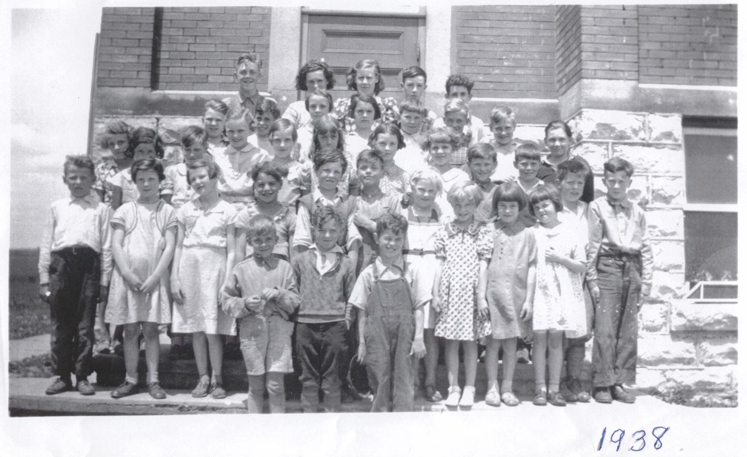
Pupils At The Motherwell Public School 1938
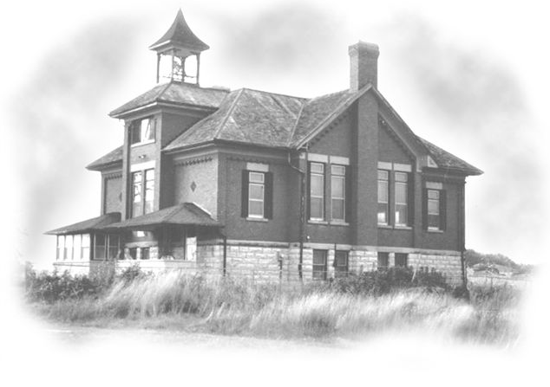
Motherwell Public School In 2005
Once in a while when for some reason we were going to be late for school or if it was raining, my mom would drive us in the old 1929 model A Ford. If there were any kids on the way walking, mom would pick them up to so they too would not be late or get wet. I remember how the kids would run away from the rear end of the car when they got out yelling.
“Run she is going to take off.” It was a bit embarrassing at the time, but I use to love telling mom’s grandchildren about this many years later. Mom would deny it, but it was true, she would gas up the motor fearing it might stall, and then she let out the clutch and spin the tires. Dirt and gravel would shoot out from behind the car. If you didn’t get out of the way in time you got showered with dirt or gravel.
The school had a huge basement with two big wood furnaces, one on either side. Two-foot long blocks of firewood were pilled across the north end of the basement from wall to wall and from the floor to the ceiling. There were two lunchrooms at the front between the two stairwells, one for boys and one for girls. Each had two rows of small wood lockers with wire fly screen fronts attached onto the wall. Two long benches were against the other wall with two rows of coat hooks above. There was a glazed over window in each room facing the front of the school which didn’t let much sun light shine in. At that time it seems school was not supposed to be a cheerful bright or sunny place. Upstairs the desks were placed in rows one behind the other attached to the hardwood floor from front to back. The Primer class sat on the east side one behind the other, with the smallest child at the front. Then first class, second class, then Jr. Third and Sr. third, followed by Jr. forth and Sr. forth with fifth class sitting on the west side of the school. When I started school almost every seat was occupied as there were over fifty pupils attending.
My first teacher was, shall I say, “Of The Old School.” She was old-fashioned prim and very stern and she thought she had to rule by fear. A large leather strap was kept draped over the front of her desk as much as to say,
“Don’t you dare?” She never left her desk without her pointer in hand. She would walk, no strut up and down the aisles between the rows of desks, pointer in hand looking for an idle child. She expected you to work and pay no attention to her or to those around you while she was sneaking up on you from behind. You were not allowed to turn your head, to see where she might be and if you did you got crack over the knuckles or on the head or ear with the pointer. I don’t think there was a single pupil, who escaped her. Sooner or later we all had an appointment with her pointer.
My second year of school was so much different. We had a new teacher, a Miss Smith and I was rather amazed to find out we no longer had to fear the teacher. Miss Smith was an excellent teacher and we could actually relax, learn and enjoy school. Our Miss Smith is still living today as I write this and she is kindly thought of by all of the pupils she taught. I would also like to kindly mention my last teacher Miss McMillan with whom I still keep in contact. After I lost my hearing to scarlet fever she gave me special attention. Perhaps at the time I didn’t know how to appreciate it, but I do today.
The upstairs was one great big room with a platform going across the front from wall to wall and behind it was a black board all the way across. On both sides was a row of large tall windows. At the back there was a teacher’s room and a library room and two staircases, one for the boys and one for the girls.
The teacher’s desk sat dead front centre on the platform, with an eagle eye view of the whole room.
I always liked the smell of our schoolhouse. I am not sure just what it was? Paper and books and school supplies? We used a slate board and a slate pencil for most of our general schoolwork. But I remember how much I loved a brand new scribbler or workbook as we called them. There were two kinds. The scribbler had soft grey paper, which was used for arithmetic, and another kind had smooth white paper, which was used for subjects like geography and literature. The wood desk we sat in was not intended to be too comfortable, but even then a few guys managed to steal a few winks of sleep. Our desktops each had a groove across the front for a pen or pencil. On the right side was what was called an ink well, a small glass chamber sunk into the wood and a flip up steel lid to let you into the ink well. The small kids started out with just pencils, and later on learned how to use a pen with a single nib. These pens made the kind of writing you see on all those scrolls in old books. It can be absolutely beautiful. Most kids had ink spills sooner or later on their clothes or desk and almost everyone had ink stained fingers Sooner or later you would have to grab a blotter and soak up that blot of ink you made. With kids it was inevitable. Later on after you mastered the pen and nib you started to use the fountain pen, but nothing writes like those old fashioned pens with nibs if you master the art and know how to do it. It was still years later that the first ball pens came out. It was then that truly good penmanship went out the window.
There was little time taken from school hours for sport activities, and teachers never took school time to upgrade themselves, and at that time I never heard of a parent teacher’s night. The teacher worked through the trustees and vice versa. School for both pupil and teacher was serious business, and neither was ever allowed to forget it. Few pupils learned to like it and most longed for the day when they could escape. It was largely about an education driven by fear of the teacher and the school board or powers that be, with little thought given to make it entertaining or enjoyable. Still most teachers did their very best, as they too, were caught in a strict system and bore a heavy workload
I found that even with such a demanding workload they showed individual attention to those in need. When I started school, we had one teacher teaching eight grades or classes. I never heard of a teacher striking in all the years I was in school. Not only did teachers teach you while in school, but also they were expected to be still in charge of you on the way home from school until you reached home. In the summer many of the boys got caught swimming or fishing in the Thames River on the way home from school. Without a written note from your parents this was a no no, and if the teacher caught you she would send you home. The next morning you might even get called to the front of her desk and asked to explain yourself. She left no doubts in the minds of all you had sinned.
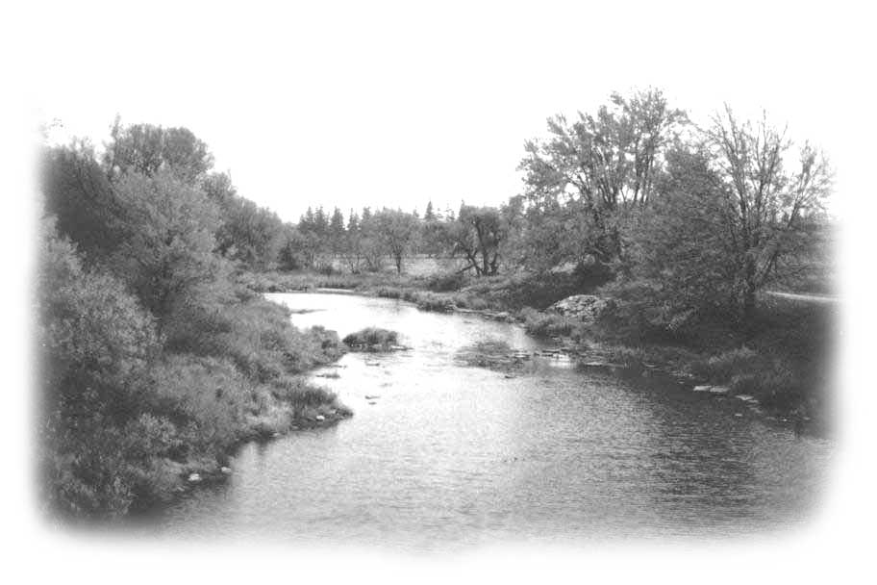
Once about a half dozen of we boys decided to go swimming in the Thames River south of the Motherwell Bridge and beyond the rapids. We were almost out of sight; except for a spot at the very west, end of the bridge and we were all frolicking in the water having a great time when some one shouts,
“There’s the teacher.” Six nude boys streak ashore, and dressed in great haste and made fast tracks for
The Thames River, Looking South
from the Motherwell Bridge
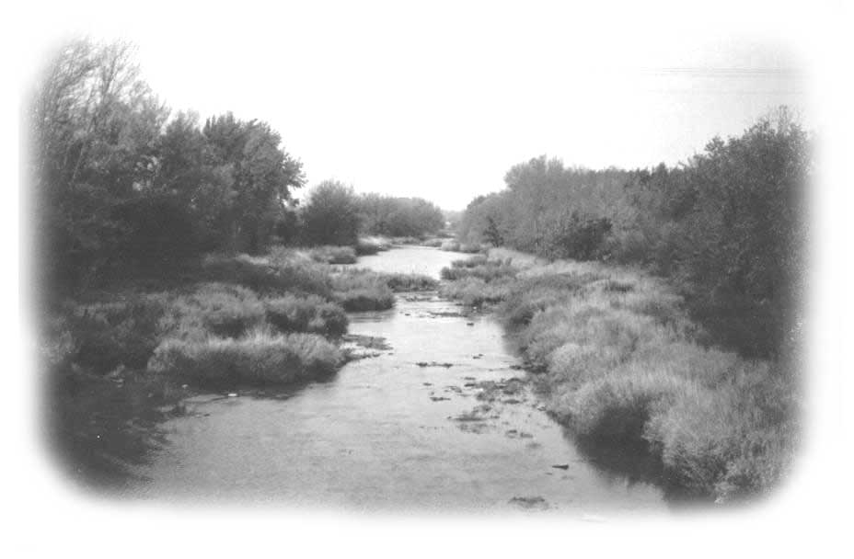
home. I bet the teacher still chuckled over that one for years, but as they say,
“Boys will be boys.”
Sometimes in the winter the teacher allowed us to take our sleighs or toboggan down to the riverbank on our noon hour to play. It was on such an occasion that I got a broken arm. I had a rather cumbersome hand-made sleigh, one that my dad had made to haul bags of feed to the barn from the road with when our lane was blocked with snow. I had just started down the hill when a faster toboggan rammed my sled and made it change course. There had been an old lime kiln dug into the hillside at one time many years ago and my sleigh dove over it and from there it was a more or less a shear drop onto the river ice.
Thames River, Looking North from the
Motherwell Bridge
Somehow I landed with my arm twisted behind me and I was in a lot of pain. The kids gathered round and sort of rolled me onto my sleigh and pulled me back up hill all the way back to the school. The teacher came down to the boy’s coatroom and tried to take a look at my arm. But it seems my arm had somehow jackknifed inside my leather jacket sleeve. And try as they might they could not get my arm out of the sleeve. My Aunt Maude in Detroit had given this jacket to me. It had been her son’s until he outgrew it and it was now my prized possession, and I could see it was in great danger.
The teacher took a large pair of shears and began cutting up the sleeves and I bellowed and she thought I was in great pain. My pain was not so much from my broken arm as it was from having my leather jacket sleeve cut up. But the teacher didn’t realize that until many years later. The arm was broken and Dr. Pridham and nurse Mrs. Churchill set it in his office in Mitchell. I still bear a scar on my left wrist from this accident.
It was a wonder there were not more serious accidents on that hill for as I said, Boys Will Be Boys, and all boys must have fun. Tony Gettler a neighbour boy had one of the best bobsleds in the community. It was a privilege to be invited for a ride on it. We would use the hill on the west side of the bridge when it was packed with snow. We would travel all the way from the top of the hill down past the store and far beyond. You steer a bobsled from the front bob, usually with your feet but Tony would lie face down on the bobsled with his hand on the front bobs to steer. Then perhaps four or five boys would sit on top of him from front to back. All with their feet locked up inside of the arms of the guy in front. Someone would be stationed at the foot of the hill to signal that all was clear, that is no cars or sleighs were in sight. Then with a good push off from behind down the hill we would fly sweeping across the bridge at a mighty speed and at times gliding far beyond the village store. What a ride?. What a rush? We knew now what a great thrill was and that we were brave and fearless. Again we would have a long walk back up the hill for yet another ride.

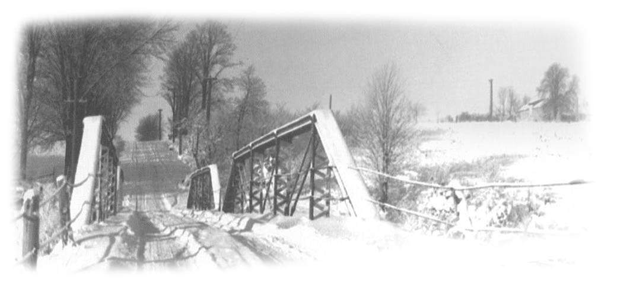
The Old Motherwell Bridge Looking West
Teachers were also expected to take an active place in the community, that is, they might teach a Sunday school class in the local church or sing in choir or even help with the Church Christmas Concert. To be sure we got much better mileage out of our teachers in those days, and fewer complaints. A teacher’s life was very much committed not only to the school children but to the community, but one might say a good teacher got a just reward in one respect. They won a lifetime of respect from the students they taught.
At school we learned many things besides our A B C’ s, so one might call it a lesson in culture. I’m not sure if that is what you would call it or not. Our community had been divided in 1925 when the United Church came into being. A small fifty percent of the community did not wish to join the United Church so they left and built a new but smaller church right next door to the school. So our community found itself split half United and half Presbyterian. This caused a bitter feud among the older generation. But the children in the school got along well together and they wondered what the fuss was all about. I expect the teachers we had at that time had a lot to do with this.
It showed us that with proper guidance … and when teachers or parents did not instil unkind thoughts, kids are able to sort things out and get along just fine. I myself never seemed to suffer because my family was English living in a very Scotch community, and while my parents went to the United Church many of my best friends were Presbyterians.
This third school survived until September 1967 when the students attended the new South Perth Centennial School on the Mitchell Road. The old school was sold to a Mr Jack Lancaster of St Marys for $4,700.00 plus $200.00 extra for the bell.
“A Lesson Learned ”
One day I came home from school with a very burning question for my dad. It was nearing Federal Election time and I was hearing pro’s and con’s on Liberals and Conservatives from kids in school and I wanted to know if we were Liberal or Conservative. It had to be one or the other, so I reasoned as everyone took a solid stand on these important issues. The way I looked at it was, our neighbours the Morrisons were Liberal and drove Ford cars and went to the Presbyterian Church. On the other hand the Browns were Conservatives, they drove Chev cars and went to the United Church.
It seemed everyone followed the family line generation after generation and his or her kids swore to do likewise. So it was only logical that we had to be something, but then my dad was different in many ways. For instance he loved cars and he had gone through several different kinds of cars all of them pretty old as he just could not afford a new one, but he loved his wheels. Right then he owned a Durant. He had proudly driven it home from Mitchell one day and my mom would not speak to him for weeks, as to mom a car was just something that got you from A to B and cost you money. But in answer to my question re- Liberals or Conservatives: Dad gave me the best piece of political advice I have ever received. Dad said,
“ We are not anything, so don’t marry yourself off to a political party, as money and power always corrupts people. So you must vote them in knowing, in time you will have to vote them out when they go corrupt.” I have found this to be 100 percent true. Yet most people still don’t seem to see the big picture as they refuse to see the writing on the wall. The government has gone corrupt, and its time for change. Just vote them in and expect to have to vote them out. Don’t marry them Show no mercy. ..Thanks Dad for the truth. It makes my political life much easier.

“ Motherwell Village,” by the Thames
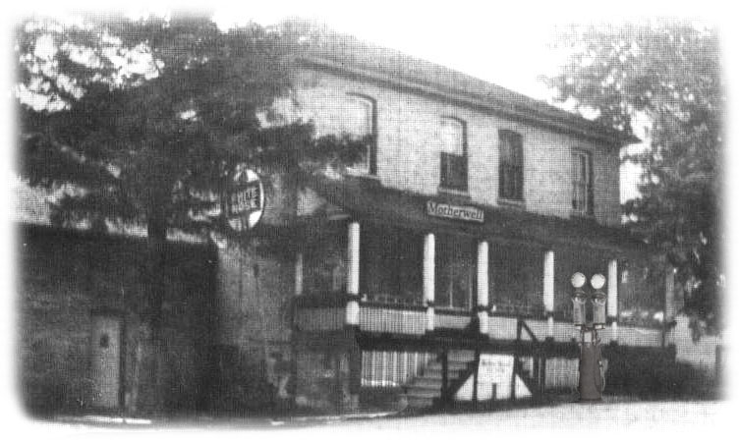

The Village Store at Motherwell
In the summer time I used to love the view of the Motherwell village as you came down the hill from the west. Great maple trees lined the road on both side forming a canopy over top. The west end of the steel bridge a commanding sight, above the Thames River below. There is something that seems just right, about an old steel bridge over a river that fits into a perfect pastoral picture with a village. The rumble of your car tires as you cross over the wooden planks disturbs the stillness and silence below. In mid- summer a blaze of multi-colour greeted you once you crossed the river. A cloud of coloured hollyhocks blazed the way of the south side ditch, from the bridge to the blacksmith shop. Bert Brown the village Blacksmith planted them there to hide a lesser view. Bert also had great lawns and many flower beds around his house and yard on the north side of the road. No one did more to make the village a pleasant place to live or visit than Bert Brown.
For many years during my childhood “The Village Store” was run by Ernie and Bessie Watson who were old school friends of my dad. It was there that all family and community and political problems got thrashed out in front of the counter. I like to think everyone benefited from the good old fashion pro and con and went home just a wee bit wiser, whether it was in the interest of the village, the township, the county, the province or country. Nothing was ever too complicated or difficult in those days that it could not be solved right there in the village store.

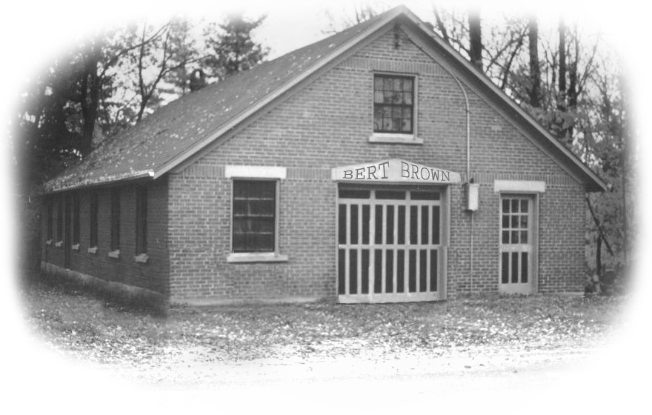
Bert Brown’s Blacksmith Shop - Motherwell Village

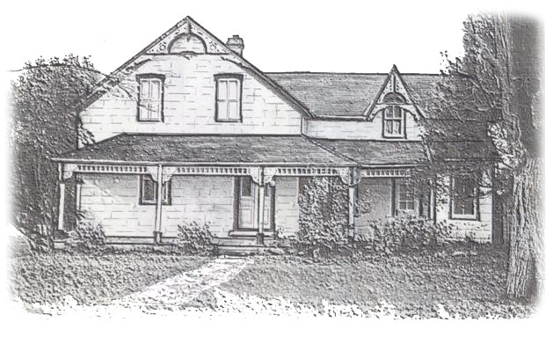
Bert Brown’s House In The Motherwell Village
To the west of the house towards the river Bert Brown had a large Old English garden which continued to bloom from early spring through to late fall. Great beds of tulips and daffodils and narcissus greeted the village each spring. Many kinds of perennials and bi-annuals which were strange to the rest of us bloomed all summer long into fall. Most farmers or farmer’s wives settled for the traditional oldies such fiddlehead ferns and peonies in the spring and phlox for the summer and perhaps a day lily. Most spectacular was the blaze of Bert’s hollyhocks and delphiniums

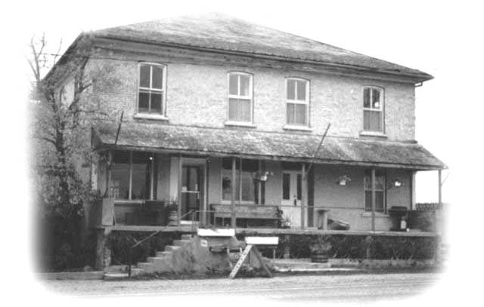
The Motherwell Store – in 2005
Once the active centre of the Motherwell community, “The Village Store” now stands vacant in 2005, abandoned to its fate. Warm memories flood to my mind of the place this store had in the lives of all who lived in the Motherwell community.
Perhaps we remember best the friendly jingle of the bell over the door as you entered. Or was it the welcomed heat as you came in out of the cold in the winter? Perhaps it was the smell of dry goods on shelves and counter such as only found in a country store. Here, there were always friendly smiles and pleasant conversation awaiting you The store was no doubt the heart of the community, the school the mind and the church the very soul. Put together, you have a community.
How does one put a value of our historic past which for a time served us so well? It was from this village store we received our daily needs and in many winters it proved to be our very life line as we would be snowed in for weeks.
It was in this blacksmith shop we had our horses shod and our plough points sharpened. It was here we had our broken machinery welded and wagon boxes made. It seems in the end we just walked away and let it fall in ruin, but has it not always been so. Every now and then I wander north along the river “Thames” and through the village “Motherwell” and sit a spell and think of those yester-years when all was well in Motherwell. Ah, old memories run deep.
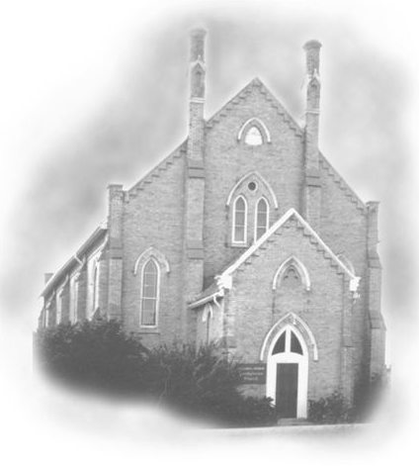
The Motherwell United Church (Mitchell Road)
Sundays
Sundays were, like life in slow motion. It was truly a day of rest. We got up a bit later and spent a little bit more time at the breakfast table. We planned the day yet there was no distraction from what Sunday was meant to be, a day when one shows thankfulness and respect to God for the blessings he bestowed upon us all week. There was no Sunday movies or shopping malls or even television as neither had been invented yet. If you didn’t make too much noise you might be allowed to play “Andy Andy Over” over the summer kitchen after church.
The church played a very important part in the lives of everyone in the community. You were expected to send your kids to Sunday School every Sunday and the parents were expected to turn up for the Church service, which followed. If you missed two or three Sundays in a row your standing in the community was at very low ebb. I didn’t mind Sunday School so much as our Superintendent George Urquart had a great voice and loved to sing. He gave us lots of hymns to sing, long ones with half a dozen verses. He never tired of the oldies like, “ Jesus loves me this I know ” “ The old rugged cross” “Jesus keep me near the cross” and of course “Onward Christian Soldiers” My first and best Sunday School teacher was Mrs. Leslie Brown a dear sweet little old lady who let me talk my head off to her in class. She learned first hand all about the rabbits that came to our orchard every night to eat the frozen apples left on the ground. Or how many deer were seen on our wheat field, and how many pheasants came to eat the frozen corn silage beside the silo. She learned a lot from me every Sunday.
After Sunday School came church and dad and mom would turn up in their Sunday best, dad wearing his old navy wedding suit and my mom like all the ladies covering her hair with a large brim hat. They would stand talking to neighbours before the service began. Eventually we all climbed the staircase to the upstairs part of the church and walked down the aisle one after the other in single file. Dad would be in the lead followed by mom, then my three sisters Laurine, Pearl and Jean and I would bravely bring up the rear. When dad came to our pew, which was mid way along the north side wall, he would turn around facing his family with his hand outstretched to the top of the seat. One by one we all slid in taking our places leaving mom next to dad and then Jean the youngest next to mom. Dad of course sat on the outside next to the aisle protecting his family from all within. Church seats in those old churches were never intended to be too comfortable. Maybe they were supposed to be a part of our redemption. The seats in our old church were pure torture cutting into the centre of the back. I am sure someone must have had a great sense of humour when he built them, then came out to watch us suffer every Sunday, year after year. .
Mr. Anthony was our minister for many of those early years in the thirties; he was a short, round, bald man with a paunch up front, and a voice that droned on and on. Sometimes it faded away entirely and just when you thought he was done, finished, left, he came back with vigour and added more hell fire and sin. At my tender age I didn’t understand much of what he said, but I had it figured we were all in very deep trouble. He loved to pray great long long prayers and the congregation loved it even more as a respite to rest their weary heads on the rear of the seat in front of them. Oh they didn’t just plop their heads down there right away. It was a gradual thing; their heads would slowly but surely sink until their heads rested on the back of the seat in front of them. I found all of this, of great interest and I wondering whose head would touch wood first; my money was on Harold McKay.
In front of us sat two brothers and two sisters, about my dad’s and mom’s age. They were great farmers and very good neighbours. Every Sunday the one brother had lots of razor cuts on his face and neck. He would tear off small pieces of newspaper and stick them on the cuts to stop the blood from flowing. Our first safety razors were anything but safe and our first blades were called Blue Gillette. If you had a bad complexion or were in great haste to shave you would take lots of flesh off your face with great ease and suffer great pain. As I was not getting much out of this hell fire and sin stuff, I would concentrate on the pieces of newspaper on my neighbour’s face and neck. I would lean forward and try to read his face. My dad chastened me when I got home; he said I should not try to read the funnies during the church service. I found it very much more entertaining than the hell fire and sin stuff. Long before the prayer was over some of the greatest guys I ever knew would be resting their heads on their arms on the back of the pew in front of them…sound asleep. While going to church was considered a must to maintain your social standing in the community, it also seemed our daily lives were lived in full view of the whole community. Thus a man was judged not by his wealth but by the straightness of his furrow and a women by her garden or her needle work.

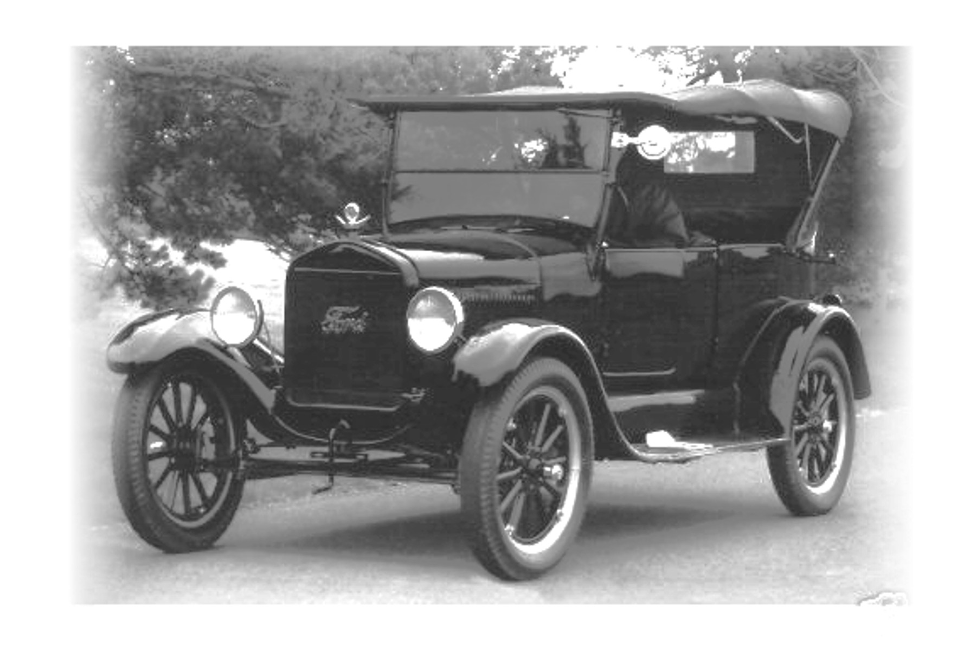

Horse and Buggy’s Cars and Radios
When I think of my dad and cars I remember how he loved to tell the story of his very first car. It seems he was able to talk his dad into buying a new model A Ford in 1925. My grandmother had two sisters living in Woodstock they liked to visit. My Grandparents would set out in the early morning with the horse and buggy to make this round trip from the farm at Motherwell to Woodstock and back. It was a very long and tiring trip of maybe over fifty miles one-way. They would arrive home very late in the evening exhausted from the day’s trip yet they still had chores to do. With this car they were able to drive down to Woodstock and back with more time to visit, yet home in good time to do the milking, and other night chores.

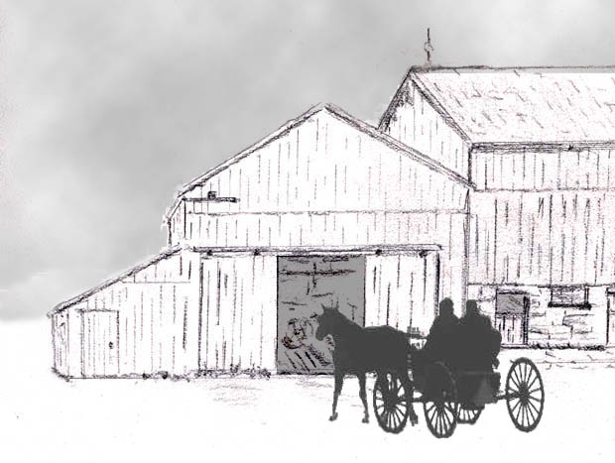
Getting Home After Dark
They marvelled at this new convenience, and how it was going to change their lifestyle forever. My grandfather himself never drove a car or a tractor in his lifetime. He left that to dad, besides he loved his horses. At this time my dad was courting my mother at Munroe some seven miles north of the farm. He asked my grandpa if he could take the car to see my mom. My Grandfather promptly said,
“ No, it has had enough for one day. Take the horse and buggy,” and with that he threw the buffalo robe over the hood of the car and said, “ Let it rest ”
Our first radio was a box twice as long as it was high; I would say it was ten inches high and twenty inches long. The front had several dials that lit up with wondrous lights of colour when it was turned on. It was a thing of great beauty and total mystery. We as children were not allowed to touch it. It sat on a small table in the northwest corner of the huge dining room. I have to admit I paid it a few sneak visits when everyone was out of the house. A few times I even turned it on to watch its magic lights light up. There was a large horn like speaker with a long cord attached to it. Dad would carry the speaker out to the kitchen every night when he came in from work after the evening chores. He would have to go into the dining room and turn on the radio. Then we all gathered around the horn in the kitchen and listened in fascination, as it was “Pure Magic.”
My grand parents lived in one part of our old farm home and each night after the news was over I would go in and tell my grandpa the latest world news hot from the radio. I soon found out that the more exciting the news was the happier my grandfather seemed to get. I loved my grandfather and I liked to see him happy so I poured it on. I would try to make it a bit more interesting for him. Grandpa came from England and he longed for news of home so I tried to help him out if there was a bad fire in London and 6 people died I would make it an even dozen. If there was a wind storm in Liverpool, and took out a block of houses I would have it take out 3 blocks of houses. I was getting along fine, or so I thought until my Grandfather started to ask my dad for more detail of these strange happenings. Oh boy! I was caught and they called it a lie, which made me very sad and I was asked to explain what was going on. Well I said I found out that I could make my grandpa real happy by telling him larger stories. Dad and Mom were really provoked with me and they explained that this was just like lying. I promised never to do this again not even to make my grandpa happy. I wondered if they would ever trust what I said again?
One cold winter day we had gone to St.Marys to shop. I decided to just sit in the car and wait on them to return. I remember that it was very cold and I soon wished I had gone with them somewhere inside where it was warm. But I sat in the back seat of the car stamping my feet to keep them warm and watched the few people walking on the street. We were parked mid way on the first block on the north side facing west. A door opened a short distance down the street and a man looked out and then looked up and down the street as if to see if all was clear. He re-entered and then directly backed out carrying one end of a table. The table had a heavy green throw draped over it, the kind a lot of people threw over their pianos in those days to keep the dust out. When the first man took a step backward, and down onto the sidewalk .........just for a moment the throw shifted and I could see two dangling arms and feet hanging down, from under the table. There was a man tied up under the table and that was why they had a throw on while they moved it. The two men loaded it onto a truck which was sitting there and drove off to the west over the bridge and out of sight. I have thought of this many times since and wondered just what was going on. When my folks came back from shopping I was all excited and tried to tell them what I had seen. They thought I was still telling wild stories like I had been telling my grandpa and so they would not believe me. This was a lesson for me and I could see that when people know you tell lies they wont believe you when you tell the truth ... a lesson learned.
My folks were English and the community of Motherwell was totally Scottish. When my grandfather arrived from England he was not actually welcomed into the community. Young people today tend to forget that this country was settled in block or areas, of nationalities. The Germans settled mostly to the north and east of the town of Mitchell. The English settled at Munro and Carlingford and the Scottish in the Fullarton and Motherwell and Staffa area and the Irish in the Dublin area west of Mitchell. This kind of block settlement went on all over the country. It was a good idea at the time as then they could help each other out best in their own language, while they gradually learned to speak English. In the early days a young man did not venture alone out of his own territory to parties or dances in another community, as he was not always welcome. If he did so he had to mind his manners and keep his mouth shut. Many a bloody fight got started over nothing other then you were out of your own territory and not wanted there.
It is truly wonderful that we survived all that, to arrive at where we are today with intermarriage of all people in all areas of the country. At that time it just didn’t seem possible it might ever happen Catholics and Protestant just never married without getting kicked out of the family-sad but oh so true.
For a few years in the late thirties my sisters and I were lucky as the neighbour’s daughter often got a ride to school in her Uncles Bill’s old truck. You will find this story hard to believe but I swear it is true. Our neighbours had a long laneway, which filled with snow so the uncle parked his truck at the road between two great stone gateposts. In those days when it was so cold, most cars or trucks were very hard to start first thing in the morning. The car or truck motors would just not turn over, as they were frozen stiff. This Uncle Bill would carry a sack of straw out to the road every morning and push it under the truck motor and light it on fire. There was a bit of bush between the neighbour and us. My sisters and I would be standing at the road, freezing, while waiting on our ride. All the time we were watching for the smoke, as then we knew Bill was heating up the truck motor and hopefully it would start and soon be on their way. Uncle Bill started his truck this way on many cold winter mornings for years. Now I don’t recommend this procedure for today’s cars or trucks, but it worked for him so please don’t knock it.
The thirties and early forties were desperately cold, which made life on the farm all the harder. What made matters worse was there was very little money to be made at farming. Fat hogs at over 200 pounds would dress out at maybe 170 pounds and at 28 cents a pound would earn you about $47.00 each. From this they would deduct the cost of shipping and handling, so you ended up with maybe $42.00. Little pigs eight weeks old would sell for about $5.00 or $6.00 each, and there were times you actually could not sell them at all. Eggs sold for about 28 to 30 cents a dozen for grade A large. They were packed into thirty dozen crates. You could not expect more than eight to nine dollars a crate after they were graded by hand. If you could sell a fat hen for a dollar it made your day, but that might mean you had to eat salted pork out of the barrel for supper. If you have never tasted salted pork out of the barrel then you have never lived, and if you have... you’re lucky to have lived to talk about it. Absolutely nothing tasted so vile as salted pork from a barrel. We ate it not because we liked it, but because our parents didn’t give us a choice.
While these prices will seem almost impossible for you to believe today, you also need to know that bread sold for ten cents a loaf, and a gallon of gas sold for twenty-eight cents. You could hire a man for one dollar a day or twenty-five dollars a month if you gave him room and board.
It was not an easy life being a hired man on a farm. He would be up at six AM to do barn chores and then after working all day in the fields he was expected to help milk cows by hand each night. That was room and board. It was in a sense as if he were one of the family and thus expected to work the same hours as everyone else. The difference was of course he got paid $1.00 a day. As for the family on the farm it seemed they got free board and were able to hang onto the farm. Sometimes we envied the hired man as he had few expenses and no bills to pay and we would see him in town on Saturday night blowing his money at the local bar. He would be back to work on Monday morning looking a bit the worse for wear. He would be broke and waiting for next weekend’s pay check to do up the town. Ah, such was life.
I remember my dad hiring a very young man. He was asking a dollar a day, but not room and board. My dad told him that no one was paying a kid a dollar a day. He explained that his mother and several kids were living in the old Dow house on the side road alone and the money was to go to her to pay the rent and to help feed the kids and he wanted to be at home with them every night. Dad hired him and never regretted it. That is the way we were.
In many ways we were lucky as we had lots of good firewood in our bush to keep our furnace going. Then my mom and my grandfather were good gardeners so we always had a good garden, and an orchard full of apples. In the fall we dug our Irish Cobbler potatoes, which in those days were huge and free of scabs and stored them in the cellar. There were carrots in a barrel of earth, turnips in the barn root house, and lots of apples both for eating and to make applesauce and pies. We never tired of mom’s apple or raspberry pudding at our noon time dinner.
There was an open area in our bush where trees had been cut out and it was now overgrown with new kind of crops. First in the springtime the fiddlehead ferns would show their wonderful heads then grow and spread out. Wild flowers such as the bloodroot, hepatica and dogtooth violets and mayflowers grew in the opening. The red and white trillium and the Jack in the pulpit and tiger lilies all lobbied for space. But once the wild raspberry plant got started it soon overgrew everything else and within a few years there would be lots of berries to pick.
In mid summer, usually in July, mom would don a pair of dad’s overalls and shirt and a straw hat, and gather my three sisters and me to go to the bush to pick wild raspberries. Every once in a while my dad might need some help from me but my mom would say,
”You can have the three girls but I want Jack as he can pick more than the three girls put together.” Now picking raspberries in the bush in mid summer was no picnic for us, but it was for the mosquitoes. Some times we literally got eaten alive, but you could not go home until all the pot and pails were full. As time went by, with the heat and the mosquitoes we all got tired and cranky and mom would give us a little pep talk and say,
“Just one more pail full each and we will go” Then it would be,
“Now if we top this basket or pot up we are done.” It always seemed to work. Pearl was a very good berry picker, but Laurine and Jean knew when enough was enough and would go and sit in the car and wait on us. Mom would make lots of home made raspberry jam and the rest as fruit in quart jars; some times we picked thirty to forty quarts in a picking. Some winters we had as many as 150 quarts of raspberries on the shelf in the basement. That’s enough for lots of puddings and raspberry pies. My three sisters and I still love our raspberry pudding turned upside down with whip cream for special occasions.
My Dad and The Bucher Knife
My dad often had to fill in for my mom while she was at the Women’s Institute meeting at the Motherwell United Church. It seems occasionally while trying to save all the little kids in China they had to stay late at the church for supper. Actually, the ladies came well prepared to stay for a long, long time in their good old fashioned way with a potluck supper. Soon steaming bowls of heavenly food were on the table and perhaps for dessert one of Mrs. Nairn’s masterpieces, which was a dark chocolate cake.
Meanwhile back home on the farm, dad would come in from doing the early evening chores to find four hungry kids on his hands. Each kid was just as hungry as any little kid in China, or so it seemed to dad. My dad was self-taught in his very own ways of survival and he never changed in a lifetime. He would head straight to the knife drawer in the old kitchen cabinet and out came that old magic Butcher Knife. None of us were allowed to touch it! We all knew there was something very special about a butcher knife. It was not a thing for kids to handle. To tell the truth we didn’t give a lot of thought to why, for in those days kids did as they were told and asked few questions. One thing we did know was my dad could work wonders with a Butcher Knife and nothing else to get a whole meal.
My mom made those wonderful large round loaves of home-made bread, yeasty in flavour and spongy to the touch, with an aroma my sisters and I would gladly die for today. With his Butcher Knife dad would slice the whole loaf and then place it on the table without a plate. My mom would never do this so we thought it was, as kids would say today, “real cool.”
Then there was a large bowl of home-made butter, which we kids helped to make by taking turns shaking cream in a large jar. The cream of course came from our very own cows, with old Boots and Bessie being kindly thought of.
Next we all followed dad with the Butcher Knife into the cool unheated front hall where on the floor sat a huge round wooden cheese box made of elm thinly sliced from great elm logs right there at the local box factory in Fullarton village. The box was made to hold three large round cheeses, each about four inches high and eighteen or twenty inches across. The cheese was made in the Stacy cheese factory right next door to the box factory. Beside the cheese box sat a full-size cream can, which in the fall was filled with local honey. We all loved to sneak into the hall with Knife, as when he sliced off generous pieces of cheese or a large curl of honey there were always a few small pieces for us.
Of course when mom was home we were not to tell her as it was called piecing before mealtime, and that was a no, no, but I’m sure my mom knew all about it.
The butcher knife worked well in the cream can too, and soon large golden curls of honey filled a bowl. Then we would follow dad and the butcher knife back to the kitchen where dad lit the coal oil lamp and soon a warm glow settled over the kitchen table. Dad would have his tea and my sisters and I would fill our glasses with our own milk.
Then we gathered around the table in the glow of the lamplight, knowing enough not to touch anything until the blessing was said. We thanked the Lord for this his blessing, and for dad and the butcher knife, and please God don’t forget those starving little kids in China.
While there was always a shortage of cash I never remember being hungry. There were always homemade scones and tea biscuits on hand in our kitchen and a fresh chocolate cake every weekend. My mom was a good cook and I know she worked hard to see that we didn’t know hunger. But just the same I was aware many people did know hunger - especially all those little kids in China, so I always had to clean up my plate, no matter how full I was. “Eat it up; the little kids in China are starving.” Oh yes, I worked hard to save a lot of little kids in China.
Mom bought sugar and flour in one hundred pound bags and would bleach these sacks to get the printing out and to also make them whiter. From these sacks my mother and all the neighbourhood ladies made tablecloths and bed sheets and pillow covers. As children on the farm at that time we were not at all worldly. What you have never had or known about, you never miss. So all that we had we were thankful for, and we didn’t feel we missed much. It also seemed all our neighbours were in the same shoe. There were a few people in our community that we knew had money, and I respect these people to this day, as at that time they never flouted their wealth nor measured their friendships in dollars.
My mom spent many evenings doing needlework and crocheting by lamplight. It is something I fondly remember. When the neighbour ladies came to visit she would show off her needlework and crocheting to them with great pride. She was really good at it. Every winter mom set up her quilting frame in the dining room and she would spend hours in there alone quilting, but once in a while mom would ask her friend Joy Smith, or my Aunt Pearl Butson for help.
We did our chores, ate our supper and did our home work all by lamp or lantern light. I always found it fascinating to watch my grandfather or my dad light a lamp or lantern from a hand rolled newspaper taper. They would tear off a small piece of newspaper and roll it from one corner tightly into a taper. Then lick the end with their tongue to make the end stick so it would not unroll. The taper was lit by sliding it under the lid on the stovetop, or if the kitchen lamp was already lit, they stuck the taper into the lamp chamber.
There is nothing more comforting than looking into your kitchen window from the outside of your home at lamp light within. It has a certain glow that is mellow and warm and caressing. We took coal oil lanterns to the barn and hung them on wires or nails from the ceiling beams. We moved the lantern from nail to nail as the chores proceeded. We needed a lot of lantern light when the days got short and dark in fall and winter. We milked the cows then separated the milk in the cream separator and fed the pigs and did all the nightly chores by lantern light. This meant going up into the hayloft and forking hay down the chute for the cattle to eat below. Kids handled lanterns everyday so I often wonder why there were not more barn fires than there were through out those years
Farm Cats
The farm cats all appeared in the cow stable at milking time like clockwork. They all sat around patiently waiting while you milked the cows. Some times when your favourite old cat was close by, you would aim a squirt of fresh cow’s milk at her. She soon learned how to catch it in the mouth, but it would splash all over the cat’s face. After she enjoyed the treat she would have to wash up. Sometimes several other cat friends would volunteer to help out. I never passed up the chance of squirting milk at one of my sisters just to watch them run! My dad would scold me for wasting good milk. But when you are a brother with sisters there are things that you just naturally have to do.
After the milking is done, you start up the cream separator, which was turned by hand to separate the cream from the milk. This became my steady job very early in life. I had to keep a sharp eye on the flow of the cream, as I could not hear the bell that rings when your speed is down. The bell rings because you are turning the handle too slow and your cream will not test 32 percent butterfat, as it was supposed to make butter. While working with the separator it was hard to keep the cats out of the skim milk pail and they were always under you’re feet trying to outwit each other to get the first lap of fresh milk.
Have you ever seen a half dozen or more farm cats drinking fresh warm skim milk from a milk pail? It is a sight to see. The milk foam on the pail can be four or five inches above the top of the pail. In order to drink milk the cats have to submerge their heads through this foam down into the skim milk several inches below. The cats up to their shoulders in foam will surround the pail and you would think they were a bunch of headless cats. One wonders how they manage to drink and breathe submerged in so much foam. Farm cats depended largely on this skim milk morning and night as the mainstay of their diet, as they get no other food unless they hunted for it. Thus they sit and drink and drink until they are very wide and can hold not one lap more. Then they all sit around and wash each other up before finding a comfortable manger to sleep off their milk-full tummies. Good farm cats were well worth their board as they kept the mice and rats and sparrows out of the barns and other buildings. These are all treasured memories I have of those early years of out farm, our community our school and our church.
While one would not want to return to those days, I am glad that I was there to experience it. Because of those tough times when we had so little we can better appreciate all the good things that we have today. Our neighbours and us shared many of the same problems caused mostly by hard times and the lack of knowledge to better ourselves and perhaps even our unwillingness to make change. But we worked hard with what we had and helped one another, and we survived those thirties. There is a saying,
“ Tough times never last, but tough people do” and I know from experience, that this is true. Almost a hundred percent of those people in Motherwell that I grew up with made good at what ever they chose to do with their lives, and now we have this special bond that keeps us forever together. We feel that we lived in times that put us to test; we passed that test, so now know each other’s and our true worth.
Life as “ The Only Boy ”
Being the only boy on a family farm, means that all the odd jobs fall on you alone. It means that seven days a week you have to be available all of the time and as long as you’re needed you don’t really have a life of your own. The chores you are given to do will gradually increase, as you get older and stronger. You are a free hired man, and if you are not getting an education you will feel trapped with no future. As the only boy there will be no time for ball games or hockey games as 7 PM is milking time and the cows are waiting. When there are several boys in a family you might take turns getting off, but as an only boy you are trapped.
My dad did not play any sports, nor had his father, and neither my grandfather or my dad could see why anyone would waste their time playing games as there was no money to be made there at that time. It only meant one less pair of hands to hoe corn or to milk cows. In all those early years on the farm I never had a bike and my dad never bought me a bat or ball.
At school I liked football. We called it rugby, but I have never owned a football of my own. Other than to play ball on the school play ground, I played neither on a ball team nor on a hockey team. It was out of the question because as the only boy I was needed at home
When I first arrived home from school during the winter months my first job was to load blocks of wood from the woodpile onto my sled and draw it around the house to the furnace room window. I was to throw in enough wood to last the night and all of the next day. Being a kid I usually tried to take as big a load as I could and often much of it would fall off before I got there. As I had just walked home from School I might still be cold so I didn’t appreciate the nightly job. But it had to be done and I was the only boy to do the job. It would be many years before my sisters got liberated and asked to help me.
As I grew older there were times that I felt a great need to do something for myself. This something might take me away from the farm and the farm duties I was expected to do. I was made to feel very guilty for leaving my dad and mom with all the work for even an evening. I know I felt trapped, more I felt because I was just needed, and not appreciated. For years I tried hard to please my dad and mom, but it seemed as if they thought if they said any good things to or about you then you might get a big head and get hard to handle. It was important to keep your kids humble and not too worldly. Kids should never have an opinion of their own on anything, especially one that is different from your parents.
My dad got up on the wrong side of the bed every morning. All the years that I was home on the farm he would call me each morning, never in a gentle voice of a father, but in a loud demanding voice of the boss. The voice said,
“Get up!” I well knew he meant NOW. I stumbled forth sleepily and he would say, the only 3 words that he would utter until after the early milking was done and he sat down at the breakfast table. The words were,
“GET THE COWS.” All morning we would by-pass each other doing chores together but he would not talk. He never said an unnecessary word let alone a kind word before breakfast. It was as if he was angry at the whole world and me. I never got used to this. Somehow I always felt it was because of me and I should do better. Somehow I should please him. It was not that I didn’t love my dad; it was more that I didn’t understand him, and at times I know I even feared him. My dad was just not a morning person. It was not a healthy way to start off every day.
I think this is why I became so unsettled in my early youth and at the times I did not understand myself. It was as if I was needed but not wanted here. My dad had a very quick and uncontrollable temper, which made me afraid of him. One morning, just after we finished milking the cows he attacked me with a claw hammer leaving me with some very bad bruises, two of which were on my head. At the breakfast table my mom asked me what happened. I was too ashamed and perhaps even afraid to tell her the truth so I told her I fell down the steps at the barn. She never did find out what happened.
Every morning after breakfast, my dad had to go to the village store for tobacco. He never bought more then a day’s supply at once. I never could understand why it would not make sense to buy enough tobacco to last 2 or 3 days or a week but of course I was just a dumb little kid who didn’t understand adult ways. He would always ask mom if she needed anything before he went. My mom always tried to keep her grocery bill down, so as not to run up a bill. But men had to have tobacco

